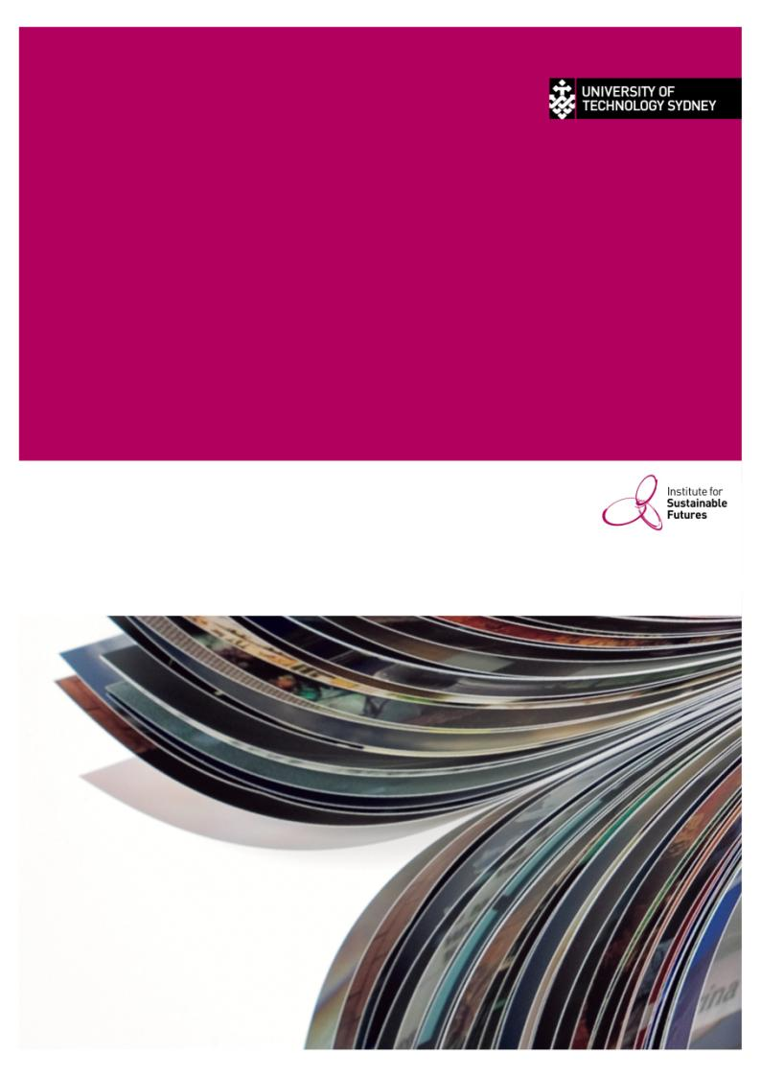

|  |
| --- |
| INSTITUTE FOR SUSTAINABLE FUTURES |
| EVALUATION OF the ENVIRONMENTAL EFFECTS OF THE WELS scheme  Final Report |

2015

ABOUT THE AUTHORS

The Institute for Sustainable Futures (ISF) was established by the University of Technology, Sydney in 1996 to work with industry, government and the community to develop sustainable futures through research and consultancy. Our mission is to create change toward sustainable futures that protect and enhance the environment, human well-being and social equity. We seek to adopt an inter-disciplinary approach to our work and engage our partner organisations in a collaborative process that emphasises strategic decision-making.

|  |  |
| --- | --- |
| For further information visit: | [**www.isf.uts.edu.au**](http://www.isf.uts.edu.au) |

Research team: Julian Fyfe, John McKibbin, Stephen Mohr, Benjamin Madden, Andrea Turner, Christian Ege

Citation

Cite this report as:

Fyfe, J., McKibbin, J., Mohr, S., Madden, B., Turner, A., Ege, C., 2015, Evaluation of the Environmental Effects of the WELS Scheme, report prepared for the Australian Commonwealth Government Department of the Environment by the Institute for Sustainable Futures, University of Technology, Sydney.

review

|  |  |  |  |
| --- | --- | --- | --- |
| Version | Author | Reviewed by | Date |
| Draft v0.1 | JF, JM | AT | 28-07-2014 |
| Draft v0.1 |  | Department of Environment |  |
| Final draft | JM | AT, JF | 4-09-2014 |
| Final report |  | Department of Environment |  |
| Final report (for publication) | JM | PM, AT | 02-03-2015 |

**Institute for Sustainable Futures**

University of Technology, Sydney

PO Box 123

Broadway, NSW, 2007

[**www.isf.edu.au**](http://www.isf.edu.au)

© UTS March 2015

UTS:INSTITUTE FOR SUSTAINABLE FUTURES

2 march 2015

**Evaluation of the Environmental Effects of the WELS Scheme**

FINAL REPORT

Prepared for the Australian Commonwealth Government Department of the Environment

EXECUTIVE SUMMARY

The Institute for Sustainable Futures (ISF) at the University of Technology Sydney, undertook a review of the environmental effects of the Water Efficiency Labelling and Standards (WELS) Scheme on behalf of the Australian Government Department of the Environment.

The review analysed several facets of the Scheme, including:

* the interactions between WELS and other urban water policies
* changes in the products registered and sold since the commencement of WELS
* changes in water consumption since the commencement of WELS
* energy, greenhouse and household bill impacts associated with reduced water consumption

An extensive policy review was performed to identify interactions between the WELS Scheme and other complementary urban water policies. The analysis confirmed that the WELS Scheme has formed a central reference for urban water policy in Australia, with a total of 32 reviewed policies referencing WELS, including 20 water efficiency programs, 4 energy efficiency programs, 6 building codes, regulations and rating schemes, and 3 tenancy laws.

The analysis of product registrations found a consistent shift and convergence across all product categories toward more efficient products.

This trend was confirmed through analysis of sales tracking data and interviews with product providers and suppliers, notwithstanding a recent levelling off of sales-weighted efficiency improvements in recent years.

Detailed modelling was then performed to estimate household water savings arising from efficiency improvements since the commencement of WELS. This included detailed end use modelling to construct a ‘bottom up’ model of how individual water appliances consume water, and appliance cohort component stock modelling to identify how historical and future shifts in sales translate to overall water consumption reductions over time owing to the incremental replacement of appliance stock.

The analysis estimated a total of 70 gigalitres per annum in water savings have already been achieved by 2013, owing to changes in appliance water intensities since the commencement of WELS. These water savings are expected to increase considerably in future years to 204 GL per annum by 2030 as the appliance stock mix is slowly replaced with more efficient models.

Importantly, the analysis removed water savings that were already ‘in the pipeline’ prior to the commencement of WELS owing to existing regulations and historical purchasing preference changes. Despite considerable baseline savings, the analysis found the WELS Scheme and a range of complementary policies have approximately doubled the reductions that would have otherwise been projected. This ‘deepening’ of water savings following the commencement of the WELS Scheme is shown clearly in Figure ES-1.

Figure ES‑1 - Estimated household water savings since the commencement of the WELS Scheme

Analyses were then performed to estimate how the water efficiency improvements translated to energy, greenhouse gas and household bill reductions. The analysis found an estimated cumulative greenhouse gas emission reduction of 46 megatonnes CO2 equivalent by 2030, and an estimated financial benefit to all households of $520 million in 2013, set to rise to $2 billion per annum by 2030 based on current energy and water price projections, as shown in Table ES‑1.

Table ES‑1 - Snapshot of estimated water savings, GHG reductions and bill savings

|  |  |  |  |
| --- | --- | --- | --- |
|  | 2013 | 2021 | 2030 |
| Annual water savings [GL/a] | 70 | 147 | 204 |
| Cumulative GHG reduction [MT CO2-e] | 5.5 | 20.4 | 46.4 |
| Annual total household utility bill savings [$m/a] | 520 | 1,390 | 2,063 |

Table of Contents

1 INTRODUCTION 1

1.1 Objectives 1

1.2 Scope 1

1.3 Outline of this report 2

2 THE WATER EFFICIENCY LABELLING AND STANDARDS SCHEME 3

2.1 History 4

2.2 Product Registration 4

2.3 Star Ratings 5

3 INTERACTION WITH URBAN WATER PLANNING AND POLICY 8

3.1 Water Restrictions and Public Awareness Campaigns 9

3.2 Utility pricing 9

3.3 Water efficiency programs 10

3.4 Energy Efficiency programs 17

3.5 Building Codes, Regulations and Rating SChemes 18

3.6 Mandatory Point of Sale Disclosure and Tenancy Laws 18

3.7 Implications for Evaluation of WELS 24

4 CHANGES IN PRODUCTS REGISTERED WITH WELS 26

4.1 Introduction 26

4.2 Analysis 26

4.3 Findings 28

5 CHANGES IN PRODUCT SALES 46

5.1 Data Collection and Analysis 46

5.2 Findings 48

6 CHANGES IN WATER CONSUMPTION 53

6.1 Analysis 53

6.2 Findings 67

7 ENERGY AND GHG IMPACTS 71

7.1 Introduction 71

7.2 Analysis 71

7.3 Findings 72

8 HOUSEHOLD BILL IMPACTS 75

8.1 Introduction 75

8.2 Analysis 75

8.3 Findings 77

9 CONCLUSIONS 79

REFERENCES 80

APPENDIX A: INTERVIEW TRANSCRIPT 83

APPENDIX B: MODELLING ASSUMPTIONS 87

APPENDIX C: SHOWERHEAD REPLACEMENT ESTIMATE METHODOLOGY 89

TABLE OF TABLES

Table 2‑1 - Current WELS ratings 6

Table 2‑2 WELS and other minimum water efficiency standards 7

Table 3‑1 - Water efficiency programs in major metropolitan centres and their links to WELS 11

Table 3‑2 Energy efficiency programs in major metropolitan centres and their links to WELS 19

Table 3‑3 National and state building codes and regulations 20

Table 3‑4 Tenancy laws affecting water efficiency 22

Table 4‑1 Registration status changes recorded in the WELS database and their interpretation 27

Table 5‑1 Data provided in GFK whitegood sales data report 46

Table 5‑2 - Plumbing and sanitary product manufacturers/suppliers and retailers contacted 47

Table 5‑3 - Top-loading clothes washing machine sales by star band 48

Table 5‑4 - Front-loading clothes washing machine sales by star band 49

Table 5‑5 - Dishwasher sales by star band 50

Table 6‑1 Flush volumes and full flush frequencies by toilet stock type 65

Table 6‑2 Assumed tap operational flow rates 66

Table 6‑3 - Snapshots of estimated annual water savings since the commencement of WELS 69

Table 6‑4 - Snapshots of estimated cumulative water savings since the commencement of WELS 70

Table 7‑1 - Energy intensity of water services in major cities 71

Table 7‑2 - Assumed hot water proportions by end use 72

Table 7‑3 - Snapshots of estimated annual energy consumption reductions associated with water savings since the commencement of WELS 73

Table 7‑4 - Snapshots of estimated cumulative greenhouse gas emission reductions associated with water savings since the commencement of WELS 74

Table 8‑1 – Annual residential utility bill savings associated with water savings since the commencement of WELS 78

Table 8‑2 – Cumulative residential utility bill savings associated with water savings since the commencement of WELS 78

TABLE OF FIGURES

Figure 1‑1 Report outline 2

Figure 2‑1 Overview of WELS legislative framework 3

Figure 3‑1 Influences to household water consumption 8

Figure 3‑2 – Estimated coverage of reviewed efficiency programs 17

Figure 4‑1 New and renewed registrations by year. 28

Figure 4‑2 WELS-registered products by type over time. 29

Figure 4‑3 Number of brands over time 30

Figure 4‑4 Distribution of star rating over time: (a) tapware; (b) flow controllers; (c) showers 31

Figure 4‑5 Distribution of star rating over time: (a) toilets; (b) urinals; (c) clothes washing machines; (d) dishwashers 32

Figure 4‑6 Cumulative distribution function for (a) taps and (b) showers 33

Figure 4‑7 Cumulative distribution function for flow controllers 33

Figure 4‑8 Cumulative distribution function for (a) toilets and (b) urinals 34

Figure 4‑9 Cumulative distribution function for (a) dishwashers and (b) clothes washing machines 34

Figure 4‑10 Dishwasher hot and cold water consumption on the primary connection 35

Figure 4‑11 Clothes Washing machine hot and cold water consumption on warm wash cycles 36

Figure 4‑12 Percentage of taps with flow controllers and auto shutoff 37

Figure 4‑13 Percentage of showers with flow controllers and bonus water saving features 37

Figure 4‑14 Toilets by flushing mode over time 38

Figure 4‑15 Average nominal flush volumes for toilets 39

Figure 4‑16 Urinals number of stalls 40

Figure 4‑17 Urinal flush mechanisms 40

Figure 4‑18 Dishwasher supplementary water connections 41

Figure 4‑19 Rated Capacity of Dishwashers 42

Figure 4‑20 Breakdown of top versus front loader clotheswashing machines 43

Figure 4‑21 Washing Machine connections over time 43

Figure 4‑22 Clothes Washing machine program run time and percentage of registered models with a record for program time 44

Figure 4‑23 Percentage of washer dryers that use water in the dryer 45

Figure 4‑24 Label CWM dryer function water consumption 45

Figure 5‑1 Cumulative uptake of efficient showerheads through water and energy efficiency programs 51

Figure 6‑1 - Illustrative diagram of stock modelling mechanics 54

Figure 6‑2 Penetration of clothes washing machines 55

Figure 6‑3 Modelled stock cohorts for all clothes washing machines 55

Figure 6‑4 Observed and modelled clothes washing machine sales shares by type 56

Figure 6‑5 - Modelled stock cohorts for top loaders 57

Figure 6‑6 - Modelled stock cohorts for front-loaders 57

Figure 6‑7 Modelled and reported stock of front and top loader clothes washing machines 58

Figure 6‑8 Sales-weighted water consumption by clothes washing machine type over time 59

Figure 6‑9 Stock-weighted clothes washing machine water intensity 59

Figure 6‑10 Dishwasher ownership 60

Figure 6‑11 Reported and predicted dishwasher appliance sales 61

Figure 6‑12 Dishwasher sales-weighted water consumption 61

Figure 6‑13 Sales shares for efficient and inefficient showers 62

Figure 6‑14 Modelled and reported shower stock 63

Figure 6‑15 Toilet market share by flush volume category 64

Figure 6‑16 Toilet stock by flush volume category 65

Figure 6‑17 – Estimated household water savings since the commencement of WELS 67

Figure 6‑18 - Estimated annual water savings since the commencement of WELS 68

Figure 6‑19 - Composition of estimated water savings in 2021 69

Figure 6‑20 - Estimated cumulative water savings since the commencement of WELS 70

Figure 7‑1 - Estimated annual energy savings associated with water savings since the commencement of WELS 73

Figure 7‑2 - Estimated cumulative greenhouse gas emission reduction associated with water savings since the commencement of WELS 74

Figure 8‑1 - Australian mean retail electricity and gas prices (DOI 2014) 75

Figure 8‑2 - Retail water prices in major metropolitan regions 76

Figure 8‑3 - Australian mean retail water price 76

Figure 8‑4 - Annual residential utility bill savings associated with water savings since the commencement of the WELS scheme 77

Acronyms

|  |  |
| --- | --- |
| BASIX | Building Sustainability Index |
| COAG | Council of Australian Governments |
| CWM | Clothes washing machines |
| DoE | Department of the Environment |
| DW | Dishwashers |
| FC | Flow controllers |
| GHG | Greenhouse gas |
| HH | Households |
| ISF | Institute for Sustainable Futures |
| WELS | Water Efficiency Labelling and Standards Scheme |
| WSAA | Water Services Association of Australia |

# INTRODUCTION

In April 2014, the Institute for Sustainable Futures, part of the University of Technology Sydney, was commissioned by the Australian Government Department of the Environment (DoE) to undertake an analysis of the environmental effects of the Water Efficiency Labelling and Standards (WELS) Scheme. Specifically, the brief requested estimates of the changes in household water consumption and greenhouse gas (GHG) emissions since the commencement of the WELS Scheme. This report presents the methodology and findings of analysis to estimating these impacts.

The WELS Scheme was designed to reduce water consumption by regulating the sale of basic plumbing products, sanitary ware and water-using appliances to both:

* improve levels of water efficiency, and
* provide consumers with information on product water intensity.

The WELS Scheme interacts with a complex urban water management environment that is influenced by a mix of: government policy and regulations; community awareness and expectations; utility planning, pricing and programs; sustainability drivers; and climate. Accordingly, the water savings since the commencement of WELS are not attributed to WELS exclusively, but rather understood as a consequence of a broad mix of actions in the urban water environment of which WELS has been a central part.

## Objectives

The objectives of this study were to:

* characterize the changes in products registered in the WELS database since the Scheme’s inception
* quantify changes in household water consumption related to residential appliances over the life of WELS
* estimate energy, GHG, and household bill reductions associated with the changes in household water consumption
* explore the role of WELS in influencing the above changes

## Scope

The study involved:

* analysis of the interactions between WELS and other urban water policy and planning instruments, including a literature review of water and energy efficiency programs, building regulations and rating schemes, and tenancy codes
* analysis of the WELS database to determine key trends in product registrations
* primary and secondary sales data collection to determine changes in product sales by WELS rating
* numerical modelling of water consumption by domestic end use and associated energy, GHG and household bill impacts

## Outline of this report

The outline of this report is shown in Figure 1‑1. Following the introduction, section 2 describes the background and coverage of WELS. Section 3 summarises analysis of Interactions between the WELS Scheme and other complementary policy and planning instruments. Section 4 discusses changes in the products registered under WELS while Section 5 analyses their translation to shifts in product sales. The product registrations and sales are then used to model water consumption impacts in section 6, followed by analyses of the corresponding energy, GHG and household bill reductions associated with those changes in section 7 and 8. The study conclusions are presented in section 9.

Figure 1‑1 Report outline

# THE WATER EFFICIENCY LABELLING AND STANDARDS SCHEME

The WELS Scheme was introduced in 2005 with the principal objectives of:

* conserving water supplies by reducing water consumption
* providing information for purchasers of water-use and water-saving products
* promoting the adoption of efficient and effective water-use and water-saving technologies

The Scheme requires common water-using devices including taps, showers, flow controllers, toilets, urinals, clothes washing machines (and water-using clothes dryers) and dishwashers to be registered under the Scheme. WELS is administered by the Australian Government Department of the Environment in partnership with the State and Territory governments. It is legislated through the acts shown in Figure 2‑1 together with complementary legislation enacted by the States and Territories to ensure national coverage.

Product-specific standards

Showers, tap equipment, flow controllers, lavatory equipment, urinal equipment, dishwashers, clothes washing machines and, clothes dryers

WELS Standard AS/NZS6400:2005 Water Efficient Products

Figure 2‑1 Overview of WELS legislative framework

To be registered, products must meet *AS/NZS6400:2005 Water-efficient products—Rating and labelling*. Depending on its level of efficiency and other measures of performance, a product is rated between 0 and 6 stars and assigned a label that must be displayed at the point of sale to enable consumers to judge the relative water efficiency of a product. To achieve a WELS rating, products must also meet specific performance standards, details of which are available at <http://www.waterrating.gov.au/industry/regulations-standards>. Product ratings are outlined in section 2.3.

By providing readily understandable information that enables consumers to compare models on the basis of relative (and absolute) water efficiency, WELS influences the choice of models installed, and hence the water consumption associated with the corresponding end use. It may also be argued that a proportion of the water savings achieved by demand management policies and programs that are linked to or reference WELS such as some rebate schemes and building regulations are attributable to the Scheme.

## History

The origins of WELS can be traced back to 1988 when a voluntary water efficiency scheme was established and administered by Melbourne Metropolitan Board of Works before being taken over by Sydney Water (Guest 2010, p 11). In 1999 administration of the National Water Conservation Rating and Labelling Scheme was handed to the Water Services Association of Australia (WSAA). It was reported that this voluntary scheme was not effective in achieving significant water savings, as only a small proportion of available models were labelled (Wilkenfeld and Associates 2004). With widespread support from industry for a mandatory water efficiency labelling scheme, WELS replaced the voluntary scheme in 2005.

WELS required all products imported or manufactured after 1 July 2006 to be registered and labelled before being sold with the following grace period arrangements for products imported or manufactured prior to 1 July 2006:

* unlabelled tap ware, showers, lavatory and urinal equipment permitted to be retailed until end 2006
* unlabelled dishwashers and clothes washers permitted to be sold from manufacture/import until end 2007

In 2013 product registration arrangements under WELS were changed in response to an independent review of the WELS scheme conducted in 2010. 2013 also marked the introduction of mandatory registration for flow controllers, which until November of that year had only been subject to a voluntary system.

## Product Registration

WELS requires all products imported or manufactured since 1 July 2006 to be registered and labelled before they are sold. Products could previously be registered under family groups for five years. The registration and fees determination of 2013 changed the arrangements such that products now have to be registered individually and registration lasts for one year only. If the Minister makes a change to the WELS Standard that affects the registration of a product, it needs to be re-registered (WELS Regulator, 2008).

## Star Ratings

The current WELS star ratings detailed in AS/NZS 6400 are summarised in Table 2‑1. Currently showers can only be rated as high as three stars, but the standards allow for categorization by flow rate within the 3 star band, which is planned to be converted to higher star ratings once a ‘force of spray’ test is incorporated into AS/NZS 3662 and/or AS/NZS 6400. The 5 star rating for toilets is currently available only to equipment that has an average flush of not more than 3.3 litres and incorporates an integrated hand basin. The water consumption figures for 6 star ratings for toilets are indicative only as the rating is not currently available as explained below. Zero star ratings are assigned to taps, showers and urinals that fail performance requirements.

### Minimum water efficiency standards

In addition to providing water efficiency ratings, WELS stipulates minimum water efficiency standards for a number of products as well as making references to other standards that enforce some form of minimum water efficiency standard. For toilets WELS prescribes a maximum average flush volume of 5.5 L (assuming one full flush to every four half flushes). It also requires adherence with AS/NZS 1172.2, which specifies acceptable cistern-pan models and corresponding minimum and maximum flush volumes in Table 2‑1. The acceptable classes of toilets according to AS/NZS 1172.2 include:

* Single flush toilets – 6 litre and 4 litre classes
* Dual flush toilets – 6/3 litre and 4.5/3 litre classes
* Replacement cisterns to match pre-installed pans – 9/4.5 litre

The acceptable range for the average flush volume of 9/4.5 litre toilets is 4.5 - 5.5 litres per flush. However under WELS a 2 star toilet cannot have an average flush volume of more than 4.5 litres per flush, effectively excluding 2 star toilets from the market. There are also no 6 star toilets available due to the lack of overlap between WELS and AS 1172.2. The range of acceptable flush volumes for 4.5/3 litre toilets is 3.1 - 3.5 litres per flush, but to achieve a 6 star WELS rating, a toilet must not have an average flush volume of more than 2.5 litres per flush.

To obtain a WELS rating, urinals must satisfy AS/NZS 3500.1, which requires a maximum flush volume of 2.5 litres for a single stall or 600mm wall equivalent. Minimum water efficiency standards were introduced for clothes washing machines in 2011 whereby machines with a capacity of 5kg or more must meet a water efficiency star rating of at least 3 stars and machines with a capacity of less than 5kg must achieve a rating of at least 2.5 stars. Minimum water efficiency standards that apply to WELS products are summarised in .

Table 2‑1 - Current WELS ratings

|  |  |  |  |  |  |  |  |  |  |
| --- | --- | --- | --- | --- | --- | --- | --- | --- | --- |
| Product type | Unit of Measure | 0 | 1 | | 2 | 3 | 4 | 5 | 6 |
| Taps and flow controllers | L/min | >16 | 12 to 16 | | 9 to 12 | 7.5 to 9 | 6 to 7.5 | 4.5 to 6 | <4.5 |
| Toilets |  |  |  | |  |  |  |  |  |
| Full Flush | L/flush | N/A | <9.5 | | <9.5 | <6.5 | <4.7 | <4.7 | <4.7 |
| Half Flush | L/flush | N/A | <4.5 | | <4.5 | <3.5 | <3.2 | - | - |
| Average Flush | L/flush | N/A | <5.5 | | <4.5 | <4.0 | <3.5 | <3.0 | <2.5 |
| Urinals | L/single stall or L/600 mm width of continuous wall | > 2.5 L serving single stall or > 4.0 L for two stalls or wall equivalent OR ⌘  OR having a flushing control mechanism that flushes more than two stalls or equivalent width of continuous wall | < 4.0 L serving two or more stalls or wall equivalent, AND conscious, demand-driven or smart-demand operation⌘ | | < 2.5 AND conscious, demand-driven or smart-demand operation⌘ | < 2.0 AND conscious, demand-driven or smart-demand operation⌘ | < 1.5 AND smart- demand operation⌘ | < 1.5 AND smart- demand operation⌘ | < 1.0 AND smart- demand operation with a urine- sensing device |
| Clothes washing machines | ☸ Rating rounded down to nearest half star | | | | | | | | |
| Dishwashers |
|  |  | **0** | | **1** | **2** | **3** | **(a)** | **(b)** | **(b)** |
| Showers | L/min | >16 | | 12 to 16 | 9 to 12 | 7.5 to 9 | 6 to 7.5 | 4.5 to 6 | 4.5 to 6 |

☸ Where WC = water consumption of the model in litres; BWC = base water consumption = 2.5 + P × 1.6; P = number of place settings of the dishwasher; WRF = water reduction factor per additional star (17.5%) = 0.175.

⌘ Having an activation device with a sensitivity field not greater than 300 mm from the front of the urinal.

Table 2‑2 WELS and other minimum water efficiency standards

|  |  |  |  |
| --- | --- | --- | --- |
| Category | Product | WELS minimum standards | Other minimum standards |
| **Plumbing products** | Showers | Under consideration | Plumbing codes and regulations (refer to section ) |
|  | Tapware | Under consideration |
|  | Flow controllers | Under consideration |  |
| **Sanitary ware** | Toilets | Full flush < 9.5 L, half flush < 4.5 L, average flush volume < 5.5 L | Table 4.1 in AS/NZS 1172.2.  Plumbing codes and regulations |
|  | Urinals |  | < 2.5 L for each single stall or each 600 mm length of continuous urinal wall (AS/NZS 3500.1) |
| **Whitegoods** | Clothes washing machines | 3 stars for > 5 kg machines  2.5 stars for < 5 kg machines |  |
|  | Dishwashers | Under consideration |  |

### Amendments

There have been some minor changes made to the ratings since the original AS/NZS 6400 was released. The first amendment was made in May 2006 and changed the upper limits to full, half and average flush volumes to an average flush range. In December 2006 (Amendment 3), the toilet ratings were switched back to the original specification. Amendment 5 from June 2011 introduced the minimum standard for clothes washing machines described earlier.

# INTERACTION WITH URBAN WATER PLANNING AND POLICY

The WELS Scheme was introduced in mid-2006 at the peak of one of the worst droughts in Australian recorded history. The ‘Millennium’ drought impacted most regions of Australia to varying degrees and lasted for over a decade. As governments and water utilities sought to secure water supplies, demand management measures and instruments became integral components of the urban water planning landscape.

WELS was introduced nationally by the Australian Government in collaboration with the State governments to facilitate the shift from inefficient to efficient water-using fixtures and appliances. The mechanism for achieving this was to inform consumers and encourage, or in some cases mandate, better efficiency standards. By establishing a nationally recognized set of standards, it has also provided a mechanism by which state authorities and water utilities can encourage, even accelerate uptake of efficient products through building codes and water efficiency programs.

As depicted in Figure 3‑1, the influence of the WELS Scheme on the widespread decline in urban water consumption observed across Australia is inextricably linked to the various demand management measures and instruments implemented by government and water utilities alike. This section outlines the context within which WELS has operated, describing various forms of demand management that have helped to reduce both behavioural and structural household water demand.

Figure 3‑1 Influences to household water consumption

## Water Restrictions and Public Awareness Campaigns

Broad-based demand management in the form of water restrictions and consumer/community awareness campaigns have proven highly effective in curbing demand, primarily in the residential sector, by changing water use behaviours and habits. Water restrictions target discretionary outdoor water usage by prohibiting certain forms and times of use, typically becoming more stringent with increasing scarcity. Public awareness campaigns have taken various forms including information on domestic water saving measures, publishing current consumption and water supply levels, and setting usage targets.

Public awareness campaigns on water efficiency have had a long history in Australia. However, restrictions and public campaigns were introduced at similar times by utilities across the country as they moved to secure supplies during the drought, making it difficult to separate their effects on water consumption. Nonetheless, their combined effect significantly reduced both peak and overall demand in both the residential and non-residential sectors. And while discretionary outdoor use was an easy target of these measures (and was the explicit focus of restrictions), research has shown that householders also responded by changing indoor usage patterns including:

* turning off taps when brushing teeth
* using toilet half flush more frequently
* only using the washing machine for a full load
* taking shorter showers
* checking for leaks and fixing leaking taps

Beatty et al. (2011) estimated indoor water use reductions of more than 40% in response to drought and restrictions across the Sydney Water supply zone. The analysis reportedly controlled for Sydney Water’s active demand management programs, and the impacts of building regulations (BASIX) and WELS, thus the reductions should reflect the effects of behaviour change alone.

While restrictions have largely been lifted or pared back since 2010, their effects have been lasting, to the extent that levels of bounce back observed following the lifting of restrictions in the past have not occurred this time around. While this suppression of bounce back can be attributed to permanent shifts in outdoor and indoor water use behaviour, it is compounded by the reductions in structural demand achieved by water efficiency programs and regulations (discussed below) and the WELS Scheme.

## Utility pricing

Significant increases in both water and energy pricing have occurred in the 2000s and will have affected the residential sector water demand in different ways. Due to the presence of restrictions and the fact that the volumetric component of water bills is relatively small in most jurisdictions and that water bills are typically read on 3 monthly cycles (creating a lag between demand and paying for water), rises in water prices have had a limited impact on domestic water consumption. A price elasticity analysis conducted by Sydney Water for the period 2004 to 2009 (during the Millennium drought) found that a 10% increase in price would produce a 1.1% reduction in long-term household consumption (Abrams et al 2011). The 16% reduction already achieved by level 2 restrictions had left little scope for further reductions in discretionary use.

More recently energy prices have risen contributing to a reduction in energy demand, which may also translate to reductions in hot water demand. However, research linking water use and energy consumption is relatively new (Kenway et al, 2011; Fyfe et al, 2011) and the extent to which energy prices influence hot water usage has not yet been fully explored.

## Water efficiency programs

Water efficiency programs have been used by water utilities and government bodies to reduce both indoor and outdoor water usage in the residential sector (as well as non-residential and non-revenue water) in most jurisdictions across Australia. They have taken various forms including giveaways, rebates, exchanges and home audits and retrofits. Although some water efficiency programs were in place in the 1990s, such as Kalgoorlie-Boulder Water Efficiency Program and Rous Regional Demand Management Strategy, pro-active water efficiency was not implemented at a significant scale until the Sydney Water Corporation commenced water efficiency initiatives in 1999.

Table 3‑1 provides details on the major indoor residential water efficiency programs that have been implemented around Australia. The table is not exhaustive as it covers only major metropolitan utilities, but aims to illustrate the form, timing and scale of programs that have been in operation since the WELS Scheme came into force. Several of these programs involve 100,000s of inefficient products being replaced by products of a standard equivalent to WELS 3 stars or higher. In a number of jurisdictions the savings of these products have been measured through ex-post statistical evaluation (Turner et al, 2014).

Table 3‑1 - Water efficiency programs in major metropolitan centres and their links to WELS

| Scheme | Description | Years Active | Participants | WELS Reference |
| --- | --- | --- | --- | --- |
| WaterFix (Sydney Water) | Households were provided with the opportunity to have a qualified plumber install a new 3 star-rated water efficient showerhead, tap flow regulators, toilet cistern flush arrestor for single flush toilets and to repair minor leaks. Savings of 20.9 kL/hh/a were measured through evaluation (Turner et al, 2005). The WaterFix service changed from July 2011 to a cost-recovery model, merging the original WaterFix and Toilet Replacement Programs. Now the service offers tap and toilet leak repairs and installation of 3-star showerheads, 4-star dual flush toilets and 3-star flow regulating aerators or 4-star in-body flow regulators. | 1999 - ongoing | 485,211 | WELS 3-star showerheads, WELS 4-star dual flush toilets, WELS 3-star flow regulating aerators, WELS 4-star in-body flow regulators (Sydney Water, 2013) |
| Dual Flush Toilet Rebate (Sydney Water) | A $200 rebate was given to households replacing a single flush toilet with a 4 star-rated or higher dual flush toilet, as part of the NSW Government's Climate Change Fund. | 2010 - 2011 | 6,954 | WELS 4-star dual flush toilets |
| Washing Machine Rebate (Sydney Water) | Sydney water offered customers a $150 rebate for buying a water efficient washing machine, initially commencing in 2006 with rebates for 4 star-rated washing machines, which was subsequently modified to 4.5 star-rated and eventually in 2010 to 5 star-rated machines. Estimated saving of 18 kL/hh/a. | 2006 - 2010 | 186,634 | WELS 4 to 5-star washing machines |
| Toilet Replacement Service (Sydney Water) | The toilet replacement service enabled householders to replace existing single flush toilets with a choice of three new 4 star-rated dual flush toilets with prices starting from $330. Estimated saving 23 kL/hh/a. | 2008 - 2011 | 28,224 | WELS 4-star toilets |
| Showerhead Exchange Program (Hunter Water) | In partnership with local councils, Hunter Water Corporation initiated a showerhead exchange program where participants can swap their old inefficient showerheads with WELS 3 star-rated or above rated showerheads | 2010 - ongoing | 5,641 (as of 2012) | WELS 3-star showerheads |
| Toilet Replacement Program (Hunter Water) | The toilet replacement program offered rebates for households to replace their existing inefficient single-flush toilets with WELS 4-star rated toilets | 2010 - 2011 | 1,773 | WELS 4-star toilets |
| Home Retrofit Program (Hunter Water) | The Home Retrofit Program offered a household audit of selected fixtures and fittings, installation of tap aerators and showerheads | 2010 - 2012 | 2,186 | WELS 3-star showerheads |
| WaterSmart (ACT) | The WaterSmart Homes residential indoor water tune-up was a program that subsidised the cost of a plumber coming to a participant house to fix leaks and install a 3-star showerhead, up to two tap aerators and a cistern flush arrestor. Households paid $30 for the cost of the visit and one 3-star showerhead, ($22 for each additional showerhead). | 2004 - 2007 | 7,260 | WELS 3-star showerheads |
| ToiletSmart (ACT) | The ToiletSmart program assists homeowners holding pensioner concession status to a 4-star toilet free of charge. ToiletSmart Plus water saving options including WELS rated showerheads are available at a reduced price to households who have accepted a ToiletSmart upgrade | 2008 - ongoing | 7,179 (as of September 2012) | WELS 4-star toilets, WELS 3-star showerheads |
| Home WaterWise Service (South East Queensland) | The service involved a licensed plumber visiting homes to install a range of water saving devices and provide advice on water saving strategies. It included: installation of a 3-star rated efficient showerhead, installation of water efficient aerators on bathroom and kitchen taps, fixing of up to three leaking taps, installation of cistern weights in single flush toilets and where requested the option to have up to two additional 3 star rated showerheads installed for an extra cost. In addition personalised advice was provided on more ways to save water around the home and provision of education tools. | 2006- 2008 | 228,564 | WELS 3-star showerheads |
| Living Victoria Water Rebate Program (Victoria) | Rebates have been provided in Victoria for a number of years. Rebates are limited to one per household except for the showerhead exchange, which is limited to two. Rebates include WELS related products such as: 5-star rated WELS/4 star energy rated washing machines (finished in June 2012), replacement of single flush or less efficient dual-flush toilets, exchange of inefficient showerhead for 3-star rated showerheads. | 2011 - 2015 |  | WELS 5-star clothes washing machines, WELS 3-star dual flush toilets, WELS 3-star showers (DEPI, 2012) |
| Retailer Showerhead Exchange Programs (Melbourne) | Program run by all 3 Melbourne retailers (Yarra Valley Water-YVW, South East Water-SEW, City West Water-CWW). It allows residential customers to exchange their old showerheads for free 3-star rated water efficient showerheads by taking their old showerheads and latest water bill into approved collection points such as water retailer offices, council locations, Australia Post outlets and Bunnings Warehouse outlets. Some retailers also require participants to sign an agreement to surrender any greenhouse gas (GHG) abatement credit that may arise from installing the showerhead. This potentially allows the retailer to collect carbon credits from the reduction of energy consumption and GHG associated with the reduced shower water heating load. | 2006 - ongoing | 454,178 | WELS 3-star showerheads |
| Retailer Toilet Replacement Program (Melbourne) | Program run by all 3 Melbourne retailers (YVW, SEW, CWW). Prices start at $284 (including $100 Living Victoria Water Rebate) which includes removal and recycling of old units and standard installation of a new 4-star or 5-star toilet by a qualified plumber. Partnership with Select Solutions using Caroma toilets. | YVW in 2009, SEW to June 2012, CWW in July 2009 | 13,680 | WELS 4-star dual flush toilet |
| Geelong Showerhead Exchange Program (Barwon Water) | Barwon Water's showerhead exchange program offers the free exchange of an inefficient showerhead for an efficient 3-star rated showerhead. | 2008 - ongoing | 3,870 (as of 2011) | WELS 3-star showerheads |
| Waterwise Rebate Program (WA) | In 2003, the Waterwise rebate program was launched to encourage the uptake of efficient appliances by the WA government. The program which closed in 2009, offered rebates on: bores ($300), 4.5-star washing machines ($150) , showerheads, flow regulators ($20), rainwater tanks ($600), greywater systems ($500), aerobic treatment units, soil wetting agents, tap timers, swimming pool covers ($200), waterwise irrigation systems ($300), sub surface irrigation rolls ($10), rain sensors ($20) and garden assessment ($30). | 2003 - 2009 | 351,000 | WELS 4.5-star clothes washing machines, WELS 3-star showerheads |
| Showerhead Swap (WA) | A program available to residential customers and endorsed Waterwise Councils in Perth. Participants exchanged up to two of their showerheads for free efficient models. The most recent water bill was required. Showerheads could be exchanged at local Bunnings stores and eligibility included rental properties. | February 2011 - April 2013 | 124,000 | WELS 3-star showerheads |
| Toilets to Go (WA) | Water Corporation has partnered with Select Solutions and Caroma to provide households (and businesses) with the chance to swap single flush toilets with 4-star dual flush toilets for a reduced cost. A choice of 3 toilets are available at a cost of $438, $579 and $676 including installation fees. |  |  | WELS 4-star toilets |
| Pensioner Retrofit Program (WA) | A free retrofit program available for pensioners in a selection of Perth suburbs. The program involved a plumber visiting the house, repairing leaking toilet cisterns and taps by replacing valves/washers (not replacement of taps or pipes), retrofitting 3-star showerheads and retrofitting up to four 4-star tap aerators to sinks where required. The service was available until June 2013 or until 4,000 pensioners have been signed up to the program. | 2012 to June 2013 | Program run until June 2013 or until 4,000 participants signed up | WELS 3-star showerheads and WELS 4-star tap aerators |
| Waterwise Retrofits for Community Facilities (WA) | Free program for not-for-profit organisations and shared community facilities in Perth and Mandurah to receive a site audit, leak repairs, supply and installation aerators on sink and basin taps, water efficient showerheads, and dual flush toilet suites. | Current |  | 4 star WELS rated tap aerators, WELS 3-star showerheads, WELS 4-star dual flush toilets |
| H2ome Rebate Scheme (SA) | The H2ome Rebate Scheme was launched by the South Australian Government to encourage domestic water savings. The rebate scheme provided households with incentives to purchase a range of water saving products and appliances, including toilets, showerheads and washing machines | 2007 - 2012 | 268,772 rebates | WELS 3-star showerheads, WELS 3-star dual flush toilets, WELS 4.5-star washing machines |

Although it is now difficult to ascertain the extent to which these programs referenced WELS in their water efficiency programs *historically*, current documentation of the campaigns all use WELS ratings to classify the water efficient products that were/are offered under respective programs. WELS has thus become the universal basis for informing consumers and specifying product orders with suppliers. Prior to the introduction of the WELS Scheme, classification of water efficient products were based on flow rates/volumes and the WSAA “A” rating structure.

### Review coverage

Figure 3‑2 provides an indication of the reach and coverage of the efficiency programs given in Table 3‑1.

Figure 3‑2 – Estimated coverage of reviewed efficiency programs

## Energy Efficiency programs

As water efficiency programs declined following the easing of the Millennium drought, energy efficiency programs have begun to emerge as governments move to reduce greenhouse gas (GHG) emissions and assist low-income households manage recent sharp increases in electricity prices. One of the largest components of household energy bills is water heating, thus energy efficiency schemes have targeted inefficient showerheads to achieve low-cost energy savings. Together with previous water efficiency programs targeting showerheads, these programs have made considerable headway in accelerating the turnover of inefficient showerhead stock. Table 3‑2 lists the major energy efficiency programs that have been operating in Australia since the inception of WELS.

## Building Codes, Regulations and Rating SChemes

Building codes and regulations have played a key role in improving household water efficiency by recommending and in some cases mandating minimum water efficiency standards for plumbing products. An early example of this was the widespread switch to dual flush toilets amongst new and renovated dwellings, which was triggered when the national plumbing code mandated their installation in the 1980s. In NSW the Building Sustainability Index (BASIX) mandates minimum water and energy (GHG) standards for new dwellings and renovations through a planning certification process. It sets performance-based targets for water efficiency against which designs are assessed to obtain certification. The assessment credits higher water efficiency scores for designs incorporating higher WELS-rated products. There are also a number of high-profile voluntary urban development and building sustainability rating schemes that encourage installation of water efficient plumbing fixtures. Table 3‑3 summarises current building codes, regulations and rating systems across Australia that make reference to water efficiency.

## Mandatory Point of Sale Disclosure and Tenancy Laws

Another feature in the water efficiency policy landscape has been laws that promote general improvement in the water efficiency of housing stock by mandating disclosure of dwelling performance at the point of sale and requiring landlords to install water-efficient fixtures before they can pass on the variable usage charges of water bills to their tenants. Mandatory disclosure regulation has been under consideration at state and federal levels since a 2009 Council of Australian Governments (COAG) communiqué proposed ‘the phase-in of mandatory disclosure of residential building energy, greenhouse and water performance at the time of sale or lease, commencing with energy efficiency by 2011’ (O’Leary 2012). Despite this, there are currently no active laws that mandate disclosure of dwelling water efficiency in Australia. In Queensland a form of mandatory disclosure called the Sustainability Declaration - a compulsory checklist of sustainability considerations, including water (efficiency), that had to be completed by the vendor when selling a house, townhouse or unit – was introduced in 2010, but was repealed in 2012.

Despite being directed at social equity outcomes (affording tenants the opportunity to minimise their water consumption bills), tenancy laws relating to water efficiency (summarised in Table 3‑4) help to accelerate the turnover of inefficient plumbing fixtures.

Table 3‑2 Energy efficiency programs in major metropolitan centres and their links to WELS

| Scheme | Description | Years Active | Participants | WELS Reference |
| --- | --- | --- | --- | --- |
| Energy Savings Scheme (NSW) | The Energy Savings Scheme (ESS) provisions the creation of Energy Savings Certificates (ESC) which are created through approved energy saving activities, which are then redeemable to liable parties including electricity retailers who buy ESCs to meet their own obligations under the ESS. ESCs can be created with the installation of ultra low-flow showerheads to electric hot water systems, or electrically boosted solar or heat pump systems | July 2009 to December 2011 (showerhead replacement) |  | WELS 3-star showerheads |
| Home Power Saver Program (NSW) | The Home Power Savings Program (HPSP) was an initiative by the NSW Government to put downward pressure on the cost of living in the state by specifically targeting residential energy consumption in the low-income household sector. Participants in the HPSP scheme received a Power Savings Kit, which included WELS rated showerheads | May 2010 - June 2012 |  | WELS 3-star showerheads |
| Victorian Energy Efficiency Target (Victoria) | The Victorian Energy Efficiency Target (VEET) scheme's purpose is to reduce greenhouse gas emissions and to encourage the efficient use of electricity and gas. Accredited energy savings activities, including the installation of efficient shower heads, can generate certificates (VEECs) which are redeemable to liable parties including electricity retailers who buy VEECs to meet their own obligations under the VEET. | January 2009 - ongoing |  | WELS 3-star showerheads |
| Climate Smart Home Service (Queensland) | The Climate Smart Home Service was a Queensland Government initiative that offered both structural and behavioural measures to Queensland households through a home energy assessment, installation of CFLs and efficient showerheads, and provision of a personal energy action plan. | 2009 - 2012 | 344,000 | WELS 3-star showerheads |

Table 3‑3 National and state building codes and regulations

| Code/regulation/rating | Description | WELS Reference |
| --- | --- | --- |
| Queensland Development Code | Part *4.1 - Sustainable Buildings* of the Queensland Development Code stipulates that in new class 1 and class 2 buildings in areas serviced by a water service provider, showerheads, toilets and taps must all facilitate the efficient use of water. | WELS 3-star showerheads, WELS 4-star toilets, WELS 3-star basin taps |
| Building Code of Australia, Western Australia Addition | New Class 1 residential buildings or Class 1 residential buildings being renovated, altered, extended, improved or repaired in Western Australia are required to comply with Volume Two of the Building Code of Australia, including the WA Addition for water use. | WELS 3-star showerheads, WELS 4-star toilets, WELS 4-star basin taps |
| ACT Water and Sewerage Regulation 2001 | The Water and Sewerage (Energy Efficient Hot-Water Systems) Legislation Amendment Bill 2009 enacted changes to the Water and Sewerage Regulation 2001 that requires each shower outlet connected to a newly installed or retrofitted efficient hot water system be fitted with a showerhead with maximum flow capacity of 9 litres per minute | WELS 3-star showerheads |
| BASIX (NSW) | Performance based efficiency certification system, whereby certain targets in water and energy use must be met to receive BASIX certification which is required for development approval for new houses and units. According to BASIX information, a typical single dwelling design will meet the target for water conservation if it includes: showerheads, tap fittings and toilets with at least a 3A/3 star; a rainwater tank or alternative water supply for outdoor water use and toilet flushing and/or laundry. | WELS 3-star showerheads, WELS 3-4-star toilets, WELS 3-star basin taps |
| Green Star | Voluntary environmental rating system used to evaluate the performance of building designs and construction. The rating system consists of 9 categories of rating tools which assess buildings or projects on management, indoor environmental quality, energy, transport, water, materials, land use & ecology, emissions and innovation. The installation of WELS rated fixtures and appliances are used as benchmarks for the performance rating of buildings | WELS rated appliances and fixtures referenced as benchmarks in water efficiency performance ratings |
| NABERS | The National Australian Built Environment Rating System is a system of frameworks used for rating offices, shopping centres, hotels, homes and data centres on their environmental performance. Buildings are given star ratings based on four performance areas: energy efficiency, water efficiency, waste management and indoor environment. | WELS ratings given as reference for improving efficiency of water appliances and amenities |
| EnviroDevelopment | EnviroDevelopment is a voluntary branding scheme for developers to certify new residential, commercial and industrial developments as environmentally sustainable. The Water element of the certification requires reduced potable water use through efficiency and alternative sources. The criteria for efficiency include the use of fittings with a higher WELS rating than mandated through regulation. | WELS ratings used as the basis for assessing the water efficiency of fittings installed in a new development. |

Table 3‑4 Tenancy laws affecting water efficiency

| Scheme | Description | WELS Reference |
| --- | --- | --- |
| Residential Tenancies Regulation 2010 (NSW) | According to the NSW Residential Tenancies Regulation 2010, residential premises must meet prescribed water efficiency standards before tenants are required to pay water usage charges. The prescribed water efficiency standards are that all showerheads and taps must have a maximum flow rate of 9L/min, and that there must be no leaking fixtures on the premises at the commencement of the rental agreement. | WELS 3 star-rated showerheads, WELS 3-star taps |
| Residential Tenancies and Rooming Accommodation Regulation 2009 (Qld) | The QLD Residential Tenancies and Rooming Accommodation Regulation 2009 guarantees that property lessors are only able to pass on full water consumption charges to tenants if the rental premises are water efficient, with minimum water efficient standards of 9L/min taps, and 9L/min showerheads required to be met for premises to be considered water efficient. The QLD regulation also gives minimum water efficient toilet standards of 6.5/3.5L/flush for dual flush toilets. | WELS 3-star showerheads, WELS 3-star taps, WELS 3-star dual-flush toilets |
| Residential Tenancies (Minimum Housing Standards) Amendment Bill 2011 (Not passed) (ACT) | The ACT Residential Tenancies (Minimum Housing Standards) Amendment Bill 2011 proposed to implement amendments to the ACT Residential Tenancies Regulation that would require tenancies to meet minimum water and energy efficiency standards. Proposed water efficiency requirements were: maximum 9L/min showerheads, maximum 9L/min taps, and maximum 6.5/3.5L dual flush toilets. The proposed amendment was not passed through the ACT Legislative Assembly. |  |
| Residential Tenancies Act 1997 (Vic) and Residential Tenancies Regulations 2006 (Vic) *[amendments introduced by Residential Tenancies Amendment (Prescribed Rating for Replacement Water Appliances) Regulations 2014 (Vic) which will commence on 1 October 2014]* | The Act provides that, when a water appliance, fixture or fitting supplied by the landlord of rented premises (or caravan park owner) needs to be replaced, then the replacement needs to have at least the prescribed level of rating in a prescribed rating system.  The Act also provides that, if a tenant (or caravan resident) is arranging for urgent repairs to be carried out because the landlord (or caravan owner) will not do so, and the water appliance that needs to be replaced does not have at least a prescribed level of rating in a prescribed rating system, the tenant (or caravan resident) may replace it with an item that has a rating that is of or above a prescribed level of rating in a prescribed rating system.  From 1 October 2014, the prescribed level or rating in a prescribed rating system for the purposes of the Act will be a 3-star rating in the WELS Scheme, or a 2-star or 1-star rating in the WELS Scheme if, because of the age, nature or structure of the plumbing in the rented premises (or caravan), a replacement with a 3-star rating cannot be installed or, when installed, will not operate effectively. | WELS rated appliances, fixtures or fittings |

## Implications for Evaluation of WELS

The policy interactions mapped above provide a valuable context for understanding the water savings associated with WELS. The complexity and depth of interaction between WELS and the broader policy landscape means that any attempt to directly attribute water savings to WELS would not yield meaningful results. However, it is also important to emphasise that many of the complementary measures would not be as effective without the support of the WELS Scheme. Hence formulating at least a qualitative appreciation of the influence of WELS is important to both establishing an appropriate modelling baseline and interpreting the results.

Prior to WELS, industry stakeholders (including manufacturers, importers and the plumbing industry) were already required to meet different standards and regulations – a situation not unique to these industry sectors. For plumbing products, legislation and standards (such as the WaterMark scheme) covered aspects such as the quality of fittings and minimum flow rates. AS 3500 has specified the maximum allowable water use per flush for toilets since 1993 – although this was not made mandatory in some states until recently. The plumbing code mandated dual flush models in the 1980s. Energy labelling has been mandatory for washing machines and dishwashers since 1998. It should therefore be recognised that significant structural water savings were already in train prior to the commencement of WELS.

Water restrictions primarily influence behavioural aspects of water use, both indoor and outdoor, which must be allowed for in the end use modelling. It is also feasible that they influence decisions regarding the purchase of water-using products, in which case WELS would play a critical role in informing those decisions. The same could be said if, despite its low elasticity of demand, water pricing also influenced consumer choices.

Water and energy efficiency programs essentially stimulate the uptake of water efficient devices and accelerate the turnover of inefficient stock. In the absence of WELS, structural water efficiency gains through water efficiency programs would still have occurred as those programs were initiated in response to the drought. As mentioned previously, however, the introduction of WELS provides readily understandable information for program providers to use in marketing and consumer information, and also a nationally recognised standard against which to specify water efficiency to suppliers. As the number of efficient products available has increased over the last decade (as can be seen in the following section) the clarity and message of the WELS Scheme has become more useful both to organisations running efficiency programs and to consumers. So whilst the savings from water efficiency programs cannot be attributed to the WELS Scheme directly, WELS certainly played a significant role in their success.

Of the various products that have been offered through water and energy efficiency programs, showerheads are the only product that are likely **not** to have been replaced without the incentive of the program on account of the relative difficulty associated with their replacement and the amount of subsidy on offer. It is therefore important that the stimulated turnover of showerheads be incorporated in the model baseline.

Perhaps more important than the role the WELS Scheme played in water efficiency programs is the legacy it enables. WELS ensures that inefficient stock that has been converted to efficient models through these programs does not simply revert back to inefficient stock at the end of its lifetime or at the next renovation. Thus WELS ‘locks in’ the savings from water efficiency programs.

With regards to the broader policy instruments (building codes, regulations and ratings, mandatory disclosure and tenancy laws), WELS provides the foundations that underpin robust and nationally consistent application of water efficiency standards. While water efficiency standards could be described in different terms in the absence of WELS, the difficulties associated with formulating, benchmarking and enforcing such standards would pose a significant barrier to such policies being devised or adopted. The WELS Scheme has essentially paved the way for these other important water efficiency policy mechanisms.

# CHANGES IN PRODUCTS REGISTERED WITH WELS

Since registration and labelling under the WELS Scheme is mandatory, the WELS database provides a record of all taps, showers, flow controllers, toilets, urinals, clothes washers and dishwashers that have been on the market since the Scheme’s inception. This section presents an analysis of the database that explores the changes to products available on the market since the beginning of 2006.

## Introduction

The WELS database contains records of all products currently or previously registered under the WELS scheme, with information on key product characteristics, water consumption and WELS star ratings. The database contains all products registered from November 2005 onward. Before the enactment of the Water Efficiency Labelling and Standards (Registration Fees) Determination on 22nd January 2013 products were registered in ‘families’ and the registration period lasted 5 years. Since then products have been required to be registered individually with each product assigned its own registration number. In addition the registration period now spans 1 year under a tier based registration system. On the 22nd January 2012, the data on registered products were transferred to a new database. Products that did not pay the tier fee by the 11th of April 2013 expired on the 12th April 2013. Similarly, products that failed to renew their registration on the 22nd January 2014 expired on that day.

## Analysis

The database was provided to ISF in the form of a MS Excel workbook containing a spreadsheet for each product. The data were analysed using the Python programming language and MS Excel. The analysis involved segmentation of the data by calendar year and by the following categories:

* Star rating
* Water Consumption on label
* Nominal flow rate
* Manufacturer/supplier
* Product characteristics

The main concern in performing this analysis was to ensure that only active products were counted in a given year. A look-up table provided a record of when the registration status of a product changed and the nature of that change. The various entries in the look-up table and their interpretation are given in Table 4‑1. In addition, to be considered active, a product had to be registered for at least three months of the year. Product renewals were counted as any product that had a status of registered the year previous.

Table 4‑1 Registration status changes recorded in the WELS database and their interpretation

|  |  |
| --- | --- |
| Status | Interpretation |
| Cancelled | Product is no longer available to be sold after the cancelled date |
| Expired | Product is no longer available to be sold after the expired date |
| Expiring | Product is in the process of becoming expired but is still available to be sold - treated the same as registered |
| Recommend to cancel | Product may become cancelled but is still available to be sold, treated the same as registered |
| Registered | Product is available to be sold |
| Renewed | Treated same as registered |
| Suspended | Product is no longer available to be sold after the suspended date |

### Data issues

The database was found to contain two minor errors:

1. Three taps, five showerheads and 17 Lavatories had blank entries for star rating
2. Two washing machines classified as being ‘Non Drum’ type are recorded as having a ‘Drum’ action. Similarly there is one washing machine of type ‘Drum’ whose action is recorded as ‘impeller’ (as opposed to ‘drum’).

The conflicts between the washing machine action and type were left unchanged due to the small number of records. For the missing star ratings, a star rating was inferred from the ‘Water consumption on label’ field as described below.

**Showers**

|  |  |
| --- | --- |
| Assumed star rating | Water consumption on label |
| * 3 (> 7.5 but <= 9.0) | * 8.9 |
| * 3 (> 7.5 but <= 9.0) | * 9.0 |

**Taps**

|  |  |
| --- | --- |
| Assumed star rating | Water consumption on label |
| * 5 | * 5 |
| * 6 | * 3.5 |

**Toilets**

|  |  |
| --- | --- |
| Assumed star rating | Water consumption on label |
| * 3 | * 3.6 |
| * 4 | * 3.5 |

## Findings

Figure 4‑1 shows new and renewed/continued WELS product registrations by year. Despite the ‘barrier’ WELS registration represents to putting a product on the market, the number of registrations has increased steadily and substantially since 2006 (save for 2014, which at the time of writing is still to run its course). Between 2006 and 2010 registrations had a five-year lifespan, thus following the initial registration of all products on the market in 2006, most registrations were *continuing* rather than new. Nonetheless there was consistent, albeit declining, year-to-year growth in total registered products over this period. Since 2011 registrations have continued to grow; however new products have made up a larger fraction of total registrations. This indicates that the flexibility afforded by one-year registrations by individual product (rather than by product family) has resulted in greater product turnover and/or re-registration of existing products as new products (as opposed to simply renewing the existing registration). 2014 shows an apparent drop in renewals (which should all have been completed by late January), but a large increase in new products is already apparent. On account of recent changes made to the way products are recorded in the database and the year being incomplete, 2014 has not been included in subsequent analyses.

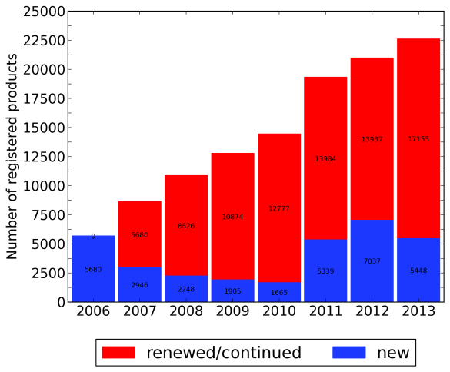

Figure 4‑1 New and renewed registrations by year.

Figure 4‑2 shows the breakdown of WELS-registered products by year. In 2013 there were some 22,603 products registered with WELS, the majority of which were tapware (58%), followed by showers (22%) and toilets (12%). Dishwashers (DWs) and clothes washing machines (CWMs) were much smaller in number, at 4.0% and 2.4%, respectively. Urinals, which only service the non-residential sector, and flow controllers, which are an add-on component to taps, make up the balance of products registered with WELS.

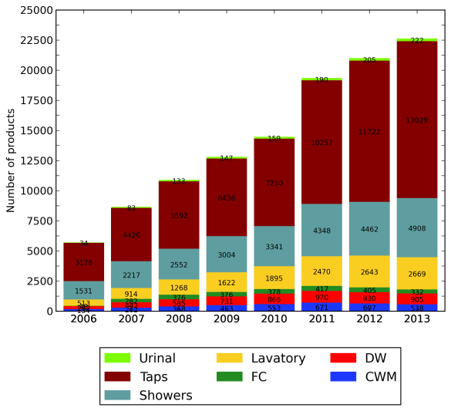

Figure 4‑2 WELS-registered products by type over time.

### Brands

As shown in Figure 4‑3, the number of brands has steadily increased up to 2012. Again tapware, showers and toilets make up the bulk of the diversity in the market, although tapware would appear to have a significantly higher ratio of products to brands than other product types, such that tapware brands made up only 28% of the market in 2013 (compared with 58% of products). In 2013 there was a slight decline in the number of brands dropping from 800 to 790. This was due to a handful of CWM, DW, FC, shower and urinal brands dropping out of the market, while tapware and lavatory brands slightly increased in number.

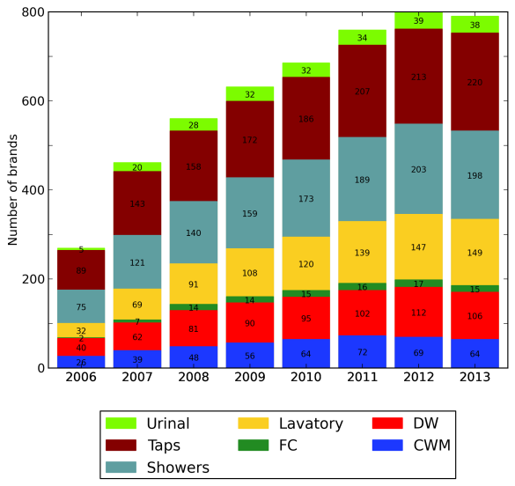

Figure 4‑3 Number of brands over time

### Star ratings

Figure 4‑4 presents the breakdowns of showers, tapware and flow controllers by WELS star rating over time. Tapware and showers exhibit a general increase in rated efficiency, while the rating breakdown of flow controllers has largely remained unchanged despite the growth in registered products. The dominance of 4-star and above taps has grown from 57% to 82%, with the portion of 5-star and 6-star taps increasing substantially from 23 to 44% of available product. 3-star 7.5-9 L/min showers have been and continue to be by far the dominant shower rating (76% to 81%). Zero star showers initially rose in 2007 from 13.1% to 16.4% of the market, but have since declined to just 4% in 2013. The portion of products in the two top efficiency bands has risen only marginally from 9% to 13%. The share of the top two star bands for FCs has remained around 60% since 2008, while the portion of 2- and 3-star FCs has stayed below 30% since 2007.

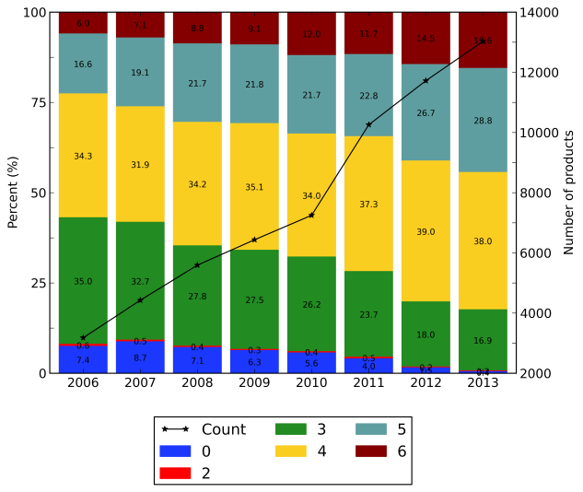

(a)

(b)

(c)

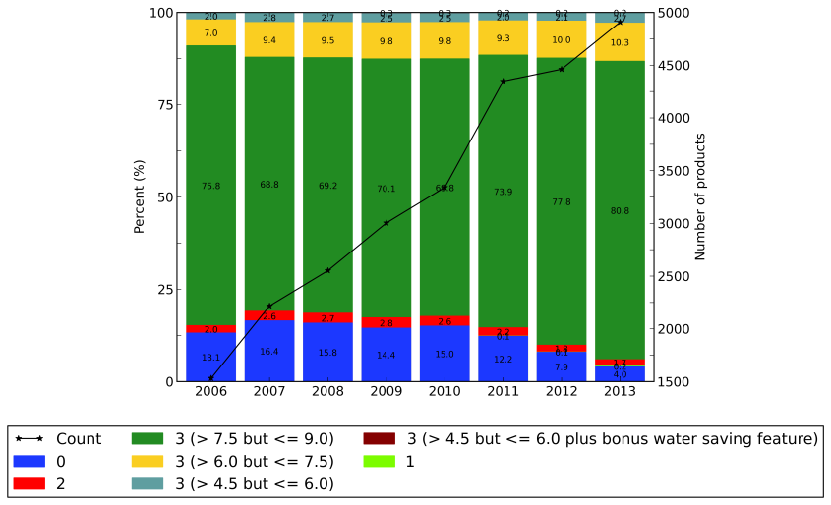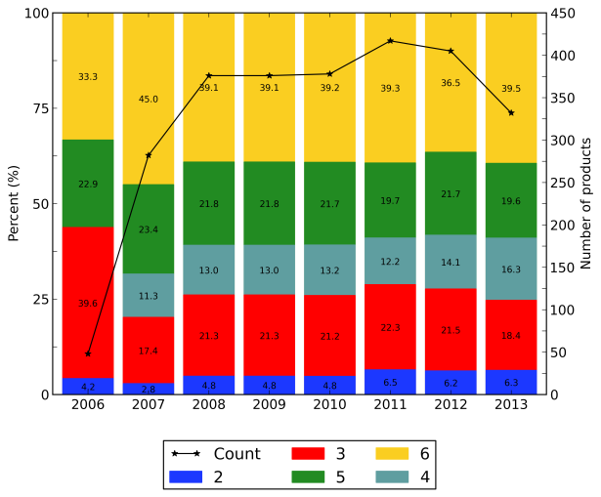

Figure 4‑4 Distribution of star rating over time: (a) tapware; (b) flow controllers; (c) showers

Star rating breakdowns for toilets, urinals, CWMs and DWs are given in Figure 4‑5. Toilets have made a steady shift from predominantly 3-star to mainly 4-star, with the portion of 4-star toilets growing from 23% to 69%. Since 9/4.5 litre toilets tend to have an average consumption of 5.5 litre (1-star) and the next more efficient toilet products available on the market are 6/3 litre models (3-star), there have been no registered 2-star toilet products. 3-star models dominate the urinal market growing from around 40% to now make up 51%. A general shift towards efficiency has resulted in 2-star and below urinals now making up just 12% of market.

The most marked shifts in WELS-registered products have been observed in the whitegoods. Clothes washing machines have exhibited a clear shift from being dominated by 4-star models to mainly 4.5-star models. The share of 3.5-star and below has declined continuously since inception of WELS, decreasing from 50% in 2006 to only 24% in 2013. Similarly, where the dishwasher market was originally dominated by 3.5 star and below products, 4-star and above products now account for 70% of available products (up from 10% in 2006), with all of the star bands above 4 growing since 2006. 1-star models are now almost non-existent, while 1.5-, 2-, 2.5-star and even 3- and 3.5-star are seemingly following the same fate.

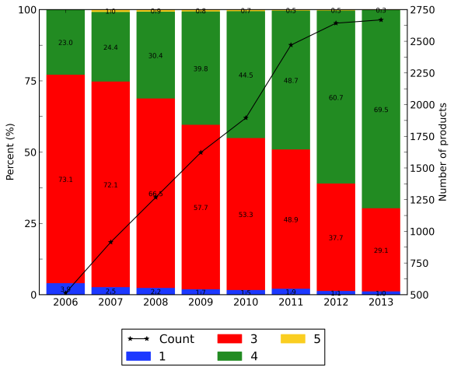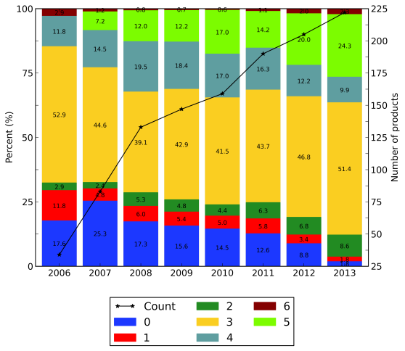

(a)

(b)

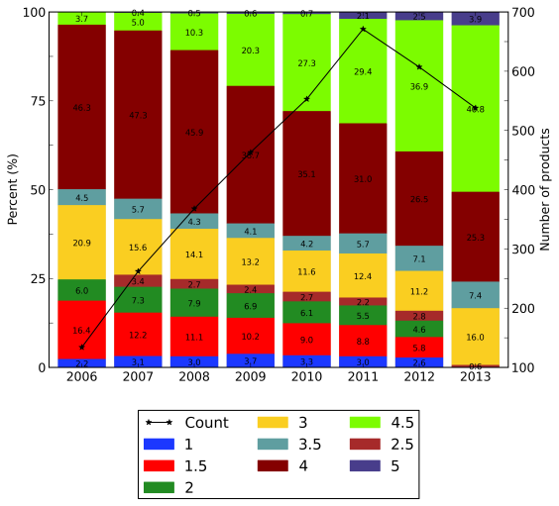

(c)

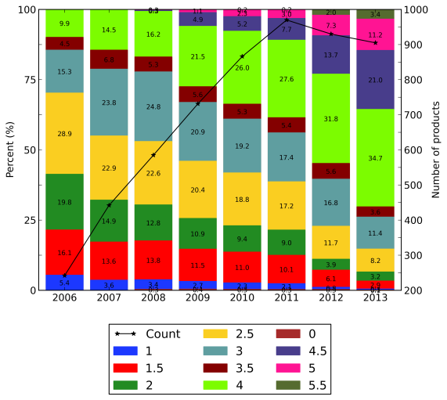

(d)

Figure 4‑5 Distribution of star rating over time: (a) toilets; (b) urinals; (c) clothes washing machines; (d) dishwashers

### Water consumption

Figure 4‑6 presents cumulative distribution functions for tap and shower (WELS label) flowrates by year. Each line gives the fraction of products in the database that had the label flowrate indicated on the x-axis or less. Steeper lines towards the left of the plot indicate a more efficient range of products. The coloured bands indicate flowrates that fall within WELS star bands.

Plot (a) in Figure 4‑6 shows that taps have undergone a subtle shift towards more efficient products over time, moving from around 25% of products having a label flowrate less than 7.5 L/min in 2006, to more than 50% in 2013. Plot (b) shows that the large majority of registered showers has always comprised models with a flowrate of 9 L/min or less. There have been small increases in the distribution of showers below 9 L/min since 2006 corresponding to the reduction in 2-star and below models.

Figure 4‑7 presents the same type of plot for flow controllers, which shows a more uniform distribution of flowrates across the range of registered products. The intervening years between 2006 and now are very similar, but there is a clear shift towards more efficient products across the range by 2013.

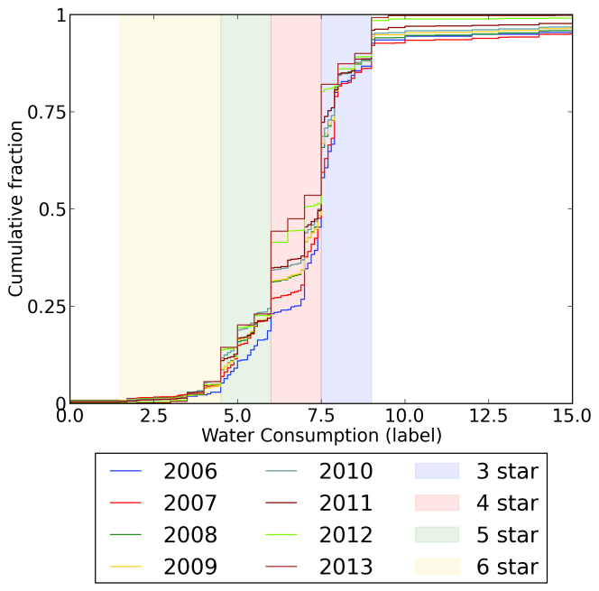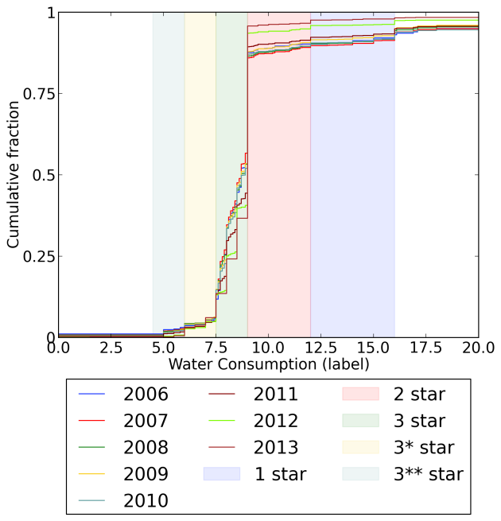

(a)

(b)

Figure 4‑6 Cumulative distribution function for (a) taps and (b) showers

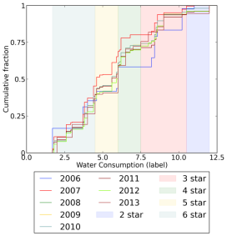

Figure 4‑7 Cumulative distribution function for flow controllers

Cumulative distribution functions for toilets and urinals are given in Figure 4‑8. Since 2006 only a small fraction of registered toilets have had average consumption more than 4.0 L/flush. Again there has been a subtle shift in the market towards lower water consumption, with almost 75% of registered models now using 3.0 L/flush or less. The shift in urinals has been more dramatic, with the distribution of registered models generally using less water in 2013 than in 2006, particularly in the 0.8 – 1.5 L/flush label consumption range. In 2006, almost 50% of urinals used 2.0 or more litres to flush a single stall. The corresponding flush volume in 2013 is around 1.6 L.

(a)

(b)

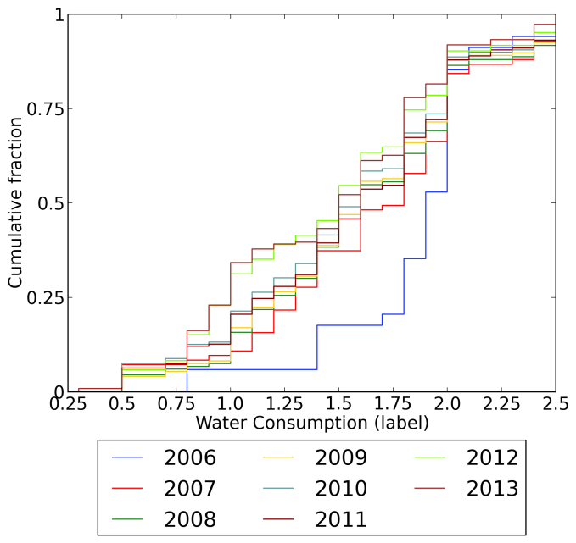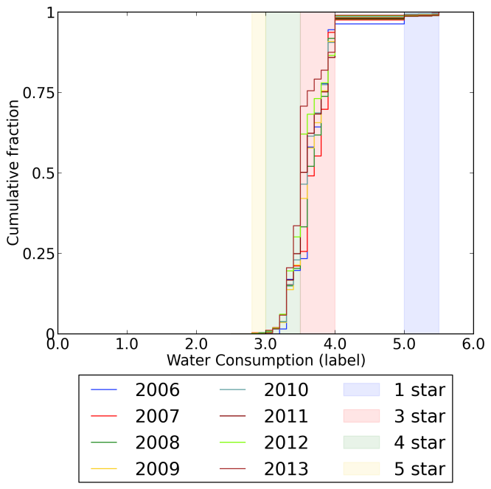

Figure 4‑8 Cumulative distribution function for (a) toilets and (b) urinals

The trend towards lower water consumption amongst dishwashers is clearly evident in plot (a) of Figure 4‑9. Water consumption across the entire range of models shifts towards greater efficiency. By 2013 around 90% of models were using around 14 litres or less per wash compared with less than 25% in 2006. The range of registered clothes washing machines has also shown a move to lower water consumption with each year. However, the shifts have predominantly been at the mid- to high end of the water consumption range. Machines using 100 litres per wash or less made up just over 60% of the product range in 2006. In 2013 the share had increased to almost 90%. The share of machines using 60 litres or less however has barely changed since 2006.

(a)

(b)

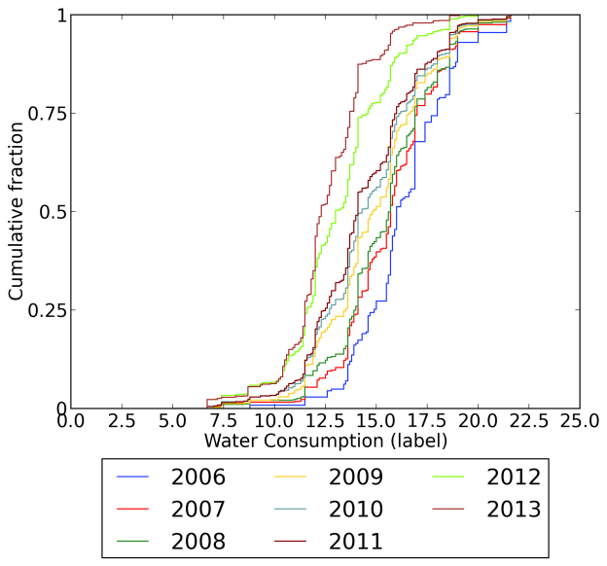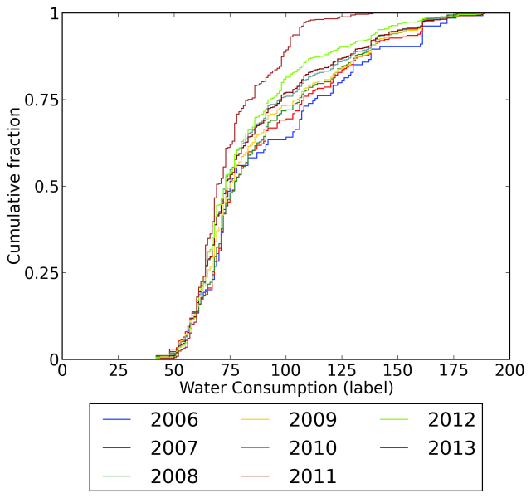

Figure 4‑9 Cumulative distribution function for (a) dishwashers and (b) clothes washing machines

Figure 4‑10 is a time series of box-whisker plots[1] for dishwasher total, hot and cold water consumption, which shows that water consumption in dishwashers is exclusively made up by cold water use. From this it may be inferred that all machines have internal heating elements. Median and average water consumption has declined steadily since 2006. As also evident in Figure 4‑9, the variability between products has dropped in recent years, indicating convergence towards more water efficient models across the product range. Figure 4‑11 presents the same time series of box plots for warm wash clothes washing machine cycles. Median (and average) cold and total water consumption have declined significantly since 2006, although the upper end of the consumption range has remained the same until 2013 when there appears to have been a significant drop in the proportion of low efficiency models. Hot water consumption has declined also, although as a percentage of total consumption, average hot water consumption has stayed around 25%.

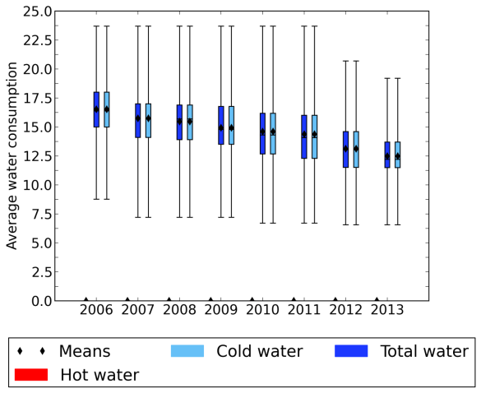

Figure 4‑10 Dishwasher hot and cold water consumption on the primary connection

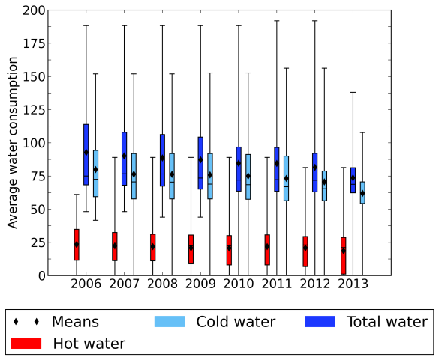

Figure 4‑11 Clothes washing machine hot and cold water consumption on warm wash cycles

### Product type characteristics

#### Taps

Figure 4‑12 shows the rapid rise in the incorporation of flow controllers into tapware. In 2006 no tap had a flow controller, whereas in 2013 90% of taps were fitted with at least a flow controller. From 2006 to 2008 96% of taps previously had no device to limit flow, compared with less than 9% now. Auto shutoff features have remained stable at around 4% of the market share, although since 2008 an increasing number of taps incorporate both a flow controller and auto shutoff.

#### Showers

As shown in Figure 4‑13 flow controllers were generally not incorporated into showers during the first three years of the WELS Scheme. However by 2013 they were used in the large majority (88%) of all registered shower products. Only a very small fraction of showers (<1%) incorporate a bonus saving feature, and in all cases this is combined with a flow controller.

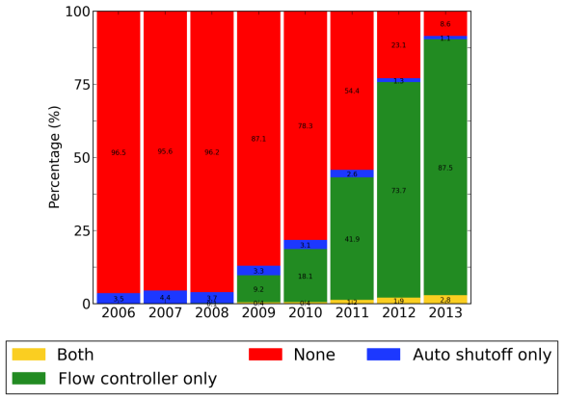

Figure 4‑12 Percentage of taps with flow controllers and auto shutoff

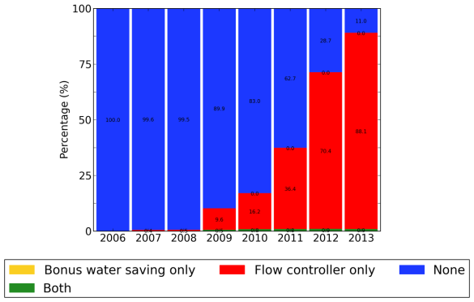

Figure 4‑13 Percentage of showers with flow controllers and bonus water saving features

#### Toilets

Figure 4‑14 shows that reporting of the flushing mode of toilets was quite low in the early years of the WELS Scheme, with 62% registered models having no record for the database field. The lack of reporting issue was only fully rectified in 2013. Without a complete set of data for this field, it is not possible to properly gauge whether there has been a shift to more dual flush toilets, but it is clear that by 2013, single flush toilets are very much a specialised lavatory product. Toilet products incorporating a solenoid valve were not released onto the market until 2009 (data not presented). By 2013 46 models (1.7% of registered toilet products) had a solenoid valve.

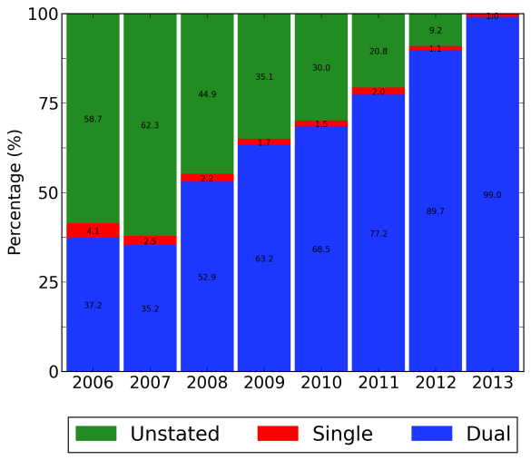

Figure 4‑14 Toilets by flushing mode over time

Figure 4‑15 shows the average ‘nominal full flush’ and ‘nominal average flush’ volumes reported from product testing have decreased steadily since 2007, while ‘nominal half flush’ volumes have remained largely unchanged. Note that these data sets are based on performance testing rather than values given on WELS labels and that the four ‘nominal half flush’ volumes represent the results from four discrete tests. Interestingly the variability in those flush volumes (indicated by error bars representing standard deviation) has been very similar from year to year.

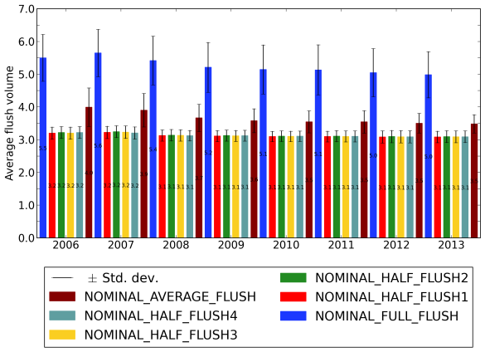

Figure 4‑15 Average nominal flush volumes for toilets

#### Urinals

Registrations of urinal products have been dominated by single stall products, the share of which has risen steadily from 76% to 96% between 2006 and 2013 (see Figure 4‑16). By 2013, urinals greater than 2 stalls in size have all but disappeared from the market. Conscious operation urinal flush mechanisms have become less popular with a decrease from 65% in 2006 to 37% in 2013 (see Figure 4‑17). In the same period smart demand-operated flush mechanisms have increased from 21% to 51%. Standard demand-driven models make up less than 15% of registered urinal products. Urine sensing flushing devices constitute a very small fraction of registered products at less than 4% in 2013.

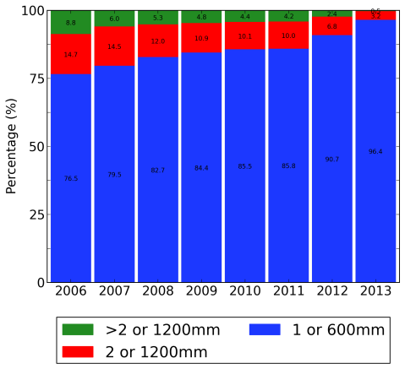

Figure 4‑16 Urinals number of stalls

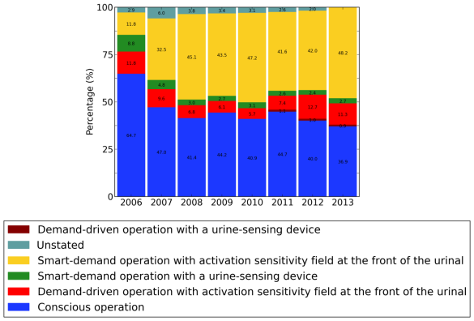

Figure 4‑17 Urinal flush mechanisms

#### Dishwashers

As noted earlier, dishwashers are generally fitted with internal heating elements, thus allowing them to draw from cold water connections. Currently, however around 60% of models allow for supplementary connection to a hot water tap (down from 68% in 2006). Typically a supplementary connection refers the hose supplied with the machine being capable of handling hot water as opposed to the machine being fitted with an additional physical connection.

Figure 4‑18 presents the reported proportions of dishwashers with supplementary connections by connection type. According to the database records, a minority of models have a cold water supplementary connection. Such connections would seem to be a duplication of the primary connection and might best be interpreted as no supplementary connection. Note however, that where a cold water supplementary connection was recorded as having zero water consumption it was assumed to not in fact be a supplementary connection. Almost 30% of products registered in 2013 claimed to have a cold supplementary connection but zero water consumption on the supplementary connection. This suggests that registrants are misinterpreting the fields in the registration form.

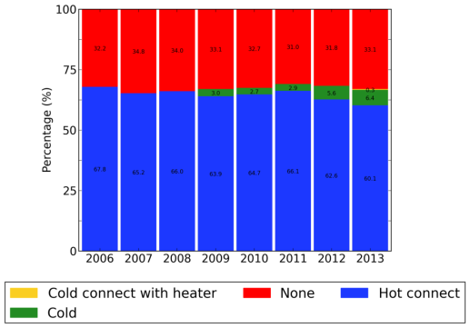

Figure 4‑18 Dishwasher supplementary water connections

Figure 4‑19 presents percentages of dishwashers within three rated capacity bands: <12 place settings, 12-13 settings and 14+ settings. In 2006-2007 the capacity was dominated by 12 and 13 place setting models (69%) whereas less than 12 capacity were only 5% of the market. Over time models have shifted towards <12 or 14+ capacities, with 11% rated less than 12 and 44% rated at 14 or more.

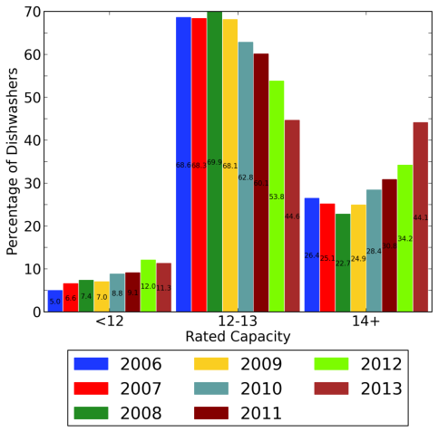

Figure 4‑19 Rated Capacity of Dishwashers

#### Clothes washing machines

In 2006 CWMs available on the market were already mostly front loader types (59%) as shown in Figure 4‑20. By 2013 front loaders had come to dominate the market at nearly 75% of available models. This broad shift towards front loaders is also evident in sales data (see section 5.2.1) and in household appliance stock (see section 6.1.1). Figure 4‑21 shows that an increasing number of models incorporate internal heating elements with cold water connected machines constituting 46% of all available models. The rise in front loading machines has coincided with a trend towards longer program times. Figure 4‑22 shows that while program time has only recently started to be widely documented, there is a distinct rise in average program time since records commenced.

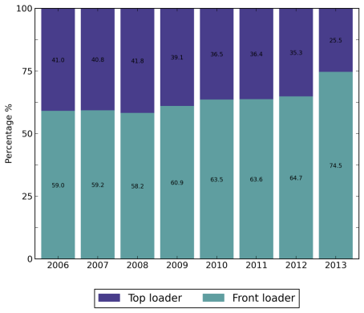

Figure 4‑20 Breakdown of top versus front loader clothes washing machines

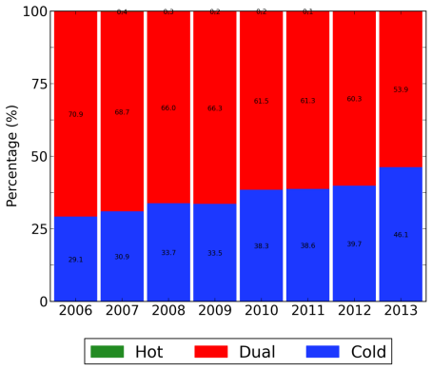

Figure 4‑21 Clothes washing machine connections over time

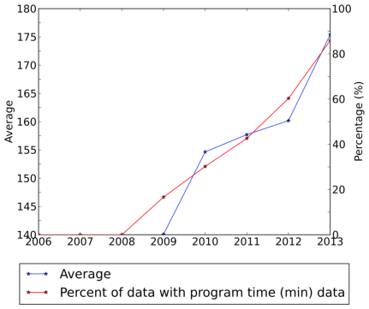

Figure 4‑22 Clothes Washing machine program run time and percentage of registered models with a record for program time

Figure 4‑23 presents the number of combination washer/dryer models with a dryer function together with the percentage of those that claim to use water in the drying process. Such models make up around 10% of registered products, but only recently have registrants started to record whether or not the machine uses water in the drying process. Figure 4‑24 presents box plots of dryer function water consumption, showing an apparent rise in drying cycle water consumption, and increasing variability in reported consumption. Given the very recent rise in reporting of washer-dryer products (indicated by the count of observations marked by the red line), it is unclear as to whether this accurately reflects consumption or whether it might be a reporting issue.

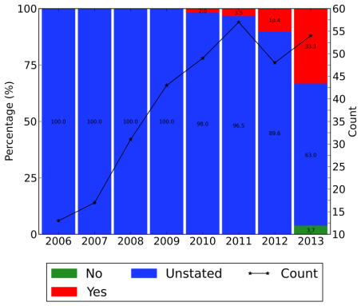

Figure 4‑23 Percentage of washer dryers that use water in the dryer

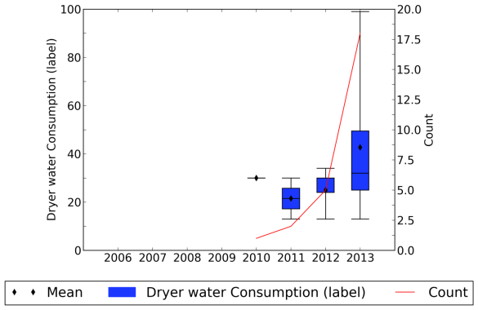

Figure 4‑24 Label CWM dryer function water consumption

# CHANGES IN PRODUCT SALES

As has been shown in Section 4, there has been a significant shift and convergence in the efficiency of appliances registered under the WELS Scheme. This section analyses how this shift in registered products has translated to the sales of WELS labelled products. The information gathered through this analysis directly informed the stock modelling used to estimate water savings in Section 6.

## Data Collection and Analysis

### Whitegood products

Sales data for WELS-labelled clothes washers and dishwashers were drawn from two sources. The first was the *Greening Whitegoods* report released by the Equipment Energy Efficiency Committee that explored the changes in energy and water efficiency attributes of whitegoods from 1993 to 2009 (Energy Efficient Strategies 2010). The study examined sales of whitegood appliances using data produced by the market research company GFK. The data drawn from the report is considered to be of high quality as it has already been through rigorous analysis and cross-checking. To cover the years from 2010 to present, ISF commissioned GfK to prepare a data report on appliance sales incorporating similar information to that presented in the *Greening Whitegoods* report (see Table 5‑1). The data report included sales from the year 2007 onwards.

Table 5‑1 Data provided in GFK whitegood sales data report

|  |  |
| --- | --- |
| Clothes washers | Dishwashers |
| Model Type (Top Loader, Front Loader, Combo) | Number of place settings |
| Rated capacity (kg) | Water Star Rating |
| Water Star Rating | Energy Star Rating |
| Energy Star Rating | Energy Consumption (kWh/use) |
| Energy Consumption (kWh/use) | Water Consumption (L/use) |
| Water Consumption (L/use) | Sales Units |
| Sales Units | State/territory |
| State/territory |  |

### Plumbing and sanitary products

To the knowledge of the authors and consulted product providers, no market-wide sales tracking surveys are currently being performed for showers, tapware and toilet products. To obtain a sense of market penetration and sales of these product types, key product suppliers and retailers were contacted to arrange interviews with company representatives. Table 5‑2 lists the companies contacted for the interviews and those that agreed to be interviewed. Interviews primarily addressed sales distributions by product type and WELS rating, but also covered topics such as the reported drivers underlying purchasing preferences and emerging technologies. The full interview script is presented in Appendix A.

Table 5‑2 - Plumbing and sanitary product manufacturers/suppliers and retailers contacted

|  |  |  |
| --- | --- | --- |
| Company | Description | Participation |
| Manufacturers/suppliers | |  |
| Company 1 | Leading manufacturer of fixtures and fittings. | Full interview |
| Company 2 | Leading manufacturer and supplier of plumbing products | Full interview |
| Company 3 | Manufacturer and supplier of plumbing products. | Full interview |
| Company 4 | Leading manufacturer of showers and taps. | Full interview |
| Company 5 | Manufacturer of tap products and accessories. | Interview could not be arranged |
| **Retailers** | |  |
| Company 6 | Leading consumer (DIY) and trade retailer of plumbing and sanitary products | Initial briefing interview but declined to answer most questions |
| Company 7 | Leading consumer and trade retailer of plumbing and sanitary products | Initial briefing interview but declined to answer most questions |
| Company 8 | Leading consumer retailer of plumbing and sanitary products | Did not respond to interview request |
| Company 9 | Leading trade retailer of plumbing and sanitary products | Did not respond to interview request |

## Findings

### Clothes washing machines

Table 5‑3 and Table 5‑4 present a breakdown of the percentage proportion of total sales by year and WELS star bands for top-loading and front-loading washing machine types, produced from the GFK data report. For both top-loading and front-loading washing machine types, there has been a general percentage increase in sales of 3.5-star and above appliances over the 2007-2013 period, with some variation between years. The largest increase was associated with 4.5-star front-loading machines, experiencing a 6,500% increase in sales over the period. An exception to this has been 4-star rated front-loading washing machines, which have experienced a 74% reduction in sales in 2013 compared to 2007. Sales of 3-stars or less appliances have been in steady decline over the period.

Table 5‑3 - Top-loading clothes washing machine sales by star band

|  |  |  |  |  |  |  |  |
| --- | --- | --- | --- | --- | --- | --- | --- |
| Year | 2007 | 2008 | 2009 | 2010 | 2011 | 2012 | 2013 |
| Total sales | 405,703 | 414,603 | 389,528 | 420,614 | 451,818 | 447,331 | 436,336 |
| No star (%) | 0.001 | 0 | 0 | 0 | 0 | 0 | 0 |
| 1-star (%) | 0.5 | 0.4 | 0.3 | 1.7 | 1.2 | 0.2 | 0.1 |
| 1.5-star (%) | 26.4 | 16.1 | 10.3 | 8.7 | 6.0 | 0.2 | 0.02 |
| 2-star (%) | 7.1 | 12.3 | 7.4 | 9.2 | 6.2 | 1.3 | 0.04 |
| 2.5-star (%) | 1.0 | 2.5 | 2.3 | 1.9 | 2.1 | 0.8 | 0.7 |
| 3-star (%) | 50.1 | 31.7 | 38.5 | 51.3 | 53.2 | 46.5 | 49.3 |
| 3.5-star (%) | 0 | 0 | 0 | 0.5 | 12.2 | 30.5 | 28.8 |
| 4-star (%) | 14.9 | 37.2 | 40.7 | 26.3 | 19 | 20.5 | 20.9 |
| 4.5-star (%) | 0 | 0 | 0.5 | 0.5 | 0.01 | 0.001 | 0.01 |
| Weighted average water consumption | 92 | 96 | 100 | 96 | 95 | 95 | 96 |

Table 5‑4 - Front-loading clothes washing machine sales by star band

|  |  |  |  |  |  |  |  |
| --- | --- | --- | --- | --- | --- | --- | --- |
| Year | 2007 | 2008 | 2009 | 2010 | 2011 | 2012 | 2013 |
| Total sales | 322,653 | 349,340 | 344,999 | 334,992 | 349,148 | 343,958 | 374,956 |
| No star (%) | 0.002 | 0.0004 | 0 | 0 | 0 | 0 | 0 |
| 3-star (%) | 0.3 | 0.04 | 0.01 | 0.002 | 0.002 | 0.001 | 0.003 |
| 3.5-star (%) | 0.4 | 0.1 | 0.01 | 0.02 | 0.8 | 1.3 | 2.9 |
| 4-star (%) | 97.7 | 90.6 | 29.0 | 13.4 | 14.2 | 15.2 | 21.6 |
| 4.5-star (%) | 1.3 | 8.8 | 70.1 | 85.5 | 84.1 | 82.3 | 73.4 |
| 5-star (%) | 0.3 | 0.4 | 1 | 1.1 | 0.9 | 1.2 | 2.1 |
| Weighted average water consumption | 58 | 60 | 61 | 62 | 63 | 64 | 66 |

### Dishwashers

Table 5-5 below presents a breakdown of the percentage proportion of total sales by year and WELS star bands for dishwashers from the GFK data report from 2007 to 2013 inclusive. Similarly with clothes washing machines, there has been a general decline in sales in 3-star and below dishwashing machines, and a marked increase in 4-star and higher appliances over the period. From 2007 to 2010, there was a steady increase in sales of 3-star rated dishwashers of approximately 113%, however sales of 3-star machines have been in steady decline since 2011. Sales of 4-star and 5-star appliances have increased by 636% and 4,545% respectively over the 2007 to 2013 period.

Table 5‑5 - Dishwasher sales by star band

|  |  |  |  |  |  |  |  |
| --- | --- | --- | --- | --- | --- | --- | --- |
| Year | 2007 | 2008 | 2009 | 2010 | 2011 | 2012 | 2013 |
| Total sales | 303,076 | 322,043 | 357,873 | 352,289 | 374,854 | 364,969 | 381,109 |
| No star (%) | 1.6 | 0.5 | 0.1 | 0.02 | 0.01 | 0.01 | 0.003 |
| 1-star (%) | 14.1 | 10.5 | 4.9 | 1.1 | 0.6 | 0.5 | 0.7 |
| 2-star (%) | 56.4 | 36.4 | 29.0 | 22.1 | 12.4 | 8.5 | 8.5 |
| 3-star (%) | 15.8 | 26.6 | 26.5 | 29.0 | 23.4 | 13.5 | 8.2 |
| 4-star (%) | 12.0 | 25.8 | 38.9 | 47.4 | 60.9 | 68.4 | 70.2 |
| 5-star (%) | 0 | 0.3 | 0.5 | 0.4 | 2.7 | 9.0 | 12.5 |
| 6-star (%) | 0 | 0 | 0 | 0 | 0 | 0 | 0.01 |
| Weighted average water consumption | 15 | 15 | 15 | 14 | 14 | 13 | 13 |

### Showers

The star rating of showers has converged around the two 3 star rating bands. While significant sales were reported for 7.5 litre per minute rated showerheads in earlier years of WELS, all suppliers and retailers reported that the sales are almost entirely (~90%) around the upper band 9 litre per minute 3-star rating.

The main reported driver for the earlier popularity of more efficient showerheads was the widespread showerhead replacement programs undertaken by utilities and state government agencies that largely mandated the more stringent 7.5 litre rating (summarised in Sections 3.4 and 3.5). Figure 5‑1 shows the cumulative uptake by state of efficient showerheads distributed through residential water efficiency and energy efficiency programs.

Figure 5‑1 Cumulative uptake of efficient showerheads through water and energy efficiency programs

These schemes have largely ceased operating now, and sales are now predominantly (~90%) focussed on the upper 9L/min (3 star) rating.

Product providers reported that a significant number of these showerheads would comply with the more stringent 7.5L/min standard, however the 9L/min standard was often preferred to reduce compliance costs. Note that both achieve the same ‘3 star’ rating, meaning the selling point of the lower 7.5L/min standard is significantly reduced.

There is still a market for the 7.5 litres per minute rated models based on commercial and hotel properties seeking environmental ratings, however this is a relatively small market compared to direct consumer sales.

Internal marketing undertaken by retailers seems to suggest that perceived shower experience was a dominant consideration underlying purchasing preferences, although flow rates are still a factor in product selection. Anecdotally few consumers are connecting their showerhead choice to ways of reducing their energy bills, suggesting a clear opportunity for improved consumer education.

### Toilets

There was a mandated requirement for 6/3 litre 3-star toilets that pre-dated WELS under the Australian state and territory plumbing codes. However the market has strongly favoured low flush models and this has driven the widespread shift from 6/3 litre 3-star toilet to 4.5/3 litre 4 star models. Interviewees confirmed that the market is now almost exclusively selling 4-star rated models and that flush volume was a key consideration in purchasing preferences.

### Taps

The efficiency of tap product sales differed with respect to the specific end use application. Generally kitchen tap mixer sales have mostly focussed on the 4-star category, driven by customer requirements to get a good flow rate for sink filling. With respect to bathroom taps, tap sales have mostly been in the 5-star category with some 6-star rated products selling in basin taps. Market research undertaken by suppliers and retailers suggests that aesthetics are the principal driver underlying tap purchasing preferences.

# CHANGES IN WATER CONSUMPTION

This section examines changes in domestic water consumption associated with products that are covered under the WELS Scheme.

## Analysis

The overarching approach to the water consumption modelling was to construct two scenarios.

* A ‘reference case’ was constructed to reflect the changes already in effect in 2006 when the WELS commenced. This scenario includes all existing behaviour, policy settings and sales preferences as of 2006, projected with population and household growth to 2030.
* A ‘WELS case’ was then constructed to reflect changes that occurred following the inception of the WELS scheme. This scenario maintained the same appliance usage behaviour but incorporated policy and sales changes that occurred since 2006, projected with the same population and household growth to 2030.

The two scenarios were developed to model how changes in sales and policies since the inception of WELS have translated into water savings, while attempting to remove savings that were already in train as a result of existing policies. The water consumption of both scenarios was modelled using two key methods: end use modelling and fixture/appliance stock modelling, detailed below.

**End use modelling** involves estimating the water consumed by each appliance from the ‘bottom up’ by evaluating the following equation:

**Water consumption = behaviour × stock × flow**

* *‘behaviour’* is how the appliance is used, such as the minutes per day that a showerhead is running, or the number of loads of washing each week, typically informed by appliance usage surveys
* *‘stock’* is the number of appliances by type (e.g. by star rating etc.), typically informed by sales tracking surveys and quantified using cohort component appliance stock modelling (see below).
* *‘flow* is the water consumption per unit of activity for each stock type (e.g. litres per wash), typically informed by end use measurement studies.

A key element of an end use water consumption estimate is how the installed stock of appliances changes over time owing to changes in purchasing preferences, minimum performance standards, and the natural replacement of appliance stock over time. This is necessary because there is an inherent delay between changes in current appliance sales, and the overall water consumption of households. This is simulated using an approach called appliance **cohort-component or vintage** **stock modelling**. The mechanics of such models are illustrated in Figure 6‑1.

Figure 6‑1 - Illustrative diagram of stock modelling mechanics

Each year a new cohort of appliances is created. This number is equal to the growth of the total installed stock that year, combined with any appliances from previous years that need replacement. The number of remaining appliances in subsequent years is then reduced to account for its replacement over time, modelled by a lognormal decay with defined half-life and spread. The approach therefore provides a rigorous means for capturing the full benefits of past and current changes in purchasing preferences. The following sections provide an overview of the key assumptions employed in this modelling for each appliance.

### Clothes washing machines

The total appliance stock was first derived by multiplying the number of households by household penetration figures obtained from surveys, shown in Figure 6‑2 below.

Annual sales of clothes washing machines were then modelled using an appliance stock model, with an assumed appliance half-life of 13 years and a spread factor (standard deviation) of 0.25. The output of this model is shown in Figure 6 3.

Figure 6‑2 Penetration of clothes washing machines

Figure 6‑3 Modelled stock cohorts for all clothes washing machines

Simulated clothes washing machine sales were then apportioned into two broad stock types: combined top-loaders and twin tubs, and front-loaders[2], using sigmoidal curves derived using the sales tracking data (EES 2010; GFK 2014) as shown in Figure 6‑4.

Figure 6‑4 Observed and modelled clothes washing machine sales shares by type

The appliance sales by type were then input to two additional stock models to simulate decay amongst appliance cohorts as shown in Figure 6‑5 and Figure 6‑6. Comparison of observed stock percentages for front loaders (ABS 2012) with simulated stock percentages allowed the appliance lifetime average and standard deviation parameters used in the stock models to be validated as shown in Figure 6‑7.

Figure 6‑5 - Modelled stock cohorts for top loaders

Figure 6‑6 - Modelled stock cohorts for front-loaders

Figure 6‑7 Modelled and reported stock of front and top loader clothes washing machines

Annual sales-weighted average water consumption figures drawn from (EES 2010; GFK 2014) were then multiplied with each clothes washing machine cohort by year. As shown in Figure 6‑8, the ‘base scenario’ assumed no further improvements in water efficiency beyond 2006, while the ‘WELS scenario’ incorporated subsequent improvements in sales-weighted energy efficiency before levelling off beyond 2013 in line with preceding trends. The output from the clothes washing machine stock cohorts and the sales-weighted water consumption data was a stock-weighted clothes washing machine water intensity as shown in Figure 6‑9.

Figure 6‑8 Sales-weighted water consumption by clothes washing machine type over time

Figure 6‑9 Stock-weighted clothes washing machine water intensity

The stock-weighted water intensity was then multiplied by the number of loads per household, which was informed by appliance usage surveys (Redhead et al 2013; Roberts 2005, 2012b), modelled as a function of household size.

Household loads = 2.425 * household size ^ 0.631

The result was a projection of the total water consumption for all clothes washing machine, shown in the results section (6.2) below.

### Dishwashers

The analysis for dishwashers was similar to the analysis performed for clothes washing machines, the main difference being that dishwashers are not split into separate appliance categories. The penetration of dishwashers in Australian homes was informed by household surveys and modelled as shown in Figure 6‑10.

Figure 6‑10 Dishwasher ownership

The stock models uses an appliance half-life of 15.7 years and a spread factor of 1.2, determined by fitting sales predicted by the stock model against sales data (EES 2010; GFK 2014) as shown in Figure 6‑11. As per the analysis for clothes washing machines, sales-weighted water consumption was informed by the sales tracking data presented in the previous chapter (see Figure 6‑12). The ‘reference’ scenario assumed no improvement in water efficiency beyond 2006, while the ‘WELS’ scenario incorporated surveyed efficiency improvements to 2014. Dishwasher machine usage frequency was informed by the most recent Melbourne end use study (Redhead et al 2013), and modelled as a log-linear function of household size:

Dishwashing machine frequency = 1.342 + 1.321 x ln(household size)

Figure 6‑11 Reported and predicted dishwasher appliance sales

Figure 6‑12 Dishwasher sales-weighted water consumption

### Showers

Showers were divided into two broad stock types:

* ‘inefficient showers’ defined as having a flow rate above 9 litres per minute
* ‘efficient showers’ defined as having a flow rate below 9 litres per minute

The relative sales of inefficient and efficient showerheads were informed by the WELS database analysis and interviews undertaken with leading product suppliers in Australia. Figure 6‑13 summarises the assumed sales shares.

Figure 6‑13 Sales shares for efficient and inefficient showers

As shown the market share of efficient showerheads rose dramatically following the inception of the WELS, with efficient showerheads accounting for over 92% of shower sales from a base of around 65%. In addition to sales from natural attrition of stock, cohorts of ‘stimulated sales’ were overlaid on both scenarios, representing the accelerated turnover of shower stock due to efficient showerhead retrofit and rebate schemes. The number of stimulated sales was informed by the review of complementary efficiency programs and schemes described in Section 3 and are presented in Figure 5‑1. The review covered all of the main metropolitan utility programs and state schemes as detailed in Appendix C. Despite not covering regional utility conservation programs, the stimulated sales estimates should represent the vast bulk of stimulated stock turnover.

Stimulated showerhead replacements were simulated in the stock models by forcing the turnover of existing appliance stock beyond their natural replacement rate. These replacements were drawn from the annual appliance cohorts consistent with their representation in that year. That is, the replacement of showerheads through rebate schemes was assumed to be independent of the stock vintage. The normal (non-stimulated) product half-life average (11 years) and spread (1) parameters were calibrated using efficient percentage stock data (ABS 2013) as shown in Figure 6‑14.

Figure 6‑14 Modelled and reported shower stock

Note the slight bump in the simulated stock shares of efficient and inefficient showers. This is the modelled impact of the showerhead rebate programs. The analysis highlights the importance of targeting baseline sales through market transformation policies. Such policies serve to lock in the savings from incentive programs that would otherwise be short-lived.

Operational flow rates of showers[3] were based on end use measurement studies, which have shown inefficient showers to have a mean operational flow rate of around 11 litres per minute, while efficient showerheads have a mean operational flow rate of 6.5 litres per minute. The stock-rated flow rate was then multiplied by the frequency and duration of showerheads, 0.75 showers per day and 7 minutes per shower respectively, all based on end use measurement studies (Roberts 2005, 2012b; Redhead et al 2013).

### Toilets

Toilets were divided into five product categories:

* Single flush toilets
* Dual flush 11/6L
* Dual flush 9/4.5L
* Dual flush 6/3L
* Dual flush 4.5/3L

The sales shares of these five appliance types changed as a response to regulations in Australia in the 1980s mandating all new pans to be above a set standard. A series of increasingly efficient dual flush models followed finishing with building/plumbing code changes in 1996 mandating new toilet pans below a 6/3 litre flush volume. The more efficient 4.5/3 litre flush model entered the market following the inception of the WELS scheme, thus this model was restricted to the WELS scenario only. The shares of toilet sales over time is shown in Figure 6‑15 below.

Figure 6‑15 Toilet market share by flush volume category

The sales shares were input to a five-part stock model. The stock replacement parameters were calibrated to the observed decay in single flush toilet stock (ABS 2013), producing a toilet half-life of 25.35 years and spread of 0.36. The resulting stock shares are shown in Figure 6‑16 below.

Figure 6‑16 Toilet stock by flush volume category

The operational full and half flush volumes of these different pans were drawn from end use measurement studies (Roberts 2005, 2012b; Redhead et al 2013). End use measurement studies suggest there is a tendency toward using full flush more often for more efficient dual flush models. It is unclear whether this is a consequence of toilet performance or user interface design. A full flush factor was therefore applied to dual flush models to produce average flush volumes that are consistent with end use measurement study findings. Resulting weighted flush volumes by stock type are given in Table 6‑1.

Table 6‑1 Flush volumes and full flush frequencies by toilet stock type

|  |  |  |  |  |
| --- | --- | --- | --- | --- |
| Toilet type | Full flush frequency factor | Full flush volume [L] | Half flush volume [L] | Weighted flush volume [L] |
| Single flush | 0.3 | 9.9 |  | 9.9 |
| Dual flush 11/6L | 0.4 | 10 | 5.8 | 7.2 |
| Dual flush 9/4.5L | 0.9 | 8.3 | 4.4 | 5.7 |
| Dual flush 6/3L | 0.9 | 5.4 | 2.9 | 4.15 |
| Dual flush 4.5/3L | 0.3 | 4.3 | 2.9 | 3.75 |

Flush volumes were then multiplied by the flush frequency of 3.9 flushes per person per day, once again based on end use measurement studies to calculated average daily household consumption.

### Taps

Taps were divided into two end uses:

* Kitchen sink taps, largely used for dishwashing
* Bathroom taps, largely used for handwashing

Each was split into two stock types:

* inefficient taps, defined as the taps typically installed prior to the WELS
* efficient taps, defined as those taps installed following WELS

Stock turnover was modelled in a similar fashion to showers; however the models could not be validated against ABS or other sales or stock data and stock half-life and standard deviation parameters were assumed (13 and 0.5 years, respectively). As with showers, the sink and basin tap end use models relied on estimates of operational flow rates (as opposed to capacity flow rates) for efficient and inefficient categories. The literature review found that while operational flow rates are generally reported on, they are not divided up between different tap efficiency bands as they are with showers. Thus, estimates of operational flow rates were derived by comparing model outputs for stock-weighted average operational flow rate for sinks, basin and combined tap types as well as overall daily household and per capita tap consumption against corresponding measured values from end use studies. Table 6‑2 summarises the final operational flow rates adopted in the basin and sink tap models.

Table 6‑2 Assumed tap operational flow rates

|  |  |
| --- | --- |
| Tap type | Operational flow rate [L/min] |
| Kitchen inefficient | 6.5 |
| Kitchen efficient | 4.0 |
| Bathroom inefficient | 3.3 |
| Bathroom efficient | 2.0 |

Kitchen tap behaviour was broadly split into free-flowing events and filling events, based on appliance usage surveys (Roberts 2005, 2012b; Redhead et al 2013) finding 60% wash dishes using the plug, 13% under running water, and 27% a combination thereof (assumed equal proportions of both activities). For filling events it was assumed a typical 20 litre sink was filled half way, also based on appliance use surveys (Roberts 2012b).

Basin tap usage (including where kitchen and laundry sinks are used in a manner similar to a basin) was assumed to be dominated by free-flowing events. Published end use measurement studies indicate that overall tap usage frequency averages around 20 per capita per day (Redhead et al 2013; Beale & Stuart 2011), including sink uses, and that the vast majority of tap uses are 30 seconds or less (Roberts 2012b). Thus values of 19 events/person/day and 25 seconds/event were adopted for model frequency and duration parameters, respectively.

## Findings

The difference between the modelled water consumption for the reference and WELS scenarios was then calculated to infer the savings since the inception of WELS. Figure 6‑17 provides a summary of these water savings.

Figure 6‑17 – Estimated household water savings since the commencement of WELS

The top line of the chart highlights that significant water efficiency improvements were already ‘in the pipeline’ prior to the commencement of the WELS Scheme. The additional sections carved from these baseline water savings represent the impact of shifts in the efficiency of appliance sales following the commencement of WELS.

Note this analysis covers WELS products only and therefore excludes outdoor end uses including lawns, gardens, pools and spas.

Figure 6‑18 - Estimated annual water savings since the commencement of WELS

Figure 6‑18 highlights how the savings arising from the WELS Scheme dramatically increase over time from 70 GL/a in 2013 to 204 GL/a in 2030. This is the core strength of regulatory and informational policies relative to incentive policies such as rebates. Incentive policies serve to accelerate the turnover of appliance stock to more efficient models and have been valuable for ‘bringing forward’ savings in many metropolitan regions during severe drought. However in the absence of complementary policies, the savings tends to erode over time owing to the natural attrition of appliance stock. Regulatory and informational policies on the other hand target the efficiency of underlying appliance sales, meaning the savings increase into the future.

As shown in Figure 6‑19, the results highlight that a significant share of the estimated water savings is attributable to showers (35%) and taps (35%), followed by clothes washing machines (19%), toilets (9%), and dishwashers (2%).

Figure 6‑19 - Composition of estimated water savings in 2021

Note toilets fill a surprisingly small share of the savings. This is a consequence of the removal of baseline improvements that were already ‘in the pipeline’. Any replacement of toilets with 6/3 litre toilets was already mandated, so this shift was excluded from the savings.

This also goes some way towards explaining the disproportionately high share of the savings from taps. As distinct from most of the other appliances, no existing shift was underway in the efficiency of taps prior to 2006, whether from regulations or purchasing preferences. As such, the analysis finds a significant shift in the efficiency of taps relative to the baseline.

Snapshots of the annual savings estimates in 2013, 2021 and 2030 are given in Table 6‑3.

Table 6‑3 - Snapshots of estimated annual water savings since the commencement of WELS

|  |  |  |  |
| --- | --- | --- | --- |
|  | 2013 [GL/a] | 2021 [GL/a] | 2030 [GL/a] |
| Showers | 23 | 48 | 71 |
| Clothes washing machines | 14 | 27 | 31 |
| Dishwashers | 1.2 | 3.4 | 5.3 |
| Toilets | 6.1 | 16.5 | 28 |
| Taps | 26 | 44 | 69 |
| Total | 70 | 147 | 204 |

Figure 6‑20 plots the cumulative savings from the year 2005 to 2030 and gives snapshots of the cumulative savings.

Figure 6‑20 - Estimated cumulative water savings since the commencement of WELS

Table 6‑4 - Snapshots of estimated cumulative water savings since the commencement of WELS

|  |  |  |  |
| --- | --- | --- | --- |
|  | 2013 [GL] | 2021 [GL] | 2030 [GL] |
| Showers | 129 | 428 | 979 |
| Clothes washing machines | 54 | 226 | 493 |
| Dishwashers | 4.4 | 24 | 65 |
| Toilets | 20 | 115 | 321 |
| Taps | 99 | 434 | 993 |
| Total | 607 | 1,227 | 2,853 |

# ENERGY AND GHG IMPACTS

## Introduction

Water efficiency improvements typically result in substantial energy and greenhouse gas reductions. This component of the research sought to estimate those complementary benefits.

## Analysis

Energy savings occur owing to one of two mechanisms: avoided water treatment and pumping, and avoided domestic water heating.

The avoided water treatment and pumping was calculated by reference to recent research quantifying the energy intensity of water and wastewater services in major metropolitan water systems across Australia (Cook, Hall & Gregory 2012)

The figures, which were for 7 major metropolitan regions, were weighted by their respective populations to yield an Australia-wide mean water and wastewater energy intensity of water and wastewater as shown in Table 7‑1.

Table 7‑1 - Energy intensity of water services in major cities

|  |  |  |
| --- | --- | --- |
| City | Energy intensity [GJ/ML] |  |
|  | **Water** | **Wastewater** |
| Sydney | 2.03 | 1.77 |
| Melbourne | 1.35 | 3.08 |
| SEQ | 2.29 | 2.84 |
| Perth | 3.93 | 2.98 |
| Canberra | 1.78 | 3.04 |
| Adelaide | 2.80 | 3.72 |
| Newcastle | 1.61 | 2.27 |
| Australia (weighted by pop) | 2.16 | 2.68 |

The applied energy intensities accounted for a 70% sample of the Australian population, but critically exclude regional and rural water systems.

The water heating energy was calculated using a relatively simple end use model.

Firstly the total hot water demand was calculated by estimating the proportion of end use water demand sourced from hot water as summarised in Table 7‑2.

Table 7‑2 - Assumed hot water proportions by end use

|  |  |
| --- | --- |
| End use | Hot water proportion |
| Basins | 22% |
| Clothes washing machines | 25% |
| Showers | 46% |
| Sinks | 46% |

The water heating stock was then divided into electric, gas and solar water heaters based on ABS appliance stock survey data (ABS 2011).

A simple thermal calculation was applied to estimate the energy demand for each water heater type as follows:

Heating energy = m x C x ΔT / e + piping losses + standing losses

Where m = the mass of water heated

C = the specific heat of water (4.18 J/ kg °C)

ΔT = change in temperature from supply to thermostat temp

e = heating efficiency of heater

The heating efficiency of the heater differed by water heater type, with electric water heaters operating around 98% efficient, and gas water heaters operating at 85% (EES 2008). Standing losses were assumed to be 2.2 kWh / day for both electric and gas water heaters.

The water service energy and domestic water heating energy were combined to determine the complementary energy savings associated with the water efficiency improvements.

The estimated energy savings were then translated into greenhouse gas reductions using published Scope 3 emission factors (DOI 2013). Note that the analysis assumes the greenhouse gas intensity of electricity remains constant from the most recent actuals. There is considerable policy uncertainty associated with the emission intensity of electricity into the future so choosing a defensible projection was not possible.

## Findings

Figure 7‑1 shows the estimated energy savings arising from water savings since the commencement of the WELS Scheme. The analysis demonstrates that the dominant share of energy consumption reductions arise from domestic water heating, at 92% of total electricity savings in 2030. Table 7‑3 provides snapshots of estimated annual energy consumption reductions.

Figure 7‑1 - Estimated annual energy savings associated with water savings since the commencement of WELS

Table 7‑3 - Snapshots of estimated annual energy consumption reductions associated with water savings since the commencement of WELS

|  |  |  |  |
| --- | --- | --- | --- |
|  | 2013 | 2021 | 2030 |
| Annual electricity consumption reduction  [PJ/a] | 4.4 | 9.0 | 12.3 |
| Annual gas consumption reduction [PJ/a] | 2.0 | 4.0 | 5.4 |
| Cumulative electricity consumption reduction [PJ] | 21 | 77 | 176 |
| Cumulative electricity consumption reduction [PJ] | 9 | 34 | 78 |

Figure 7‑2 shows the estimated cumulative greenhouse gas reductions associated with water savings since the commencement of WELS. The reductions ramp up from 5.5 megatonnes CO2 equivalent in 2013 to 46.4 in 2030. The analysis also demonstrates that the dominant share of greenhouse gas reductions arise from avoided domestic water heating. Snapshots of cumulative greenhouse gas reductions are given in Table 7‑4.

Figure 7‑2 - Estimated cumulative greenhouse gas emission reduction associated with water savings since the commencement of WELS

Table 7‑4 - Snapshots of estimated cumulative greenhouse gas emission reductions associated with water savings since the commencement of WELS

|  |  |  |  |
| --- | --- | --- | --- |
|  | 2013 | 2021 | 2030 |
| Cumulative greenhouse gas emission reduction  [MT CO2-e] | 5.5 | 20.4 | 46.4 |

# HOUSEHOLD BILL IMPACTS

## Introduction

Water efficiency improvements typically result in substantial financial savings, both in terms of reduced water bills and reduced energy bills owing to avoided domestic water heating. This component of the research sought to estimate the reduction of household water and energy bills owing to water savings since the inception of WELS.

## Analysis

The retail price paths of electricity, gas and water were firstly established over the forecast period from 2006 to 2030. For electricity and gas, we referred to published government projections commissioned to quantify the household impacts of the E3 program (DOI 2014), shown in Figure 8‑1 below. Note that owing to the recent withdrawal of the Carbon Pricing Mechanism, the price path without a carbon price was applied.

Figure 8‑1 - Australian mean retail electricity and gas prices (DOI 2014)

No Australia-wide price paths have been published for retail water prices, necessitating an estimate to be formed. This involved firstly collating water price forecasts published by utilities and regulators for major metropolitan regions including Sydney (IPART 2012), Canberra (ICRC 2013), Newcastle (Hunter Water 2012), Melbourne (CWW 2012), Brisbane and Gold Coast (DEWS 2014), Perth (ERA 2013) and Adelaide (ESCSA 2014). Where tiered pricing was present, we selected the tier in which the median household water consumption for that city would lie as we were only concerned with the marginal savings rather than estimating the total bill.

The calculated price paths for each major Australian city are shown in Figure 8‑2.

Figure 8‑2 - Retail water prices in major metropolitan regions

These metropolitan price paths were then weighted by their respective populations to form an estimated Australia-wide price path as shown in Figure 8‑3 below.

Figure 8‑3 - Australian mean retail water price

The price paths for electricity and gas were then multiplied by the domestic water heating energy savings calculated in Section 7 to form a total estimated household bill reduction for Australia.

## Findings

Figure 8‑4 shows the estimated annual residential utility bill reductions associated with water savings since the commencement of the WELS Scheme.

Figure 8‑4 - Annual residential utility bill savings associated with water savings since the commencement of the WELS scheme

The analysis shows annual residential utility bill savings have already reached an estimated $520 million per annum, with savings set to grow to $2 billion per annum by 2030. The analysis also highlights the relative shares of the utility bill savings, with electricity bill reductions associated with avoided water heating contributing the largest share (57%), followed by water bill reductions (35%), and gas bill reductions (8%). Gas bill reductions are much smaller than electricity bill reductions owing to their smaller share of the water heating stock and the lower price of gas relative to electricity. Annual and cumulative snapshot tables for 2013, 2021 and 2030 are provided in Table 8‑1 and Table 8‑2 below.

Table 8‑1 – Annual residential utility bill savings associated with water savings since the commencement of WELS

|  |  |  |  |
| --- | --- | --- | --- |
|  | 2013 [$m/a] | 2021 [$m/a] | 2030 [$m/a] |
| Residential water bill reductions | 188 | 486 | 715 |
| Residential electricity bill reductions | 282 | 784 | 1,181 |
| Residential gas bill reductions | 50 | 119 | 168 |
| Residential total utility bill reductions | 520 | 1,390 | 2,063 |

Table 8‑2 – Cumulative residential utility bill savings associated with water savings since the commencement of WELS

|  |  |  |  |
| --- | --- | --- | --- |
|  | 2013 [$b] | 2021 [$b] | 2030 [$b] |
| Residential water bill reductions | 0.6 | 3.5 | 9.1 |
| Residential electricity bill reductions | 1.1 | 5.6 | 14.9 |
| Residential gas bill reductions | 0.2 | 0.9 | 2.3 |
| Residential total utility bill reductions | 2.0 | 10.0 | 26.3 |

# CONCLUSIONS

The analysis of policies interacting with the WELS scheme found that WELS has established itself at the centre of urban water management in Australia. A total of 32 complementary policies were identified referencing WELS including 19 water efficiency programs, 4 energy efficiency schemes, 6 building codes, regulations and rating schemes, and 3 tenancy laws.

The analysis of WELS product registrations found a significant shift and convergence toward improved water efficiency across all product categories, and primary and secondary sales tracking research confirmed that the shift has passed through to shifts in product sales, driven by improved customer information and a range of complementary incentives and regulations.

The analysis of water savings since the inception of WELS revealed a significant reduction in household water consumption. The analysis estimated a total of 70 gigalitres per annum in water savings have been recognised by 2013, owing to changes in appliance water intensities since the commencement of WELS. These water savings are set to increase considerably in future years to 200 GL per annum by 2030 as the existing appliance stock is slowly replaced with more efficient models.

Importantly, the analysis removed water savings that were already ‘in the pipeline’ prior to the commencement of WELS owing to existing regulations and historical purchasing preference changes. Despite considerable baseline savings, the analysis found subsequent changes approximately doubled the reductions that would have been previously projected.

These water savings were found to translate to considerable greenhouse gas emission reductions, with an estimated cumulative reduction of 46 megatonnes carbon dioxide equivalent by 2030.

Finally, households are also anticipated to benefit financially from water savings, both in terms of direct water bill reductions and indirect energy bill reductions from domestic water heating, with an estimated $520 million per annum saving in 2013, ramping up to $2 billion per annum saving by 2030.

# REFERENCES

Abrams, B., Kumaradevan, S., Sarafidis, V. and Spaninks, F., 2011, *The Residential Price Elasticity of Demand for Water*, Joint Research Study, Sydney, February.

Australian Bureau of Statistics (ABS), 2011, 4602.0.55.001 - Environmental Issues: Energy Use and Conservation, Published by the Australian Bureau of Statistics

Australian Bureau of Statistics (ABS), 2013, 4602.0.55.003 - Environmental Issues: Water Use and Conservation, Published by the Australian Bureau of Statistics

Australian Government Department of the Environment, Water, Heritage and the Arts (DEWHA) (2008), Energy use in the Australian Residential Sector – 1986 -2020, Published by the Department of the Environment, Water, Heritage and the Arts, Commonwealth of Australia

Australian Government Department of Industry, Innovation, Climate Change, Science, Research and Tertiary Education (DOI), 2013, Australian National Greenhouse Accounts - National Greenhouse Accounts Factors, published by the Department of Industry, Innovation, Climate Change, Science, Research and Tertiary Education, Commonwealth of Australia.

Australian Government Department of Industry (DOI), 2014, Impacts of the E3 program, report prepared by the Australian Government Department of Industry on behalf of the Equipment Energy Efficiency Committee.

Beale, C, Stuart, R., 2011, South East Queensland residential end use study, prepared for the Urban Water Security Alliance, Technical Report No 47

Beatty, K., 2011, Unsung water savings: how people in Sydney saved water during drought restrictions, paper presented to the Efficient Conference, Australian Water Association

City West Water (CWW), 2012, Water Plan 2013-18 - Price Review 2013-2018, Published by City West Water, Victoria

Cook, S. Hall. M. and Gregory, A., 2012, Energy use in the provision and consumption of urban water in Australia: an update, CSIRO Water for a Healthy Country Flagship, Australia, Prepared for the Water Services Association of Australia.

Economic Regulation Authority (ERA), 2013, Inquiry into the Efficient Costs and Tariffs of the Water Corporation, Aqwest and the Busselton Water Board, Published by Economic Regulation Authority, Western Australia

Energy Efficient Strategies 2010, Greening White Goods - A Report into the Energy Efficiency Trends of Whitegoods in Australia from 1993 – 2009, report prepared for the Equipment Energy Efficiency Committee

Essential Services Commission of South Australia (ESCSA), 2014, Determination of SA Water's Drinking Water and Sewerage Revenue 2013/14 - 2015/16, <http://www.escosa.sa.gov.au/projects/186/determination-of-sa-water-s-drinking-water-and-sewerage-revenue-2013-14-2015-16.aspx>, last access: 24/07/2014

Fyfe, J., Mohr, S., May, D. and Rickwood, P., 2011, Statistical evaluation of water, electricity and greenhouse gas savings from the Think Water, Act Water residential efficiency programs, report prepared for the ACT Environment and Sustainable Development Directorate by the Institute for Sustainable Futures, University of Technology, Sydney.

Guest, C, 2010, Independent Review of the Water Efficiency Labelling and Standards Scheme

Hunter Water, 2012, Price Submission Summary, published by Hunter Water Corporation, New South Wales

Independent Competition and Regulatory Commission (ICRC), 2013, Releases of final report and price direction – regulated water and sewerage services, Media Release published by the Independent Competition and Regulatory Commission, Australian Capital Territory

Independent Pricing and Regulatory Tribunal (IPART), 2012, Review of prices for Sydney Water Corporation's water, sewerage, drainage and other services – From 1 July 2012 to 30 June 2016, Published by Independent Pricing and Regulatory Tribunal of New South Wales.

Kenway, S. J., P. Lant, A. Priestley, and P. Daniels., 2011, The connection between water and energy in cities - a review. *Water Science and Technology* 63(9): 1983-1990.

O’Leary, T., 2012, Residential energy efficiency and mandatory disclosure practices, paper presented at the Annual Pacific Rim Real Estate Society Conference

Queensland Department of Energy and Water Supply (DEW), 2014, Bulk water prices, <http://www.dews.qld.gov.au/policies-initiatives/water-sector-reform/water-pricing/bulk-water-prices>, last access: 24/07/2014

Redhead, M., Athuraliya, A., Brown, A., Gan, K., Ghobadi, C., Jones, C., Nelson, L., Quillam, M., Roberts P., Siriwardene, N., 2013, Melbourne Residential Water End Uses Winter 2010 / Summer 2012, report prepared by City West Water, South East Water, and Yarra Valley Water for the Smart Water Fund, report ID 10TR5-001

Roberts, P., 2005, 2004 Residential End Use Measurement Study, report prepared on behalf of Yarra Valley Water

Roberts, P., 2011, Residential Water Use Study Volume 1 – Winter 2010, report prepared on behalf of Yarra Valley Water

Roberts, P., 2012a, 2011 Appliance Stock and Usage Patterns Survey, report prepared on behalf of Yarra Valley Water

Roberts, P., 2012b, Residential Water Use Study Volume 2 – Summer 2012, report prepared by Yarra Valley Water

Trading Economics, 2014-2030 Outlook, <http://www.tradingeconomics.com/australia/forecast>, last accessed: 24/07/2014

Turner, A., Fyfe, J., Rickwood, P. and Mohr, S., 2014 Evaluation of implemented Australian efficiency programs – results, techniques and insights, Water Science and Technology, in press

Wilkenfeld and Associates, 2004, Regulation Impact Statement - Proposed National System of Mandatory Water Efficiency Labelling for Selected Products

UTS:INSTITUTE FOR SUSTAINABLE FUTURES

**APPENDICES**

APPENDIX A: INTERVIEW TRANSCRIPT

APPENDIX B: MODELLING ASSUMPTIONS

APPENDIX C: SHOWERHEAD REPLACEMENT ESTIMATE METHODOLOGY

# APPENDIX A: INTERVIEW TRANSCRIPT

###### Introduction

ISF is undertaking research on behalf of the Federal Government Department of the Environment to evaluate the impacts of their Water Efficiency Labelling and Standards Scheme on household water consumption.

As part of this research, we are conducting a series of interviews with key product providers and retailers to better understand how the efficiency of appliances has changed in recent years.

We understand that some of the information we will asking for may be commercially sensitive, and we want to make it clear that you are under no obligation to respond.

However we want to stress that our research focuses on the market-wide impacts only and the data you provide to us will only be published as market aggregates and will not be attributed to individual companies.

ISF is a university research institute bound by rigorous ethical standards on how we conduct, handle, and disclose private or commercially sensitive information and we are happy to provide a data agreement if you wish.

Do you have any questions regarding your participation in the research before we begin?

##### Taps

1. Market

* What would you estimate the current size of the Australian taps market in terms of total numbers of taps sold?
* *What proportion of the Australian taps market does your company represent (% all taps sold)?*
* What proportion of taps manufactured/imported/sold by your company would be
  + Less than 3 Star
  + 3 Star
  + 4 Star and above
* Do you think your sales reflect sales in the broader market? Comment on any key differences?
* What proportion of taps go into residential compared to non-residential markets (specify whether answer relates to company sales or sales in the market as a whole)?

If the interviewee has a strong sense of the figures above, prompt for historical data.

1. Natural penetration

* The number of efficient taps on the market has been increasing over time. Without WELS what do you think would be the ultimate market penetration of 3 Star, 4 star (and above) taps, particularly in the residential sector?

1. Impacts on marketing

* To what extent has WELS impacted on the marketing of your tap products both in terms of:
  + the extent to which marketing references water efficiency and
  + the number of products that are subject to WELS-related marketing?

1. Other impacts and consequences

* Can you comment on the impacts (positive and negative) of WELS on your company and the Australian taps market more broadly? *e.g.*
  + *stimulating development/sourcing of new products,*
  + *increasing sales of more efficient products,*
  + *discontinuation of particular models/styles,*
  + *improving/reducing quality*
  + *more/less imports?*

1. New and competing products

* Do you see any new tapware products coming onto the market that will dramatically change household tap water use?

1. Efficiency programs

* How have utility and government water efficiency programs affected your sales of taps? (ask which programs, eg, building codes etc)

##### Toilets

1. Market

* What would you estimate the current size of the Australian toilets market in terms of total numbers of toilets sold, including replacement cisterns?
* *What proportion of the Australian taps market does your company represent (% toilets sold)?*
* What proportion of toilets manufactured/imported/sold by your company would be
  + 1-star 9/4.5L replacement cisterns
  + 3-star including
    - 6L or 5.5L single flush?
    - 4L single flush
  + 6/3 L dual flush toilets
  + 4-star dual flush toilets (4.5/3 L)
  + 5-star toilets (4.5/3 L with integrated basins)
* Do you think your sales reflect sales in the broader market? Comment on any key differences?
* What proportion of toilets sold supply residential compared to non-residential markets (specify whether answer relates to company sales or sales in the market as a whole)?

If the interviewee appears to have a strong grasp of the above figures prompt for historical data

1. Natural penetration

* The number of efficient toilets on the market has been increasing over time, primarily on account of minimum efficiency standards. Without WELS what do you think would be the ultimate market penetration of 4-star and 5-star toilets would be, particularly in the residential sector?

1. Impacts on marketing

* To what extent has WELS impacted on the marketing of your toilet products both in terms of:
  + the extent to which marketing references water efficiency and
  + the number of products that are subject to WELS-related marketing?

1. Other Impacts and consequences

* Can you comment on the impacts (positive and negative) of WELS on your company and the Australian toilet market more broadly? *e.g.*
  + *stimulating development/sourcing of new products,*
  + *increasing sales of efficient products,*
  + *discontinuation of particular models/styles,*
  + *improving/reducing quality*
  + *more/less imports?*

1. New and competing products

* Do you see any new products coming onto the market that will dramatically change household toilet water use?

1. Efficiency programs

* How have utility and government water efficiency programs affected your sales of toilets? (ask which programs, eg, building codes etc)

##### Showers

1. Market

* What would you estimate the current size of the Australian showers market in terms of total numbers of showers sold,?
* *What proportion of the Australian showers market does your company represent (% showers shold)?*
* What proportion of showers manufactured/imported/sold by your company would be
  + 3 star (> 4.5 but <= 6.0 L/min plus bonus water saving feature)
* 3 star (> 4.5 but <= 6.0 L/min)
  + 3 star (> 6.0 but <= 7.5 L/min)
  + 3 star (>7.5 but <= 9.0 L/min)?
  + 2 star (9 - 12 L/min)?
  + 1 star (12-16 L/min)
  + 0 Star (> 16 L/min) including high end ‘luxury’ high water users i.e. over 15-20L/min?
* Do you think your sales reflect sales in the broader market? Comment on any key differences?
* What proportion of toilets sold supply residential compared to non-residential markets (specify whether answer relates to company sales or sales in the market as a whole)?

If the interviewee appears to have a strong grasp of the above figures prompt for historical data

1. Natural penetration

* Efficient showerheads have been increasing over time. Without WELS what do you think would be the ultimate market penetration of 3-Star showers would be, particularly in the residential sector?

1. Impacts on marketing

* To what extent has WELS impacted on the marketing of your shower products both in terms of:
  + the extent to which marketing references water efficiency and
  + the number of products that are subject to WELS-related marketing?

1. Other Impacts and consequences

* Can you comment on the impacts (positive and negative) of WELS on your company and the Australian shower market more broadly? *e.g.*
  + *stimulating development of new products,*
  + *increasing sales of efficient products,*
  + *discontinuation of particular models/styles,*
  + *improving/reducing quality*
  + *more/less imports?*

1. New and competing products

* Do you see any new products coming onto the market that will dramatically change water used for showering?
* High end ‘luxury’ high water uses occupy a particular niche in the market. Do you think these will grow to represent a significant proportion of showers in the residential sector?
* How common do you think showers fitted with two (or more) independent showerhead and tap fittings are?

1. Efficiency programs

How have utility and government water efficiency programs affected your sales of showers? (ask which programs, eg, building codes etc)

# APPENDIX B: MODELLING ASSUMPTIONS

|  |  |  |  |
| --- | --- | --- | --- |
| Parameter | Unit | Value Used in Model | Range in Literature |
| **Showers** | | | |
| Shower frequency | Showers/pp/day | 0.75 | 0.73 – 0.9 |
| Shower length | Minutes | 7 | 5.92 – 7.1 |
| Shower half-life | Years | 11 |  |
| Inefficient showerhead flow rate | L/minute | 11 | 8.5 – 21.1 |
| Efficient showerhead flow rate | L/minute | 6.5 | 6.3 – 7.7 |
| Hot water temperature | °C | 40 |  |
| **Toilets** | | | |
| Toilet half-life | Years | 25.35 |  |
| Full-flush factor (inefficient) | % of flushes | 33 | 33 - 47 |
| Full-flush factor (efficient) | % of flushes | 50 | 46 - 50 |
| Flush frequency | Flushes/pp/day | 3.9 | 3.3 – 4.2 |
| Single Flush water consumption | L/use | 9 | 6.5 – 9.9 |
| Dual Flush (11) water consumption (full) | L/use | 7.06 | 6.9 |
| Dual Flush (9) water consumption (full) | L/use | 5.96 | 5.7 – 6 |
| Dual Flush (6) water consumption (full) | L/use | 5.15 | 4.1 – 5.2 |
| Dual Flush (4) water consumption (full) | L/use | 4.35 | 4.3 – 4.6 |
| **Clothes washing machines** | | | |
| Clothes washing machine half-life | Years | 13 | ~14 |
| **Dishwashers** | | | |
| Dishwasher half-life | Years | 15.7 |  |
| **Kitchen Sink** | | | |
| Events per week (no dishwasher) | Event/hh/week | 10.1 | 10.1 |
| Events per week (dishwasher) | Event/hh/week | 5.9 | 5.9 |
| Inefficient flow rate | L/min | 6.5 | No data |
| Efficient flow rate | L/min | 4 | No data |
| Duration | Minutes | 5 | No data |
| Wash with plug | % of events | 60 | 60 |
| Wash with running water | % of events | 13 | 13 |
| Was with fill and running | % of events | 27 | 27 |
| **Bathroom Basin** | | | |
| Inefficient flow rate | L/min | 3.3 | No data |
| Efficient flow rate | L/min | 2 | No data |
| Frequency | Events/pp/day | 19 | 5.5 – 20 |
| Duration | Minutes | 0.25 | 0.17 – 0.5 |

# APPENDIX C: SHOWERHEAD REPLACEMENT ESTIMATE METHODOLOGY

**INTRODUCTION**

The following sections provide the detailed methodology applied to derive an estimate of the total showerheads replaced as a consequence of a range of rebate schemes and other policies implemented across Australia over the period 2005 through to 2014.

**NEW SOUTH WALES**

**GGAS and ESS Programs**

New South Wales Greenhouse Gas Abatement Certificates (NGACs) generated through showerhead installation activities as part of the Greenhouse Gas Abatement Scheme (GGAS) were obtained for the years 2006/07 to 2008/09 inclusive. Energy Saving Certificates (ESCs) generated through showerhead installations in the Energy Savings Scheme (ESS) were also obtained for the years 2009 to 2011. To determine the total number of showerheads installed in NSW through the both the GGAS and ESS programs, NSW hot water ownership statistics were first collated from residential appliance and energy use studies (DEWHA, 2008[4], & ABS, 2005[5]) to obtain percentage proportions of hot water system type by year (Table 1 below).

**Table C-1: Hot Water System Ownership**

|  |  |  |  |  |  |  |  |  |  |  |  |  |
| --- | --- | --- | --- | --- | --- | --- | --- | --- | --- | --- | --- | --- |
| Hot Water System Type | 2006 | | 2007 | | 2008 | | 2009 | | 2010 | | 2011 | |
| **% Ownership** | | | | | | | | | | | | |
| Electric | | 68.3 | | 67.4 | | 66.5 | | 65.6 | | 64.7 | | 63.9 |
| Solar | | 2.9 | | 3.2 | | 3.4 | | 3.7 | | 3.9 | | 4.1 |
| Gas | | 28.0 | | 28.7 | | 29.4 | | 30.1 | | 30.7 | | 31.4 |
| Other (Primarily Wood) | | 7 | | 7 | | 7 | | 7 | | 7 | | 7 |
|  | |  | |  | |  | |  | |  | |  |
| % Solar Electrically Boosted | | 93.9 | | 93.9 | | 93.9 | | 93.9 | | 93.9 | | 93.9 |

The hot water system breakdowns in Table C-1 were then used to calculate NGACs and ESCs generated from showerhead installations on electric and electrically boosted solar hot water systems (gas and other hot water system types are beyond the scope of the GGAS and ESS schemes). To determine total showerhead installations, certificate numbers for each hot water system type were divided by the relevant savings factor as determined in the GGAS and ESS rules and regulations.

**Home Power Save Program**

Raw data for showerhead installations under the Home Power Saver Program was obtained from the NSW Office of Environment and Hertiage, who implemented the program.

**VICTORIA**

**VEET Scheme**

To determine showerheads installed under the Victorian Energy Efficiency Target (VEET) scheme, total showerhead activities for 2009 to June 2014 were collected from the VEET certificate registry. As a showerhead activity can consist of the installation of a maximum number of 2 showerheads per household, shower saturation per dwelling modelled from ABS data was used to estimate the number of showerheads installed under the VEET scheme. Shower saturation ranged from 1.52 to 1.56 showers per household for 2009 to 2014. As per the VEET certificate calculation methodology (ESC, 2014) [6], each year's shower saturation figure was multiplied by each year’s VEET showerhead activities count, yielding an estimated figure for installed showerheads over the duration of the VEET scheme to date.

**Water Retailers' Showerhead Exchange Programs**

Data was obtained from each of the Melbourne water retailers (South East Water, Yarra Valley Water and City West Water) detailing total showerheads installed under each retailer's showerhead exchange programs, running as far back as the 2006/07 financial year. This data was obtained from retailers' annual reports as well as from the retailers directly.

As the Melbourne water retailers used VEET scheme providers in partnership to deliver their showerhead exchange programs, showerhead exchange program installation figures for the period that the VEET scheme has been in effect (January 2009 to current) were not included in the modelling.

**AUSTRALIAN CAPITAL TERRITORY**

**Water Smart Homes**

Raw data was obtained for all showerhead installations conducted under the Water Smart Homes, and was then aggregated per year for the 2005 to 2007 period of the program.

**QUEENSLAND**

**ClimateSmart Home Service**

Raw data for showerhead installations under the ClimateSmart Home Service (CSHS) program was obtained from Local Government Infrastructure Services (LGIS), who implemented the program on behalf of the Queensland Government. The data included a breakdown of showerhead installations for both Queensland network providers; Ergon and Energex.

**WESTERN AUSTRALIA**

**Waterwise Showerhead Swap**

The total number of showerheads installed through the Waterwise Showerhead Swap were obtained from WA Water Corporation annual reports. This figure was divided by month over the duration of the program (February 2011 to April 2013) and summed by year to give total annual showerhead installations.

**SOUTH AUSTRALIA**

**H2ome Program**

The total number of showerheads installed through the H2ome Program were obtained from SA Water annual reports. This figure was divided by month over the duration of the program (November 2007 to June 2012) and summed by year to give total annual showerhead installations.

**Table C-2: Showerhead replacement estimates by program**

|  |  |  |  |
| --- | --- | --- | --- |
| Efficiency Program | State/Region | Total Shower Heads Used in Model | Years Active |
| Greenhouse Gas Abatement Scheme | New South Wales | 174,128 | 2006 - 2009 |
| Energy Savings Scheme | New South Wales | 398,385 | 2009 – 2011 (showerheads) |
| Home Power Saver Program | New South Wales | 38,340 | 2011 - 2014 |
| Hunter Water Showerhead Swap | Newcastle and Hunter | 9,838 | 2009 - 2011 |
| South East Water Showerhead Exchange Program[7] | Melbourne | 105,451 | 2006 - 2008 |
| Yarra Valley Water Showerhead Exchange Program[8] | Melbourne | 107,192 | 2006 - 2008 |
| City West Water Showerhead Exchange Program[9] | Melbourne | 60,885 | 2006 - 2008 |
| Victorian Energy Efficiency Target scheme | Victoria | 441,212 | 2009 - ongoing |
| Geelong Showerhead Swap | Geelong | 3,871 | 2008 - 2010 |
| Home WaterWise Service | Queensland | 201,136 | 2006 - 2008 |
| ClimateSmart Home Service | Queensland | 68,932 | 2009 - 2011 |
| Home Water Smart | Australian Capital Territory | 7,808 | 2005 - 2007 |
| Waterwise Showerhead Swap | Western Australia | 124,000 | 2011 - 2013 |
| H2ome Retrofit Program | South Australia | 29,488 | 2007 - 2012 |

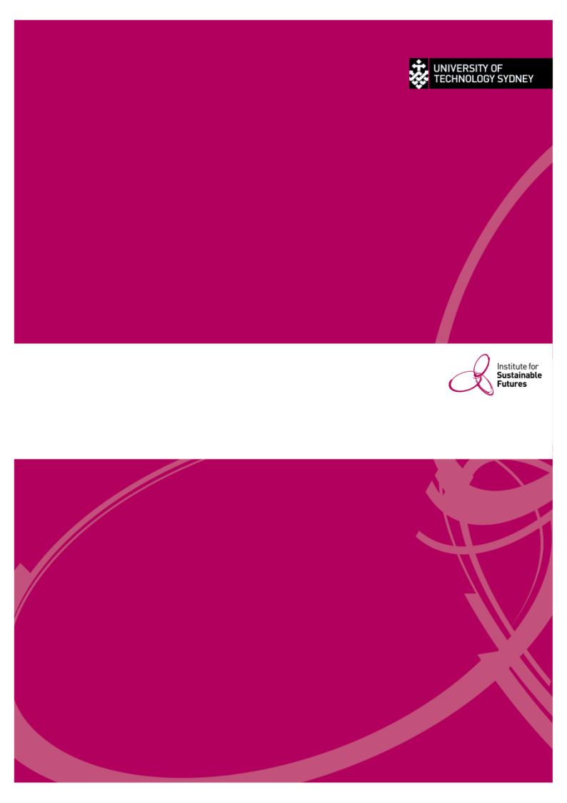

1. Box whisker plots present the range of observations in a group together with the 25th, 50th and 75th percentiles, which indicate the value below which each percentage of observations of observations fall. The upper and lower bounds of the ‘box’ indicate the 25th and 75th percentiles, the middle line in the box the median or 50th percentile, and the whiskers the full range of the obsevations (0 and 100th percentiles).
2. Combination top/front loaders (drum type machines with top access) and washer-dryer machines were both incorporated into the front loader category.
3. As opposed to capacity flow rates, which are used as the basis for the efficient/inefficient classification of showers.
4. DEWHA. (2008). *Energy Use in the Australian Residential Sector 1986 - 2020.* Commonwealth of Australia
5. ABS. (2005). *4602.0 Environmental Issues - Table 3.15.* Australian Bureau of Statistics
6. ESC. (2014). *Explanatory Note - Creating Victorian Energy Efficiency Certificates From Prescribed Activities.* Essential Services Commission - Victorian Government.
7. South East Water Showerhead Exchange Program ran from 2006 to 2013 with total showerheads exchange numbering 194,702. From 2009 onwards, SEW used VEEC accredited providers to deliver showerheads. To prevent double counting, only showerheads delivered up to the initiation of the VEET scheme were used in the model
8. Yarra Valley Water Showerhead Exchange Program ran from 2006 to 2013 with total showerheads exchange numbering 188,887. From 2009 onwards, YVW used VEEC accredited providers to deliver showerheads. To prevent double counting, only showerheads delivered up to the initiation of the VEET scheme were used in the model
9. City West Water Showerhead Exchange Program ran from 2006 to 2013 with total showerheads exchange numbering 112,442. From 2009 onwards, CWW used VEEC accredited providers to deliver showerheads. To prevent double counting, only showerheads delivered up to the initiation of the VEET scheme were used in the model