Report

WELS Labelling of the Dryer Component of Washer - Dryers

Aleksander Szann
Access Product Information Consultants
© Commonwealth of Australia 2008

This work is copyright. Apart from any use as permitted under the Copyright Act 1968, no part may be reproduced by any process without prior written permission from the Commonwealth, available from the Department of the Environment, Water, Heritage and the Arts.
Requests and inquiries concerning reproduction and rights should be addressed to: Assistant Secretary
Market Development Branch
Department of the Environment, Water, Heritage and the Arts
GPO Box 787
CANBERRA ACT 2601.

Disclaimer

The views and opinions expressed in this publication are those of the author and do not necessarily reflect those of the Australian Government, the Minister for Climate Change and Water, or the Minister for the Environment, Heritage and the Arts.

While reasonable efforts have been made to ensure that the contents of this publication are factually correct, the Commonwealth does not accept responsibility for the accuracy or completeness of the contents, and shall not be liable for any loss or damage that may be occasioned directly or indirectly through the use of, or reliance on, the contents of this publication.

For more information contact: WELS@environment.gov.au

Executive summary

Combination washer-dryers are popular because:

- they are able to wash and dry clothes in a single machine
- they are compact and can be more easily located in spaces smaller than those required by separate washer and dryer units.
As the washer component of these products is already required to be labelled under the Water Efficiency Labelling and Standards (WELS) Scheme, and these products use significant volumes of water, evidence exists to support labelling of the dryer mode of these products. There is also the possibility that stand alone dryers which utilise the same drying principle as the washer-dryers of this study will be released onto the market and the labelling proposed in this report would also apply to such products.

Labelling of the dryer would inform consumers:

- that the dryer uses water for the drying process
- that the rated capacity (kg of clothes) of the dryer is less than the rated capacity of the washer
- that the volume of water used for drying a load of clothes can be greater than that used for washing a larger load of clothes
- about the dryer’s water efficiency for comparison with other similar products.

Labelling would also encourage manufacturers to improve the water efficiency of their products as most of these machines consume more water (per unit of capacity) in drying mode than in washing mode.

Out of a number of options considered in this study for possible rating algorithms, the preferred algorithm is the one that:

- more clearly distinguishes between the quantity of water consumed (per unit of capacity) by the products and their respective assigned water ratings
- has a reasonable similarity with the corresponding energy rating.

The minimum water rating bands for dryers have been set to commence at 1-star to correspond with the minimum rating for washing machines. It is noted that some of the products in this study consumed excessive quantities of water in their drying mode and as such their rating would be less than 1-star.
It is therefore suggested that the manufacturers and/or distributors modify these products in order to improve their water efficiency. Otherwise, consideration should be given to excluding these products from supply (in a manner akin to current minimum standards for toilets).

Introduction

Although combination washer-dryers only form a small proportion of the washing machine and dryer market, these products are popular because they combine the operations of washing and drying in a single machine. Also, because these products are a single unit they can be more easily located in a smaller space than separate washer and dryer units. As such, these products are popular in high rise apartments which generally have limited laundry space. A further advantage these products have over conventional dryers is that in their dryer mode they internally condense all moisture extracted from the washed clothes, and do not blow it out into the surrounding space. As such, these products can be located anywhere plumbing and power are available, without concern that they would add humidity to the surrounding area.

Figure 1 – Dryer mode of combination washer-dryer

Heater duct
Heater

Sensor 1

Water nozzle
Fan

Sensor 2

Outer bowl

Condenser duct

Drain

Side view

Dry hot air Heated moist air Warm dry air
Cool dry air

Mode of operation of dryer

The clothes drying process of a combination washer-dryer can be broadly represented by the schematic diagram of Figure 1 on the previous page.

In the drying process, a fan blows cool air over a dryer heater which heats the air. The hot air passes via a duct through to the drum containing the washed and spun-dry clothes.

The dry hot air then passes through the moist clothes, causing some of the moisture to evaporate. The moist vapour and the air that has cooled as a result of extracting the moist vapour from the washing, then passes through the perforations in the drum and onto an exit duct at the rear of the drum.

The moist vapour and the cooled air travel up a condenser duct and through a spray of cold water which cools and condenses the moist vapour. Any lint that enters the condenser duct with the vapour and cooled air is also washed away by the water spray.

The condensed vapour, spray water, and any lint, drains to a drain pump which empties the contents to waste.

The cooled air that flows past the water spray passes through the fan again and the whole process is continually repeated until sensors 1 and 2 detect that moisture from the washed clothes has been adequately removed.

In conventional dryers, air is heated and circulated through washed clothes. The heated air extracts moist vapour from the wet clothes, and together with any lint, is then blown out of the dryer and into the surrounding space. The dryer of a combination washer-dryer operates as a closed-loop energy system, as all the energy from the heated air is recycled back through the washing rather than blown out of the machine. However, as the water from the spray and the condensate are pumped to waste, these machines are design-challenged to be water efficient.

Labelling

As WELS already requires that the washing component of this product be registered, and since the drying mode of this product uses water to dry the washing, it is recommended that the dryer component should also be WELS labelled.

Labelling the dryer of these products would inform consumers that these products use water during the drying process, and that they also use significant quantities of water. Such information should encourage manufacturers to improve the water efficiencies of their products. As the water consumption of these machines in dryer mode, per unit of dryer capacity, varies from 4.56 L/Kg to 20.80 L/Kg, there appears to be sufficient potential for improving water efficiency.

The need to improve the water efficiency of these products is further highlighted by the fact that for most of these machines, the water consumed (per unit of capacity) in the drying mode is greater than that in the washing mode. It should also be noted that although the physical size of the drum in the machine is fixed, the rated capacity of the machine in drying mode is only about half that of the rated capacity in washer mode.

As such, the user of the machine has to either remove about half the full wash load and then dry the removed washing at a later time, or only use half the washer load so that the machine can wash and dry the clothes without the need for the user to handle wet washing. In the latter scenario, the washer would be used about twice as often as that for which the washer was WELS rated. In this case, it is likely the user will use significantly more water over their weekly washing, unless the machines
load-sense or users manually reduce water levels to match their loads.

Data

Table 1 sets out comparative data for all the washer-dryers registered under energy rating and WELS schemes. Not all data for all products appear in the table, as some products registered for energy are not available in Australia, and are therefore not registered for WELS.

Tables 3 to 8 indicate the star ratings for Options 1 to 6 respectively that would be achieved by a dryer having a specified rated capacity and a water consumption as determined by the procedure in AS/NZS 2442.1 Performance of household appliances — Rotary Clothes Dryers.

For the purposes of maintaining uniformity with a similar table for washing machines in
AS/NZS 6400 Water efficient products — Rating and labelling, Tables 3 to 8 indicate star ratings ranging from 1 to 6 stars in half-star steps, and rated capacities ranging from 1.0 to 10.0 kg load capacities in 0.5 kg steps.

The formula used to calculate the parameters in Options 1 to 6 is given below.

⎛ WC ⎞
loge ⎜ ⎟

Star Rating Index =

where

1+
loge
⎝ BWC ⎠
(1−WRF )

BWC = base water consumption = Litres x C

C = rated load capacity of the dryer (kg) WC = water consumption of the model in litres WRF = water reduction factor per additional star

The Base Water Consumption (BWC) and the Water Reduction Factor (WRF) used in the calculations of Options 1 to 6 are summarised in Table 2 below.

Table 2 – Summary of option criteria

Option | BWC  (Base Water Consumption) | WRF  (Water Reduction Factor)
 | litres/kg | % reduction in water per additional star
1 | 15.0 | 25.0 %
2 | 15.0 | 30.0 %
3 | 16.0 | 30.0 %
4 | 17.0 | 30.0 %
5 | 18.0 | 15.0 %
6 | 18.0 | 30.0 %

Figure 2 illustrates the linear regression of the water consumption and the rated capacity of each of the registered products.

Figures 3 to 8 represent the star ratings for Options 1 to 6 respectively (as indicated in Tables 3 to 8 respectively) for each of the products in this study.

Proposed algorithms

The criteria for proposing a suitable water rating algorithm for dryers were that:

- there would be a sufficient range of water consumption values within each rating band, but not so broad as to allow a product to increase its star rating with minor improvements to its water consumption
- the ratings that would be assigned to current products would allow future improvement in product water efficiencies without the need to re-scale the algorithm within at least a 5-year period
- the ratings that would be assigned to current products would align with, but preferably not exceed, the corresponding energy rating
- most (if not all) of the current products should fall within a 1-6 water star rating band.

As with the algorithm in AS/NZS 6400 Water efficient products — Rating and labelling for washing machines, the minimum water rating for condenser dryers was set at 1-star. In this regard it was noted that three products in this study consistently fell below this minimum for each of the Options considered. The water consumption of these is considered excessive and if they cannot be modified to attain the
1-star minimum rating they should not be offered for sale.

Referring to the above mentioned criteria for suitable algorithms, Options 1 and 5 were eliminated as possibilities because some of the current products would already be rated at 5 and 6-stars. As such, these algorithms would not encourage any future water efficiency improvements. Although Options 2, 3, 4 and 6 are similar, Option 2 is recommended because the ratings using the parameters in this option most closely meet all the above mentioned criteria.
Table 1 – Comparative data
8
WELS Labelling of the Dryer Component of Washer-Dryers

Item | Capacity  Dryer  (kg) | Water  Consump  Dryer  (L) | Water Consump per dryer capacity  Dryer  (L/kg) | Capacity  Washer  (kg) | Water  Consump  Washer  (L) | Water Consump per washer capacity  Washer  (L/kg) | Regist’d Energy Star rating  Washer | Regist’d Energy Star rating  Dryer | Regist’d WELS Star rating  Washer | Water Star ratings
 |  |  |  |  |  |  |  |  |  | Option 1  Base:15L WRF: 0.25 | Option 2  Base: 15L WRF:0.3 | Option 3  Base: 16L WRF:0.3 | Option 4  Base: 17L WRF:0.3 | Option 5  Base: 18L WRF:0.15 | Option 6  Base: 18L WRF:0.3
1 | 1.5 | 28 | 18.67 | 5 | 62.8 | 12.56 | 1 | 1 | — | 0 | 0 | 0 | 0 | 0 | 0
2 | 2 | 39 | 19.50 | 5 | 100 | 20.00 | 2.5 | 1 | — | 0 | 0 | 0 | 0 | 0 | 0
3 | 2.5 | 11.4 | 4.56 | 5.5 | 48.2 | 8.76 | 4 | 3.5 | 4 | 5 | 4 | 4.5 | 4.5 | 6+ | 4.5
4 | 2.5 | 52 | 20.80 | 5 | 53.4 | 10.68 | 4 | 1.5 | 3.5 | 0 | 0 | 0 | 0 | 0 | 0
5 | 3.5 | 25.4 | 7.26 | 7 | 68 | 9.71 | 4 | 2.5 | 4 | 3.5 | 3 | 3 | 3 | 6+ | 3.5
6 | 3.5 | 31.5 | 9.00 | 6.5 | 63.7 | 9.80 | 3.5 | 2.5 | 4 | 2.5 | 2 | 2 | 2 | 5 | 2.5
7 | 3.5 | 31.5 | 9.00 | 6 | 68 | 11.33 | 3 | 2.5 | — | 2.5 | 2 | 2.5 | 2.5 | 5 | 2.5
8 | 3.5 | 31.5 | 9.00 | 7 | 71.1 | 10.16 | 3 | 2.5 | 4 | 2.5 | 2 | 2.5 | 2.5 | 5 | 2.5
9 | 4 | 39 | 9.75 | 8 | 74.5 | 9.31 | 4 | 2 | 4 | 2.5 | 2 | 2 | 2 | 4.5 | 2.5
10 | 4 | 39 | 9.75 | 8 | 74.5 | 9.31 | 4.5 | 2 | 4 | 2.5 | 2 | 2 | 2 | 4.5 | 2.5
11 | 4 | 41 | 10.25 | 8 | 67 | 8.38 | 4.5 | 2 | 4.5 | 2 | 2 | 2 | 2 | 4 | 2.5
12 | 4 | 41 | 10.25 | 8 | 67 | 8.38 | 4.5 | 2 | 4.5 | 2 | 2 | 2 | 2 | 4 | 2.5
13 | 4 | 41.36 | 10.34 | 7.5 | 76.71 | 10.23 | 4 | 3 | 4 | 2 | 2 | 2 | 2 | 4 | 2.5
14 | 4 | 46 | 11.50 | 8 | 59.6 | 7.45 | 4.5 | 2.5 | — | 1.5 | 1.5 | 1.5 | 2 | 3.5 | 2
15 | 4 | 58 | 14.50 | 7 | 48.9 | 6.99 | 4 | 2 | — | 1 | 1 | 1 | 1 | 2 | 1.5
16 | 4 | 58 | 14.50 | 7 | 71.5 | 10.21 | 4.5 | 2 | 4 | 1 | 1 | 1 | 1 | 2 | 1.5
17 | 4 | 58 | 14.50 | 7 | 71.5 | 10.21 | 4.5 | 2 | 4 | 1 | 1 | 1 | 1 | 2 | 1.5
18 | 4 | 58 | 14.50 | 7 | 82.8 | 11.83 | 4 | 2 | — | 1 | 1 | 1 | 1 | 2 | 1.5
19 | 4 | 58 | 14.50 | 8 | 86 | 10.75 | 4 | 3 | — | 1 | 1 | 1 | 1 | 2 | 1.5
20 | 4 | — | — | 7 | 115 | 16.43 | 3.5 | 2.5 | — | — | — | — | — | — | —
21 | 5 | 34.08 | 6.82 | 9 | 91.48 | 10.16 | 4 | 2.5 | 4 | 3.5 | 3 | 3 | 3 | 6+ | 3.5
22 | 5 | 64 | 12.80 | 9 | 87 | 9.67 | 4.5 | 1.5 | 4 | 1.5 | 1 | 1.5 | 1.5 | 2.5 | 1.5
23 | 5 | 72 | 14.40 | 9 | 113 | 12.56 | 4 | 2 | — | 1 | 1 | 1 | 1 | 2 | 1.5
24 | 6 | 62 | 10.33 | 10 | 114.68 | 11.47 | 4 | 3.5 | — | 2 | 2 | 2 | 2 | 4 | 2.5
25 | 6 | 76 | 12.67 | 10 | 77.9 | 7.79 | 4.5 | 2 | 4.5 | 1.5 | 1 | 1.5 | 1.5 | 3 | 1.5

Dark blue shading indicates where an option would place models in the 5, 6 and beyond star bands.
Figure 2 — Linear regression graph

Water usage of washer-dryers

80

70

y = 11.583x
Dryer water consumption

50

40

30

20

10

0

0 1 2 3 4 5 6 7

Dryer load capacity

BWC=15xCapacity
Table 3 — Dryer star rating – (Option 1)

WRF=0.25 (25% reduction per star)

Dryer Load Capacity (kg)

 | 1 Star | 1.5 Stars | 2 Stars | 2.5 Stars | 3 Stars | 3.5 Stars | 4 Stars | 4.5 Stars | 5 Stars | 5.5 Stars | 6 Stars
0 | 0 | 0 | 0 | 0 | 0 | 0 | 0 | 0 | 0 | 0 | 0
1.0 | 15.0 | 13.0 | 11.3 | 9.7 | 8.4 | 7.3 | 6.3 | 5.5 | 4.7 | 4.1 | 3.6
1.5 | 22.5 | 19.5 | 16.9 | 14.6 | 12.7 | 11.0 | 9.5 | 8.2 | 7.1 | 6.2 | 5.3
2.0 | 30.0 | 26.0 | 22.5 | 19.5 | 16.9 | 14.6 | 12.7 | 11.0 | 9.5 | 8.2 | 7.1
2.5 | 37.5 | 32.5 | 28.1 | 24.4 | 21.1 | 18.3 | 15.8 | 13.7 | 11.9 | 10.3 | 8.9
3.0 | 45.0 | 39.0 | 33.8 | 29.2 | 25.3 | 21.9 | 19.0 | 16.4 | 14.2 | 12.3 | 10.7
3.5 | 52.5 | 45.5 | 39.4 | 34.1 | 29.5 | 25.6 | 22.1 | 19.2 | 16.6 | 14.4 | 12.5
4.0 | 60.0 | 52.0 | 45.0 | 39.0 | 33.8 | 29.2 | 25.3 | 21.9 | 19.0 | 16.4 | 14.2
4.5 | 67.5 | 58.5 | 50.6 | 43.8 | 38.0 | 32.9 | 28.5 | 24.7 | 21.4 | 18.5 | 16.0
5.0 | 75.0 | 65.0 | 56.3 | 48.7 | 42.2 | 36.5 | 31.6 | 27.4 | 23.7 | 20.6 | 17.8
5.5 | 82.5 | 71.4 | 61.9 | 53.6 | 46.4 | 40.2 | 34.8 | 30.1 | 26.1 | 22.6 | 19.6
6.0 | 90.0 | 77.9 | 67.5 | 58.5 | 50.6 | 43.8 | 38.0 | 32.9 | 28.5 | 24.7 | 21.4
6.5 | 97.5 | 84.4 | 73.1 | 63.3 | 54.8 | 47.5 | 41.1 | 35.6 | 30.8 | 26.7 | 23.1
7.0 | 105.0 | 90.9 | 78.8 | 68.2 | 59.1 | 51.1 | 44.3 | 38.4 | 33.2 | 28.8 | 24.9
7.5 | 112.5 | 97.4 | 84.4 | 73.1 | 63.3 | 54.8 | 47.5 | 41.1 | 35.6 | 30.8 | 26.7
8.0 | 120.0 | 103.9 | 90.0 | 77.9 | 67.5 | 58.5 | 50.6 | 43.8 | 38.0 | 32.9 | 28.5
8.5 | 127.5 | 110.4 | 95.6 | 82.8 | 71.7 | 62.1 | 53.8 | 46.6 | 40.3 | 34.9 | 30.3
9.0 | 135.0 | 116.9 | 101.3 | 87.7 | 75.9 | 65.8 | 57.0 | 49.3 | 42.7 | 37.0 | 32.0
9.5 | 142.5 | 123.4 | 106.9 | 92.6 | 80.2 | 69.4 | 60.1 | 52.1 | 45.1 | 39.0 | 33.8
10.0 | 150.0 | 129.9 | 112.5 | 97.4 | 84.4 | 73.1 | 63.3 | 54.8 | 47.5 | 41.1 | 35.6

Figure 3 – Option 1

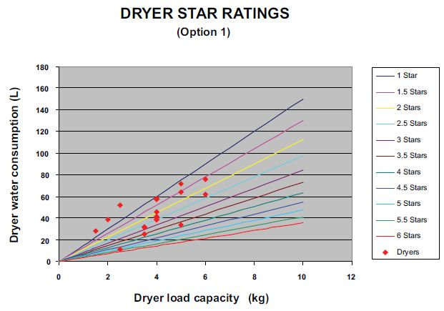

Table 4 — Dryer star rating – (Option 2)

BWC=15xCapacity

WRF=0.3 (30% reduction per star)

Dryer Load Capacity (kg)

 | 1 Star | 1.5 Stars | 2 Stars | 2.5 Stars | 3 Stars | 3.5 Stars | 4 Stars | 4.5 Stars | 5 Stars | 5.5 Stars | 6 Stars
0 | 0 | 0 | 0 | 0 | 0 | 0 | 0 | 0 | 0 | 0 | 0
1.0 | 15.0 | 12.5 | 10.5 | 8.8 | 7.4 | 6.1 | 5.1 | 4.3 | 3.6 | 3.0 | 2.5
1.5 | 22.5 | 18.8 | 15.8 | 13.2 | 11.0 | 9.2 | 7.7 | 6.5 | 5.4 | 4.5 | 3.8
2.0 | 30.0 | 25.1 | 21.0 | 17.6 | 14.7 | 12.3 | 10.3 | 8.6 | 7.2 | 6.0 | 5.0
2.5 | 37.5 | 31.4 | 26.3 | 22.0 | 18.4 | 15.4 | 12.9 | 10.8 | 9.0 | 7.5 | 6.3
3.0 | 45.0 | 37.6 | 31.5 | 26.4 | 22.1 | 18.4 | 15.4 | 12.9 | 10.8 | 9.0 | 7.6
3.5 | 52.5 | 43.9 | 36.8 | 30.7 | 25.7 | 21.5 | 18.0 | 15.1 | 12.6 | 10.5 | 8.8
4.0 | 60.0 | 50.2 | 42.0 | 35.1 | 29.4 | 24.6 | 20.6 | 17.2 | 14.4 | 12.1 | 10.1
4.5 | 67.5 | 56.5 | 47.3 | 39.5 | 33.1 | 27.7 | 23.2 | 19.4 | 16.2 | 13.6 | 11.3
5.0 | 75.0 | 62.7 | 52.5 | 43.9 | 36.8 | 30.7 | 25.7 | 21.5 | 18.0 | 15.1 | 12.6
5.5 | 82.5 | 69.0 | 57.8 | 48.3 | 40.4 | 33.8 | 28.3 | 23.7 | 19.8 | 16.6 | 13.9
6.0 | 90.0 | 75.3 | 63.0 | 52.7 | 44.1 | 36.9 | 30.9 | 25.8 | 21.6 | 18.1 | 15.1
6.5 | 97.5 | 81.6 | 68.3 | 57.1 | 47.8 | 40.0 | 33.4 | 28.0 | 23.4 | 19.6 | 16.4
7.0 | 105.0 | 87.8 | 73.5 | 61.5 | 51.5 | 43.0 | 36.0 | 30.1 | 25.2 | 21.1 | 17.6
7.5 | 112.5 | 94.1 | 78.8 | 65.9 | 55.1 | 46.1 | 38.6 | 32.3 | 27.0 | 22.6 | 18.9
8.0 | 120.0 | 100.4 | 84.0 | 70.3 | 58.8 | 49.2 | 41.2 | 34.4 | 28.8 | 24.1 | 20.2
8.5 | 127.5 | 106.7 | 89.3 | 74.7 | 62.5 | 52.3 | 43.7 | 36.6 | 30.6 | 25.6 | 21.4
9.0 | 135.0 | 112.9 | 94.5 | 79.1 | 66.2 | 55.3 | 46.3 | 38.7 | 32.4 | 27.1 | 22.7
9.5 | 142.5 | 119.2 | 99.8 | 83.5 | 69.8 | 58.4 | 48.9 | 40.9 | 34.2 | 28.6 | 24.0
10.0 | 150.0 | 125.5 | 105.0 | 87.8 | 73.5 | 61.5 | 51.5 | 43.0 | 36.0 | 30.1 | 25.2

Figure 4 – Option 2

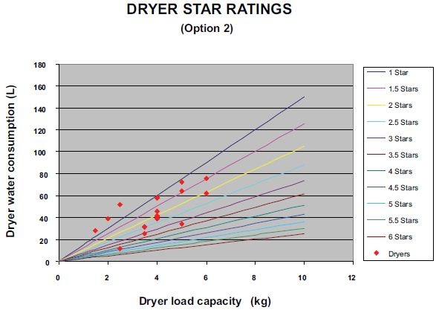

Table 5 — Dryer star rating – (Option 3)

BWC=16xCapacity

WRF=0.3 (30% reduction per star)

Dryer Load Capacity (kg)

 | 1 Star | 1.5 Stars | 2 Stars | 2.5 Stars | 3 Stars | 3.5 Stars | 4 Stars | 4.5 Stars | 5 Stars | 5.5 Stars | 6 Stars
0 | 0 | 0 | 0 | 0 | 0 | 0 | 0 | 0 | 0 | 0 | 0
1.0 | 16.0 | 13.4 | 11.2 | 9.4 | 7.8 | 6.6 | 5.5 | 4.6 | 3.8 | 3.2 | 2.7
1.5 | 24.0 | 20.1 | 16.8 | 14.1 | 11.8 | 9.8 | 8.2 | 6.9 | 5.8 | 4.8 | 4.0
2.0 | 32.0 | 26.8 | 22.4 | 18.7 | 15.7 | 13.1 | 11.0 | 9.2 | 7.7 | 6.4 | 5.4
2.5 | 40.0 | 33.5 | 28.0 | 23.4 | 19.6 | 16.4 | 13.7 | 11.5 | 9.6 | 8.0 | 6.7
3.0 | 48.0 | 40.2 | 33.6 | 28.1 | 23.5 | 19.7 | 16.5 | 13.8 | 11.5 | 9.6 | 8.1
3.5 | 56.0 | 46.9 | 39.2 | 32.8 | 27.4 | 23.0 | 19.2 | 16.1 | 13.4 | 11.2 | 9.4
4.0 | 64.0 | 53.5 | 44.8 | 37.5 | 31.4 | 26.2 | 22.0 | 18.4 | 15.4 | 12.9 | 10.8
4.5 | 72.0 | 60.2 | 50.4 | 42.2 | 35.3 | 29.5 | 24.7 | 20.7 | 17.3 | 14.5 | 12.1
5.0 | 80.0 | 66.9 | 56.0 | 46.9 | 39.2 | 32.8 | 27.4 | 23.0 | 19.2 | 16.1 | 13.4
5.5 | 88.0 | 73.6 | 61.6 | 51.5 | 43.1 | 36.1 | 30.2 | 25.3 | 21.1 | 17.7 | 14.8
6.0 | 96.0 | 80.3 | 67.2 | 56.2 | 47.0 | 39.4 | 32.9 | 27.6 | 23.1 | 19.3 | 16.1
6.5 | 104.0 | 87.0 | 72.8 | 60.9 | 51.0 | 42.6 | 35.7 | 29.8 | 25.0 | 20.9 | 17.5
7.0 | 112.0 | 93.7 | 78.4 | 65.6 | 54.9 | 45.9 | 38.4 | 32.1 | 26.9 | 22.5 | 18.8
7.5 | 120.0 | 100.4 | 84.0 | 70.3 | 58.8 | 49.2 | 41.2 | 34.4 | 28.8 | 24.1 | 20.2
8.0 | 128.0 | 107.1 | 89.6 | 75.0 | 62.7 | 52.5 | 43.9 | 36.7 | 30.7 | 25.7 | 21.5
8.5 | 136.0 | 113.8 | 95.2 | 79.7 | 66.6 | 55.8 | 46.6 | 39.0 | 32.7 | 27.3 | 22.9
9.0 | 144.0 | 120.5 | 100.8 | 84.3 | 70.6 | 59.0 | 49.4 | 41.3 | 34.6 | 28.9 | 24.2
9.5 | 152.0 | 127.2 | 106.4 | 89.0 | 74.5 | 62.3 | 52.1 | 43.6 | 36.5 | 30.5 | 25.5
10.0 | 160.0 | 133.9 | 112.0 | 93.7 | 78.4 | 65.6 | 54.9 | 45.9 | 38.4 | 32.1 | 26.9

Figure 5 – Option 3

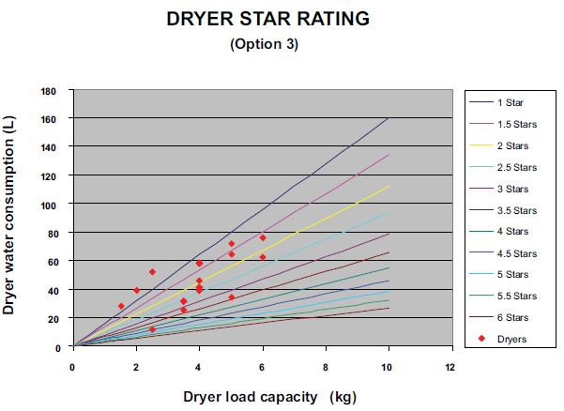

4.5 Stars
Table 6 — Dryer star rating – (Option 4)

BWC=17xCapacity

WRF=0.3 (30% reduction per star)

Dryer Load Capacity (kg)

 | 1 Star | 1.5 Stars | 2 Stars | 2.5 Stars | 3 Stars | 3.5 Stars | 4 Stars | 4.5 Stars | 5 Stars | 5.5 Stars | 6 Stars
0 | 0 | 0 | 0 | 0 | 0 | 0 | 0 | 0 | 0 | 0 | 0
1.0 | 17.0 | 14.2 | 11.9 | 10.0 | 8.3 | 7.0 | 5.8 | 4.9 | 4.1 | 3.4 | 2.9
1.5 | 25.5 | 21.3 | 17.9 | 14.9 | 12.5 | 10.5 | 8.7 | 7.3 | 6.1 | 5.1 | 4.3
2.0 | 34.0 | 28.4 | 23.8 | 19.9 | 16.7 | 13.9 | 11.7 | 9.8 | 8.2 | 6.8 | 5.7
2.5 | 42.5 | 35.6 | 29.8 | 24.9 | 20.8 | 17.4 | 14.6 | 12.2 | 10.2 | 8.5 | 7.1
3.0 | 51.0 | 42.7 | 35.7 | 29.9 | 25.0 | 20.9 | 17.5 | 14.6 | 12.2 | 10.2 | 8.6
3.5 | 59.5 | 49.8 | 41.7 | 34.8 | 29.2 | 24.4 | 20.4 | 17.1 | 14.3 | 12.0 | 10.0
4.0 | 68.0 | 56.9 | 47.6 | 39.8 | 33.3 | 27.9 | 23.3 | 19.5 | 16.3 | 13.7 | 11.4
4.5 | 76.5 | 64.0 | 53.6 | 44.8 | 37.5 | 31.4 | 26.2 | 22.0 | 18.4 | 15.4 | 12.9
5.0 | 85.0 | 71.1 | 59.5 | 49.8 | 41.7 | 34.8 | 29.2 | 24.4 | 20.4 | 17.1 | 14.3
5.5 | 93.5 | 78.2 | 65.5 | 54.8 | 45.8 | 38.3 | 32.1 | 26.8 | 22.4 | 18.8 | 15.7
6.0 | 102.0 | 85.3 | 71.4 | 59.7 | 50.0 | 41.8 | 35.0 | 29.3 | 24.5 | 20.5 | 17.1
6.5 | 110.5 | 92.5 | 77.4 | 64.7 | 54.1 | 45.3 | 37.9 | 31.7 | 26.5 | 22.2 | 18.6
7.0 | 119.0 | 99.6 | 83.3 | 69.7 | 58.3 | 48.8 | 40.8 | 34.2 | 28.6 | 23.9 | 20.0
7.5 | 127.5 | 106.7 | 89.3 | 74.7 | 62.5 | 52.3 | 43.7 | 36.6 | 30.6 | 25.6 | 21.4
8.0 | 136.0 | 113.8 | 95.2 | 79.7 | 66.6 | 55.8 | 46.6 | 39.0 | 32.7 | 27.3 | 22.9
8.5 | 144.5 | 120.9 | 101.2 | 84.6 | 70.8 | 59.2 | 49.6 | 41.5 | 34.7 | 29.0 | 24.3
9.0 | 153.0 | 128.0 | 107.1 | 89.6 | 75.0 | 62.7 | 52.5 | 43.9 | 36.7 | 30.7 | 25.7
9.5 | 161.5 | 135.1 | 113.1 | 94.6 | 79.1 | 66.2 | 55.4 | 46.3 | 38.8 | 32.4 | 27.1
10.0 | 170.0 | 142.2 | 119.0 | 99.6 | 83.3 | 69.7 | 58.3 | 48.8 | 40.8 | 34.2 | 28.6

Figure 6 – Option 4

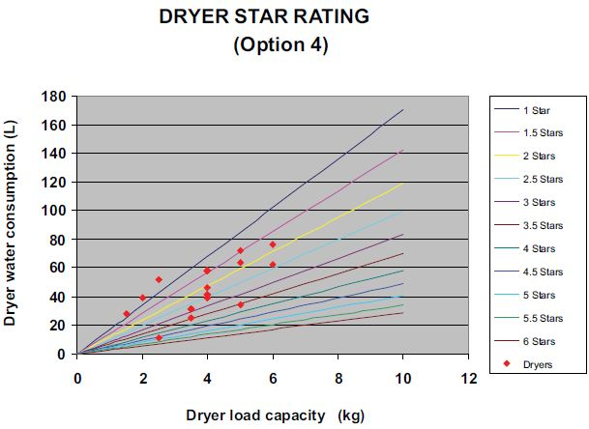

Table 7 — Dryer star rating – (Option 5)

BWC=18xCapacity

WRF=0.15 (15% reduction per star)

Dryer Load Capacity (kg)

 | 1 Star | 1.5 Stars | 2 Stars | 2.5 Stars | 3 Stars | 3.5 Stars | 4 Stars | 4.5 Stars | 5 Stars | 5.5 Stars | 6 Stars
0 | 0 | 0 | 0 | 0 | 0 | 0 | 0 | 0 | 0 | 0 | 0
1.0 | 18.0 | 16.6 | 15.3 | 14.1 | 13.0 | 12.0 | 11.1 | 10.2 | 9.4 | 8.7 | 8.0
1.5 | 27.0 | 24.9 | 22.9 | 21.2 | 19.5 | 18.0 | 16.6 | 15.3 | 14.1 | 13.0 | 12.0
2.0 | 36.0 | 33.2 | 30.6 | 28.2 | 26.0 | 24.0 | 22.1 | 20.4 | 18.8 | 17.3 | 16.0
2.5 | 45.0 | 41.5 | 38.2 | 35.3 | 32.5 | 30.0 | 27.6 | 25.5 | 23.5 | 21.7 | 20.0
3.0 | 54.0 | 49.8 | 45.9 | 42.3 | 39.0 | 36.0 | 33.2 | 30.6 | 28.2 | 26.0 | 24.0
3.5 | 63.0 | 58.1 | 53.5 | 49.4 | 45.5 | 42.0 | 38.7 | 35.7 | 32.9 | 30.3 | 28.0
4.0 | 72.0 | 66.4 | 61.2 | 56.4 | 52.0 | 48.0 | 44.2 | 40.8 | 37.6 | 34.7 | 31.9
4.5 | 81.0 | 74.7 | 68.8 | 63.5 | 58.5 | 54.0 | 49.7 | 45.9 | 42.3 | 39.0 | 35.9
5.0 | 90.0 | 83.0 | 76.5 | 70.5 | 65.0 | 59.9 | 55.3 | 51.0 | 47.0 | 43.3 | 39.9
5.5 | 99.0 | 91.3 | 84.1 | 77.6 | 71.5 | 65.9 | 60.8 | 56.1 | 51.7 | 47.6 | 43.9
6.0 | 108.0 | 99.6 | 91.8 | 84.6 | 78.0 | 71.9 | 66.3 | 61.1 | 56.4 | 52.0 | 47.9
6.5 | 117.0 | 107.9 | 99.4 | 91.7 | 84.5 | 77.9 | 71.9 | 66.2 | 61.1 | 56.3 | 51.9
7.0 | 126.0 | 116.2 | 107.1 | 98.7 | 91.0 | 83.9 | 77.4 | 71.3 | 65.8 | 60.6 | 55.9
7.5 | 135.0 | 124.5 | 114.7 | 105.8 | 97.5 | 89.9 | 82.9 | 76.4 | 70.5 | 65.0 | 59.9
8.0 | 144.0 | 132.8 | 122.4 | 112.8 | 104.0 | 95.9 | 88.4 | 81.5 | 75.2 | 69.3 | 63.9
8.5 | 153.0 | 141.1 | 130.0 | 119.9 | 110.5 | 101.9 | 94.0 | 86.6 | 79.9 | 73.6 | 67.9
9.0 | 162.0 | 149.4 | 137.7 | 127.0 | 117.0 | 107.9 | 99.5 | 91.7 | 84.6 | 78.0 | 71.9
9.5 | 171.0 | 157.7 | 145.3 | 134.0 | 123.5 | 113.9 | 105.0 | 96.8 | 89.3 | 82.3 | 75.9
10.0 | 180.0 | 166.0 | 153.0 | 141.1 | 130.0 | 119.9 | 110.5 | 101.9 | 94.0 | 86.6 | 79.9

Figure 7 – Option 5

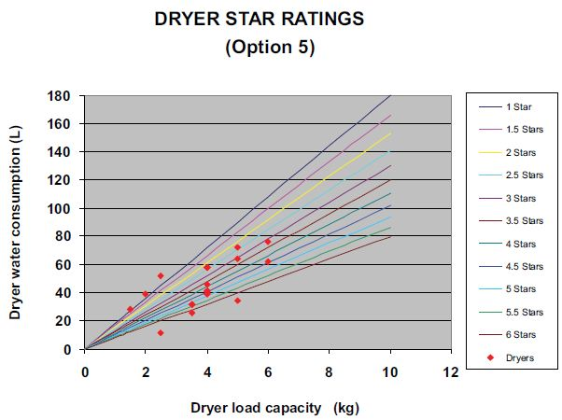

Table 8 — Dryer star rating – (Option 6)

BWC=18xCapacity

WRF=0.3 (30% reduction per star)

Dryer Load Capacity (kg)

 | 1 Star | 1.5 Stars | 2 Stars | 2.5 Stars | 3 Stars | 3.5 Stars | 4 Stars | 4.5 Stars | 5 Stars | 5.5 Stars | 6 Stars
0 | 0 | 0 | 0 | 0 | 0 | 0 | 0 | 0 | 0 | 0 | 0
1.0 | 18.0 | 15.1 | 12.6 | 10.5 | 8.8 | 7.4 | 6.2 | 5.2 | 4.3 | 3.6 | 3.0
1.5 | 27.0 | 22.6 | 18.9 | 15.8 | 13.2 | 11.1 | 9.3 | 7.7 | 6.5 | 5.4 | 4.5
2.0 | 36.0 | 30.1 | 25.2 | 21.1 | 17.6 | 14.8 | 12.3 | 10.3 | 8.6 | 7.2 | 6.1
2.5 | 45.0 | 37.6 | 31.5 | 26.4 | 22.1 | 18.4 | 15.4 | 12.9 | 10.8 | 9.0 | 7.6
3.0 | 54.0 | 45.2 | 37.8 | 31.6 | 26.5 | 22.1 | 18.5 | 15.5 | 13.0 | 10.8 | 9.1
3.5 | 63.0 | 52.7 | 44.1 | 36.9 | 30.9 | 25.8 | 21.6 | 18.1 | 15.1 | 12.7 | 10.6
4.0 | 72.0 | 60.2 | 50.4 | 42.2 | 35.3 | 29.5 | 24.7 | 20.7 | 17.3 | 14.5 | 12.1
4.5 | 81.0 | 67.8 | 56.7 | 47.4 | 39.7 | 33.2 | 27.8 | 23.2 | 19.4 | 16.3 | 13.6
5.0 | 90.0 | 75.3 | 63.0 | 52.7 | 44.1 | 36.9 | 30.9 | 25.8 | 21.6 | 18.1 | 15.1
5.5 | 99.0 | 82.8 | 69.3 | 58.0 | 48.5 | 40.6 | 34.0 | 28.4 | 23.8 | 19.9 | 16.6
6.0 | 108.0 | 90.4 | 75.6 | 63.3 | 52.9 | 44.3 | 37.0 | 31.0 | 25.9 | 21.7 | 18.2
6.5 | 117.0 | 97.9 | 81.9 | 68.5 | 57.3 | 48.0 | 40.1 | 33.6 | 28.1 | 23.5 | 19.7
7.0 | 126.0 | 105.4 | 88.2 | 73.8 | 61.7 | 51.7 | 43.2 | 36.2 | 30.3 | 25.3 | 21.2
7.5 | 135.0 | 112.9 | 94.5 | 79.1 | 66.2 | 55.3 | 46.3 | 38.7 | 32.4 | 27.1 | 22.7
8.0 | 144.0 | 120.5 | 100.8 | 84.3 | 70.6 | 59.0 | 49.4 | 41.3 | 34.6 | 28.9 | 24.2
8.5 | 153.0 | 128.0 | 107.1 | 89.6 | 75.0 | 62.7 | 52.5 | 43.9 | 36.7 | 30.7 | 25.7
9.0 | 162.0 | 135.5 | 113.4 | 94.9 | 79.4 | 66.4 | 55.6 | 46.5 | 38.9 | 32.5 | 27.2
9.5 | 171.0 | 143.1 | 119.7 | 100.1 | 83.8 | 70.1 | 58.7 | 49.1 | 41.1 | 34.4 | 28.7
10.0 | 180.0 | 150.6 | 126.0 | 105.4 | 88.2 | 73.8 | 61.7 | 51.7 | 43.2 | 36.2 | 30.3

Figure 8 – Option 6

