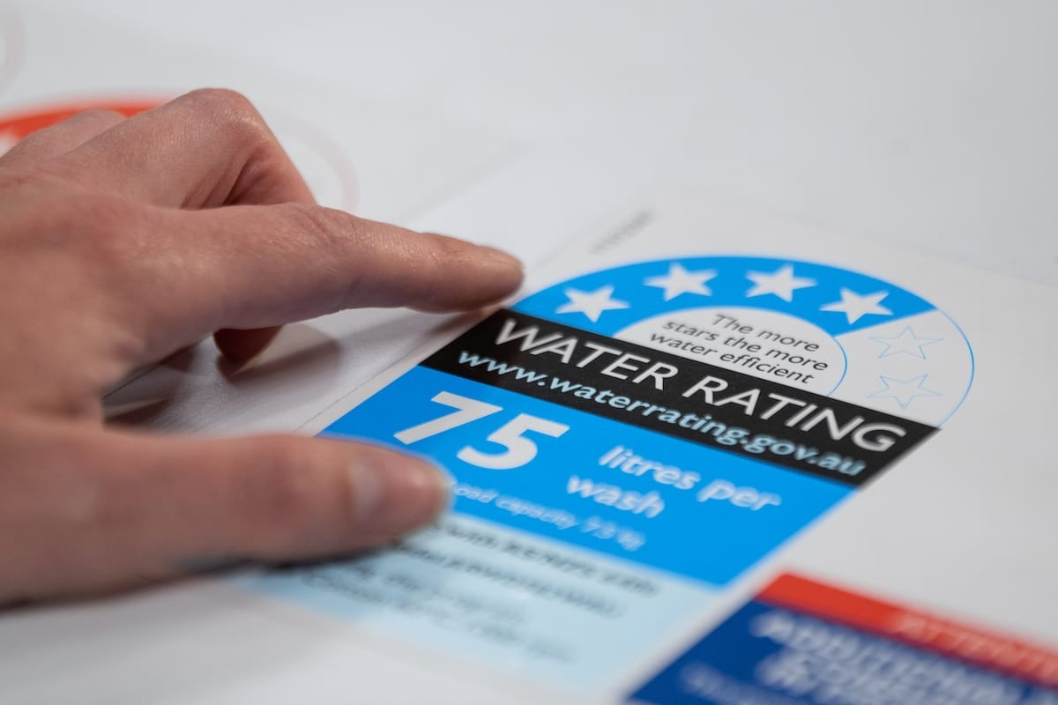

Evaluation of the environmental and economic benefits of the WELS Scheme
Prepared for DCCEEW

Institute for Sustainable Futures
November 2025 | uts.edu.au/is

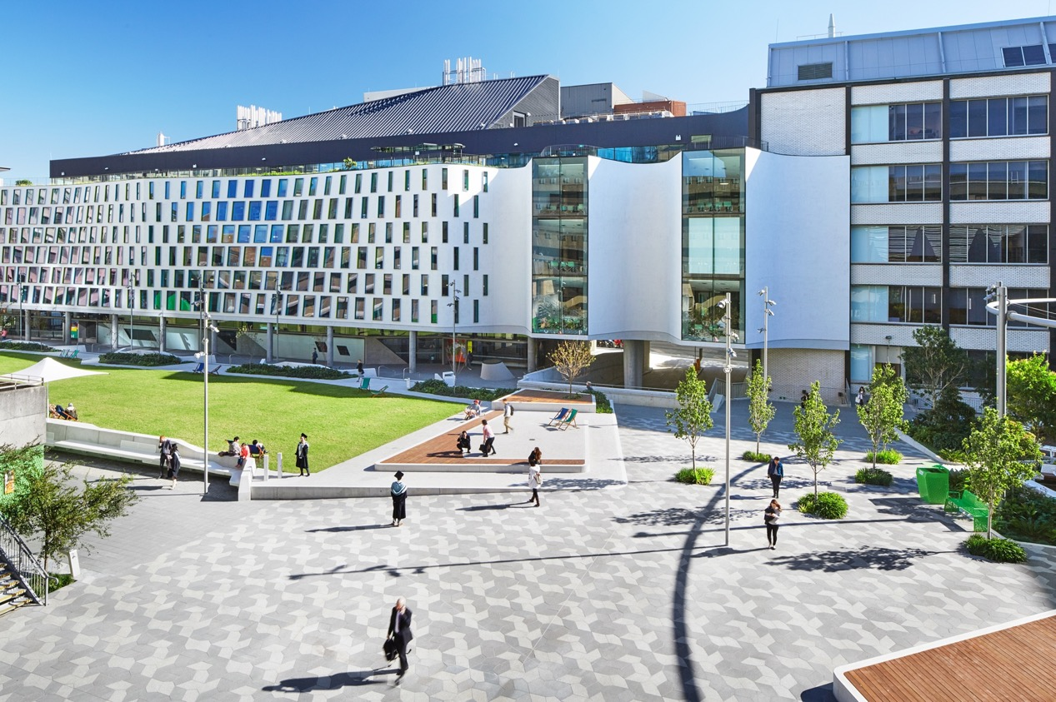
- Acknowledgements
We acknowledge the collaborative participation of industry groups, consultants and WELS product suppliers and manufacturers during this project. Including:
Australian Plumbing Manufacturers Association (APMA), AustWorld, Azzura, Bunnings, Carmody Compliance Consulting, Caroma, Consumer Electronics Suppliers’ Assocatiation (CESA), Enware, Gentec, Hansgrohe, Hisense, LG, Meir, Plumbing Products Industry Group (PPIG), Thornwaite, Vzug, Whirlpool

Research team
- A/Prof. Simon Fane
- Alexandra Butler
- Yohan Kim
- Rooma Shailaj
- Anita Bentley
- Alec Check
- Adrienne Thackway
- Emma Watts

Citation
Fane, S., Butler, A., Kim, Y., Bentley, A., Watts, E. (2025), Evaluation of the environmental and economic benefits of the WELS scheme. Report prepared for DCCEEW, Institute for Sustainable Futures at the University of Technology Sydney, December 2025.

About the authors
The Institute for Sustainable Futures (UTS-ISF) is a transdisciplinary research and consulting organisation at the UTS. ISF has been setting global benchmarks since 1997 in helping governments, organisations and communities achieve change towards sustainable futures.
- Disclaimer
The authors have used all due care and skill to ensure the material is accurate as at the date of this report. ISF and the authors do not accept any responsibility for any loss that may arise by anyone relying upon its contents. © UTS December 2025

- Institute for Sustainable Futures
University of Technology Sydney
PO Box 123 Broadway, NSW, 2007
ISF UTS website
Cover Image: Department of Climate Change, Energy, the Environment and Water (DCCEEW)
- Acknowledgment of Country
UTS acknowledges the Gadigal People of the Eora Nation, the Boorooberongal People of the Dharug Nation, the Bidiagal People and the Gamaygal People upon whose ancestral lands our university stands. We would also like to pay respect to the Elders past, present and future, acknowledging them as the traditional custodians of knowledge for these lands.

Executive Summary
This report presents a study of the environmental and economic benefits of the Australian Water Efficiency Labelling and Standards (WELS) scheme, which has been operating since 2005. Conducted by the University of Technology (UTS) Institute for Sustainable Futures (ISF) for the Commonwealth Department of Climate Change, Energy, the Environment and Water (DCCEEW).
This study assesses the impacts of the WELS scheme from 2006 to the end of 2025 and projects future impacts to the end of 2045. This study builds on previous ISF evaluations of the WELS scheme, completed in 2015 and 2018, and expands the scope to include impacts in five non-residential subsectors: visitation (e.g., gyms, pools, public toilets), employment and study (e.g. offices, schools, universities/TAFE), accommodation (e.g. hotels, motels) and aged care/hospitals. Data from other non-residential sectors were not available at this time. This study also incorporates significant shifts in both sales data for some products and the national energy policy, as well as updating utility prices and population dynamics that have occurred since the 2018 evaluation.
The study began with an initial review and analysis of the WELS database to examine product ratings and efficiency trends over time. A key element of the study was interviewing and surveying manufacturers, importers, suppliers and retailers to get current sales data and understand changes in the efficiency of fixtures and appliances sold in recent years.

Product efficiency rating trends of products registered for the market
There was a general upward trend in the average WELS star rating across most product categories between 2006 and 2025. As of 2025, nearly all registered products are rated 3 stars or above, reflecting the introduction of the minimum WELS efficiency standards. For plumbing fixtures, this 3-star level also aligns with the National Construction Code (NCC), which is a general set of provisions for the design, construction and performance of buildings as well as plumbing and drainage systems.
The sales data analysis shows a notable shift in dishwashers towards higher efficiency with 5+ star models comprising over 80 per cent (%) of sales in 2025. Washing machines have had slower uptake of high-efficiency models with 4+ star models comprising over 80% of washing machines sales in 2025. Toilet efficiency has slightly declined with 4+ star model sales dropping from nearly 90% in 2018, to 85% in 2025. For urinals, there was a decline in the sales of 6-star models which fell from ~70% in 2016 to 55% in 2025, which may reflect an uptake of waterless urinals, but which are not yet covered under the scheme. This could not be confirmed.
The study found a transformation of the tapware market has occurred with the proportion of 5+ star taps being sold having grown significantly in the last seven years and now contributing to over 60% of sales. Shower water efficiencies have also improved since 2018 with the sales of 4+ star models increasing from ~5% to 20% and the sales of 3-star models correspondingly decreasing from ~95% to 75%.
Given that the trend towards higher efficiency in some product markets has stabilised, driving further water savings may require encouraging further innovation in product design or other initiatives such as expanding the type of products within the scheme.

Water, energy and greenhouse gas emissions savings
The initial analysis informed the subsequent water modelling by using the proportions of WELS star rated products expected to be in the market in 2025. Residential and non-residential water consumption, energy and greenhouse gas (GHG) emission savings for the historic and projected future stock of WELS rated products were modelled to estimate the impact of the scheme (and associated measures) from 2005 to 2045.
Since commencement, the WELS scheme has delivered substantial national savings across water, energy, GHG emissions and customer bills with further increases projected by 2045.
The scheme is modelled to have saved 2,060 GL of water, $16.7B in customer bills (of which $12B is in residential household bills) and $890M equivalent of GHG emissions over the past 20 years since commencement in 2006. In 2025 alone, water savings ranged across states and territories from 3.6 GL in the Northern Territory (NT) to 62.3 GL in New South Wales (NSW) and totalled 209 GL nationally. Of the 209 GL saved, about two-thirds (141 GL) was from the residential sector alone. Given the administrative cost of approximately $2.8M per year, this equates to an average of $17 in cost to the government per ML of water saved for the past five years.
Water savings are expected to increase to 320 GL/year by 2045 (see Figure ES1 below), for a total of 7,670 GL of water saved by 2045. Given that not all non-residential subsectors that would use WELS rated products were able to be included in the modelling and WELS rated appliances used in non-residential settings were also excluded, the estimates might be considered conservative.

Figure ES1 Water savings due to WELS rated fixtures and appliances
Electricity savings in 2025 ranged from 104 TJ in Australian Capital Territory (ACT) to 2,621 TJ in Queensland, totalling 6,827 TJ nationally and are expected to grow to 11,829 TJ/year by 2045. Gas savings in 2025 ranged between 1 TJ in the NT to 2,829 TJ in Victoria, totalling 6,084 nationally. Gas savings are expected to peak between 2025 to 2030 and then decrease to 6090 TJ/year by 2045 due to gas hot water systems being phased out in Victoria as part of the state’s gas substitution roadmap and that they have the highest proportion of gas hot water systems across states and territories. Figure ES2 shows that annual GHG emissions savings are expected to decrease for most states with an average decrease of 64% between 2025 and 2045.

Figure ES2 GHG emissions savings due to WELS rated fixtures and appliances by State

Cost savings
The total utility bill savings for Australian households and businesses in 2025 totalled $1,630M/year, approximately 72% ($1,176M) of which comes from the residential sector (see Figure ES3). This is equivalent to $107 in bill savings per household for 2025. Households are assumed to have 2.5 people per household on average, in line with findings from the last Census performed in 2021 (Australian Institute of Family Studies, 2023). National bill savings are expected to grow a further 31% to $2,134M/year ($113/household/year in 2025 AUD) by 2045, reflecting the enduring impact of the WELS scheme on decreasing water and energy use. For the Commonwealth, the WELS scheme has cost about $17/ML of water saved in administration expenses over the past five years.

Figure ES3 Utility bill savings due to WELS rated fixtures and appliances by State

National and global significance
The findings of this study demonstrate the ongoing national and global significance of the Australian WELS scheme. After 20 years of operation, it continues to deliver substantial benefits in conserving water resources, reducing household and business utility bills and cutting greenhouse gas emissions. These impacts are contributing to urban water security across the country and supporting national climate change commitments. The scheme’s role is further strengthened by its alignment with other regulatory measures and its predictability for both the water sector and related industries.
Internationally, the report reinforces that the WELS scheme stands as a benchmark for water efficiency regulation, offering a proven model for other countries grappling with growing water stress due to climate change and urbanisation. The scheme’s success demonstrates the value of including harmonised national legislation, industry engagement, technical standards development, having a public register of products and effective compliance and enforcement as well as consumer education aspects in such a scheme.
The WELS scheme strengthens Australia’s position as a leader in globally relevant policy options for advancing sustainable water use and supporting broader energy and emissions reduction strategies.

Contents
1 Introduction 7
1.1 WELS scheme overview 7
1.2 Previous WELS scheme environmental and economic evaluations 8
1.3 Purpose of this study 9
2 WELS and water management in Australia 11
2.1 History of the WELS scheme 11
2.2 Wider urban water policy context 12
2.3 What does this study evaluate? 14
3 Approach 16
3.1 Review and analysis of the WELS database 17
3.2 Sales data collection and analysis 17
3.3 Modelling of consumption and (water, energy and GHG) savings 17
3.4 Economic analysis (of utility bill savings and GHG) 18
4 Results – WELS Database and Sales Data Analysis 19
4.1 All products 19
4.2 Appliances 22
4.3 Lavatory equipment 24
4.4 Plumbing products 26
4.5 Projections of future water efficiency - basis for assumptions 30
5 Results – Modelled Water, Energy, GHG and Bill Savings 31
5.1 National Results Summary 31
5.2 Water Savings 33
5.3 Energy Savings 36
5.4 GHG Savings 37
5.5 Bill savings 37
6 Discussion and Conclusions 39
6.1 Insights from the 2025 study 39
6.2 Comparison to the 2018 WELS evaluation 41
6.3 Implications 44
6.4 Conclusion 45
Appendix A WELS 2025 Star Ratings and Water Efficiencies 48
Appendix B Global Water Efficiency Labelling Schemes 50
Appendix C Detailed Project Methodology 53
Appendix D Data Sources 62
Appendix E Sales Data Interview and Survey Questions 65
Appendix F Key Input Data Tables 67
Appendix G State Level Results 72
Appendix H All Results Tables 88

- List of Figures
Figure 1 Example WELS product label 7
Figure 2 WELS wider urban water policy context 15
Figure 3 Overall study methodology 17
Figure 4 Active WELS Product Registrations (All Products) 20
Figure 5 WELS Database Average Star Band Results (All Products) 21
Figure 6 WELS Database Star Proportion Results (All Products) 21
Figure 7 WELS Database Star Proportion Results (Dishwashers) 23
Figure 8 WELS Database Star Proportion Results (Washing Machines) 23
Figure 9 Sales Data Results (Appliances) 24
Figure 10 WELS Database Star Proportion Results (Toilets) 25
Figure 11 WELS Database Star Proportion Results (Urinals) 25
Figure 12 Sales Data Results (Lavatory Equipment) 26
Figure 13 WELS Database Star Proportion Results (Taps) 27
Figure 14 WELS Database Star Proportion Results (Showers) 27
Figure 15 Sales Data Results (Plumbing Products) 28
Figure 16 WELS Active Product Registrations (Plumbing Products – Low Pressure only) 29
Figure 17 WELS Database Star Proportion Results (Taps - Low Pressure only) 29
Figure 18 WELS Database Star Proportion Results (Showers – Low Pressure only) 30
Figure 19 National Water Savings for the Residential and Non-Residential Sectors 32
Figure 20 National Energy Savings (Gas and Electricity) 32
Figure 21 National Greenhouse Gas Savings 33
Figure 22 National Bill Savings (AUD$ 24/25) 33
Figure 23 National Water Savings by State/Territory 34
Figure 24 National Water Savings by Fixture 34
Figure 25 Water Savings Per Capita (Residential) 35
Figure 26 Water Savings Per Capita (Non-residential) 35
Figure 27 National Electricity Savings by State/Territory 36
Figure 28 National Gas Savings by State/Territory 36
Figure 29 National GHG savings for Australia and by State/Territory 37
Figure 30 National Bill Savings and GHG Emission Saving by Sector (AUD$ 24/25) 38
Figure 31 National Bill Savings by State (AUD$ 24/25) 38
Figure 32 Annual water savings, 2018 and current evaluations 42
Figure 33 Number of international visitor nights by state (Source: www.tra.gov.au) 43
Figure 34 Cumulative Greenhouse Gas Savings (National), 2018 and Annual 43
Figure 35 Emission Intensity of Electricity (National), 2018 and Annual 44
Figure 36 Annual bill savings, 2018 and current evaluations 44
- List of Tables
Table 1 Sales Data Market Representation Results 22
Table 2 High level 2025 WELS Savings results (calendar year) 31
Table 3 Comparing results of this study with the previous 2018 evaluation 42
Table 4 Product WELS star bands (current as of August 2025). Note figures in red are below the current WELS minimum water efficiency standard for that product type. 48
Table 5 Summary of water efficiency labelling schemes, globally ^{1,2} 50
Table E1 Sales Data Interview and Survey Questions 65
Table F1 Water price for each state 67
Table F2 Electricity price for each state 68
Table F3 Gas price for each state 69
Table F4 Emission intensity (electricity) for each state 70
Table F5 Emission intensity (gas) for each state 71
Table H1 Calendar year annual water savings for each state 88
Table H2 Financial year annual water savings for each state 89
Table H3 Calendar year annual electricity savings for each state 90
Table H4 Financial year annual electricity savings for each state 91
Table H5 Calendar year annual gas savings for each state 92
Table H6 Financial year annual gas savings for each state 93
Table H7 Calendar year annual cumulative GHG savings for each state 94
Table H8 Financial year annual cumulative GHG savings for each state 95
Table H9 Calendar year annual bill savings for each state 96
Table H10 Financial year annual bill savings for each state 97

- Introduction
This study by the Institute for Sustainable Futures at the University of Technology Sydney (UTS-ISF) is a broad evaluation of the benefits of the Australian Government's Water Efficiency Labelling and Standards (WELS) scheme. The WELS scheme mandates water efficiency labelling and sets minimum standards for plumbing fixtures and major water using appliances in Australia. This study modelled the environmental and economic benefits of the WELS scheme and associated measures that together improve water use efficiency in Australian homes and businesses. The evaluation estimates historical savings since the scheme’s inception and projects future reductions in water and energy use, associated greenhouse gas (GHG) emissions and utility bill savings.
  - WELS scheme overview
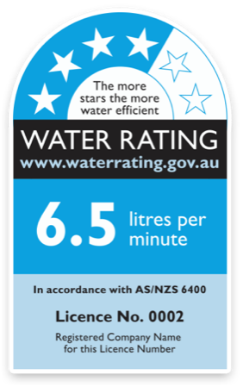
Figure 1 Example WELS product label
Source: www.waterrating.gov.au
The WELS scheme is a Commonwealth government-run initiative, now celebrating its 20th year of operation. It is mandated by the Water Efficiency Labelling and Standards Act (WELS Act) 2005, which came into effect on 1 July 2005, and by complementary state and territory WELS legislation.
The scheme’s core objectives are to:
- conserve water supplies by reducing water consumption,
- provide information for purchasers of water using and water saving products, and
- promote the adoption of efficient and effective water use and water saving technologies.
The scheme achieves these objectives through a readily recognisable and trusted star rating system that is displayed on product labels or in text advice commonly available online (Quantum Market Research, 2014) and by imposing minimum water efficiency standards for key items. The national legislation and regulations are supported by WELS legislation in each Australian state and territory. The scheme is implemented through a system for product testing, product registration, scheme monitoring and compliance.
A broad range of water-using equipment common in homes (and commercial business) are covered by the scheme, including showers, taps, toilets, urinals, dishwashers and washing machines (see Appendix A). Since 1 July 2006, all products covered by the scheme, whether imported or manufactured in Australia, must be registered and labelled when they are supplied or offered for supply e.g. through advertising. Since 2013, products must be registered individually, and registrations renewed annually. Further information on the scheme relevant to consumers, product manufacturers and retailers is readily available on the WELS website (www.waterrating.gov.au).
From a water planning perspective, reducing demand through water efficiency is the equivalent as providing additional water supply to meet increasing demand. Across a range of water resource projects in Australia, water efficiency was the cheapest source of available water, particularly in comparison to desalination, recycled water or rainwater from tanks (WSAA, 2020).
It is important to recognise that while the WELS scheme has contributed significantly to national water savings, it functions within a broader landscape of water efficiency and demand management drivers, including drought response programs, regulatory reforms, utility-led demand management and technological innovation. The scheme operates as part of Australia’s wider urban water policy framework, which includes local water savings initiatives, building standards, voluntary schemes (such as SmartDrop or Green Star buildings) and behavioural interventions. These interconnected influences mean that the water efficiency outcomes observed cannot be attributed to WELS alone. Instead, this study evaluates WELS as an enabling platform, one that underpins and enhances water-saving efforts across industry and the broader population in Australia. It considers the impact of WELS rated products across all areas of application (homes and businesses), while acknowledging that these outcomes are also shaped by complementary policies, tools and external drivers. This broader context is discussed further in Chapter 2.
    - Global significance
The Australian WELS scheme operates in partnership with the New Zealand Government’s WELS scheme under a combined technical standard AS/NZS6400:2016 Water efficient products – Rating and labelling. Implementation and enforcement for each country’s regulations under the scheme are the responsibility of their respective governments.
On a global scale, other nations operate similar water efficiency labelling and standards schemes (e.g. USA’s WaterSense and China’s Water Conservation Certificate). The key strength of the Australian WELS scheme is that it specifies mandatory water efficiency standards, with a clear star rating system, for all products on the Australian market. The Australian WELS scheme also has a robust approach to program evaluation to ensure transparent reflection and reporting on its effectiveness. A range of existing national schemes and information on their benefits evaluation approaches have been listed in Appendix B.
At a global level there has been partnership in developing an international ISO standard for water efficiency labelling, with the Australian WELS scheme serving as a one of the foundational models. A proposal for this ISO standard was drafted with input from countries including Singapore, China, Malaysia, New Zealand and Australia, gaining approval as ISO 31600:2022. The standard provides guidance and a framework for establishing water efficiency labelling programs for plumbing fixtures and appliances, empowering countries to develop their own national schemes. Its agreed scope focuses on recommended tests for water consumption and includes a repository of standards to accommodate existing scheme requirements, with products aligning with those in Australia’s WELS scheme.
    - 20th Anniversary
As the Australian WELS scheme celebrates its 20th anniversary, this evaluation showcases its achievements in terms of driving reductions in water and energy consumption and related GHG emission and utility bill savings. Over the years, the scheme has driven nationally important water savings and a marked reduction in per capita water use across the country. The label is embedded in the market and most of the Australian public recognise and rely on the label when making their purchasing decisions (DCCEEW, 2025). Even as population growth and climate change present continuing challenges, the WELS scheme remains a key mechanism, ensuring that Australia continues to lead in water efficiency and ensuring water security in urban areas. The ongoing refinement of the scheme, such as the introduction of 5-star shower rating and minimum water efficiencies for most products, reflects a commitment to embracing novel technologies and supporting new water efficiency innovations. This study highlights the scheme’s enduring relevance and points to a growing importance for the country into the future.
  - Previous WELS scheme environmental and economic evaluations
The WELS scheme has been subject to several evaluations to assess its environmental and economic impacts since its inception. UTS-ISF has conducted two of these previously, in 2015 and 2018 (ISF, 2015, 2018). These studies are separate from the 5-yearly mandated independent reviews of the scheme such as the one conducted in 2020 by Allen + Clarke Consulting (2020), which considered efficiency, effectiveness and the cost of administering the scheme. These regulatory reviews do not quantify the environmental and economic impacts. This 2025 study aims to quantify the environmental and economic impacts though modelling, and in doing so builds on the approach and methodology of the previous ISF 2015 and 2018 environmental and economic evaluations of the scheme.
    - 2015 evaluation
The 2015 evaluation of the WELS scheme assessed the schemes impact since inception: measuring changes in water use, energy consumption, greenhouse gas emissions and household costs. The evaluation aimed to quantify water savings from residential appliance and plumbing improvements only, estimate associated energy and GHG reductions and explore the role of the WELS scheme in driving these changes.
It found that the WELS scheme had become a key reference in Australian urban water policy, cited by 32 complementary measures including building regulations, water efficiency programs and tenancy laws. Product data revealed a clear shift across all categories (such as taps, showers, toilets, dishwashers and washing machines), towards more water efficient models.
The methodology for the study involved constructing two scenarios: a 'reference case' reflecting the situation in 2006 when the WELS scheme began, and a ‘with WELS case' reflecting changes post-2006. Both scenarios projected water consumption to 2030, considering population and household growth. The modelling uses two key methods - an end use model and a fixture/appliance stock model. The end use modelling estimated water consumption based on water consumption being equal to behaviour x stock x flow rate. 'Behaviour' referred to how fixtures and appliances were used, 'stock' is the number and type/star rating of fixtures and appliances and 'flow' is the water consumption resulting from the use of a given product.
An important factor to consider was how the installed stock of appliances changes over time due to purchasing preferences, performance standards and natural replacement. This was simulated using an appliance/fixture cohort-component or ‘vintage stock modelling’, which tracked new appliance cohorts and their replacement over time, using a defined decay model. This approach captured the changes in purchasing preferences and water efficiency-related programs and policies.
Unlike the current study, water savings were modelled for households (residential) only, but similarly water savings were used to estimate the associated reductions in energy and GHG emissions and customer bills.
    - 2018 evaluation
The 2018 evaluation of the WELS scheme expanded on the methodology used in the 2015 study, reassessing and extending its long-term impact on product water efficiency, environmental outcomes, and economic costs and benefits. The evaluation included updated modelling of water, energy, and greenhouse gas (GHG) savings, utility bill reductions and provided a detailed cost-benefit analysis. Expanding from the residential-only scope of the 2015 evaluation, the 2018 evaluation included the non-residential sector, albeit only covering the subsector of employment and study (e.g., offices, schools, universities/TAFE),
The study found that water savings attributed to WELS and associated measures reached 112 GL/year in 2017/18 and were projected to grow to 231 GL/year by 2036. Taps contributed to the largest share of savings, followed by showers and washing machines. Water used in WELS rated products was seen to have decreased since 2006. However, due to population growth, overall water use from WELS rated products was expected to return to 1990 levels (~1200 GL/year) by 2028, highlighting the need for additional measures. Energy savings were estimated at 13 petajoules (PJ) per year in 2017/18, mostly from reduced hot water use, and were projected to reach 22.5 PJ/year by 2036. This translated to 1.92 Mt CO₂-e in GHG savings in 2017/18, with a cumulative 57.6 Mt CO₂-e projected by 2036.
Annual utility bill savings for households and businesses were estimated at $1.05 billion in 2017/18, projected to rise to $2.64 billion by 2036. Three-quarters of savings came from reduced energy use, with reduced customer bills for electricity and natural gas. A cost-benefit analysis showed the scheme was highly cost-effective, with a benefit-cost ratio of 8.8 by 2017/18, increasing to 96 by 2036. Total benefits exceeded $5 billion by 2018 and were projected to surpass $18.6 billion by 2036.
  - Purpose of this study
Given the significant shifts in energy mix, energy policy, utility prices and population dynamics since the 2018 evaluation, this study aimed to update modelling estimates for the environmental and economic benefits of the WELS scheme and associated measures. As with previous studies, this research estimated the impacts on the residential sector, with an expanded scope that also encompasses water consumption beyond the household setting (i.e. water use while outside of home). In addition to employment setting (offices and work sites) that was modelled in the previous evaluation, this study expands to include visitation settings (e.g., gyms, pools, public toilets), education (e.g. schools, universities/TAFE), accommodation (e.g., hotels, motels) and aged care/hospital settings.
Key to the updated evaluation was a market survey and interviews of plumbing product and appliance suppliers to provide estimates of current product sales, organised by WELS star bandings. The analysis also includes revised predictions of future water, energy, GHG emissions and utility bill savings associated with the scheme. The study looks at historical impacts over the 20 years since the scheme was initiated in 2006 until the end of the current year (2025) and then projects future impacts for the next 20 years to 2045.
    - Report Outline
This report documents the 2025 WELS scheme evaluation of environmental and economic benefits. It includes the following chapters:
Chapter 1 - Introduction. This chapter provides an overview of the WELS scheme, summary of previous ISF-led WELS evaluations and context for this evaluation.
Chapter 2 – WELS and water management in Australia. This chapter discusses the history of WELS including regulation predating the scheme and recent amendment. It also provides background on the wider urban water policy context that influences the success and impact of WELS.
Chapter 3 – Approach. This chapter outlines the tasks involved in the research project and an overview of the methodology. Details of the method have been provided in Appendix C and key data sources are found in Appendix D, E and F.
Chapter 4 – Results – WELS Database and Sales Data Analysis. This chapter presents the results of an analysis of the WELS database and sales data acquired through product manufacturer and supplier interviews and surveys.
Chapter 5 – Results – Modelled Water, Energy, GHG and Bill Savings. This chapter presents the updated modelling results for the with and without WELS scenarios, documenting the water, energy, GHG emission and bill savings for Australia as a whole. State level results are found in Appendix G.
Chapter 6 – Discussion and Conclusions. This chapter explains the overall insights of the evaluation.
- WELS and water management in Australia
The WELS scheme was developed and operates within a wider context of urban water management in Australia.
  - History of the WELS scheme
Introduced through the WELS Act in 2005, the scheme’s launch closely aligned with the prolonged 'Millennium Drought' in Australia (late 1996 to early 2010), positioning the WELS scheme at the centre of national water efficiency initiatives. During this period, governments and water utilities implemented a range of demand management measures, such as rebates, product swaps and retrofits, all of which specified products based on WELS star ratings. Additionally, updates to planning and plumbing regulations increasingly referenced these ratings to reduce water demand.
The scheme is administered by a dedicated team within the Australian Government Department of Climate Change, Energy the Environment and Water (DCCEEW). Since 1 July 2006, any regulated water-using products imported into or manufactured in Australia must be registered and bear the scheme’s label or information in text advice when offered for supply.
    - Before the WELS scheme
Before the introduction of the mandatory WELS scheme, water efficiency labelling operated on a voluntary basis under the National Water Conservation Rating and Labelling Scheme, established in 1988. Initially managed by the Melbourne Metropolitan Board of Works (now Melbourne Water), this scheme later passed to the Water Efficiency and Plumbing Group (WEAP Group). In 1994, building on the Victorian scheme, a national voluntary water efficiency labelling scheme was established by the WEAP Group and the Australian Water Resources Council (AWRC). This nationwide scheme passed to Melbourne Water and Sydney Water in 1995 and later, in 1999, to the Water Services Association of Australia (WSAA). Participation was limited, with only a fraction of potential product models carrying labels, which restricted its impact on national water savings. Recognising the need for broader uptake, the WELS Act was enacted to make water efficiency labelling compulsory and allow for minimum water efficiency standards.
The technical requirements that products must be tested to and meet are specified in the AS/NZS 6400 standard, ‘Water efficient products – Rating and labelling’, which predates the WELS scheme itself. Originally introduced as MP 64 - 1992, it provided the framework for the earlier voluntary labelling initiative and underwent several updates before incorporating WELS requirements in its 2005 revision.
Both WELS and its precursor operated alongside a range of other standards and regulations for WELS-regulated plumbing fittings and appliances. Notable among these are the:
- National Certification Plumbing and Drainage Products (NCPDP) Scheme: Launched in 1988, this voluntary program set out water conservation goals for plumbing product regulation, coordinated by Standards Australia and relevant authorities.
- WaterMark Certification Scheme: Building on the NCPDP, the inaugural Plumbing Code of Australia (2004) made WaterMark certification a legal requirement, which then became essential for WELS product registration. WaterMark itself has no water efficiency objectives but provides certification that plumbing and drainage products are fit for use and safe.
- AS 3500: This standard established maximum flush volumes for toilets from 1993, although full adoption across states took time. Dual-flush toilets became a code requirement in the 1980s.
- Energy Labelling: Washing machines and dishwashers have been subject to mandatory energy labelling since 1998.
Some of these pre-existing measures already contributed to improved efficiency for specific products, so the water savings attributed to WELS should be understood as additional benefits on top of those earlier advances.
    - Amendments to the WELS scheme
AS/NZS6400:2005 (the first technical standard to incorporate the WELS specifications) has been updated over time with the current version being AS/NZS6400:2016. Improvements included changes to upper limits to flow rates, adjustments to star bands and the introduction of minimum standards.
In 2022, Amendment No. 1 and Amendment No. 2 were published for AS/NZS 6400:2016, with Amendment No. 1 being approved in June and Amendment No. 2 in November. Key updates included:
- Updated shower star rating: a new five-star rating category introduced for high-pressure showers meeting extra performance test requirements.
- WELS registration number: A WELS registration number is now mandatory in all product text advice.
- Improved labelling: New label designs were introduced to provide more accurate information to consumers in a simpler format. Notably for combination showers, where only one shower head can operate at any time, the standard requires an additional information label.
- Transitional arrangements: Transitional arrangements were put in place to allow businesses to adapt to the new label designs and other changes.
- Minimum water efficiency: for tap equipment of not less than 3-star, dual-flush cistern lavatory equipment of not less than 3-star, for urinal equipment of not less than 2-star, and for dishwashers: not less than 3.0-star for machines with a place setting capacity of 9 or greater and not less than 2.5-star for those with less than 9 place settings. These minimum water efficiency requirements for plumbing fixtures aligned to the installation requirements under the National Construction Code (NCC).
- Enhanced labelling and display requirements: for displaying WELS information in advertising, print media, electronic and physical displays - ensuring the information has a clear and obvious connection to the registered product.
  - Wider urban water policy context
The WELS scheme does not operate in isolation. Since its introduction in 2005, WELS has been part of a growing network of urban water efficiency policies shaped by drought response, building regulations, national reform frameworks and increasing awareness of the energy-water nexus. This section outlines how WELS fits within the broader context of Australian urban water management, tracing key milestones in the evolution of water efficiency efforts and highlighting how water-saving priorities have shifted over time.
The scheme's enduring influence stems from its clear information label, minimum standards and its nomenclature, which underpins various initiatives and informs government building and plumbing regulations. Examples include the NCC which mandate minimum water efficiency for fixtures and New South Wales (NSW)'s BASIX (Building Sustainability Index) which uses WELS ratings in its tool for assessing water savings targets for new dwellings and renovations.
    - Millennium drought responses
The Millennium Drought (1997–2009) was a pivotal event in Australia's urban water history. It profoundly reshaped public attitudes toward water use and led governments to adopt both emergency and long-term measures to reduce consumption (Productivity Commission, 2021). During this period, many jurisdictions introduced Drought Response Plans or Drought Management Plans that included progressive restriction stages, public awareness campaigns and water use audits.
Water efficiency emerged as a central strategy to reduce demand. Programs such as Queensland’s Home WaterWise Rebate Scheme, Victoria’s 5-Star Building Standard and the national rollout of water-saving fittings, which included dual-flush toilets and efficient showerheads, gained momentum (DCCEEW, 2022). The WELS scheme, introduced midway through the drought in 2005, provided a critical tool to support these programs by standardising performance benchmarks for water-using appliances (ISF, 2018). Many rebate schemes made minimum WELS ratings a prerequisite for eligibility, helping accelerate market transformation.
This period marked the mainstreaming of water efficiency into household behaviour, urban planning and appliance design. The uptake of efficient appliances increased dramatically, with showers, taps and toilets showing consistent improvements in performance (Smart Approved WaterMark, 2025). WELS-labelled products became highly visible in retail settings and were often promoted through state-sponsored drought response campaigns.
    - Links to energy savings programs
Following the Millennium Drought, governments increasingly recognised the close relationship between water and energy efficiency, particularly the high energy intensity of hot water use (Kenway & Scheidegger, 2012). With water heating accounting for a significant portion of residential energy bills, programs that targeted water efficiency also began to intersect with broader climate and energy agendas.
Several Commonwealth and state-level programs (such as the NSW Energy Savings Scheme and the Victorian Energy Upgrades Program) began incorporating water-efficient showerheads as low-cost energy-saving measures (IPART, 2015). This synergy further embedded WELS-labelled products into retrofit programs aimed at reducing greenhouse gas emissions and easing energy cost burdens for low-income households.
Over time, this intersection led to coordinated rebate and retrofit initiatives that simultaneously targeted water and energy savings. These included free showerhead replacement schemes, appliance buyback programs, and community-led retrofitting initiatives. Notable examples of these coordinated schemes include:
- Washing machine exchange program (NSW) providing a subsidy to low-income households to upgrade their inefficient top-loading washing machine to a water and energy efficient front-loading machine (Service NSW, 2025).
- Showerhead discounts of $70 (Victoria) for households and businesses to replace inefficient showerheads below WELS 3-star (>9L/min flow rate) with more efficient showerheads (Victoria EECA, 2024) and showerhead exchange programs enabling people to bring in inefficient showerheads to ‘public exchange locations’ (Greater Western Water, n.d).
- Toilet and irrigation rebates as well as showerhead swaps (WA) under the Waterwise program (Water Corporation, 2025).
By enabling clear identification of water- and energy-efficient products at the point of sale, the WELS scheme played a foundational role in the effectiveness of these dual-purpose programs (ISF, 2015).
    - Building codes and regulations
The integration of water efficiency into building codes and tenancy regulations marked a shift from short-term behavioural responses to embedded infrastructure change. The NCC and the Plumbing Code of Australia incorporate WELS performance requirements for fittings such as toilets, taps, and showerheads (ABCB, 2022). These codes have helped lock water efficiency into the design and approval of new dwellings, ensuring long-term savings.
At the state level, regulations have gone further. NSW’s BASIX, introduced in 2004, mandates water savings targets for all new residential developments (NSW DPE, 2023). BASIX assessments often require specific WELS star ratings for appliances and fixtures, ensuring consistency between building approval processes and water labelling standards.
In the rental sector, tenancy laws in states such as NSW and Victoria require that landlords install minimum WELS rated fittings, typically 3-star toilets and 3-star showerheads, before passing on water usage charges to tenants (NSW Fair Trading, 2023; Consumer Affairs Victoria, 2025). These policies ensure that renters are not unfairly penalised for living with inefficient housing stock and have stimulated further market demand for compliant products.
In the private sector, WELS ratings support sustainable building certification schemes, particularly for Green Star building ratings and National Australian Built Environment Rating System (NABERS) water ratings. Green Star ratings are an internationally recognised, voluntary sustainability rating and certification program. It covers the design, construction and operation of buildings as well as their fit outs. NABERS was developed in Australia and is an integrated (multi-criteria) sustainability index that provides a rating from one to six stars for building efficiency for new and existing buildings of a range of function types (offices buildings, hotels, motels, aged care facilities, schools, etc.). The index specifies criteria for energy, water, waste and the indoor environment. NABERS began as a voluntary program for improving energy efficiency in commercial buildings and has developed into a national framework, with mandatory elements around reporting building performance in NSW.
    - A new wave of water efficiency
In the decade following the Millennium Drought, progress in water efficiency slowed somewhat as rainfall patterns normalised and desalination infrastructure became operational. However, recent climate variability, population growth and renewed concern over long-term water security have sparked a second wave of policy attention (WSAA, 2021).
Several jurisdictions have refreshed their water efficiency frameworks with updated strategies. For example, the Australian Capital Territory (ACT) Government will receive money from Commonwealth under the Murray-Darling Basin Plan to deliver water efficiency and demand management projects that will save a total of 6.36 GL per year (DCCEEW, 2024a) while the NSW Government has released the Water Efficiency Framework focusing on improving water performance across sectors and reducing non-revenue water losses. This framework includes a renewed emphasis on best practice water efficiency in government buildings and supports local councils to develop tailored water savings plans (NSW DPHI, 2023).
The focus has also expanded beyond households to include non-residential and commercial users, which often account for a substantial share of urban water consumption. In NSW, the Non-Residential Water Savings Handbook provides guidance for businesses on benchmarking and improving performance (ISF for NSW DPE, 2023). Victoria has similarly developed tools to assist business and industry, including the “Make Every Drop Count” program and water audits delivered in partnership with water retailers.
At the national level, the WSAA is leading efforts to benchmark non-residential performance through the National Performance Report and emerging non-residential benchmarking pilots (WSAA, 2023). These developments point toward a more diversified water efficiency agenda, one that includes schools, hospitals, offices and manufacturing facilities in addition to homes.
    - The ongoing role of WELS
Across each phase, from crisis response to policy integration and now a period of renewal, the WELS scheme has provided a consistent and credible foundation for water efficiency. By creating a nationally harmonised standard for comparing water use across products, WELS labelling has enabled other policies to be more targeted and effective. Its role has evolved alongside shifting priorities: from supporting rebate programs during drought to underpinning building codes to serving as a common language for emerging non-residential strategies.
WELS-labelled products continue to anchor a wide array of initiatives across the urban water sector. Whether helping landlords meet compliance obligations, guiding businesses through retrofit upgrades or supporting councils in reducing operational water use, the scheme remains a key enabler of water demand management (DCCEEW, 2023).
The next chapter of WELS and associated programs will likely require deeper engagement with the non-residential sector, digital water monitoring and coordination with emissions reduction targets. Continued investment in public awareness, performance data and policy alignment will be essential to maintain momentum and deliver lasting benefits across water, energy and financial outcomes.
  - What does this study evaluate?
As stated in 2015 and 2018, any evaluation of water savings associated with WELS rated products must recognise that the scheme does not operate in isolation. Water efficiency outcomes are shaped by a complex interplay of regulatory frameworks, economic incentives, behavioural programs, building standards and utility-led initiatives (see Figure 2). These multiple drivers collectively influence how WELS-labelled products are selected, installed and used across households and businesses.
As noted in previous evaluations WELS is best understood as an enabling platform that underpins broader efficiency efforts (ISF, 2018). By providing a nationally consistent and trusted labelling standard, WELS supports a range of complementary measures, including state-based rebate schemes, BASIX and NCC building requirements, tenancy regulations and appliance minimum performance standards. These policies and programs frequently reference WELS star ratings to define eligibility criteria or performance thresholds.
Recent additions to the policy landscape, such as the revised (draft) National Water Agreement (DCCEEW, 2024b), NSW’s Water Efficiency Framework (NSW DPHI, 2023), and initiatives in the ACT, Victoria and Western Australia (WA), demonstrate the evolving ecosystem in which WELS operates. Likewise, platforms such as Smart Drop Certified and digital water use dashboards offered by utilities enable households and businesses to make informed decisions, often guided by WELS ratings.
In line with the previous two evaluations in 2015 and 2018, this study seeks to evaluate the WELS scheme as an enabler of water efficiency across Australia, as illustrated in Figure 2. It recognises that observed water savings result from a combination of the WELS scheme and associated measures, such as building and retrofit programs, pricing reforms and awareness campaigns. The scheme’s greatest value lies in supporting consistent, reliable product efficiency that can be leveraged across multiple policy and market settings.
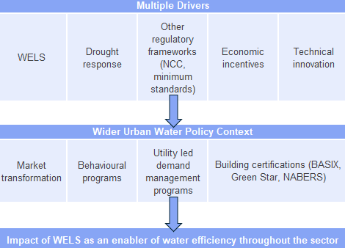
Figure 2 WELS scheme wider urban water policy context
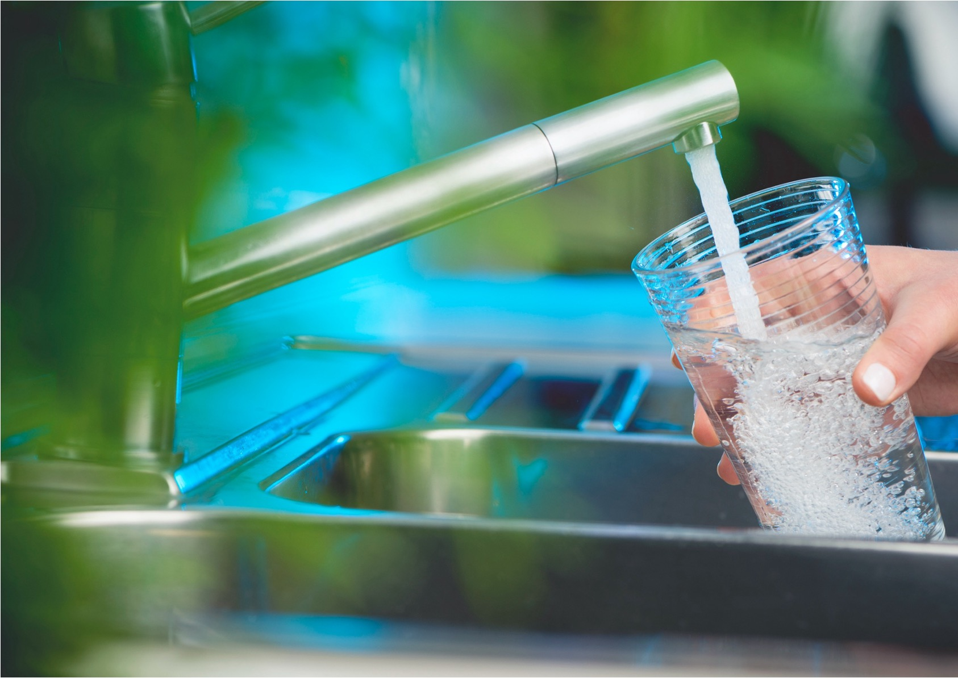


this study seeks to evaluate the WELS scheme as an enabler of water efficiency across Australia
- Approach
The primary goal of this study was to update existing modelling estimates for the environmental and economic benefits delivered by the Australian WELS scheme considering residential and non-residential sector benefits. Expanding on the previous two studies, this evaluation includes WELS rated products across five non-residential subsectors: visitation (e.g., gyms, pools, public toilets), employment and study (e.g. offices, schools, universities/TAFE), accommodation (e.g. hotels, motels) and aged care/hospitals. Only water used in WELS rated fixtures in these subsectors is included. This covers toilets, taps, showers and urinals. Commercial kitchen and laundry equipment such as glasswashers and washing machines are not WELS rated and therefore not covered. Likewise, WELS rated water-using appliances that are principally domestic but used in commercial settings are not included as the split between commercial products and domestic products in these settings is unknown.
Despite some non-residential settings and some uses not being included, the water use covered in the study can be expected to include most consumption in WELS rated products.
This evaluation spans a retrospective period of 20 years since the scheme's initiation (from the start of 2006 to December 2025), and projects future impacts for the next 20 years (to the end of 2045). The analysis is also reported in Financial Years (FY) from FY 2006/07 to FY 2045/46.
Building upon methodologies used in 2015 and 2018, the study incorporates significant shifts in energy policy, utility prices and population dynamics that have occurred since the 2018 evaluation.
The four key tasks for the study are listed below, with the connections between tasks shown in Figure 3:
- WELS database review and analysis: Reviewing and analysing the WELS database, examining product and ratings growth and efficiency trends over time.
- Sales data collection and analysis: Undertaking interviews and surveys with manufacturers, importers, suppliers and retailers to better understand how the efficiency of sold plumbing fittings and appliances has changed in recent years.
- Modelling of consumption and savings:
  - Modelling of water, energy and GHG flows: Modelling residential and non-residential water consumption, energy and GHG savings, updating UTS-ISF end-use and stock models with new data and comparing the ‘with WELS scheme’ scenario against a ‘no-WELS scheme’ scenario.
  - Economic analysis: Quantifying benefits in terms of utility bill savings (water/electricity/gas) and GHG emissions avoided.
  - State comparison: Assessing the scheme’s effectiveness via state-specific analysis and breakdown of impacts, modelling water, energy, GHG and bill savings across all eight Australian states/territories.
- Reporting: Documenting the results of the environmental and economic evaluation, providing a comparison to the previous 2018 study and discussion of the implications
1
WELS database review and analysis
2
Sales data collection and analysis
Manufacturer and supplier interviews/surveys
4

Reporting
Tasks
Outputs
Historical product registrations and trend insights
Comparison of 2018 and 2025 evaluations
Future market efficiency insights
Water/energy/GHG savings
Updated 2025 product star band proportions
Registered star band proportions
Historical and forecasted WELS impacts
Bill savings
3
Modelling of consumption and savings
regional and national
Figure 3 Overall study methodology
The following sections explains some of the key evaluation methodologies at a high level. Appendix C provides further detail on each.
  - Review and analysis of the WELS database
This task reviewed and analysed the WELS database to understand trends in water efficiency of registered products over time. Noting flow controllers were not included in the analysis, the products covered included:
- Appliances: dishwashers and washing machines (including washer-dryers).
- Lavatory equipment: toilets and urinals.
- Plumbing products: taps and showers.
The analysis explored the number of WELS registrations by product type over time, looking at both current composition and historical changes. It also tracked the trend in the water efficiency of registrations by product type, based on given star rating breakdown (at the time of rating). This analysis reveals whether the market has evolved towards more efficient products or not.
  - Sales data collection and analysis
ISF researchers contacted product manufacturers, importers, suppliers and retailers to better understand the water efficiency of sold appliances and plumbing fixtures as well as how this has changed in recent years. A total of 16 organisations agreed to participate, contributing either via online interviews or surveys (dependant on the participant’s preference). Participants were selected based on their experience with sales of WELS rated plumbing fixtures and appliances in the Australian market and perceived contribution to market(s) representation of WELS rated products. Participants included manufacturers, importers, wholesalers/suppliers, retailers and industry groups. The survey/interview questions can be found in Appendix E.
  - Modelling of consumption and (water, energy and GHG) savings
This task involved updating and expanding ISF’s existing end-use and stock-based water forecasting models to estimate water consumption of WELS rated products (see Fane et al. (2024) for existing model description). Savings were calculated by comparing two scenarios: a ‘with WELS’ case reflecting actual plumbing product and appliance uptake under the scheme, and a counterfactual ‘without WELS’ case assuming business-as-usual stock turnover without water efficiency intervention. The analysis spans both retrospective and prospective periods. Historical estimates capture the impact of the WELS scheme taking full effect from July 2006 through to the present, these estimates include the realised water, energy and GHG savings over the two decades until the end of 2025. Forward-looking forecasts extend for a further 20 years, to 2045, providing insights into the expected trajectory of WELS-related savings. Estimates were produced at the state and territory level and then aggregated nationally.
The water consumption estimates take a dual modelling approach that combines a stock model (tracking product types, efficiency and replacement over time) with a behavioural model (calculating water use as: usage behaviour × stock × flow rate).
The stock model simulates how each of the water fixture and appliance cohorts change over time due to changes in standards, consumer preferences and natural product cycles. Series of sales data collected in the past, as well as of 2025, are used to estimate the historical and future stock and sales figures for each product category.
While the primary focus of the above model is residential water consumption, individuals also use water in non-residential settings. Therefore, water savings attributed to the WELS scheme in residential contexts represent only a portion of the total potential savings.
The 2018 evaluation addressed this limitation by extending the model to include water use in employment settings, specifically offices and work sites during daytime hours.
This study further broadens the scope to incorporate additional non-residential environments where water use occurs. These include:
- Visitation settings (e.g., gyms, swimming pools, public toilets),
- Accommodation facilities (e.g., hotels, motels),
- Aged-care facilities,
- Hospitals, and
- Employment and educational institutions (e.g., offices, schools, universities, TAFEs).
These settings were selected based on their relevance to the general population and the availability of reliable data to support water demand modelling. It is acknowledged that these categories do not encompass all non-residential water use. Consequently, the actual water savings attributable to the WELS scheme are likely to exceed those estimated in this analysis.
Water use activities in these settings that fall outside the scope of WELS, such as building cleaning activities or pool filling, are excluded from the analysis. Additionally, while washing machines and dishwashers are covered under WELS, they are not included in the non-residential analysis. This exclusion is due to variability in appliance types used in such settings, where commercial-grade appliances (outside the scope of WELS) may be employed.
  - Economic analysis (of utility bill savings and GHG)
The economic analysis quantified the monetary savings on customers utility bills based on the water and energy savings. Unlike the 2018 study a full cost-benefit analysis (CBA) was not conducted. The analysis quantified dollar savings to customers from utility bills for reduced water, electricity and natural gas usage over time. The monetary value of GHG avoided is also estimated as a whole-of-society benefit, and all benefits are provided at a state-level for each year covered. All monetary values in this study are reported in 2024/25 Australian dollars (AUD) and in real terms, unless stated otherwise. Historical monetary benefits have been converted to real 2024/25 AUD based on historical inflation rates (RBA, 2025).
- Results – WELS Database and Sales Data Analysis
This chapter presents findings from the first two tasks described in Chapter 3, the analysis of the WELS product registration database and self-reported sales data from suppliers and manufacturers gathered through interviews and surveys (supplemented with market representation estimates where appropriate).
The WELS database analysis provided insight into how the water efficiency of registered products has evolved since 2006 based on all product registration. The collected sales data and analysis, in contrast, provided a snapshot of the WELS ratings for products currently being sold, based on responses from a sample of suppliers, manufacturers and retailers in each market segment. Though not all market participants for each product type agreed to participate in the study, those consulted can be considered to adequately reflect the broader market trends for each product. For all product types, participant organisations were assessed as covering most of product market, with market coverage varying between 55% and 85% depending on the product.
For reporting, products have been grouped into three categories: appliances, lavatory equipment and plumbing products (tapware), which allows for comparison across product types and timeframes.
  - All products
Across WELS-registered products, there is a strong and measurable shift toward higher water efficiency products between 2006 and 2025. Categories like taps and dishwashers have seen the most substantial improvements, with high-efficiency models now dominating the market. Washing machines and showers show gradual progress, with older lower-rated washing machine models becoming largely phased out. Toilets demonstrate very little movement in the market, with only a modest improvement, and urinals lag in transitioning to higher ratings. These trends point to the effectiveness of the WELS scheme in transforming product availability and consumer options over time. They also indicate that for some product types (like urinals, toilets and washing machines) there has been little change in the average star rating of registered products in recent years.
    - WELS database results – all products
The growth and fluctuation of active WELS product registrations from 2006 to 2025 is shown in
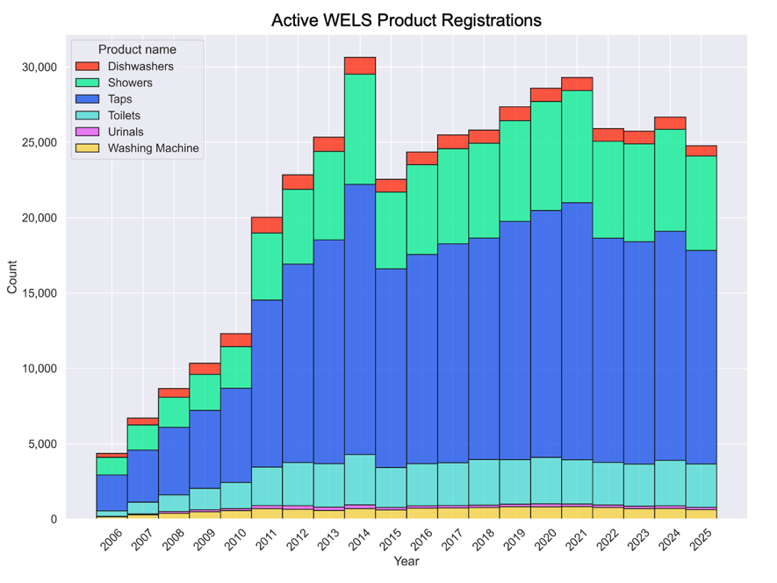
Figure 4. The count in each year refers to active registrations in that year rather than new registrations. The sharp early growth from 2006 to 2014 reflects the scheme’s early expansion and industry uptake, while recent years suggest market maturity and possible saturation in certain product categories.
Active registrations peaked in 2014 after which a new charging structure was introduced, this was followed by a slight decline and stabilisation around 25,000–29,000 products annually by 2017. Plumbing products (taps and showers) consistently represent the largest share of the market, while appliances (dishwashers and washing machines) and lavatory equipment (toilets and urinals) continue to account for a smaller proportion.
Figure 4 Active WELS Product Registrations (All Products)

Figure 5 shows a general upward trend in the average WELS star ratings across most product categories between 2006 and 2025, indicating that more water-efficient products are being registered over time. This is consistent between the average star band ratings of individual products and the proportions of star bands (Figure 6) across all combined products.
Notably, taps and dishwashers show the most consistent and substantial improvement, reaching average ratings near 5 stars. Washing machines and showers also demonstrate noticeable improvements. Toilets show moderate increases, while urinals remain relatively stable, with some fluctuation and no clear improvement in the last decade. The limited change for urinals, may be the result of uptake increasing in ‘waterless’ urinals that are not currently regulated under the WELS scheme (see section 4.3.2 below and Chapter 6 for further discussion).
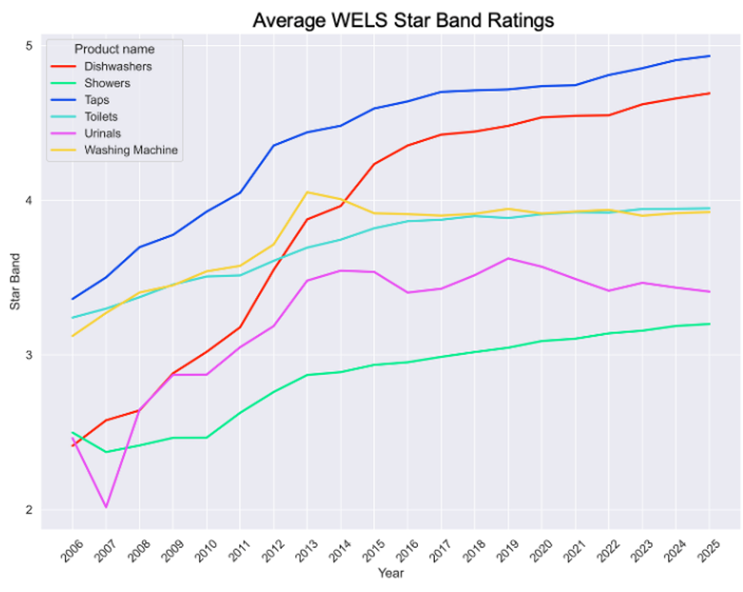
Figure 5 WELS Database Average Star Band Results (All Products)
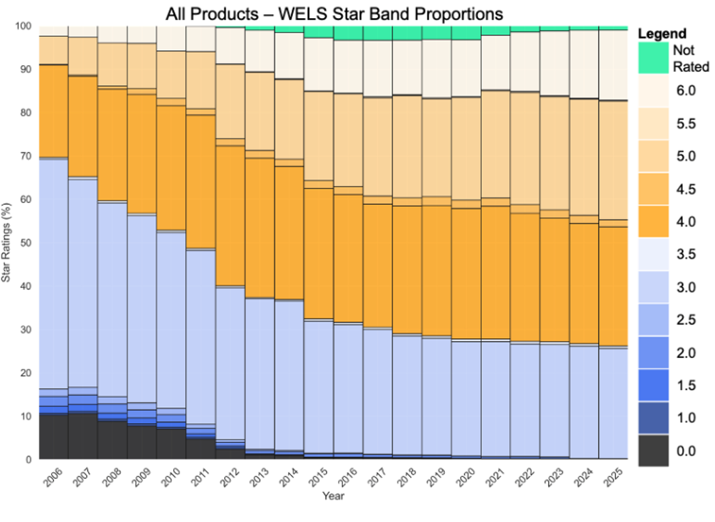
Figure 6 WELS Database Star Proportion Results (All Products)

In general, lower star ratings (0–2.5 stars) have significantly declined, while mid-to-high ratings (3–5.5 stars) have increased. By 2025, nearly all products are rated 3-star or above, reflecting strong market uptake of more water efficient technologies followed by the impact of minimum water efficiency standards introduced under the WELS scheme. The proportion of not-star rated shower products has also decreased suggesting that manufacturers are redesigning showers to meet ‘comfort’ performance requirements, which sets apart 4- and 5-star showers from 3-star showers.
To note: the ‘Not Rated’ category refers to efficient shower products that have either failed or not undergone additional spray force and coverage (‘comfort’) testing to receive an appropriate star-rating.
    - Sales data results – all products
The 2025 sales data collection and analysis, based on interviews and surveys with industry stakeholders, provided high level breakdowns of the proportions of WELS star rated products sold in the Australian market by each organisation, categorised by star rating. The star-ratings proportion results for each product are provided in individual product category sections of this chapter.
Table 1 shows estimated market representation for each product type based on both the participants self-reported market share estimates and then ISF adjusted estimates of market representations. Several organisations appeared to underestimate their market share when self-reporting. This may reflect optimism bias among marketing and sales representatives seeking growth opportunities or could be due to other factors. ISF made adjustments based on market insights reported by other participants, including their understanding of the current market breakdown(s), as well as findings from market assessment reports. These adjustments reflect ISF’s best interpretation, drawing on self-reported data, market documentation and discussions regarding competitors’ market shares.
The overall market representation was higher for lavatory equipment and plumbing products than for appliances. This was due to a gap in the sales data acquisition from two major appliance brands that did not participate. Additional desktop analysis, correlating the WELS data base analysis from the 2018 study with appliance sales data sourced for the 2018 study and then adjusting for the 2025 WELS data base analysis allowed sale estimates to be made for these two major brands. This estimated sales data was then included in the overall analysis for appliance product, proportionally increasing the market representation for appliances.
Sensitivity analysis was conducted to understand how adjusting the market representation and including missing major brands affected the product star proportion results. The overall picture of efficiency proportions was deemed not to have been significantly changed for any product. Uncertainty ranges have been provided for each product in Table 1 below.
Table 1 Sales Data Market Representation Results
Product type | Market representation (proportion of market the results represent) |  |  | Uncertainty on star proportion results
Product type | Self-reported | ISF adjusted | Including missing major brands | Uncertainty on star proportion results
Dishwashers | 50% | 55% | 95% | +/- 9%
Washing Machines | 45% | 55% | 90% | +/- 5%
Toilets | 60% | 75% | - | +/- 1%
Urinals | 50% | 70% | - | +/- 1%
Taps | 80% | 85% | - | +/- 1%
Showers | 80% | 85% | - | +/- 1%
  - Appliances
Appliances show a clear improvement in water efficiency over time, particularly dishwashers. While the 2018 study predicted moderate growth in 5- to 6-star dishwasher models, current sales data shows that these high-efficiency models now dominate, comprising over 80% of sales, 50% of those being 5.5-star and above.
Washing machines have also improved, though less dramatically. Compared to 2018 projections, which expected a shift toward mainly 4.5-star models, current sales show 4-star products are the most common, with 4.5-star units close behind.
    - WELS database results – appliances
From 2006 to 2025, Figure 7 shows a steady shift from lower star-rated dishwashers (0–2.5 stars) to higher efficiency models (3.5–4.5 stars). By 2025, approximately (~) 90% of registered models are 4+ stars (see Figure 7).
For washing machines, the picture is different. There has been consistent availability of 2.5–4 star washing machine models since 2006, with growth in 4.5- and 5-star washing machines through to 2013 and a decline in washing machines with a 2-star rating or less over the same period. The introduction of a minimum 2.5-star rating for washing machines with a capacity less than 5 kg, and a minimum 3-star rating for washing machines with a capacity of 5kg or more is evident from 2013 onward. This removed all washing machines with a 2-star rating or less from the market. From 2013 onward the proportion of washing machines by star rating has stabilised with the dominant registrations being 4-star and 4.5-star (Figure 8).
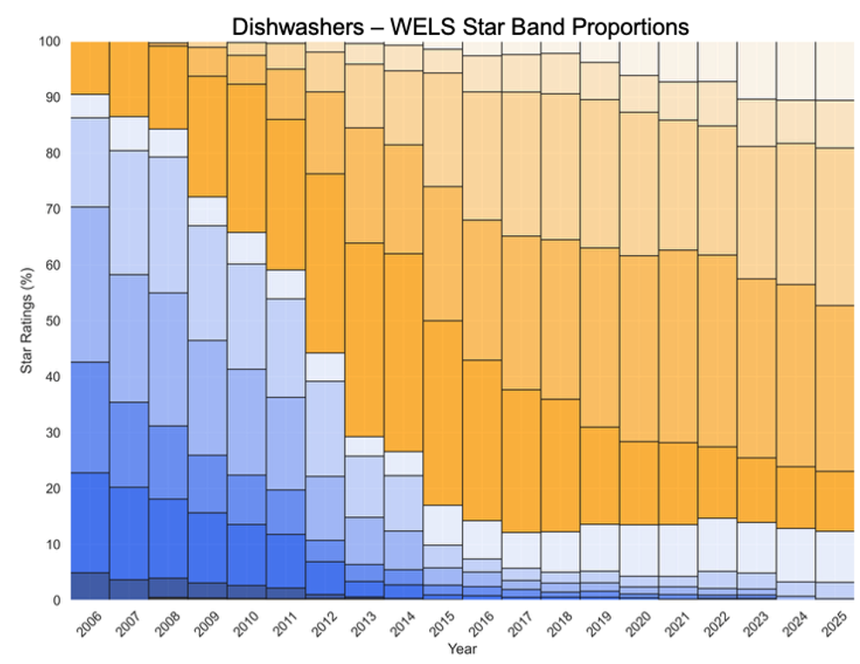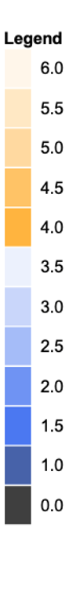
Figure 7 WELS Database Star Proportion Results (Dishwashers)

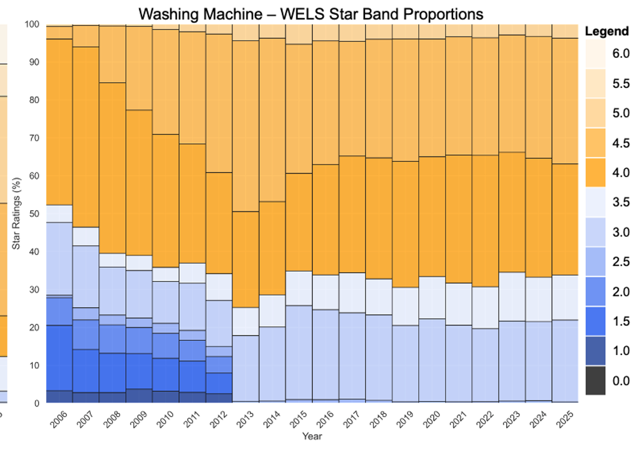
Figure 8 WELS Database Star Proportion Results (Washing Machines)
    - Sales data results – appliances
The 2025 dishwasher sales results show a notable shift toward higher efficiency, with 5- to 6-star models comprising most products sold (see Figure 9, left). Compared to the results from the 2018 study, this is a major improvement in the water efficiency of the stock of dishwasher being installed in Australian homes. It also represents a large shift in the market in only 7 years. Such a market shift was not anticipated in by the 2018 study and 2025 results significantly exceed the predictions made in 2018.

Figure 9 Sales Data Results (Appliances)
In 2025, washing machine sales estimates show a shift towards 5-star appliances but also an increase in the share of 4-star clothes washer models, compared to 2018. Overall, the results show a trend towards more water efficient machines being sold in 2025 than 2018. However, the 2018 study anticipated a greater adoption of 4.5-star and above rated units by 2025 than was found in the current study.
  - Lavatory equipment
Results for lavatory equipment show mixed outcomes. Toilet efficiency remains high but may have slightly declined, with sales of 4-star models dropping from nearly 90% in the 2018 study towards 85% in the current sales estimates, and a small increase in 3-star units (from ~10% to ~15%). Urinals show a more noticeable decline in efficiency in sales: 6-star models fell from ~70% to ~55%, while 3-star models rose to ~40%.
    - WELS database results – lavatory equipment
Toilet products have shown a near-complete market transition to 4-star units from 2006 to 2025 (Figure 10). This shift has been strong and consistent, suggesting effective regulatory or consumer pressure. However, progress has stalled, indicating that renewed efforts may be necessary to drive further improvements in efficiency. Urinal star band proportions have remained varied over time, with no dominant trend toward higher star ratings (Figure 11). A persistent decline in low-efficiency (0–2 stars) suggests slower adoption of efficient models and the introduction of the minimum water efficiency.
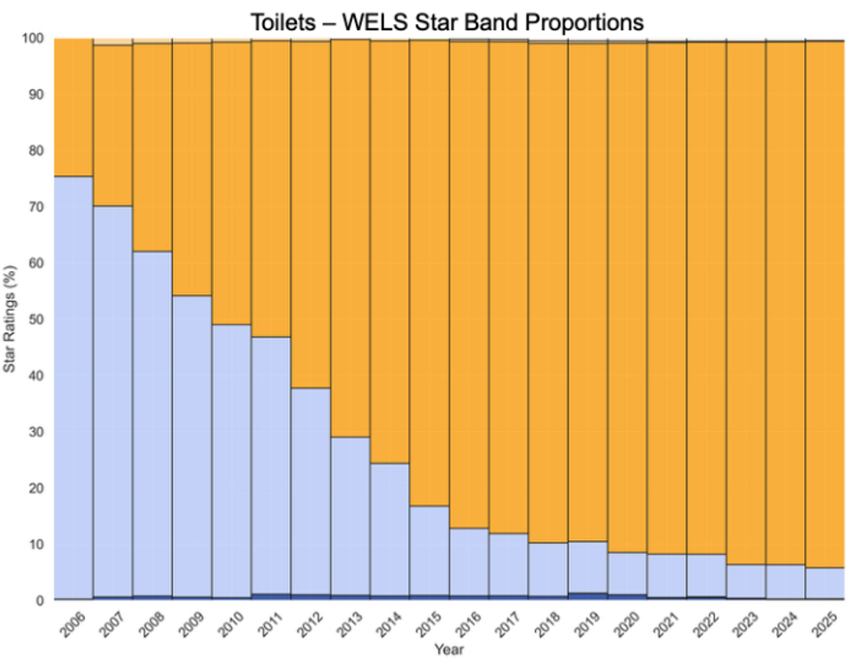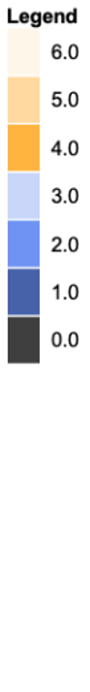
Figure 10 WELS Database Star Proportion Results (Toilets)

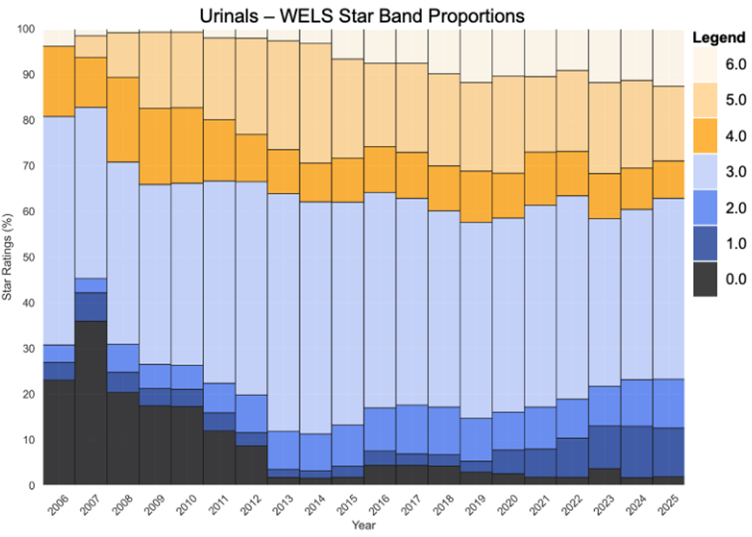
Figure 11 WELS Database Star Proportion Results (Urinals)

    - Sales data results – lavatory equipment
The 2025 sales results in Figure 12 (left) show the dominance of 4-star toilets sold. This is like the results observed in the 2018 study, where 4-star toilets also dominated sales. However, there has been a slight increase in the proportion of 3-star toilets sold in 2025 in comparison to 2018. This indicates that there is no longer a trend towards more efficient toilets being sold.
For urinals, the sales data shows that, contrary to the 2018 prediction a rise in 6-star models by 2025, the actual results a broader spread across 1-6 stars (Figure 12, right). This suggests a slower-than-expected shift toward high-efficiency urinals but may also be due to an increase in the sales proportion of waterless urinals. These are not currently classed as water using equipment and therefore not registered or rated under the WELS scheme.

Figure 12 Sales Data Results (Lavatory Equipment)
  - Plumbing products
Plumbing products demonstrate clear improvements in water efficiency, particularly tap fixtures. Since 2018, there has been a major market shift, with the proportion of 5- and 6-star taps sold increasing significantly. These high efficiency products now contribute to over 60% of sales, far exceeding the predictions made in the 2018 study. The average star rating of showers has also increased as sales of 3-star models declined from ~95% to 75%, the remaining taken up by 4- and 5-star options. Although improvements in the water efficiency of showers were anticipated, the progress has been stronger than predicted.
    - WELS database results – plumbing products
Figure 13 shows a steady shift in the taps available on the market from a dominance of 0- to 3-star products in 2006 to a market largely composed of 4-, 5- and 6-star models by 2025.
Figure 14 shows that since 2006, 3-star shower models have consistently dominated the market. In 2013 performance requirements for spray force and coverage were included in the shower standard for demonstrating the effective performance of highly efficient showers. This supported the introduction of a 4-star rating for showers in 2016, and 5-star rating introduced in 2024 and was retrospectively applied to showers meeting this rating. The share of 4-star and 5-star showers has grown since the introduction of these new star bands. Previously, some highly efficient shower products would have been classed as ‘not star rated’. With the development of spray force and coverage tests, the ‘not star rated’ class has reduced suggesting some conversions to 4- and 5-star ratings.

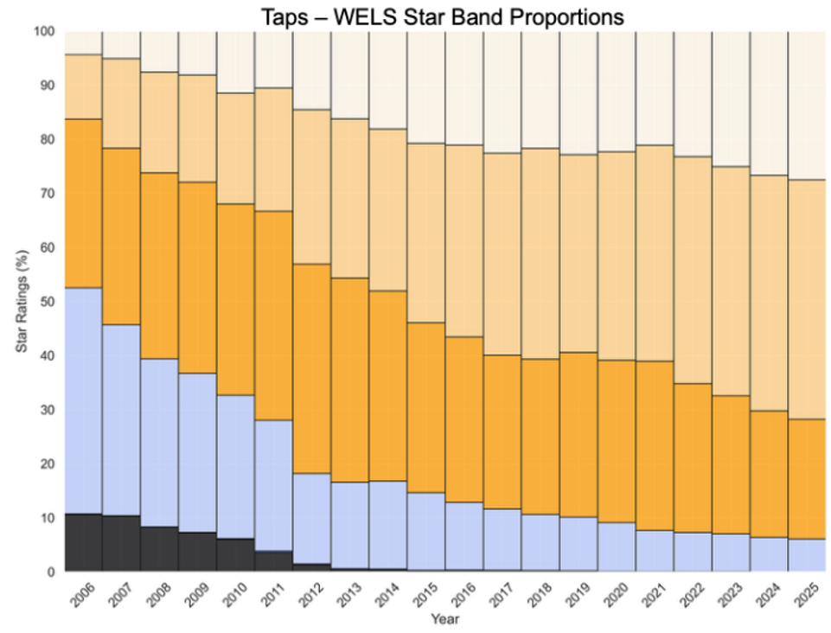
Figure 13 WELS Database Star Proportion Results (Taps)

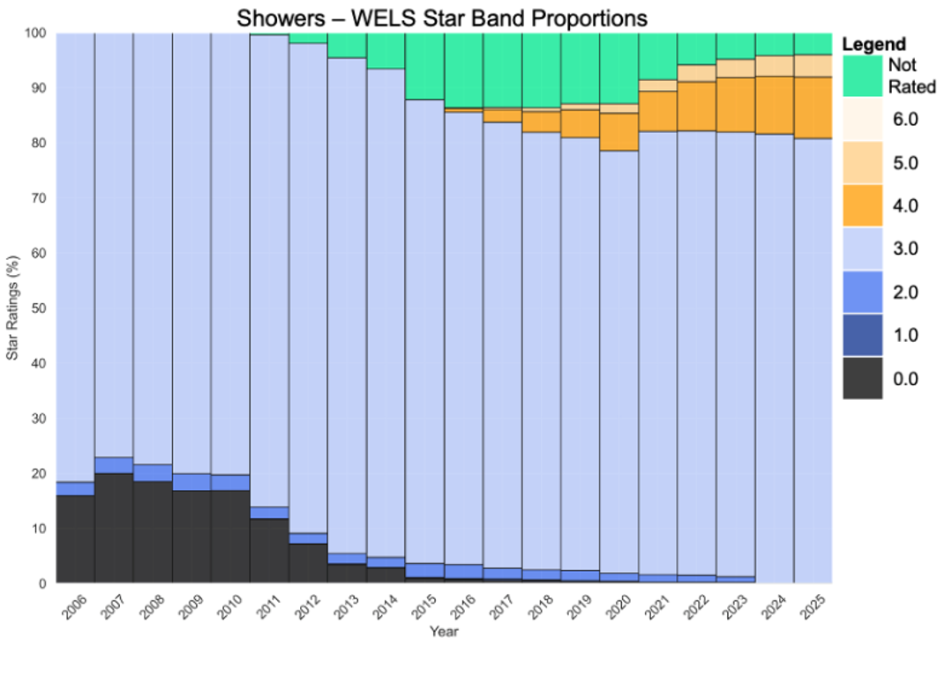
Figure 14 WELS Database Star Proportion Results (Showers)

    - Sales data results – plumbing products
Figure 15 shows that in the seven years since the 2018 study, the overall water efficiency of the taps sold has been transformed by a major increase in sales of 5-and 6-star models. This significant shift in the sales data contrast with the steady change over time that was evident in market availability in Figure 13.

Figure 15 Sales Data Results (Plumbing Products)

Sales data for showers (Figure 15) shows an increase in the proportion of 4- and 5-star products sold compared to 2018. This increase surpasses the expectations of the 2018 study. Despite this, 3-star showers continue to account for most sales.
    - Further results – plumbing products (low water pressure only)
Analysis was undertaken on plumbing products that fall into the ‘low pressure’ category. These products are designed for circumstances where the water supply pressure to a residence is 120 kPa (or 150kPa) or less. All other products are tested for high water pressure of over 150 kPa.
The tapware and shower standards requirements for low water pressure only came into effect from 2009, and therefore early registrations did not differentiate between high- and low-pressure use. Prior to 2009, the products testing requirements were consistent for high pressure installation and any taps and showers that were registered prior to 2009 have been assumed to be suitable for high water pressure installation. Consideration was given to low-pressure fittings that were registered in 2011.
Low-pressure taps and showers are only a very small proportion of total sales and so the analysis of low-pressure plumbing products was conducted using the WELS database only.
Across 2011 to 2023, the number of active model registrations for low pressure fittings (taps and showers) peaked in 2016 at ~150 models (see Figure 16). Across all years, there were more low-pressure taps than showers.
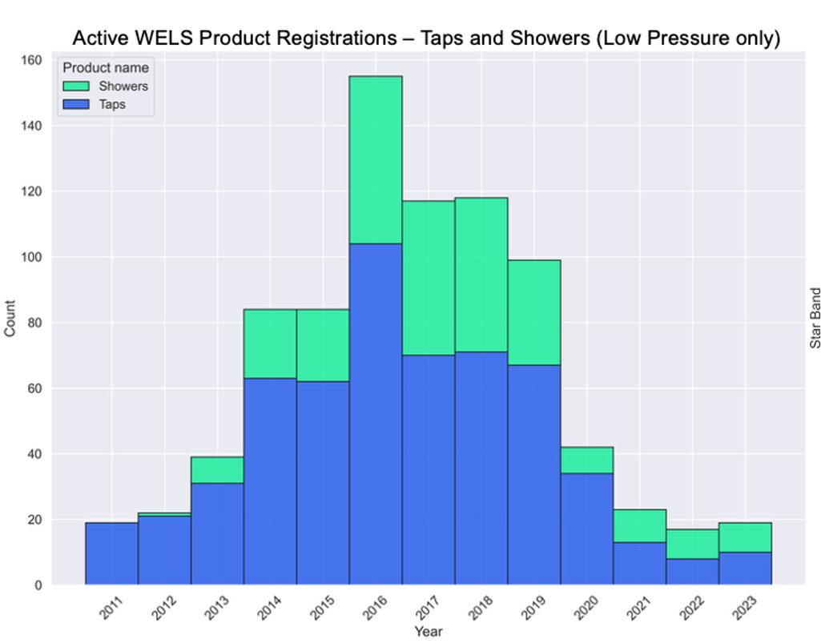
Figure 16 WELS Active Product Registrations (Plumbing Products – Low Pressure only)

Over time, the increase in product efficiency is seen to a greater extent for low pressure taps in comparison to low pressure showers (Figures 17 and 18). This is because since the introduction of minimum water efficiencies for all showers of 3+ stars, and the absence of performance standards for low-pressure showers to enable 4-, 5- or 6-star ratings, all low-pressure showers must be 3-star rated, as reflected in Figure 18. This category has reached its maximum efficiency as is appropriate to low water pressure circumstances.
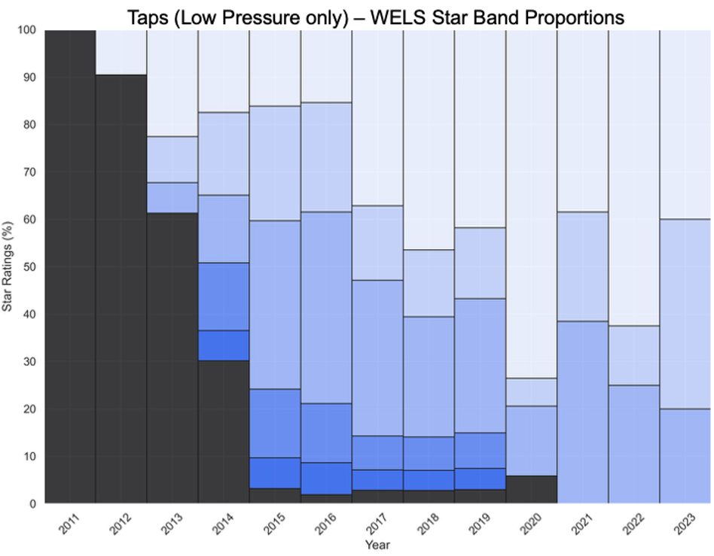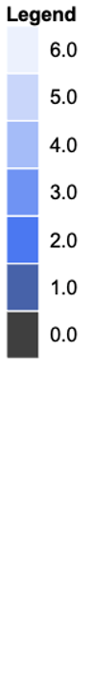
Figure 17 WELS Database Star Proportion Results (Taps - Low Pressure only)

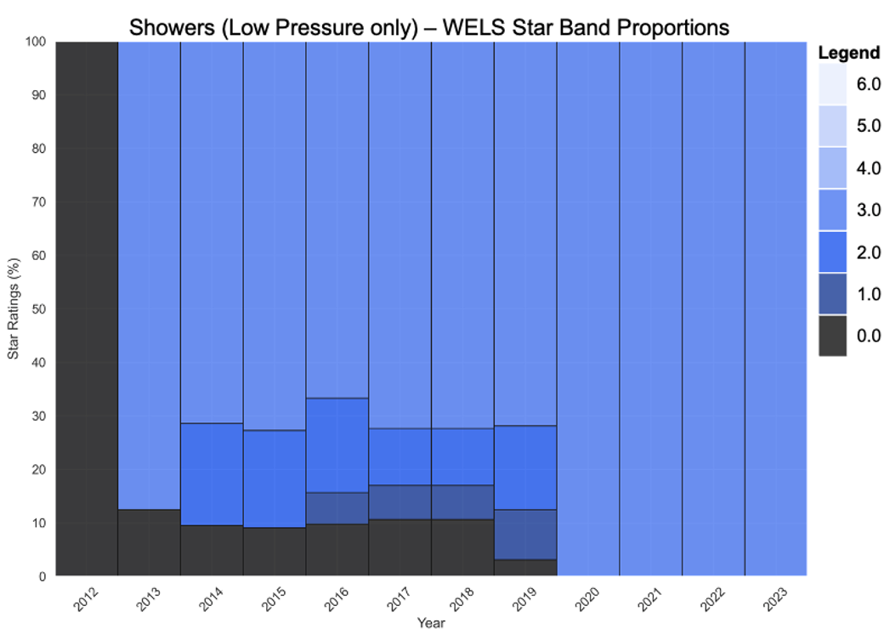
Figure 18 WELS Database Star Proportion Results (Showers – Low Pressure only)
  - Projections of future water efficiency - basis for assumptions
In projecting the future impact of the WELS scheme, the modelling assumes a flattening of water efficiency trends over time for all product types and reflects the observed trends in product registrations for washing machines, showers and lavatory goods. Only the registrations of dishwashers and taps show a continuing trend towards a higher average level of efficiency (in Figure 5). This likely also reflects the current market demand for high efficiency models of these products (see Figures 9 and 15). However, given the gains already made in water efficiency for these products and without strong evidence of to justify further increases in product efficiencies, a plateau in water efficiency improvements for new products sold and installed was applied in the modelling.
These assumptions of a flattening trend in product water efficiencies for all sales into the future means the ‘With WELS’ scenario has a conservative trajectory. Further, due to the nature of the modelling, with the sales each year feeding into the existing stock of water using products in the community, and some old stock being removed, the average water efficiency of the remaining stock will continue to increase for some decades. These results of the analysis are detailed in Chapter 5.
This conservative approach assumes both that there is no further innovation of the existing plumbing and appliance products that are regulated or that additional products – such as commercial water-using products or waterless products - have been added to the scheme. If either of these were to occur, more water, energy and costs would be saved than projected.
Note: Waterless urinals are planned to be included in the scheme as a minimum, through changes to the WELS Standard. Further information about the WELS scheme Product Expansion Program is available on the www.waterrating.gov.au website. Several commercial products are also being considered.
- Results – Modelled Water, Energy, GHG and Bill Savings
The sales data analysis informed the water modelling by embedding the proportions of WELS star-rated products projected to be in the market in 2025. Historical sales data from 2006 to 2017 were retained from the previous 2018 evaluation to allow for direct comparison. For the period between 2018 and 2025, a linear trend was assumed between the 2017 and 2025 sales data points. Beyond 2025, forecasts to 2046 assumed no further policy changes, with product sales trends flattening and stabilising to the nearest 5% or 10% mark.
The model compared two scenarios to estimate the impact of the WELS scheme (and associated measures). The “With WELS” scenario reflects actual consumption trends, informed by product sales, updated water use behaviour, and demographic growth projections. As previously explained in section 3.3, the model broadens the scope to incorporate additional non-residential environments where water use occurs, including visitation, accommodation, aged-care facilities, hospitals, workplace and education institutions.
The “Without WELS” counterfactual assumes water use would have continued along pre-2006 patterns without the scheme or any water utility or State Government water conservation programs/regulations that utilise the nomenclature of the WELS scheme. The difference in water use between these two scenarios quantifies the water savings attributable to the WELS scheme and associated measures, calculated first at the state level and then aggregated nationally.
This chapter discusses the national results across water, energy GHG emission and bill savings, and shows a comparison of state results for each category. Individual state result short reports have been provided in Appendix F. All results are combined (non-residential and residential) unless otherwise specified.
  - National Results Summary
The high level national and state results for 2025 and 2045 calendar years are presented in Table 2, while more detailed results tables (including both calendar and financial year savings) are presented in Appendix H. Results by savings categories (water, energy, GHG and bill) are discussed individually in more detail in section 5.2 onwards.
Table 2 High level 2025 WELS Savings results (calendar year)
Savings | Water  (GL/yr) |  | Electricity  (TJ/yr) |  | Gas  (TJ/yr) |  | GHG  (Mt CO2-e/yr) |  | Bill Savings* ($M/yr)
 | 2025 | 2045 | 2025 | 2045 | 2025 | 2045 | 2025 | 2045 | 2025 | 2045
Australia | 209  (13%) | 320  (16%) | 6,827  (14%) | 11,829  (17%) | 6,804  (14%) | 6,090  (16%) | 1.61  (13%) | 0.58  (16%) | 1,630  (13%) | 2,134  (16%)
NSW | 62 | 93 | 1,619 | 1,846 | 1,888 | 3,258 | 0.37 | 0.23 | 438 | 559
Victoria | 54 | 85 | 1,124 | 4,168 | 2,829 | 57 | 0.42 | 0.01 | 388 | 569
Queensland | 40 | 59 | 2,621 | 3,842 | 332 | 104 | 0.56 | 0.12 | 433 | 516
SA | 16 | 23 | 419 | 495 | 573 | 844 | 0.06 | 0.06 | 139 | 169
WA | 23 | 34 | 414 | 625 | 885 | 1,277 | 0.11 | 0.10 | 138 | 187
Tasmania | 6 | 9 | 384 | 511 | 15 | 28 | 0.02 | 0.00 | 35 | 48
NT | 4 | 6 | 140 | 231 | 1 | 1 | 0.02 | 0.02 | 20 | 29
ACT | 5 | 9 | 104 | 112 | 281 | 520 | 0.03 | 0.03 | 39 | 58
* Bill savings display only water and energy bill saving contributions. GHG bill savings are not included in these high-level results as they represent broader environmental and economic benefits rather than direct savings to households or businesses.
* Percentage savings (of total baseline demand in NO WELS scenario) are shown in brackets for each state.
Results show that to date, the WELS scheme and associated measures have generated significant water, energy and GHG savings, as well as bill savings for customers. By 2045, annual water savings in the “With WELS” scenario are projected to exceed 300,000 ML/year for Australia, with savings from the residential sector accounting for the majority (75%). Residential water savings experienced steady growth between 2005 and 2030, with growth rates slowing from 2030 onwards. Non-residential water savings has experienced faster growth and is also expected to slow down from 2030 onwards (see Figure 19). COVID 19 marked a significant decline in savings in the non-residential sector during the period encompassing 2020 to 2022, namely due to the significantly reduced demand in the accommodation sector that relies on domestic and international tourism.
Energy savings (Figure 20) are expected to reach just under 18,000 TJ/year for Australia by 2045, growing from the 13,600 TJ/year in 2025. Energy savings arise from the savings in hot water use from taps, showers, washing machines and dishwashers. Following the nationwide shift from gas to electric hot water systems over the scope of the study, energy savings correspondingly shift from gas to electricity over time.

Figure 19 National Water Savings for the Residential and Non-Residential Sectors

Figure 20 National Energy Savings (Gas and Electricity)

Annual GHG emission savings (Figure 21) reached approximately 1.6 Mt CO2-e in 2025. Analysis shows that annual GHG emission savings have peaked in 2024, and will continue to decline until 2035, where savings will fall to 2011 levels. This however is not due to reduction in effectiveness of WELS, but rather due to the improvements in the GHG emission intensity of Australian electricity networks over time. Residential demand involves more hot water than non-residential demand, and the relative scale of GHG emission savings is reflected as such.
The increased water efficiency of WELS rated products have also resulted in annual bill savings of approximately $1.6B in 2025, which is expected to continue growing to $2.1B per year in 2045 (Figure 22). It should be noted that these values are in 2024/25 AUD$ real terms, meaning that nominal savings (actual utility bill savings experienced at the time) in 2045 will be much higher due to inflation.

Figure 21 National Greenhouse Gas Savings

Figure 22 National Bill Savings (AUD$ 24/25)
  - Water Savings
For water across residential and non-residential sectors, annual savings in 2025 range between 3.6 GL (NT) and 62.3 GL (NSW) per state. NSW and Victoria account for over half of total water savings consistently across 2006 to 2045 (Figure 23). Proportional savings across the states range between 12% (SA and Victoria) to 14% (NT) of each state’s base demand as calculated in the ‘No WELS’ scenario. The NT has the smallest absolute water savings but highest proportionally (3.6 GL or 14% savings), the trend for which continues to 2045 (6.4 GL or 17% savings by 2045).
Overall, water savings across all states increase both in absolute numbers as well as in proportion to total water use by 2045. This reflects the continued and lasting effect of WELS on reducing end-use water demand in both residential and non-residential sectors.

Figure 23 National Water Savings by State/Territory

From a product or end-use perspective, basins (39%), showers (23%) and washing machines (15%) constitute the biggest proportion of water savings in 2025, a trend that remains relatively consistent out to 2045 (Figure 24). Savings from toilets are expected to remain steady despite the increase in demand, due to the installed toilet fixture stock stabilising in line with its current proportion of 4-star sales.

Figure 24 National Water Savings by Fixture

In the residential setting, WELS is projected to deliver per-capita savings of around 14 litres per person per day (L/c/d) by 2025, reducing average use from 116 to 102 L/c/d (see Figure 25). By 2045, savings increase to 17 L/c/d, with average use falling from 114 to 97 L/c/d. Most of these savings are attributed to showers (29%), basins (23%) and washing machines (22%). It should be noted that the actual household per-capita demand would be higher (for both WELS and NO-WELS scenarios), which would include outdoor water use and baths.

Figure 25 Water Savings Per Capita (Residential)

In non-residential settings modelled, WELS rated products delivered an estimated per-capita savings of around 6.8 L/c/d by 2025, reducing average use from 38.4 to 31.6 L/c/d (see Figure 26). By 2045, savings increase to 8.8 L/c/d, with average use falling from 41.0 to 32.2 L/c/d. Most of these savings are attributed to basins (71%). The overall downward spike during 2021 is due to reduced demand in accommodation settings, particularly hotels, during COVID. The savings are also conservative given the limitations of the available data.

Figure 26 Water Savings Per Capita (Non-residential) for subsectors and products modelled

  - Energy Savings
Annual electricity savings in 2025 across residential and non-residential sectors range between 104 TJ (ACT) and 2,621 TJ (Queensland) per state, totalling to 6,827 TJ nationally, an average 14% in savings on electricity used for water heating (see Figure 27). Of note is the disproportionally large electricity savings from Queensland, which accounts only for 19% of national water savings but is responsible for largest proportion of national electricity savings at 38%. This discrepancy is due to a combination of factors, including Queensland having the coldest average water network at 15.1 degrees Celsius (°C), and requiring overall more energy to heat water to desired levels, and a significantly higher stock proportion being electric hot water systems (HWS) (92% of stock) compared to other large states (NSW 55%, Victoria 36%) by 2025.

Figure 27 National Electricity Savings by State/Territory

Annual gas savings in 2025 range between 1 TJ (NT) and 2,829 TJ (Victoria) per state, totalling to 6,084 TJ nationally (see Figure 28). As the state with highest proportion of gas HWS (64% of stock), Victoria generated nearly 42% of national gas savings in 2025. This trend takes a significant downward trend by 2045, where only 57 TJ (<1% of total savings) of gas savings are expected to come from Victoria. This reflects a shift in hot water energy sources driven by the Victoria gas substitution roadmap whereby gas hot water systems are being phased out of new and existing dwellings (DEECA, 2025; Department of Transport and Planning, 2025). NT and Tasmania experience minimal gas savings due to lack of reticulated natural gas networks.

Figure 28 National Gas Savings by State/Territory
  - GHG Savings
As shown in Figure 29, to date, the WELS scheme and associated measures have delivered substantial GHG emissions savings for Australia, with annual savings rising sharply to a peak of more than 1.6 Mt CO2-e in 2024. While gas and electricity savings are projected to continue increasing (as outlined in the previous section), overall annual GHG savings are expected to decline rapidly to around 0.6 Mt CO2-e by 2035. This reduction reflects the anticipated stabilisation of electricity emission intensities at minimal levels across most states. In contrast, GHG savings in the NT are expected to continue increasing, due to the NT’s electricity emission intensity that is projected to remain at elevated levels compared with other jurisdictions by 2045.

Figure 29 National GHG savings for Australia and by State/Territory
  - Bill savings
Figures 30 and 31 demonstrate that the WELS scheme, along with associated measures relying on the scheme, have delivered substantial financial benefit to Australian households and the non-residential sectors analysed across all states through reduced water, electricity and gas bills. In 2025, total customer bill savings were estimated at $1.6 billion, with projections indicating growth to approximately $2.3 billion per year by 2045 (in AUD$ 24/25).
Notably, around half of these savings are attributable to reductions in residential water and electricity bills alone.
In addition, a monetised value of GHG emission savings is presented in Figure 30 as hashed areas, highlighting their relative scale compared with conventional bill savings. While these do not accrue directly to households or businesses, they represent broader environmental and economic benefits to society as a whole.

Figure 30 National Bill Savings and GHG Emission Saving by Sector (AUD$ 24/25)

Figure 31 National Bill Savings by State (AUD$ 24/25)

- Discussion and Conclusions
The WELS scheme has made a significant contribution to national water savings as well as energy, GHG and utility bill costs for householders and commercial businesses in the sectors modelled.
  - Insights from the 2025 study
Insights from the 2025 evaluation of the environmental and economic benefits of the WELS scheme are drawn from both the analysis of the WELS database and the collection of current sales data, as well as the results of modelling water and energy consumption, GHG emissions and utility bill impacts. The WELS database and collected sales data analysis revealed changes in the proportions of appliances, lavatory equipment and plumbing products by star rating. This analysis included both what products are available in the market and what is currently being sold. The modelling results highlight the historic and projected water, energy and bill savings resulting from WELS rated products. These results are considered at both national and state levels.
    - WELS database and sales data analysis
Both the analysis of the WELS database and 2025 sales data indicate that registered and available products have increased in water efficiency ratings from 2006 to 2025.

Appliances
Dishwashers have demonstrated the most significant and consistent gains in water efficiency, with high-efficiency models now dominating the market. Current sales data for 2025 indicate that 5- to 6-star models comprise over 80% of sales, with 50% of these being 5.5-star or above. The present level of water efficiency significantly exceeds the predictions made in the previous study of 2018.
Washing machines have also become more efficient overall, although progress has been less dramatic compared to dishwashers. Current sales data indicate that 4-star products are the most common, closely followed by 4.5-star units. The 2018 predictions anticipated a somewhat greater adoption of 4.5- and 5-star models, as well as more models below 4-star being sold. The trends show that overall efficiency has improved; however, there are signs that progress may be flattening, and the market does not appear to be moving decisively toward the highest star-rated models in the same way as has occurred for dishwashers.

Lavatory Equipment
Since the 2018 study, sales of 4-star toilets appear to have decreased slightly, from 90% in the 2018 study to about 85% in the most recent sales data. This decrease aligns with a modest rise in the sales of 3-star units. Analysis of the database reveals that the market has almost entirely transitioned to offering 4-star models, with very limited movement toward making higher-efficiency toilets more widely available.
Sales of 6-star urinal models fell from approximately 70% in 2018 to about 55% in 2025, while the proportion of 3-star models increased to around 40%. The database results indicate no clear trend toward higher star ratings for urinals. An important point of discussion is that waterless urinals are currently not included in the WELS scheme. This omission may help explain the observed decline in efficiency among WELS rated urinal products.
Proposals to include waterless urinals in the WELS scheme are now under consideration. Such a policy change could encourage greater adoption of waterless urinals and provide a more comprehensive understanding of the urinal market in future studies.

Plumbing Products
Sales data collected for taps in Australia shows a significant transformation in the market in recent years. There has been major growth in the sales of 5- and 6-star models, which now account for over 60% of products sold. This shift far exceeds the predictions made in the 2018 study. Analysis of the WELS database confirms a clear trend from 0 -to 3-star products in 2006 to 4- to-6-star models by 2025. Some stakeholders have highlighted that a 4-star rating is the maximum efficiency required for certain end uses (such as kitchen sinks) and in specific environments (such as hospitals), which is expected to impact any further movement toward even higher levels of tap water efficiency in the future.
High efficiency shower models continue to gain market share. Sales of 3-star models have declined somewhat (from approximately 95% to 75%), while 4- and 5-star models have significantly increased their share (from around 5% to 20%). Analysis of the WELS database shows a continued dominance of 3-star models, but there has been a growing availability of 4-star and above models since 2016. This shift is likely to have been aided by the introduction of the 5-star band, which now includes some models that were previously highly efficient but not star-rated.

Summary of insights
The study has revealed several significant shifts in the market for WELS rated products over the past seven years. Dishwashers and taps stand out for the major changes observed in the star ratings of products being sold. There is a greater availability of showers rated above 3 stars, and one fifth of sales now consisting of 4- and 5-star models. Washing machines sales are also trending towards much fewer inefficient models, below 4-star, being sold.
Despite these positive trends, a future plateau in increasing efficiencies is projected in the modelling of product sales meaning that savings estimates are conservative.
    - Water, energy and dollar savings

Water Savings
In 2025, the WELS scheme and associated measures is estimated to deliver water savings of about 210 GL/year. Although the rate of growth in both residential and non-residential savings is expected to slow beyond 2030, total savings are still projected to reach 320 GL/year by 2045. Residential savings represent the dominant share, accounting for approximately two thirds of the total savings.
Basins constitute the biggest proportion of water savings (39%) in 2025, followed by showers (23%) and washing machines (15%). This is a trend that remains relatively consistent out to 2045. Basins account for over 70% of savings for the non-residential sector.

Energy Savings
Electricity savings are projected to grow continually out to 2045 reaching an estimated 11,800 TJ/year in 2045 from 6,800 TJ/year in 2025. The push for electrification, including state-level policies such as the Victorian gas substitution roadmap, translates to more electric hot water systems over gas systems overtime. While the two energy sources are fundamentally different in nature, in energy terms (TJ), electricity savings overtook gas saving in 2022.
Natural gas savings are projected to peak around 7100 TJ/year in 2028 and are then currently projected to slowly decline to around 6000TJ/year in 2045. Future policy announcements about gas substitution by state governments may well see a faster growth in electricity savings and a resultant faster decline in natural gas savings than projected. This would be driven by a goal of decarbonising the economy more quickly away from GHG emitting hot water heating systems

GHG Savings
GHG emissions savings are projected to decrease 64% on an annual basis from 2025 to 2045. Emission savings peaked in 2024 at 1.7 Mt CO₂-e/year and can be expected to drop significantly to just under 0.6 Mt CO₂-e/year by 2045. Residential GHG emissions savings contribute significantly more than that of non-residential sector. NSW, Victoria and Queensland constitute most of GHG savings in 2025, with WA replacing Victoria by 2045. The patten of GHG emission savings is driven by a policy drive to move away from natural gas hot water heaters in some jurisdictions and the projected rapid increase in the proportion of renewable energy within Australia’s electricity networks over this period.

Bill Savings
Nationally, annual water and energy utility bill savings remain strong and will continue to increase. Bill savings are projected to increase 31% from 2025 to 2045 in real terms, totalling 2.13B AUD$/year by 2045 (in current dollar terms) or 2.25B AUD$/year with GHG accounted for. This increase does not account for inflation, which will increase the dollar amount of future bill savings to customers (if not its value). Residential bill savings contribute to over half of total bill savings, with growth in both sectors (residential and non-residential) slowing after 2035. NSW, Victoria and Queensland dominate bill savings, which total a projected 1.75B AUD$/year in savings in these states by 2045.

Summary of state-level insights
By 2045, NSW and Victoria are projected to deliver the largest water savings, at nearly 95,000 ML/year and 85,000 ML/year respectively, however the highest growth in both states is expected to occur before 2030. The key drivers of water savings in nearly all states are residential dwellings and high-use products such as showers, basins and washing machines, though non-residential visitation and accommodation facilities are significant contributors in tourism-oriented states and territories. Queensland is projected to save nearly 60,000 ML/year by 2045, again led by residential homes, while WA (34,000 ML/year) and SA (23,000 ML/year) are projected to save significant volumes. Tasmania, the ACT and the NT are projected to save between 6,000 to 9,500 ML/year by 2045, with the non-residential sector (particularly accommodation) leading water savings in the NT.
Energy savings differ by state depending on the fuel mix of natural gas versus electricity used for water heating. NSW, SA, WA and ACT are all currently gas-led, while Queensland, Tasmania, and the NT are dominated by electric hot water heaters. This reflects local infrastructure, historic pricing and patterns of energy substitution patterns such as use of solar water heaters and policies for stopping natural gas connections to new residential estates. Victoria shows a transition, with both gas and electricity savings significant but shifting almost completely toward electricity as the gas substitution roadmap phases out gas hot water systems from 2027. GHG outcomes are dominated by the residential sector in all states apart from the NT, which has more of an even split.
Bill savings consistently reach their highest values in larger states, led by NSW at about $438M AUD$/year in 2025, followed by Queensland at 434M AUD$/year and Victoria at 388M AUD$/year. This is driven primarily by their larger population, combined with higher water prices compared to other states. WA and SA bill savings are currently estimated at 138M and 139M AUD$/year, respectively. Tasmania (35M AUD$/year), the ACT (39M AUD$/year) and the NT (20M AUD$/year) in 2025 still realise substantial benefits relative to population. By 2045 the largest bill savings are found for Victoria, then NSW, Queensland, WA and SA. The change in ranking reflecting differences between states in terms of population growth, water prices and fuel mix for hot water.
Residential households capture most of the bill savings across jurisdictions, with water consistently providing the largest direct financial gain, and electricity savings particularly prominent in Queensland and Tasmania. In all cases, GHG-related savings represent avoided societal costs rather than direct household returns, underscoring the broader policy significance of the WELS scheme. A more detailed breakdown of insights at the state level for water, energy, GHG and bill savings can be found in Appendix G.
  - Comparison to the 2018 WELS evaluation
The results of the current study are compared with the results from previous WELS scheme evaluation (ISF, 2018) in Table 3 below. The differences for each savings category result from a combination of factors including improved modelling, updating the data used, changes in demographic and energy related forecasts, and the impact of COVID during 2020 to 2022.

Table 3 Comparing results of this study with the previous 2018 evaluation
 | Study | 2016 | 2026 | 2036
Annual water saving  (GL/year) | 2018 | 101 | 185 | 231
Annual water saving  (GL/year) | 2025 | 104 | 219 | 289
Cumulative GHG saved  (Mt CO2 –e / year) | 2018 | 9.1 | 31.5 | 55.9
Cumulative GHG saved  (Mt CO2 –e / year) | 2025 | 6.4 | 21.7 | 31.3
Annual residential bill savings  ($M/ year) | 2018 | 1,160 | 1,879 | 2,281
Annual residential bill savings  ($M/ year) | 2025 | 885 | 1,625 | 2,008
    - Changes in water savings
There is only a minor difference in historical (2006-2024) water savings between the 2018 and current studies (Figure 32). However, the two evaluations diverge in forecasted water savings from about 2022, where the projected water savings in 2036 is 25% greater in the current 2025 study than the prior evaluation, as shown in Figure 32.

Figure 32 Annual water savings, 2018 and current evaluations

The difference in projected water savings arise primarily from the expanded scope of non-residential modelling for the current study. In the 2018 study model, non-residential usage scope was limited to workplace demand. The new model has been expanded to cover demands in:
- Hospital and aged care,
- accommodation (hotel),
- work and study (office buildings and schools), and
- visitation (Pool/gym and public bathroom).
In addition to population growth, each of these non-residential sectors are driven by projected changes in factors such as elderly (65+) population, international/domestic tourism and working/studying population, each with growth rates different (mostly higher) to that of the general population. These differences lead to increasing growth in projected non-residential water consumption, and thus, larger savings compared to the 2018 study.
Furthermore, improvements in the 2025 modelling for dishwashers resulted in lower (but more accurate) savings compared with the 2018 modelling results. In addition, the use of more accurate population data (ABS table 3101) has also resulted in slight reduction in overall residential demand compared to the previous study.
The divergence in forecasts would likely have occurred earlier, from 2016, except for the impact of COVID-19 pandemic. The current study also captures the impact of COVID, where the sudden drop in international visits (Figure 33) directly corresponds to reduced demand for the accommodation sector.

Figure 33 Number of international visitor nights by state (Source: www.tra.gov.au)
    - Changes in GHG savings
The current study projects significantly lower GHG savings over time compared to the previous study (Figure 34). The figure showing cumulative GHG emission savings rather than annual savings emphasises the difference. This change has been driven mainly by updates to the projected emission intensity of electricity networks nation-wide (Figure 35), as well as improved data on hot water systems in stock and projected sales (Roche et al., 2023) and polices initiatives such as the Victorian gas substitution roadmap.

Figure 34 Cumulative Greenhouse Gas Savings (National), 2018 and Annual

Figure 35 Emission Intensity of Electricity (National), 2018 and Annual

    - Changes in bill savings
As shown in Figure 36, the current study projects a marginally lower utility bill savings over time compared to the previous study. This outcome is due to a combination of factors, including an updated electricity price projection (AEMC, 2024), more reliable gas price data for 2018-2025 (AER, 2024), updated water price data (BOM, 2024) and improved modelling of hot water systems stock and projected sales by type (Roche et al., 2023).

Figure 36 Annual bill savings, 2018 and current evaluations

  - Implications
    - National implications
As shown in the results of this study, the WELS scheme continues to deliver significant benefits for Australia by reducing household and business utility bills, conserving water resources, and lowering energy use and associated greenhouse gas emissions. These savings strengthen the resilience of urban water systems, support national emissions reduction commitments, and provide direct cost savings to consumers. Importantly, the scheme continues to underpin and complement a wide range of other regulatory and policy measures such as building codes, tenancy laws and water efficiency programs, ensuring coherence across the broader water-energy-climate policy landscape. Its two decades of implementation provides a level of predictability for many organisations involved in managing urban water as well as some certainty for the industries impacted.
Faced with climate change and population growth, Australia’s water demand can be expected to trend upward. The WELS scheme must remain an active regulatory tool driving water efficiency choices and minimum standards, and as a key enabler of water efficiency measures and strategies that manage water use, energy use and GHG emissions.
    - Global implications
Australia’s WELS scheme continues to set a benchmark internationally for water efficiency regulation and evaluation. Its mandatory labelling, minimum standards and use of a star or similar ratings distinguish it among global counterparts. The scheme’s influence extends beyond Australia’s borders, serving as a model for other nations considering development of similar national schemes, and based on the ISO/PC 31600, the international standard.
As global water stress intensifies due to climate change and urbanisation, the WELS scheme offers a model for the regulation of water using products to increase water use efficiency for meeting local needs and broader sustainability goals. Its alignment with energy and GHG emissions reduction strategies and has the potential for highly cost-effective savings across the water, energy and emission abatement sectors.
Countries aiming to improve water efficiency can learn from Australia’s experience in harmonising technical standards, engaging industry and embedding effective regulation and consumer education. Australia’s leadership in this field positions the WELS scheme as both a national asset and a globally relevant tool for advancing sustainable water use.
  - Conclusion
This 2025 evaluation of the WELS scheme demonstrates that the scheme continues to deliver measurable national benefits across environmental, economic, and social domains. Since its implementation, the WELS scheme has facilitated sustained improvements in the water efficiencies of installed products, resulting in significant reductions in water and energy consumption, greenhouse gas emissions and utility costs for Australian households and businesses.
The scheme has saved 2,060 GL of water to date since commencement in 2006 and is projected to save a total of 7,670 GL of water by 2045. Given the administrative cost of approximately $2.8M per year, this equates to an average of $17/ML in cost to the government of water saved over the past five years.
To date, the scheme has accrued $16.7B in savings (in 2024/25 AUD) for Australia since its inception in 2006, $12B of which have been residential savings. The scheme has additionally saved $890M from reductions in GHG emissions. The scheme is projected to accrue a total savings of $55.4B by 2045, in addition to $3.9B in savings from GHG emissions reduction.
For the average household of 2.5 people ((Australian Institute of Family Studies, 2023), the scheme is estimated to save 35 L of water per day in 2025, a figure that is projected to increase to 43 L per household per day by 2045. This nets $107 in annual bill (water and energy) savings per household in 2025 with the bill savings increasing to $113 per household per year by 2045 (in 2025 dollars).
After two decades of achievement the WELS scheme remains a key component of ensuring urban water security across Australia.

References
ABCB. (2022). Australian Building Codes Board National Construction Code. Https://Www.Abcb.Gov.Au.
Allen + Clarke Consulting. (2020). 2020 Independent Review of the Water Efficiency Labelling and Standards Scheme and Intergovernmental Agreement. https://allenandclarke.com.au
Australian Institute of Family Studies. (2023). Population, households and families. https://aifs.gov.au/research/facts-and-figures/population-households-and-families
Bureau of Meteorology. (2024). National performance report 2023–24: urban water utilities. https://www.bom.gov.au/water/npr/
Consumer Affairs Victoria. (2025). Minimum standards for rental properties. Available at: https://www.consumer.vic.gov.au/housing/renting/repairs-alterations-safety-and-pets/minimum-standards/minimum-standards-for-rental-properties
DCCEEW. (2022). Department of Climate Change, Energy, the Environment and Water Urban water management in Australia. https://www.dcceew.gov.au
DCCEEW. (2023). WELS Scheme Annual Performance Report.
DCCEEW. (2024a) Joint media release: ACT fulfils water recovery commitments under Murray-Darling Basin Plan, https://minister.dcceew.gov.au/plibersek/media-releases
DCCEEW. (2024b). Updated Draft National Water Agreement, Revised Objectives, Outcomes, Principles, and Draft Glossary of Terms.
DCCEEW. (2025). Reviews and evaluation: Water Rating. https://www.waterrating.gov.au/resources/review-evaluation
DEECA. (2025). New electrification and efficiency standards and regulations for Victorian buildings. https://www.energy.vic.gov.au/households/electric-and-efficiency-standards-for-buildings
Department of Transport and Planning. (2025). Victoria’s Gas Substitution Roadmap. https://www.planning.vic.gov.au/guides-and-resources/strategies-and-initiatives/victorias-gas-substitution-roadmap
Fane, S. A., Liu, A., & Falletta, J. (2024). Assessing minimum water efficiency standards for plumbing products in homes and business. Water Supply, 24(4), 1164–1175.https://doi.org/10.2166/ws.2024.067
Greater Western Water. (n.d). Showerhead exchange program. Retrieved from Water and waste: https://www.gww.com.au/water-waste/saving-water/saving-water-home/your-bathroom/showerhead-exchange-program
IPART. (2015). Energy Savings Scheme Rule Review – Final Report.
ISF. (2015). Impact Evaluation of the WELS Scheme.
ISF. (2018). Evaluation of the WELS Scheme: Final Report.
ISF for NSW DPE. (2023). Non-Residential Water Savings Handbook.
Kenway, S. J., & Scheidegger, R. (2012). Water–energy futures for Melbourne: The effect of alternative urban growth options on water–energy demand. Water Research, 46(3), 915–928.
NSW DPE. (2023). NSW Department of Planning and Environment BASIX Overview. https://www.planning.nsw.gov.au/basix
NSW DPHI. (2023). NSW Department of Planning, Housing and Infrastructure Water Efficiency Framework. https://water.dpie.nsw.gov.au/our-work/projects-and-programs/water-efficiency/framework
NSW Fair Trading. (2023). Water charging in rental properties. https://www.fairtrading.nsw.gov.au
Productivity Commission. (2021). National Water Reform 2020: Inquiry Report no 96.
Quantum Market Research. (2014). WELS Scheme Effectiveness Report of Survey Findings.
RBA. (2025). Inflation Calculator. https://www.rba.gov.au/calculator/
Service NSW. (2025, July 8). Apply for the washing machine exchange program. Retrieved from Service NSW: https://www.service.nsw.gov.au/referral/apply-for-the-washing-machine-exchange-program
Smart Approved WaterMark. (2025). Water efficiency during and after drought. https://www.smartwatermark.org
Victoria EECA. (2024, August 22). Shower head discounts. Retrieved from Victorian Energy Environment and Climate Action: https://www.energy.vic.gov.au/victorian-energy-upgrades/products/shower-head-discounts
Water Corporation. (2025). Waterwise. Retrieved from Water Corporation: https://www.watercorporation.com.au/waterwise
WSAA. (2021). Towards Resilience: Climate change and urban water utilities.
WSAA. (2023). Non-Residential Benchmarking Pilot – Phase 1 Report.

Sources for Energy and Emission modelling estimates are provided as Appendix D.

- WELS 2025 Star Ratings and Water Efficiencies
Table 4 Product WELS star bands (current as of August 2025). Note figures in red are below the current WELS minimum water efficiency standard for that product type.
Product type | Unit of Measure | 0 stars |  | 1 star |  | 2 stars |  | 3 stars |  | 4 stars |  | 5 stars |  | 6 stars
Taps and flow controllers | L/min | >16 |  | >12 to 16 |  | >9 to 12 |  | >7.5 to 9 |  | >6 to 7.5 |  | >4.5 to 6 |  | >1.1 to 4.5
Toilets | Unit of Measure | 0 stars |  | 1 star |  | 2 stars |  | 3 stars |  | 4 stars |  | 5 stars |  | 6 stars
Full Flush | L/flush | N/A |  | ≤9.5 |  | ≤9.5 |  | ≤6.5 |  | ≤4.7 |  | ≤4.7 |  | ≤4.7
Half Flush | L/flush | N/A |  | ≤4.5 |  | ≤4.5 |  | ≤3.5 |  | ≤3.2 |  | - |  | -
Average Flush | L/flush | N/A |  | ≤5.5 |  | ≤4.5 |  | ≤4.0 |  | ≤3.5 |  | ≤3.0 |  | ≤2.5
Urinals | L/single stall or L/600 mm length of continuous urinal wall | > 2.5 L AND conscious, demand-driven or smart-demand flush operation^^  OR  Failing the flush discharge coverage and splash performance requirements. |  | ≤ 4.0 L for two single stalls or 1200 mm length of continuous urinal wall^^  OR  ≤ 7.5 L for three single stalls or 1800 mm equivalent width of continuous urinal wall^^ |  | ≤ 2.5 L AND conscious, demand-driven or smart-demand flush operation ^^ |  | ≤ 2.0 L AND conscious, demand-driven or smart-demand flush operation ^^ |  | ≤ 1.5 L AND smart- demand flush operation only^^ |  | ≤ 1.0 L AND smart- demand flush operation only^^ |  | ≤ 1.0 L AND smart- demand operation and a urine- sensing activation device
Appliances | Unit of Measure | 0 stars | 0.5 | 1 star | 1.5 | 2 stars | 2.5 | 3 stars | 3.5 | 4 stars | 4.5 | 5 stars | 5.5 | 6 stars
Clothes washing machines | log_{e} (WC / BWC)  Star rating = 1 +  log_{e} (1−WRF) ^ Rating rounded down to nearest half star
Dishwashers
Showers | Unit of measure | 0 stars |  | 1 star |  | 2 stars |  | 3 stars |  | 4 stars |  | 5 stars |  | Not Star rated
High Pressure | L/min | >16 |  | >12 to 16 |  | >9 to 12 |  | >7.5 to 9 |  | >6 to 7.5  (including compliance with spray force and coverage tests) |  | >4.5 to 6  (including compliance with spray force and coverage tests) |  | >4.5 to 7.5 AND not compliant with spray force and coverage tests OR ≤4.5
Showers | Unit of measure | 0 stars |  | 1 star |  | 2 stars |  | 3 stars  (Range D) |  | 3 stars  (Range E) |  | 3 stars  (Range F) |  | Not Star rated
Low Pressure | L/min | >16 |  | >12 to 16 |  | >9 to 12 |  | >7.5 to 9 |  | >6 to 7.5 |  | >4.5 to 6 |  | ≤4.5
^Dishwashers: WC = water consumption of the model in litres; BWC = base water consumption = 2.5 + P × 1.6; P = number of place settings of the dishwasher; WRF = water reduction factor per additional star (17.5%) = 0.175.
^Clothes washing machines: WC = water consumption of the model in litres; BWC = base water consumption = 30 × C; C = rated load capacity of clothes washer (kg) as determined under AS 2040.1; WRF = water reduction factor per additional star (30%) = 0.3.
^^Incorporating either conscious, demand-driven or smart-demand flush operating fittings, and hands-free activation device with a sensitivity field not greater than 300 mm radius from front of urinal, or longer than the continuous urinal wall.

- Global Water Efficiency Labelling Schemes
Table 5 Summary of water efficiency labelling schemes, globally ^{1,2}
Country | Scheme name & year started | Governance | Product scope/range | Evaluation of water savings
Australia | WELS  2006 | Government-led  Mandatory | Showers, taps, toilets, urinals, appliances (dishwashers and washing machines), flow controllers. | The previous (2018) review reported annual savings up to of 184 GL of water and $1.77 billion in household utility bill savings by 2026.In addition, a cumulative total saving of 31.5 Mt of carbon dioxide is anticipated by 2026.
Australia | Smart Drop Certified (formerly Smart Approved Watermark)  2006 | NGO-led  Voluntary | Independently certifies water efficient products and serviced. Certifies a wide range of products, predominantly in the following categories: watering and irrigation, pool and spa, garden. | Not evaluated.
New Zealand | Water Efficiency Labelling and Standards Scheme  2010 | Government-led  Mandatory | Showers, taps, toilets, urinals, appliances (dishwashers and washing machines). | Not evaluated.
USA & Canada | WaterSense  2006 | Government-led  Voluntary | Toilets, bathroom taps, urinals, showerheads, irrigation controllers, spray sprinklers.  Products with the WaterSense label must comply with EPA's water efficiency and performance specifications and obtain independent third-party certification⁵. | Since commencement to 2024, the scheme has helped save 9.9 trillion gallons (approx. 34,068 GL) of water and $245 billion in consumer water and energy bills³.
China | Water Conservation Certificate  2002 | Government-led  Voluntary | 30 categories of products, including urban life water saving devices, agricultural water saving irrigation and industrial water-saving equipment. | 5.28 GL in 2017 via certified toilets, taps and showers.
China | China Water Efficiency Label  2018 | Government-led | Products include faucets, toilets/pans, urinals, showers, clothes washer, reverse osmosis purifiers.  2000 toilet manufacturers had registered by June 2020⁵. | Too soon to evaluate. The average amount of annual water-saving is expected to reach 11 billion cubic meters by 2030.
Hong Kong | Water Supplies Department Water Efficient Labelling Scheme  2009 | Government-led  Voluntary till 2017; mandatory from 2018 | Products covered include: urinals, showerheads, taps, washing machines.  650 products registered in 2018. | No record of evaluation.
India | Water Efficient Products-India  Developed in 2011⁴ | Industry-led  Voluntary | Showerheads, faucets, toilets, urinals and water heaters⁴. Dishwashers and washing machines (domestic use) are also included. | Not evaluated.
Malaysia | Water Efficient Products Labelling Scheme  2013 | Government-led  Voluntary  (draft legislation since 2019 to make mandatory) | Five types of products are covered under WEPLS:  - taps which include basin tap, sink tap, shower tap and ablution tap  - water closet  - urinal equipment  - shower heads  - clothes washing machines. | No record of evaluation, although the Government is aware that the voluntary scheme has not been effective, hence draft legislation in 2019 to eventually make it mandatory.
Portugal | ANQUIP  2008 | NGO-led  Voluntary | Products such as toilets, faucets, flow meters or reducers, washing machines and showers⁶.  Estimated that 75% of toilets marketed are labelled. | No record of evaluation.
Singapore | Mandatory Water Efficiency Labelling Scheme (MWELS)  2009 | Mandatory | Taps and mixers, dual-flush low-capacity flushing cisterns, water closet flush valves, urinal flush valves and waterless urinals and clothes washing machines/dishwashers intended for household use.  Showerheads operate under a voluntary basis. | Sales of the most efficient WELS rated washing machines increased from 37% in 2011 to 88% in 2016. In 2017, per person consumption was 143 L/day, down from 165 L in 2003 (Target is 140 litres by 2030).
United Arab Emirates | ESMA Water Efficiency Label 2013 | Government-led  Mandatory |  | No record of evaluation.
Europe (34 countries) | Unified Water Label 2018  Previously The European Water Label. | Industry-led  Voluntary | Bathroom products including taps, cisterns, showers, toilets and urinals⁷.  Recognised within the ISO 31600 (2022). | Not evaluated.
United Kingdom | Waterwise Checkmark  As Water Marque 2006  As Waterwise Recommended Checkmark 2011 [relaunched July 2018] | NGO-led  Voluntary | Number of products certified prior to 2018 relaunch were:  - Bathroom and toilet - 54 products  - Kitchen - 6 products and appliances  - Outdoor - 19 products | Not formally evaluated. There is anecdotal evidence that it successfully drove water efficient products.
Sources
¹ IWA (2018). Review of international water efficiency product labelling (Draft Report), International Water Association Efficient Urban Water Management Specialist Group, September 2018.
² Energy Saving Trust (EST) (2018). Independent review of the costs and benefits of water labelling options in the UK – _Deliverable 1: Summary comparison tables of water efficiency labels, short report and narrative from this review and recommendations for labelling in the UK.
³ EPA (2024). Annual Accomplishments Report https://www.epa.gov/watersense/accomplishments-and-history
⁴ CLASP (2021). In-depth Assessment of Water Efficiency Opportunities in India https://www.clasp.ngo/wp-content/uploads/2021/01/India-Water-Efficiency-Scoping-Study.pdf
⁵Liang et al. (2022). Adoption behaviour of water efficiency labelling: origin, research progress and theoretical framework – evidence from China. Water Policy (2022). 24(1):66-82
⁶Silva-Afonso, A and Rodrigues, C. (2008) Water efficiency of products and buildings: the implementation of certification and labelling measures in Portugal.
⁷Unified Water Label Association (n.d.) Unified Water Label. https://uwla.eu/
- Detailed Project Methodology
Chapter 3 outlines the project approach including high level understanding of key evaluation methods. This appendix provides further detail on those tasks.
- Analysis of the WELS Database
This task aimed to thoroughly review and analyse the WELS database to understand trends in product efficiency over time. Noting flow controllers were not included in the analysis, the evaluated products included:
- Appliances: dishwashers and washing machines
- Lavatory equipment: toilets and urinals
- Plumbing products: taps and showers
The analysis explored the number of WELS registrations by product type over time, looking at both current composition and historical changes. It also tracked the trend in efficiency of registrations by product type, presented as a given star rating breakdown, revealing whether the market has evolved towards more efficient products.

Method
Updated WELS registration datasets were extracted from the WELS database for analysis. These included descriptive product data as well as star rating, flow rate, dates of registration and status of registration (expired, registered, etc.) for each product model. The analysis first involved cleaning and transformation of the data to ensure historical relevance followed by plotting to explore the trends within the dataset.
Transformation of the datasets was required as the ‘registration status’ for each model was provided from the perspective of only the current year i.e. 2025; additional information on year-by year status was not included. The start and end registration dates were used to replace the provided 2025 registration status with a year-by-year status measure. Exceptions were used for products that were cancelled or revoked; however, this approach generally ensures that output data reflects the historical registration validity of WELS products.
Beyond this transformation, the approach consisted of using the given star rating and mapping it against all others within the same category. This approach acknowledges that the definitions of star ratings in some categories have shifted over time, meaning that products in the same category across multiple periods of time (newer vs historic products) may not be precisely comparable. To note, if given star bands were provided with detailed information (e.g. “5 (> 4.5 but <= 6 plus spray force and coverage tests)” instead of just “5”), the star band was truncated to the higher-level star rating (e.g. “3 (> 7.5 but <= 9.0)” becoming “3”).
Given and revised star rating analysis over time was undertaken on all product categories provided in the WELS database, except for flow controllers. An additional analysis using the given star rating analysis over time was focused on low pressure only tap and shower products.

- Sales Data Acquisition and Analysis
ISF researchers contacted product manufacturers, importers, suppliers and retailers to better understand how the efficiency of sold appliances has changed in recent years. Participants either contributed via online interviews or surveys (dependant on the participant’s preference) and were selected based on their experience and with sales of WELS rated appliances in the Australian context and perceived contribution to market representation of WELS rated products.
Survey/interview questions have been included as Appendix E.

Method
Questions were asked about each organisation’s place in the Australian market for WELS rated products (taps, toilets, urinals, showers, dishwashers and washing machines). Additionally, we requested insights into sales variations across states and territories. The proportions of product sales by WELS rating (e.g. % of all taps sold that are 4-star vs 3-star) was also explored, including whether there have been any recent market changes. Finally, we enquired about anticipated changes in the future and invited any additional breakdowns of high-level product sales by WELS rating. Survey/interview questions have been included as Appendix E.
All participants that are acknowledged in this report were informed of UTS-ISF’s robust research ethics practices and procedures and the nature and objectives of this research. They also consented by either written or verbal consent to their information being analysed for the purposes of this project and presented as market aggregates in the results.
16 organisations (5 selling appliances and 11 selling plumbing products and lavatory equipment) representing both minor and major players were interviewed/surveyed and provided insights into their high-level sales proportion data. Due to differences between the extent of the market represented by participants in each category, different methods were developed for determining robust sales proportions for star ratings.
- Appliances (dishwashers and washing machines): The top players (in terms of market representation) in the appliance markets could not be connected with for this study. Desktop analysis revealed that in each category an additional 2 brands were needed to provide sufficient insight into sales proportions across the market. The market representation estimates of these brands was gleaned from industry reports (for washing machines these included ibis 2025, Mordor Intelligence, Expert Market Research, Verified Market Research) and their sales proportion data was assumed equivalent to the WELS database proportions of models sold by each brand at different star ratings. Previous ISF analysis has assessed that the relationship between registered models and sales of models is roughly linear and can be used in most cases to assume star rating sales proportions where detailed data is not available.
- Plumbing fixtures (toilets, urinals, taps and showers): The 11 contacted plumbing product organisations were either minor or major market players. The star proportion data provided during the interviews/surveys was used for analysis.
In both categories the reported market representation of each brand was slightly adjusted based on further insights gained from additional interviews with similar organisations and from industry reports. Systematic sensitivity analysis was undertaken to ensure the effect (variation on results) of ISF estimated adjustments to market representations and additional major brand inclusions were captured. These are represented as a confidence interval in the results.
The updated sales proportions and trends were then used in the modelling and estimation of water, energy, greenhouse gas emissions and financial savings from the scheme.
- Estimation of Water, Energy and GHG Savings
This task involved updating and expanding existing end-use and stock-based water forecasting models to estimate both retrospective and future water consumption of WELS rated products, and the corresponding impact on energy (electricity/gas) and GHG savings. This was achieved by comparing two scenarios of a ‘with’ and ‘without’ WELS cases across each state and then at a national level.
The water consumption estimates take a dual modelling approach that combines a stock model (tracking product types, efficiency, and replacement over time) with a behavioural model (calculating water use as: usage behaviour × stock × flow rate).
The stock model simulates how each of the water fixture and appliance cohorts change over time due to changes in standards, consumer preferences and natural product cycles. Series of sales data collected in the past, as well as of 2025, are used to estimate the historical and future stock and sales figures for each product category.
While the primary focus of the above model is residential water consumption, individuals also use water in non-residential settings. Therefore, water savings attributed to the WELS scheme in residential contexts represent only a portion of the total potential savings.
The 2018 evaluation addressed this limitation by extending the model to include water use in employment settings, specifically offices and work sites during daytime hours.
This study further broadens the scope to incorporate additional non-residential environments where water use occurs. These include:
- Visitation settings (e.g., gyms, swimming pools, public toilets),
- accommodation facilities (e.g., hotels, motels),
- aged-care facilities,
- hospitals, and
- employment and educational institutions (e.g., offices, schools, universities, TAFEs)
These settings were selected based on their relevance to the general population and the availability of reliable data to support water demand modelling. It is acknowledged that these categories do not encompass all non-residential water use. Consequently, the actual water savings attributable to the WELS scheme are likely to exceed those estimated in this analysis.
Water use activities in these settings that fall outside the scope of WELS, such as building cleaning activities or pool filling, are excluded from the analysis. Additionally, while washing machines and dishwashers are covered under WELS, they are not included in the non-residential analysis. This exclusion is due to variability in appliance types used in such settings, where commercial-grade appliances (outside the scope of WELS) may be employed.
Significant improvements have been made in reliability of input datasets, as discussed in more detail below.

Sales projections
Results from the sales data analysis were imbedded within the model to reflect the current 2025 proportions of each star rated product in the market. For each year range the following sales data was used:
- 1986-2017: Historic sales data was checked and maintained, this mirrors the sales data used for the 2018 evaluation and enables comparison between predictions made in the previous evaluation and the current results.
- 2018-2025: A linear trend was assumed between the 2017 results (from the previous evaluation’s sales data analysis) and the 2025 results (from the current evaluation’s sales data analysis).
- 2026-2046: This forecast assumed no further policy change and a slowed market effect. Meaning that for each WELS product type, the existing trends in star rating market share are predicted to slow down and stabilise over time to the nearest 5% increments in market share.
The model then compared two main scenarios:
- "With WELS" Case: This scenario reflects the actual consumption levels and changes that have occurred since the scheme's inception in 2005/06. It incorporates the collected sales data, updated end-use behaviour data from recent studies, and projections for population and dwelling growth.
- "Without WELS" Case (Counterfactual): This scenario assumes that water use would have continued based on pre-2006 conditions, existing behaviours, policy settings, and sales preferences, but without the mandatory WELS scheme.
The difference between these two scenarios quantified the savings attributable to the WELS scheme. These were initially estimated at a state level and then combined for national results. The resulting sales projections are shown in Figure C1 and Figure C2. It should be noted that projection for tap sales is further split into basin and sink, with more efficient fixtures allocated towards basin, reflecting the intended usage and the corresponding flowrates of the two fixtures.
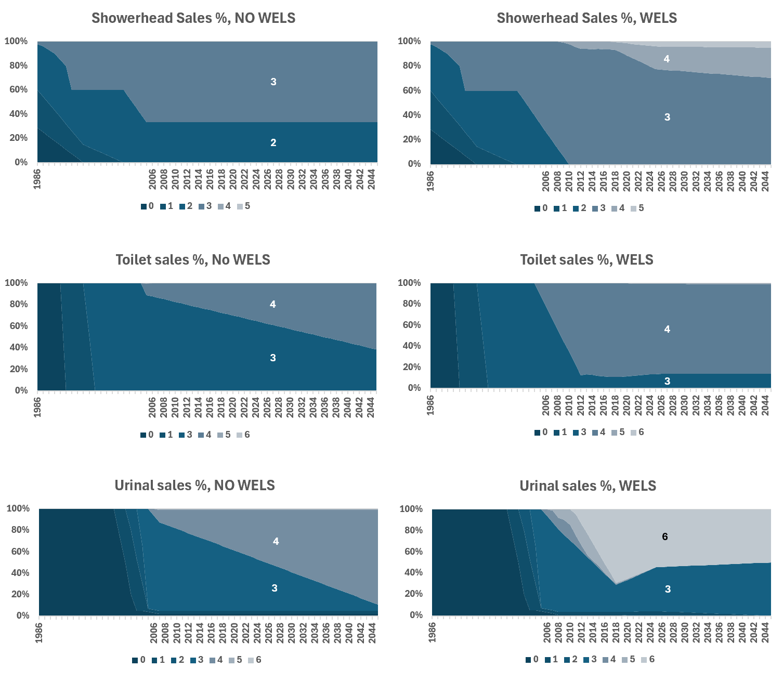
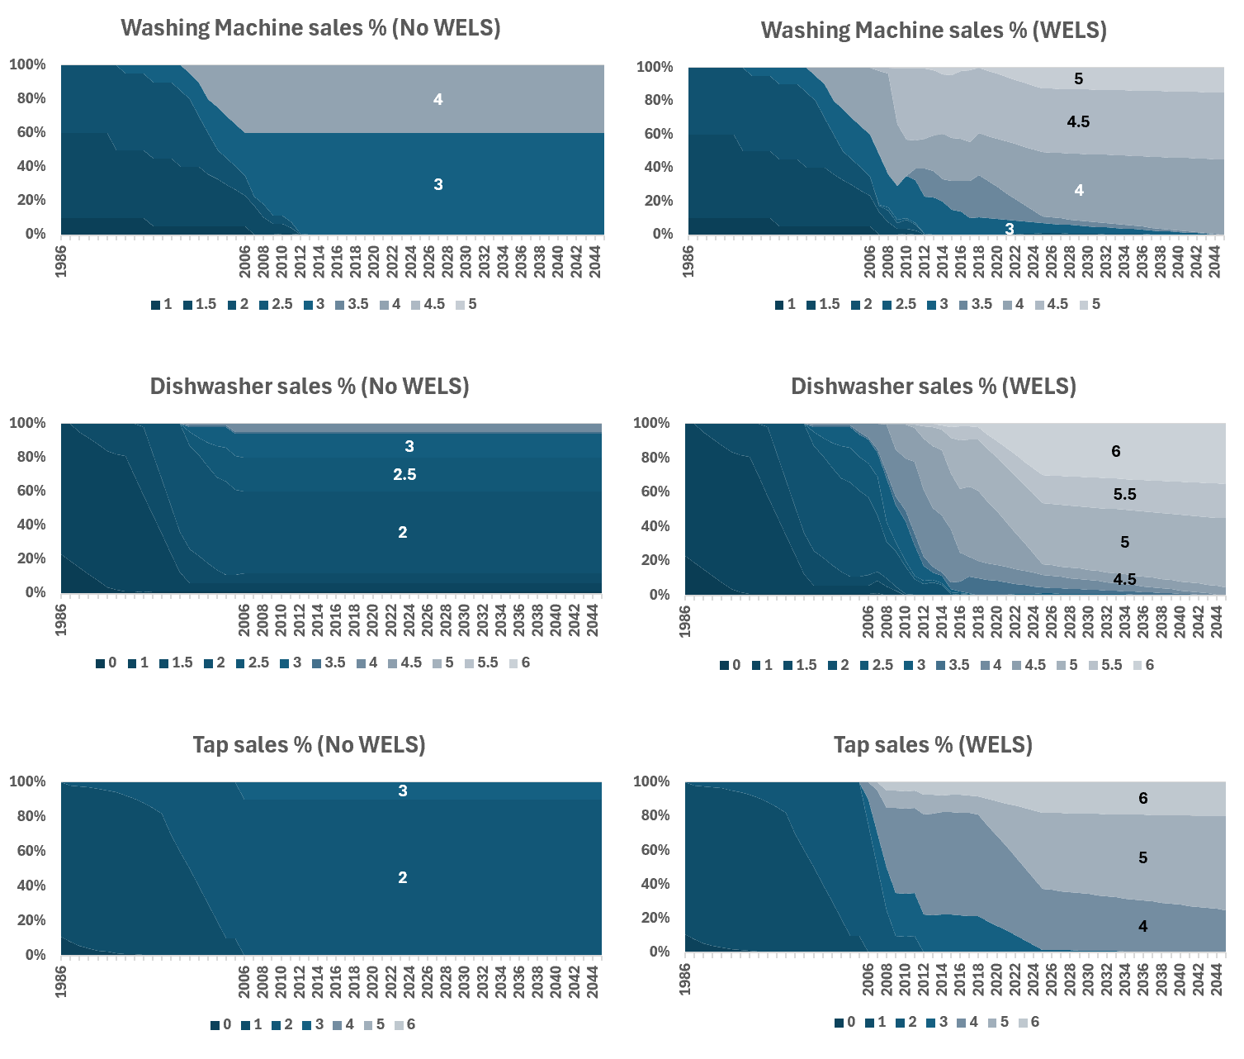
Figure C1 Sales projection by WELS star rating, under WELS and NO WELS scenarios
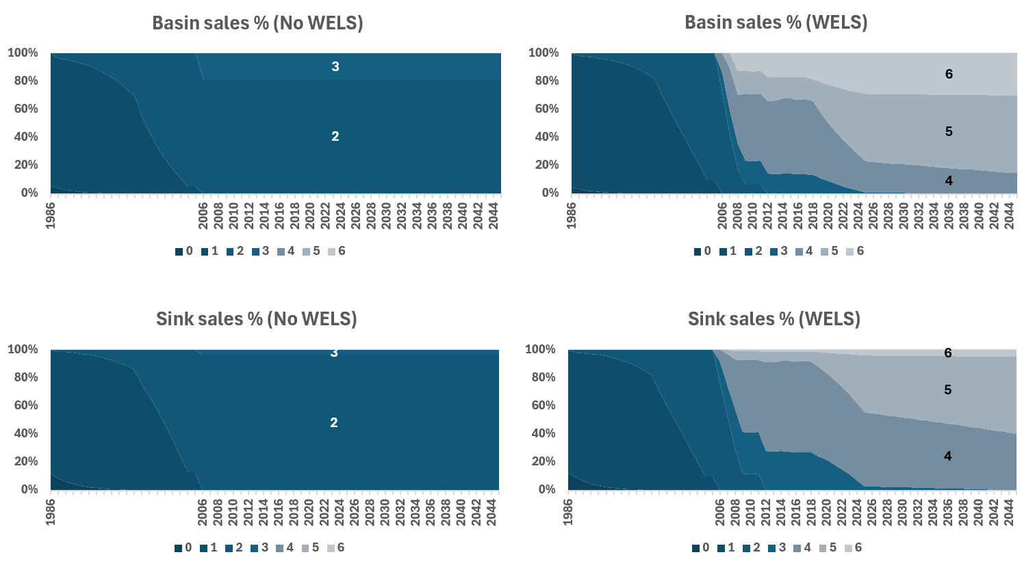
Figure C2 Sales projection by WELS star rating, under WELS and NO WELS scenarios (cont’d)

End-use modelling
A key component of the analysis was the utilisation of an end-use model. This model, originally developed by UTS-ISF in the 2000s (iSDP model v1) was recently upgraded for efficiency and analytical capability.
The updated end-use model integrates a stock model (based on sales and stock data for residential water-using products), and a water 'end-use' demographic model to forecast water demand based on population, behaviour and stock distribution. This model also estimates hot water use, with a separate UTS-ISF stock model for water heaters used to estimate energy use by type. Energy-use forecasts drive GHG estimates based on state-specific emission factor forecasts, which change overtime due to the renewable energy mix.
Water, energy and GHG savings results were calculated by comparing the with and without WELS case scenarios.
The modelling approach considered uncertainty in cost and demand outcomes. This was achieved by acknowledging that by working with large and varied data, assumptions were treated as statistical distributions rather than point values, allowing for confidence ranges in demand forecasts and scenario savings to account for sensitivity and natural data uncertainty. A graphical overview of modelling and evaluation approach is summarised in the figure below.
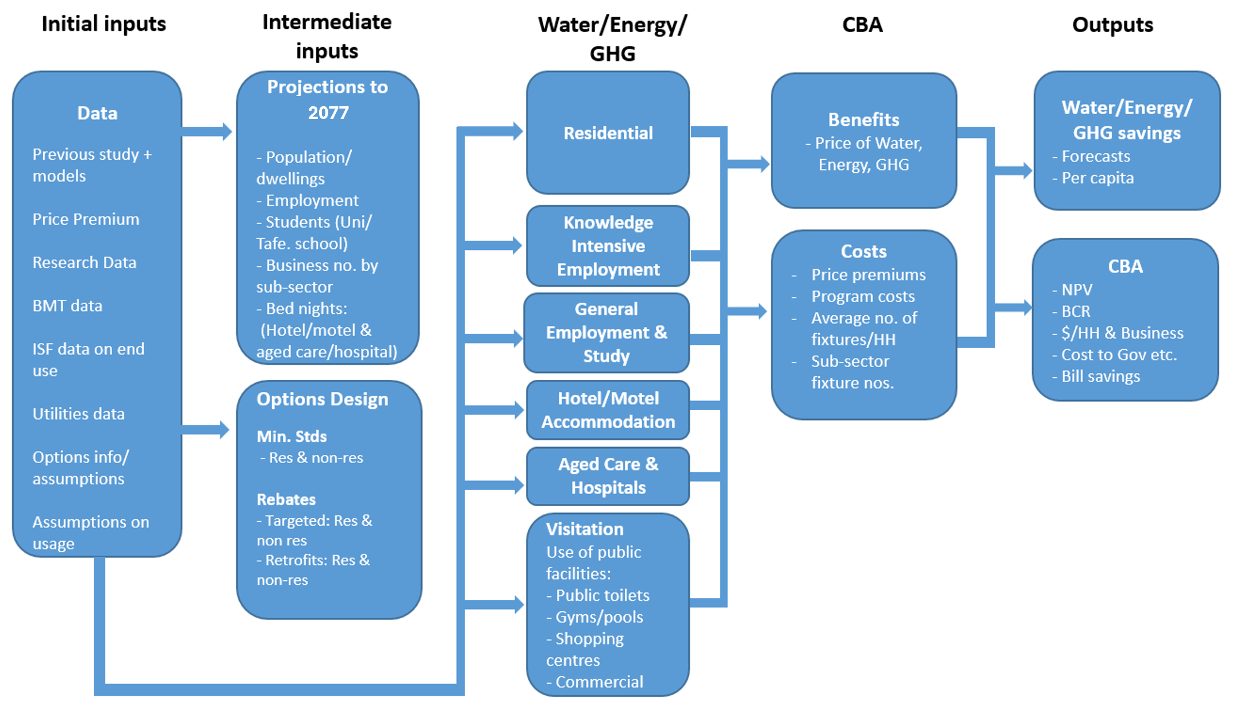
Figure C3 Overview of modelling and evaluation process

State-based analysis of water, energy and GHG impacts
The modelling approach involved developing separate end-use and appliance stock models for each Australian state and territory. This allowed for a granular breakdown of the scheme’s impact across the eight states and territories. These models were populated with state-specific data (projected and historical), including:
- ABS and data from other government bodies:
  - population by age
  - working/studying population
  - international and domestic visitation
  - Hospital bed nights
  - Aged care bed nights
  - Dwelling count
  - Occupancy by dwelling type
- end-use and stock survey data
- Hot water system sales and stock by energy type
- GHG intensity of energy (electricity and gas)
- potable water temperatures
- Water/gas/electricity price
- Water use behaviour assumptions
Sources for each dataset are listed in Appendix D. Both "with WELS" and "without WELS" scenarios were modelled at the state level, providing outputs that are comparable across jurisdictions and combined to result in a national analysis. It should also be noted that during the project, Victoria announced a ban on the installation of gas hot water systems for both the residential and non-residential sectors. This would take effect in March 2027. This ban has been reflected in the Victorian model and impacts energy and GHG savings for new builds.

GHG savings
Savings in energy leads to reduced GHG emissions that occur during energy generation. The amount of GHG emitted per unit of energy produced, or emission intensity, varies by state, year and energy type (electricity/gas). The historical and projected emission intensity for Australia is shown in Figure C4. Data source can be found in Appendix C, and the tabulated values can be found in Appendix G. Both gas and electricity emission intensity figures include Scope 3 emissions.

Figure C4 Emission intensity of electricity and gas in Australia

- Estimation of Customer Bill Savings (water and energy savings)
The economic analysis also provided a state-level breakdown of impacts. This involved using the state-specific water, energy, and GHG savings from the previous savings estimation task, combined with state-specific utility prices (water, electricity, natural gas) and the value of GHG emissions. The modelling reflected the nuances of varying utility prices across different states, allowing for a detailed understanding of how the financial benefits of the WELS scheme are distributed across Australia's diverse regions.
The resulting water and energy prices by state are shown in Figure C5 and C6. Future water prices are expected to increase at the rate of inflation and is thus shown as flat in real terms. Data sources varied for utility type and year; the complete list of sources can be found in Appendix D, and the annual values can be found in Appendix G.

Figure C5 Residential water price by state, in real 2024/25 AUD

Figure C6 Residential electricity price by state, in real 2024/25 AUD

Figure C7 Residential gas price by state, in real 2024/25 AUD

- Estimation of Gov Cost per ML Saved
The government cost per ML of water saved is calculated by diving the total water savings each year by the annual admin cost. The admin cost is taken from the 2024–25 WELS scheme CRIS. Annual estimate of cost per ML water saved is shown in Table C1.

Figure C8. Annual WELS Admin Cost (in 2024/25 AUD) and government cost per ML of water saved

Table C1. Unit cost of water saved to government
 | Admin cost (in 2024/25 AUD) | $/ML saved
2006 | $3,067,726 | $852.49
2007 | $2,971,289 | $263.89
2008 | $2,886,322 | $132.84
2009 | $3,078,295 | $93.14
2010 | $3,280,736 | $73.26
2011 | $3,297,286 | $60.12
2012 | $3,040,413 | $47.93
2013 | $2,659,108 | $37.43
2014 | $2,575,059 | $32.46
2015 | $2,229,410 | $24.71
2016 | $2,050,888 | $19.75
2017 | $2,253,246 | $18.79
2018 | $2,340,793 | $17.30
2019 | $2,459,591 | $16.44
2020 | $2,505,129 | $16.14
2021 | $2,902,738 | $18.57
2022 | $2,879,834 | $16.81
2023 | $3,204,758 | $17.14
2024 | $3,624,088 | $18.19
2025 | $3,291,000 | $15.72

- Data Sources
- Emission intensity
 | Source | Scope
(historical, GAS/ELEC) 2006~2024 | DCCEEW NGAF  https://www.dcceew.gov.au/climate-change/publications/national-greenhouse-accounts-factors-2023 | State/year  specific
(projected, ELEC) 2025~2040 | DCCEEW Australia's Emissions Projections 2024  https://www.dcceew.gov.au/sites/default/files/documents/australias-emissions-projections-2024.pdf (table 47) | State/year  specific
(projected, ELEC) 2041~2045 | linear extension from 2040 | State/year  specific
(projected, GAS) 2025~2040 | linear extension from 2025 | State/year  specific
- Energy price (electricity)
Variable | Source | Scope
(historical) 2005-2017 | Jacobs, Retail electricity price history and projected trends, AEMO  https://www.aemo.com.au/-/media/Files/Electricity/NEM/Planning_and_Forecasting/Demand-Forecasts/EFI/Jacobs-Retail-electricity-price-history-and-projections_Final-Public-Report-June-2017.pdf | State/year  specific
(historical) 2018-2024 | ACCC Inquiry into the National Electricity Market: December 2024 Report  https://www.accc.gov.au/about-us/publications/serial-publications/inquiry-into-the-national-electricity-market-2018-25-reports/inquiry-into-the-national-electricity-market-report-december-2024 | State/year  specific
(projected) 2024-2034 | AEMC Price Trends Final Report 2024  https://www.aemc.gov.au/sites/default/files/2024-11/Price%20Trends%202024%20Final%20Report.pdf | State/year  specific
(projected) 2035-2045) | ENA, Mind the Gap: Navigating a customer focused transition June 2023  https://www.energynetworks.com.au/miscellaneous/mind-the-gap-navigating-a-customer-focused-transition-2/ | State/year  specific
(historical)  2014-2025 | Synergy (Primary supplier of residential electricity in WA)  https://www.synergy.net.au/Global/Synergy-Price-Changes-2025 | WA only
(historical)  2012-2019 | AEMC 2012 pricing trends model  AEMC 2016 Residential Electricity Price Trends (EPR0049)  AEMC 2017 Residential Electricity Price Trends | ACT only
- Energy price (gas)
Variable | Source | Scope
(historical) 2005-2017 | Oakley Greenwood (2018) Gas Price Trends Review Report.  https://www.energy.gov.au/publications/gas-price-trends-review-report | State/year  specific
(historical) 2018-2020 | AER Annual Retail Market Report 2020-21  https://www.aer.gov.au/publications/reports/performance/annual-retail-markets-report-2020-21 | State/year  specific
(historical) 2021-2024 | AER Annual Retail Market Report 2023–24  https://www.aer.gov.au/publications/reports/performance/annual-retail-markets-report-2023-24 | State/year  specific
(projected) 2025-2045) | ACIL Allen (2023) Natural Gas Price Forecast  https://aemo.com.au/-/media/files/major-publications/isp/2023/iasr-supporting-material/acil-allen-natural-gas-price-forecasts.pdf  Retail residential price forecasted from trends in wholesale price projections. | State/year  specific
- Water price
Water price data is sourced from the Urban Water National Performance Report datasets collated by the Australian Bureau of Meteorology (Bureau of Meteorology, 2024). Water price ($/kL) is calculated for each state at each financial year by calculating the average utility tariff rates weighted by proportion of population served. Inflation is not included in water price. The full list of water price used for this can be found in Appendix G.
- Demographics
Variable | Source | Scope
Population  (historical) | ABS, 3101.0 National, state and territory population.  https://www.abs.gov.au/statistics/people/population/national-state-and-territory-population/latest-release  ABS, Population age and sex by structure  https://www.abs.gov.au/statistics/people/population/historical-population/latest-release | State,  Year,  Age
Population  (projected) | ABS, Population Projections, Australia  https://www.abs.gov.au/statistics/people/population/population-projections-australia/latest-release#data-downloads | State,  Year
Employment | ABS, 6291.0.55.001 - EQ06 - Employed persons by Industry group of main job (ANZSIC), Sex, State and Territory  https://www.abs.gov.au/statistics/labour/employment-and-unemployment/labour-force-australia-detailed/latest-release | State,  Year,  ANZSIC
Study | ABS, Full-time equivalent students*, 2006-2024  https://www.abs.gov.au/statistics/people/education/schools/latest-release  ABS, Current study at certificate III level or above*  https://www.abs.gov.au/statistics/people/education/education-and-work-australia/latest-release  *projections to 2045 based on % participation by age and by state. | State,  Year,  Age
Dwellings | ABS, Table 19. Dwelling structure by state and territory*. Census.  https://www.abs.gov.au/census/about-census/census-statistical-independent-assurance-panel-report/36-dwellings  *Projections to 2045 based on projected population and occupancy | State,  Census year
Occupancy | ABS, STATE (EN) and STRD Dwelling Structure by NPRD Number of Persons Usually Resident in Dwelling.  https://www.abs.gov.au/statistics/microdata-tablebuilder/tablebuilder  *Projections to 2045 assumed to have stable occupancy rate | State,  Census year
Hospital use | AIHW, Table 2.7: Patient days for public and private hospitals*, states and territories, 2018–19 to 2022–23  https://www.aihw.gov.au/hospitals/topics/admitted-patient-care  *Projections to 2045 based on population growth projections | State,  Year
Aged Care | AIHW, Bed nights for residential care*, Aged care data snapshot 2017-2025  https://www.gen-agedcaredata.gov.au/resources/access-data/2018/january/aged-care-data-snapshot  *Projections to 2045 based on elderly (65+) population growth projections | State,  Year
Accommodation  (domestic) | TRA, Visitor nights (hotels and similar)*, National Visitor Survey Results.  https://www.tra.gov.au/en/domestic/domestic-tourism-results  *Projections to 2045 based on historical data | State,  Year
Accommodation  (international) | TRA, International Trip visitation nights*^.  https://www.tra.gov.au/en/international/international-tourism-results  ^Access to full data via TRA Online via UTS library  *Projections to 2045 based on historical data | State,  Year

- Other
Variable | Source | Scope
Hot water system sales and stock | ISF (internal data), Hot water system sales and stock by energy type.  https://arena.gov.au/knowledge-bank/uts-domestic-hot-water-and-flexibility-report/ | State,  Year
potable water temperatures | WSAA, Network Temperature data (provided by WSAA for this study) | State

- Sales Data Interview and Survey Questions
Table E16 Sales Data Interview and Survey Questions
General questions | Response
- What is your name, organisation, role and how does it relate to water efficient fixtures or appliances?
- What types of products does your organisation sell?
- How do you see yourself positioned in the Australian market? E.g. high-end, non-res focused.

Product questions | Taps | Toilets | Urinals | Showers | Dishwashers | Washing Machines
Market representation
- What proportion of the Australian market does your company represent?  - Total market | [% taps sold] | [% toilets sold] | [% urinals sold] | [% showers sold] | [% DW sold] | [% CW sold]
  - Residential
  - Non-residential
- Is there any variation in your market representation between the states/territories?
- Who are the biggest 2 suppliers/retailers in terms of market representation? (Can include your organisation if appropriate).
Sales breakdown
- What proportion of products manufactured / imported / sold by your company would be rated:
- 0 star
- 1 / 1.5 star
- 2 / 2.5 star
- 3 /3.5 star
- 4 / 4.5 star
- 5 / 5.5 star
- 6 star
- Are you able to share any historic and/or current sales data by WELS rating?
- Have there been any recent (past 5 years) changes in the market that have affected your market representation or sales by WELS rating?  E.g. The pandemic  E.g. WELS minimum standards in 2022/23 | [Tap ware (all shower, basin, kitchen sink or laundry trough) – 3 star min] | [Dual flush toilets – 3 star min] | [Single stall/wall hung Urinals – 2 star min] | [Showers – 3 star min] | [Dishwashers with less than 9 place settings – 2.5 star min  Dishwashers with 9 or more place settings – 3 star min] | [Washing machine with capacity less than 5kg – 2.5 star min  Washing machine with capacity 5kg or more – 3 star min]
- Looking forward, are there any sales trends changes that you expect to see within the next 5-10 years?
E.g. Because of new technologies, star rating changes, regulatory changes, customer trends etc
- What do you think is driving the current market in WELS products? Can you foresee any drivers that would make the market less, or more, efficient?

Final questions | Response
- Is there anyone else you can think of that we should talk to for this project? Either within your organisation or another organisation.

- Key Input Data Tables

Water Price
Table F17 Water price for each state
Calendar | Water Price, $/KL (in 2024/25 AUD)
Year | NSW | VIC | QLD | SA | WA | TAS | NT | ACT
2006 | 2.89 | 1.93 | 3.29 | 1.54 | 1.42 | 1.81 | 1.72 | 4.51
2007 | 3.08 | 2.10 | 3.33 | 1.77 | 1.46 | 1.80 | 1.71 | 4.40
2008 | 3.27 | 2.27 | 3.37 | 1.99 | 1.50 | 1.79 | 1.70 | 4.29
2009 | 3.63 | 2.64 | 3.36 | 2.72 | 1.58 | 1.76 | 1.81 | 4.18
2010 | 3.82 | 3.00 | 3.60 | 3.56 | 1.84 | 1.71 | 2.04 | 4.09
2011 | 3.89 | 3.33 | 4.09 | 4.31 | 2.25 | 1.69 | 2.34 | 4.26
2012 | 3.89 | 3.44 | 4.39 | 5.16 | 2.53 | 1.67 | 2.85 | 4.50
2013 | 3.80 | 3.81 | 4.56 | 5.28 | 2.60 | 1.64 | 3.19 | 4.48
2014 | 3.74 | 3.91 | 4.65 | 4.96 | 2.61 | 1.61 | 3.21 | 4.46
2015 | 3.74 | 3.50 | 4.65 | 4.75 | 2.66 | 1.61 | 3.20 | 4.38
2016 | 3.55 | 3.37 | 4.65 | 4.39 | 2.70 | 1.60 | 3.12 | 4.23
2017 | 3.31 | 3.29 | 4.62 | 4.20 | 2.73 | 1.58 | 3.01 | 4.13
2018 | 3.26 | 3.43 | 4.59 | 4.13 | 2.79 | 1.57 | 2.93 | 3.86
2019 | 3.28 | 3.64 | 4.65 | 4.11 | 2.85 | 1.57 | 2.89 | 3.61
2020 | 3.35 | 3.61 | 4.66 | 3.58 | 2.80 | 1.52 | 2.81 | 3.52
2021 | 3.25 | 3.37 | 4.47 | 2.92 | 2.61 | 1.43 | 2.63 | 3.27
2022 | 2.98 | 3.04 | 4.12 | 2.66 | 2.38 | 1.32 | 2.40 | 2.82
2023 | 2.85 | 3.05 | 3.81 | 2.49 | 2.20 | 1.23 | 2.22 | 2.54
2024 | 2.83 | 3.23 | 3.72 | 2.45 | 2.14 | 1.20 | 2.16 | 2.57
2025 | 2.83 | 3.23 | 3.72 | 2.45 | 2.14 | 1.20 | 2.16 | 2.57
2026 | 2.83 | 3.23 | 3.72 | 2.45 | 2.14 | 1.20 | 2.16 | 2.57
2027 | 2.83 | 3.23 | 3.72 | 2.45 | 2.14 | 1.20 | 2.16 | 2.57
2028 | 2.83 | 3.23 | 3.72 | 2.45 | 2.14 | 1.20 | 2.16 | 2.57
2029 | 2.83 | 3.23 | 3.72 | 2.45 | 2.14 | 1.20 | 2.16 | 2.57
2030 | 2.83 | 3.23 | 3.72 | 2.45 | 2.14 | 1.20 | 2.16 | 2.57
2031 | 2.83 | 3.23 | 3.72 | 2.45 | 2.14 | 1.20 | 2.16 | 2.57
2032 | 2.83 | 3.23 | 3.72 | 2.45 | 2.14 | 1.20 | 2.16 | 2.57
2033 | 2.83 | 3.23 | 3.72 | 2.45 | 2.14 | 1.20 | 2.16 | 2.57
2034 | 2.83 | 3.23 | 3.72 | 2.45 | 2.14 | 1.20 | 2.16 | 2.57
2035 | 2.83 | 3.23 | 3.72 | 2.45 | 2.14 | 1.20 | 2.16 | 2.57
2036 | 2.83 | 3.23 | 3.72 | 2.45 | 2.14 | 1.20 | 2.16 | 2.57
2037 | 2.83 | 3.23 | 3.72 | 2.45 | 2.14 | 1.20 | 2.16 | 2.57
2038 | 2.83 | 3.23 | 3.72 | 2.45 | 2.14 | 1.20 | 2.16 | 2.57
2039 | 2.83 | 3.23 | 3.72 | 2.45 | 2.14 | 1.20 | 2.16 | 2.57
2040 | 2.83 | 3.23 | 3.72 | 2.45 | 2.14 | 1.20 | 2.16 | 2.57
2041 | 2.83 | 3.23 | 3.72 | 2.45 | 2.14 | 1.20 | 2.16 | 2.57
2042 | 2.83 | 3.23 | 3.72 | 2.45 | 2.14 | 1.20 | 2.16 | 2.57
2043 | 2.83 | 3.23 | 3.72 | 2.45 | 2.14 | 1.20 | 2.16 | 2.57
2044 | 2.83 | 3.23 | 3.72 | 2.45 | 2.14 | 1.20 | 2.16 | 2.57
2045 | 2.83 | 3.23 | 3.72 | 2.45 | 2.14 | 1.20 | 2.16 | 2.57

Electricity Price
Table F28 Electricity price for each state
Calendar | Electricity Price, $/GJ (in 2024/25 AUD)
Year | NSW | VIC | QLD | SA | WA | TAS | NT | ACT
2006 | 18.53 | 18.50 | 18.74 | 23.03 | 18.41 | 20.48 | 17.44 | 12.92
2007 | 19.72 | 19.72 | 19.05 | 23.64 | 19.34 | 22.00 | 18.33 | 13.57
2008 | 22.54 | 22.01 | 20.45 | 24.41 | 21.43 | 23.78 | 20.31 | 14.85
2009 | 25.50 | 24.15 | 22.46 | 25.17 | 23.64 | 24.47 | 22.39 | 16.12
2010 | 28.17 | 27.21 | 24.01 | 27.48 | 26.03 | 26.12 | 24.66 | 17.64
2011 | 32.32 | 32.25 | 26.33 | 33.46 | 30.03 | 29.97 | 28.45 | 20.42
2012 | 34.99 | 35.77 | 31.76 | 36.84 | 33.47 | 32.31 | 31.71 | 22.80
2013 | 33.06 | 36.38 | 37.95 | 35.77 | 33.65 | 29.83 | 32.30 | 24.45
2014 | 30.39 | 33.63 | 35.63 | 33.16 | 33.47 | 27.50 | 29.91 | 25.55
2015 | 31.14 | 32.56 | 30.98 | 33.00 | 34.28 | 27.77 | 28.94 | 24.82
2016 | 34.10 | 35.62 | 32.84 | 38.38 | 34.29 | 28.87 | 31.59 | 24.61
2017 | 37.40 | 39.59 | 35.28 | 44.96 | 34.78 | 30.00 | 33.11 | 27.43
2018 | 36.74 | 40.07 | 34.05 | 45.88 | 35.62 | 29.17 | 32.11 | 30.69
2019 | 33.61 | 37.70 | 31.71 | 43.17 | 35.71 | 29.41 | 31.00 | 31.04
2020 | 31.92 | 36.73 | 29.72 | 40.97 | 35.44 | 27.78 | 29.63 | 28.99
2021 | 29.72 | 33.86 | 27.32 | 37.03 | 34.48 | 24.60 | 27.37 | 26.64
2022 | 29.36 | 31.31 | 27.47 | 36.27 | 33.29 | 23.53 | 26.56 | 25.85
2023 | 33.20 | 32.99 | 31.71 | 41.23 | 32.52 | 25.12 | 28.88 | 28.11
2024 | 37.19 | 33.73 | 35.64 | 45.40 | 32.34 | 27.07 | 31.03 | 30.20
2025 | 37.31 | 31.91 | 35.10 | 43.85 | 31.49 | 24.99 | 30.12 | 30.03
2026 | 34.09 | 29.66 | 30.70 | 40.36 | 28.80 | 22.94 | 27.55 | 27.84
2027 | 31.56 | 27.34 | 27.60 | 38.85 | 26.80 | 22.44 | 25.64 | 24.89
2028 | 32.92 | 27.63 | 27.80 | 40.36 | 27.51 | 23.56 | 26.32 | 25.06
2029 | 33.61 | 27.59 | 27.55 | 40.49 | 27.75 | 24.22 | 26.55 | 25.29
2030 | 31.85 | 26.73 | 27.35 | 38.44 | 26.57 | 23.66 | 25.42 | 23.04
2031 | 30.65 | 26.03 | 27.60 | 36.82 | 25.83 | 23.62 | 24.72 | 21.41
2032 | 30.53 | 25.67 | 27.60 | 36.21 | 25.78 | 24.55 | 24.66 | 21.02
2033 | 31.83 | 27.42 | 29.30 | 37.66 | 27.06 | 26.81 | 25.88 | 20.86
2034 | 32.70 | 28.91 | 30.75 | 38.61 | 27.94 | 27.97 | 26.73 | 20.74
2035 | 32.09 | 28.37 | 30.18 | 37.89 | 27.42 | 27.46 | 26.24 | 20.35
2036 | 31.15 | 27.54 | 29.29 | 36.78 | 26.62 | 26.65 | 25.47 | 19.76
2037 | 30.48 | 26.95 | 28.66 | 35.99 | 26.04 | 26.08 | 24.92 | 19.33
2038 | 30.17 | 26.68 | 28.37 | 35.63 | 25.78 | 25.82 | 24.67 | 19.14
2039 | 29.77 | 26.32 | 27.99 | 35.15 | 25.44 | 25.47 | 24.34 | 18.88
2040 | 29.57 | 26.14 | 27.81 | 34.91 | 25.27 | 25.30 | 24.17 | 18.75
2041 | 29.63 | 26.20 | 27.87 | 34.99 | 25.32 | 25.36 | 24.23 | 18.80
2042 | 29.60 | 26.17 | 27.84 | 34.95 | 25.30 | 25.33 | 24.20 | 18.77
2043 | 29.40 | 25.99 | 27.65 | 34.72 | 25.12 | 25.15 | 24.04 | 18.65
2044 | 28.96 | 25.61 | 27.24 | 34.20 | 24.75 | 24.78 | 23.68 | 18.37
2045 | 28.59 | 25.28 | 26.89 | 33.76 | 24.43 | 24.46 | 23.38 | 18.13

Gas Price
Table F39 Gas price for each state
Calendar | Electricity Price, c/MJ (in 2024/25 AUD)
Year | NSW | VIC | QLD | SA | WA | TAS | NT | ACT
2006 | 3.5 | 1.9 | 5.4 | 4.1 | 3.4 | 2.5 | 3.5 | 2.6
2007 | 3.4 | 1.9 | 5.4 | 4.1 | 3.3 | 2.5 | 3.5 | 2.7
2008 | 3.5 | 2.0 | 5.5 | 4.2 | 3.5 | 2.6 | 3.6 | 2.9
2009 | 3.6 | 2.1 | 5.7 | 4.4 | 4.2 | 2.8 | 3.7 | 3.1
2010 | 3.6 | 2.1 | 5.8 | 4.4 | 4.6 | 3.0 | 3.8 | 3.3
2011 | 3.8 | 2.2 | 6.4 | 4.7 | 4.9 | 3.3 | 4.1 | 3.4
2012 | 4.1 | 2.3 | 7.0 | 5.3 | 5.2 | 3.7 | 4.4 | 3.6
2013 | 4.3 | 2.4 | 7.4 | 5.8 | 5.5 | 3.9 | 4.7 | 3.8
2014 | 4.8 | 2.5 | 7.7 | 6.3 | 5.3 | 4.1 | 5.0 | 4.0
2015 | 4.8 | 2.6 | 7.9 | 6.4 | 5.1 | 4.4 | 5.0 | 4.1
2016 | 4.7 | 2.8 | 8.9 | 6.3 | 5.3 | 4.7 | 5.0 | 4.1
2017 | 5.2 | 2.9 | 10.7 | 6.4 | 5.5 | 5.2 | 5.3 | 4.9
2018 | 5.4 | 3.1 | 11.5 | 6.6 | 5.9 | 5.6 | 5.6 | 5.3
2019 | 5.4 | 3.2 | 11.1 | 6.9 | 5.8 | 5.5 | 5.6 | 5.0
2020 | 5.0 | 3.1 | 10.8 | 7.0 | 5.7 | 5.4 | 5.4 | 4.9
2021 | 4.4 | 3.0 | 10.2 | 6.7 | 5.2 | 5.0 | 5.0 | 4.2
2022 | 4.4 | 3.4 | 10.0 | 7.1 | 5.3 | 5.1 | 5.1 | 3.9
2023 | 4.8 | 3.9 | 10.2 | 8.1 | 5.9 | 5.6 | 5.6 | 4.3
2024 | 4.9 | 3.9 | 9.6 | 8.6 | 6.0 | 5.7 | 5.7 | 4.4
2025 | 5.0 | 4.1 | 9.3 | 8.6 | 6.0 | 5.8 | 5.7 | 4.5
2026 | 4.9 | 4.0 | 8.9 | 8.2 | 5.9 | 5.8 | 6.0 | 4.4
2027 | 4.5 | 3.8 | 8.4 | 7.7 | 5.7 | 5.6 | 6.4 | 4.3
2028 | 4.3 | 3.7 | 8.4 | 7.5 | 5.7 | 5.5 | 6.7 | 4.2
2029 | 4.2 | 3.7 | 8.5 | 7.3 | 5.6 | 5.4 | 6.7 | 4.2
2030 | 4.0 | 3.5 | 8.3 | 7.0 | 5.4 | 5.2 | 6.7 | 4.0
2031 | 3.9 | 3.4 | 8.1 | 6.8 | 5.3 | 5.1 | 6.7 | 4.0
2032 | 3.9 | 3.5 | 7.9 | 6.7 | 5.3 | 5.1 | 6.7 | 3.9
2033 | 4.0 | 3.6 | 7.9 | 6.8 | 5.4 | 5.3 | 6.7 | 4.0
2034 | 4.1 | 3.7 | 7.8 | 7.1 | 5.5 | 5.4 | 6.7 | 4.1
2035 | 4.1 | 3.7 | 7.7 | 7.1 | 5.5 | 5.5 | 6.4 | 4.1
2036 | 4.1 | 3.7 | 7.7 | 7.1 | 5.4 | 5.4 | 5.9 | 4.0
2037 | 4.2 | 3.7 | 7.5 | 7.2 | 5.3 | 5.5 | 5.6 | 4.0
2038 | 4.2 | 3.7 | 7.4 | 7.2 | 5.3 | 5.5 | 5.7 | 4.0
2039 | 4.2 | 3.8 | 7.5 | 7.3 | 5.4 | 5.5 | 5.9 | 4.0
2040 | 4.3 | 3.8 | 7.6 | 7.4 | 5.5 | 5.6 | 6.0 | 4.1
2041 | 4.3 | 3.8 | 7.3 | 7.4 | 5.4 | 5.6 | 5.7 | 4.0
2042 | 4.2 | 3.8 | 7.1 | 7.4 | 5.4 | 5.6 | 5.5 | 4.0
2043 | 4.3 | 3.9 | 7.2 | 7.6 | 5.4 | 5.6 | 5.6 | 4.0
2044 | 4.4 | 4.0 | 7.4 | 7.8 | 5.6 | 5.8 | 5.7 | 4.2
2045 | 4.5 | 4.0 | 7.4 | 7.9 | 5.7 | 5.9 | 5.8 | 4.2

Emission Intensity (Electricity)
Table F410 Emission intensity (electricity) for each state
Calendar | Emission Intensity of Electricity (kg CO2-e/GJ)
Year | NSW | VIC | QLD | SA | WA | TAS | NT | ACT
2006 | 279 | 365 | 285 | 264 | 265 | 49 | 230 | 279
2007 | 278 | 367 | 283 | 248 | 270 | 77 | 226 | 278
2008 | 277 | 375 | 281 | 237 | 264 | 104 | 223 | 277
2009 | 278 | 378 | 277 | 221 | 251 | 101 | 220 | 278
2010 | 277 | 376 | 270 | 212 | 241 | 87 | 216 | 277
2011 | 276 | 371 | 262 | 201 | 233 | 75 | 217 | 276
2012 | 271 | 372 | 260 | 192 | 231 | 60 | 214 | 271
2013 | 269 | 362 | 258 | 181 | 225 | 45 | 212 | 269
2014 | 266 | 346 | 256 | 175 | 217 | 49 | 209 | 266
2015 | 263 | 329 | 257 | 173 | 212 | 59 | 203 | 263
2016 | 256 | 323 | 256 | 170 | 207 | 72 | 204 | 256
2017 | 249 | 314 | 258 | 146 | 198 | 59 | 194 | 249
2018 | 241 | 295 | 257 | 119 | 195 | 51 | 172 | 241
2019 | 236 | 279 | 254 | 101 | 191 | 44 | 162 | 236
2020 | 230 | 272 | 250 | 99 | 183 | 46 | 165 | 230
2021 | 223 | 265 | 247 | 97 | 176 | 48 | 168 | 223
2022 | 217 | 258 | 243 | 95 | 168 | 50 | 171 | 217
2023 | 203 | 238 | 246 | 92 | 176 | 34 | 168 | 203
2024 | 194 | 239 | 225 | 78 | 176 | 50 | 175 | 194
2025 | 153 | 233 | 206 | 67 | 156 | 61 | 169 | 153
2026 | 139 | 214 | 186 | 69 | 147 | 58 | 156 | 139
2027 | 119 | 208 | 172 | 64 | 133 | 58 | 131 | 119
2028 | 100 | 156 | 153 | 64 | 94 | 11 | 122 | 100
2029 | 64 | 106 | 103 | 47 | 72 | 11 | 122 | 64
2030 | 44 | 75 | 53 | 31 | 39 | 6 | 119 | 44
2031 | 44 | 67 | 56 | 25 | 36 | 11 | 108 | 44
2032 | 39 | 56 | 42 | 17 | 39 | 11 | 108 | 39
2033 | 25 | 56 | 44 | 19 | 39 | 14 | 108 | 25
2034 | 25 | 53 | 47 | 19 | 36 | 17 | 106 | 25
2035 | 22 | 6 | 39 | 19 | 36 | 3 | 106 | 22
2036 | 19 | 6 | 36 | 19 | 33 | 3 | 106 | 19
2037 | 17 | 3 | 33 | 17 | 33 | 3 | 106 | 17
2038 | 17 | 3 | 31 | 14 | 33 | 3 | 103 | 17
2039 | 17 | 3 | 33 | 17 | 31 | 3 | 103 | 17
2040 | 8 | 3 | 31 | 17 | 39 | 3 | 103 | 8
2041 | 8 | 3 | 31 | 17 | 39 | 3 | 103 | 8
2042 | 8 | 3 | 31 | 17 | 39 | 3 | 103 | 8
2043 | 8 | 3 | 31 | 17 | 39 | 3 | 103 | 8
2044 | 8 | 3 | 31 | 17 | 39 | 3 | 103 | 8
2045 | 8 | 3 | 31 | 17 | 39 | 3 | 103 | 8

Emission Intensity (Gas)
Table F511 Emission intensity (gas) for each state
Calendar | Emission Intensity of Gas (kg CO2-e/GJ)
Year | NSW | VIC | QLD | SA | WA | TAS | NT | ACT
2006 | 65.5 | 55.3 | 59.9 | 61.7 | 55.3 | 55.3 | 55.3 | 65.5
2007 | 65.5 | 55.3 | 59.9 | 61.7 | 55.3 | 55.3 | 55.3 | 65.5
2008 | 65.5 | 55.3 | 59.9 | 61.7 | 55.3 | 55.3 | 55.3 | 65.5
2009 | 65.5 | 55.3 | 59.9 | 61.7 | 55.3 | 55.3 | 55.3 | 65.5
2010 | 65.5 | 55.3 | 59.9 | 61.7 | 55.3 | 55.3 | 55.3 | 65.5
2011 | 65.5 | 55.3 | 59.9 | 61.7 | 55.3 | 55.3 | 55.3 | 65.5
2012 | 65.5 | 55.3 | 59.9 | 61.7 | 55.3 | 55.3 | 55.3 | 65.5
2013 | 64.1 | 55.2 | 60 | 61.7 | 55.3 | 55.2 | 55.3 | 64.1
2014 | 64.3 | 55.4 | 60.2 | 61.9 | 55.5 | 55.4 | 55.5 | 64.3
2015 | 64.3 | 55.4 | 60.2 | 61.9 | 55.5 | 55.4 | 55.5 | 64.3
2016 | 64.3 | 55.4 | 60.2 | 61.9 | 55.5 | 55.4 | 55.5 | 64.3
2017 | 64.3 | 55.4 | 60.2 | 61.9 | 55.5 | 55.4 | 55.5 | 64.3
2018 | 64.3 | 55.4 | 60.2 | 61.9 | 55.5 | 55.4 | 55.5 | 64.3
2019 | 64.3 | 55.4 | 60.2 | 61.9 | 55.5 | 55.4 | 55.5 | 64.3
2020 | 64.6 | 55.5 | 60.3 | 62.2 | 55.6 | 55.5 | 55.6 | 64.6
2021 | 64.6 | 55.5 | 60.3 | 62.2 | 55.6 | 55.5 | 55.6 | 64.6
2022 | 64.6 | 55.5 | 60.3 | 62.2 | 55.6 | 55.5 | 55.6 | 64.6
2023 | 64.6 | 55.5 | 60.3 | 62.2 | 55.6 | 55.5 | 55.6 | 64.6
2024 | 64.6 | 55.5 | 60.3 | 62.2 | 55.6 | 55.5 | 55.6 | 64.6
2025 | 64.6 | 55.5 | 60.3 | 62.2 | 55.6 | 55.5 | 55.6 | 64.6
2026 | 64.6 | 55.5 | 60.3 | 62.2 | 55.6 | 55.5 | 55.6 | 64.6
2027 | 64.6 | 55.5 | 60.3 | 62.2 | 55.6 | 55.5 | 55.6 | 64.6
2028 | 64.6 | 55.5 | 60.3 | 62.2 | 55.6 | 55.5 | 55.6 | 64.6
2029 | 64.6 | 55.5 | 60.3 | 62.2 | 55.6 | 55.5 | 55.6 | 64.6
2030 | 64.6 | 55.5 | 60.3 | 62.2 | 55.6 | 55.5 | 55.6 | 64.6
2031 | 64.6 | 55.5 | 60.3 | 62.2 | 55.6 | 55.5 | 55.6 | 64.6
2032 | 64.6 | 55.5 | 60.3 | 62.2 | 55.6 | 55.5 | 55.6 | 64.6
2033 | 64.6 | 55.5 | 60.3 | 62.2 | 55.6 | 55.5 | 55.6 | 64.6
2034 | 64.6 | 55.5 | 60.3 | 62.2 | 55.6 | 55.5 | 55.6 | 64.6
2035 | 64.6 | 55.5 | 60.3 | 62.2 | 55.6 | 55.5 | 55.6 | 64.6
2036 | 64.6 | 55.5 | 60.3 | 62.2 | 55.6 | 55.5 | 55.6 | 64.6
2037 | 64.6 | 55.5 | 60.3 | 62.2 | 55.6 | 55.5 | 55.6 | 64.6
2038 | 64.6 | 55.5 | 60.3 | 62.2 | 55.6 | 55.5 | 55.6 | 64.6
2039 | 64.6 | 55.5 | 60.3 | 62.2 | 55.6 | 55.5 | 55.6 | 64.6
2040 | 64.6 | 55.5 | 60.3 | 62.2 | 55.6 | 55.5 | 55.6 | 64.6
2041 | 64.6 | 55.5 | 60.3 | 62.2 | 55.6 | 55.5 | 55.6 | 64.6
2042 | 64.6 | 55.5 | 60.3 | 62.2 | 55.6 | 55.5 | 55.6 | 64.6
2043 | 64.6 | 55.5 | 60.3 | 62.2 | 55.6 | 55.5 | 55.6 | 64.6
2044 | 64.6 | 55.5 | 60.3 | 62.2 | 55.6 | 55.5 | 55.6 | 64.6
2045 | 64.6 | 55.5 | 60.3 | 62.2 | 55.6 | 55.5 | 55.6 | 64.6

- State Level Results
- NSW

Water Savings
By 2045, cumulative annual water savings are projected to reach almost 95,000 ML/year, with residential single dwellings accounting for over half of these savings. Non-residential uptake still represents a substantial part, particularly in the Visitation sector. Growth is strongest between 2010 and 2025, and stabilises from 2030, reflecting saturation in the uptake of efficient appliances. The dominance of residential savings reflects both population size and fixture water use patterns, whereas non-residential savings are significant in high-use facilities where daily occupancy drives demand.
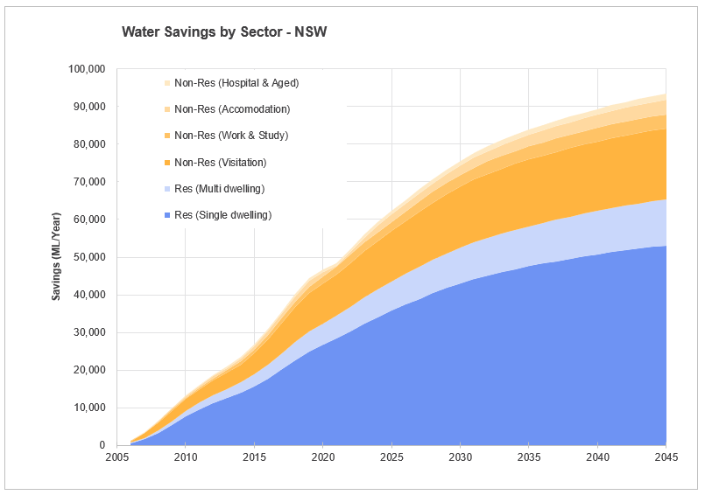
Figure G1 Water Savings by Sector – NSW

In households, washing machines, basins, and showers contribute to the largest savings, followed by toilets and sinks, whereas dishwashers contribute a smaller share. Growth is steep until 2025, then slows as high-efficiency models become standard. In non-residential settings, basins dominate, while showers and toilets add moderate savings, and urinals remain minor contributors. These results highlight the value of targeting high-use fixtures, especially tapware (predominately showers and basins), which deliver consistent and substantial savings across both residential and non-residential contexts.
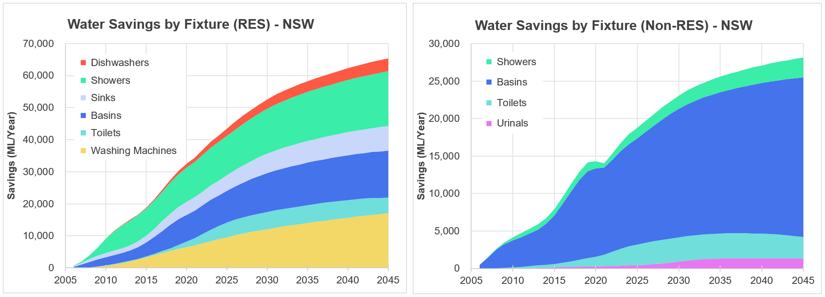
Figure G2 Water by Fixture (Res and Non-Res) – NSW

Energy and GHG Savings
Energy savings are expected to peak at just over 5,000 TJ/year by 2045, and are greater for gas, which steadily increases from 2005 to 2025, and stabilises from 2030. In contrast, Electricity savings are smaller and show a stronger plateau from 2020. GHG savings in both sectors peak sharply around 2020 at almost 425,000 t CO₂/year, then decline and stabilise at around 175,000 t CO₂/year from 2030. GHG savings for the non-residential sector are consistently smaller, peaking and stabilising at the same time as the non-residential sector.
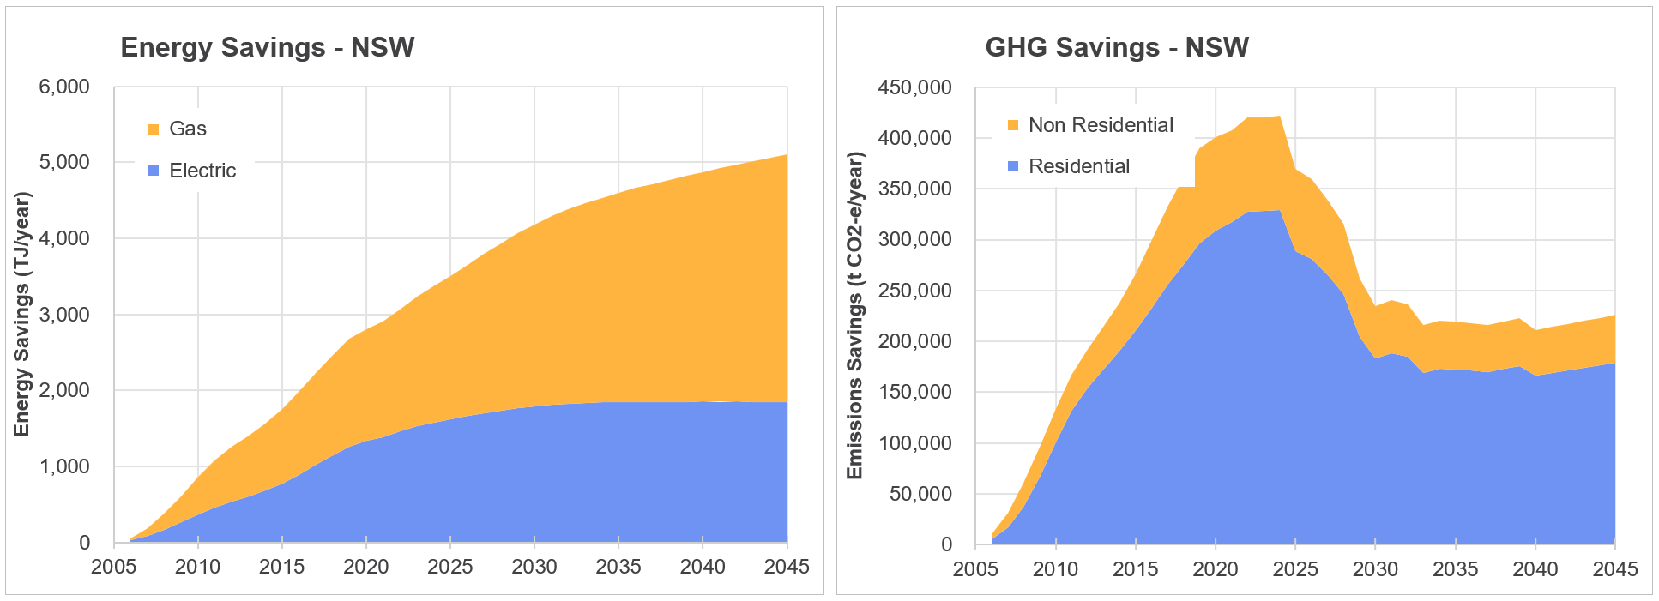
Figure G3 Energy and GHG Savings – NSW

Total bill savings in NSW reach almost 630M AUD/year by 2045. Water savings provide the largest direct financial benefit for both sectors, followed by a relatively even split between electricity and gas savings. Growth is strongest for all sectors between 2005 and 2020, and then again between 2022 and 2025. After 2025, savings are expected to increase more gradually. Residential customers capture the majority of GHG savings.
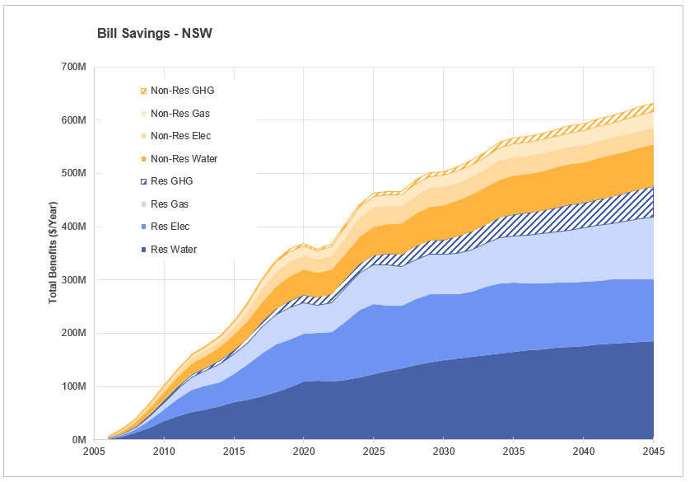
Figure G4 Bill Savings – NSW

- Victoria

Water Savings
Residential single dwellings deliver the largest water savings in Victoria, peaking near 60,000 ML/year by 2045. Multi-dwellings add a further 5,000 ML/year savings. Among non-residential sectors, visitation facilities realise the most savings, followed by accommodation. Growth is strongest between 2010–2030 as efficiency uptake expands, then stabilises. The dominance of residential savings reflects both population size and fixture water use patterns. Non-residential savings, though smaller, are significant in high-use facilities where daily occupancy drives demand, reinforcing the scheme’s reach across multiple sectors.
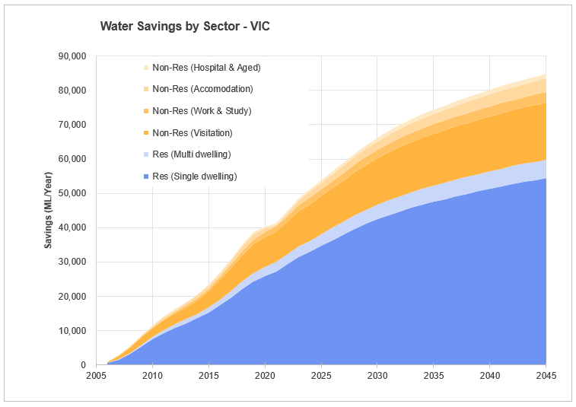
Figure G5 Water Savings by Sector – VIC
In households, washing machines, basins and showers account for most water savings, with toilets, sinks and dishwashers contributing lesser savings. Growth is steepest before 2025, then slows as high-efficiency models become standard. In non-residential settings, basins dominate savings, reaching about 20,000 ML/year by 2040, while showers and toilets add moderate gains and urinals remain minor contributors. These results highlight the value of targeting high-use fixtures, especially tapware (predominately showers and basins), which deliver consistent and substantial savings across both residential and non-residential contexts.
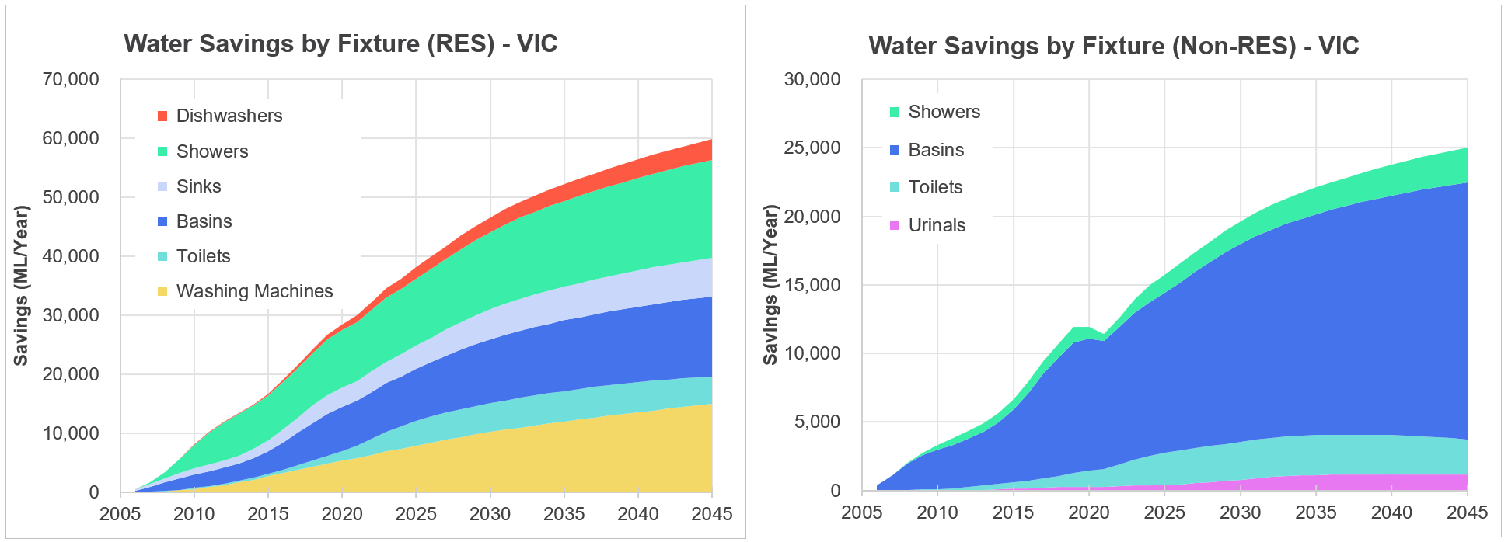
Figure G6 Water Savings by Fixture (Res and Non-Res) – VIC

Energy and GHG Savings
Gas savings in Victoria grow rapidly until 2030 before levelling. In contrast, electricity savings grow more gradually until about 2026, after which, faster growth occurs until 2040. Gas savings peak earlier, reflecting shifts in hot water energy sources driven by the Victorian gas substitution roadmap whereby gas hot water systems will be phased out in all Victorian homes from March 2027. GHG reductions mirror this pattern showing a shift from 2027 relating to declining gas reliance. Residential GHG savings peak near 350,000 t CO₂/year, while non-residential savings are about a third of that.
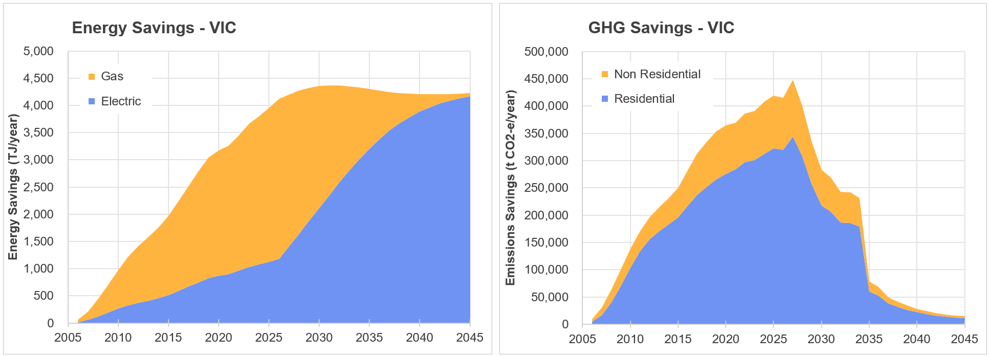
Figure G7 Energy and GHG Savings – Victoria

Bill Savings
By 2045, residential bill savings dominate, with an even split between savings associated with water and electricity savings. Non-residential water and electricity savings mirror this even split. Total customer bill benefits (excluding GHG) rise to about $550 million/year by 2035, then remain steady. GHG savings are shown as avoided societal costs, with residential contributions greater than non-residential. These represent broader environmental and economic benefits rather than direct savings to households or businesses.
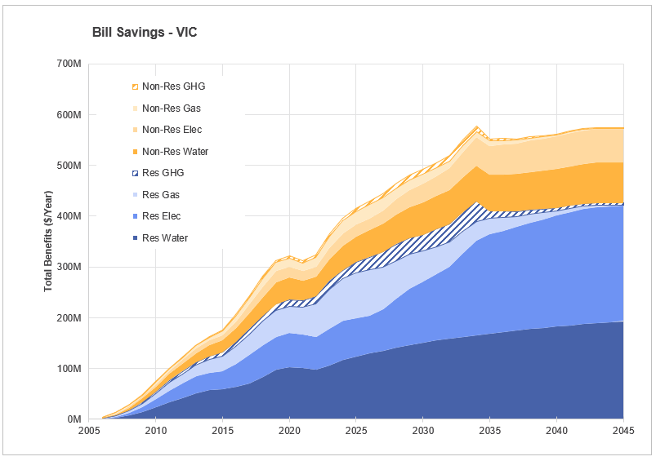
Figure G8 Bill Savings – Victoria
- Queensland

Water Savings
By 2045, Queensland is expected to save just under 60,000 ML/year of water across all sectors, the majority by residential single dwellings. As with the water savings results from NSW and VIC, Visitation facilities show the most savings from the non-residential sectors with just under 15,000 ML/year in 2045. Growth is strongest between 2010–2030 as efficiency uptake increases, then stabilises, nearing saturation of highly-efficient fixtures in all sectors.
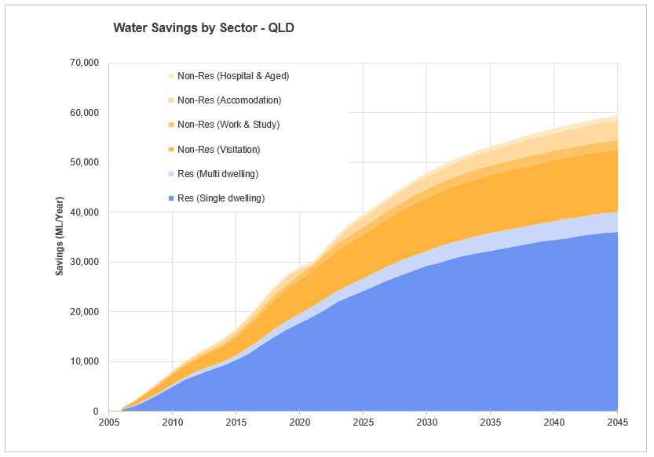
Figure G9 Water Savings by Sector – Queensland

In residential households, washing machines, basins and showers account for most water savings, with toilets, sinks and dishwashers contributing less. Growth is steepest until 2030, then slows as high-efficiency models become standard. In non-residential settings, basins dominate savings, reaching about 14,000 ML/year by 2045, while showers and toilets contribute to considerably less savings, and urinals remain minor contributors. As high-use fixtures such as tapware from predominately showers and basins become more common in both residential and non-residential contexts, consistent and substantial savings are expected.
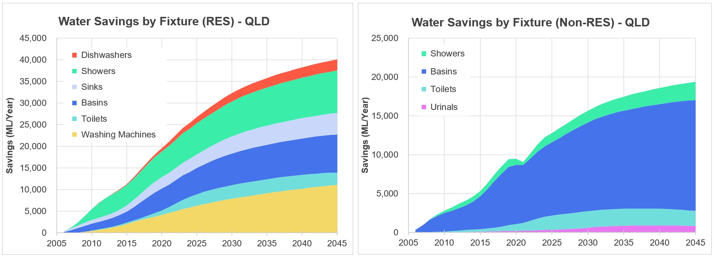
Figure G10 Water Savings by Fixture (Res and Non-Res) – Queensland

Energy and GHG Savings
Energy savings are expected to peak at nearly 4,000 TJ/year by 2045 and are dominated by electricity savings. GHG savings are dominated by the residential sector, but both sectors peak sharply in 2023-24 before declining rapidly until 2030. Beyond 2030, savings decline slowly to plateau between 100,000 and 150,000 t CO₂/year.
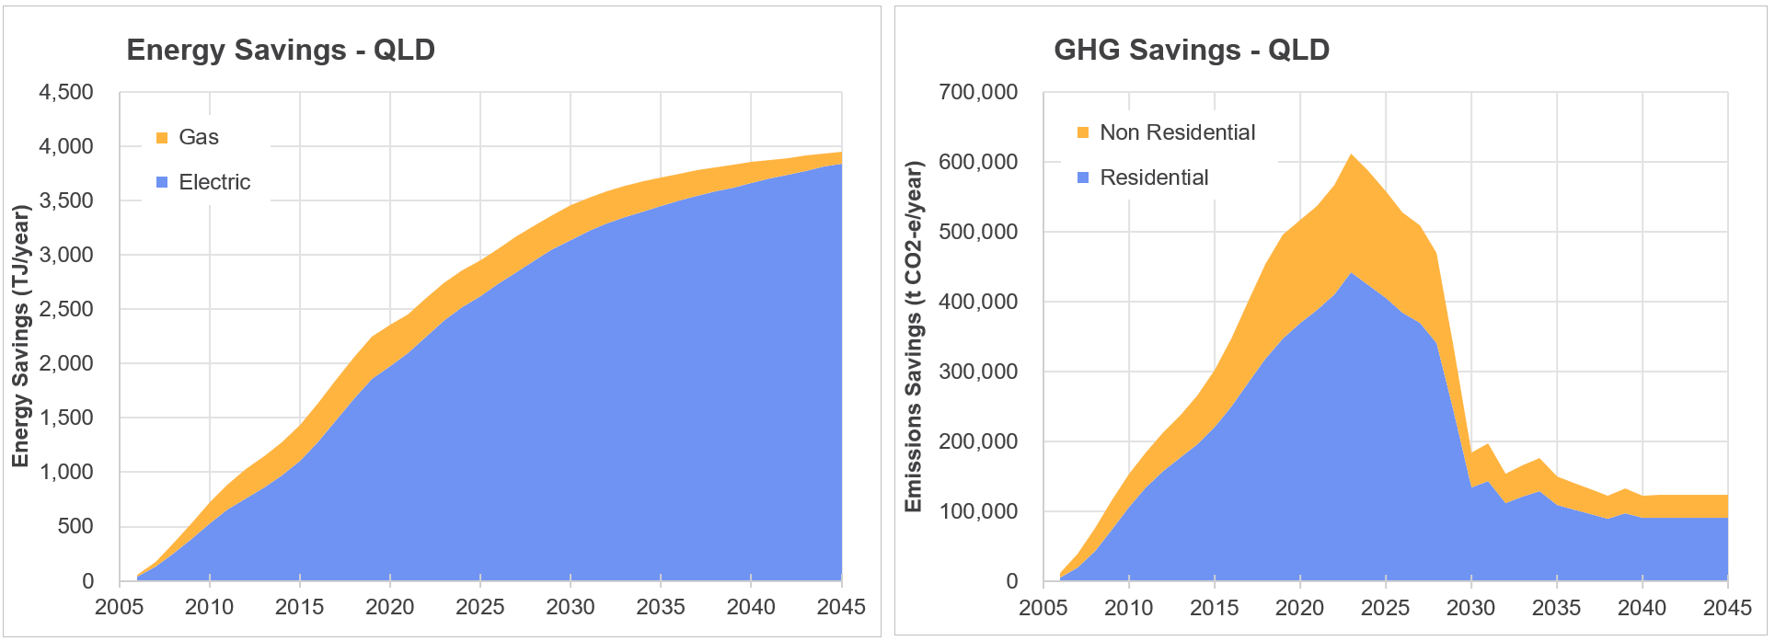
Figure G11 Energy and GHG Savings – Queensland

Bill Savings
By 2045, over half of total benefits are projected to come from residential bill savings, with the majority of these from electricity, followed water savings. Non-residential water and electricity savings show a more even split. Total customer bill benefits (excluding GHG) rise to about $500 million/year by 2035, then remain relatively steady. GHG savings are shown as avoided societal costs, with residential contributions greater than non-residential. These represent broader environmental and economic benefits rather than direct savings to households or businesses.
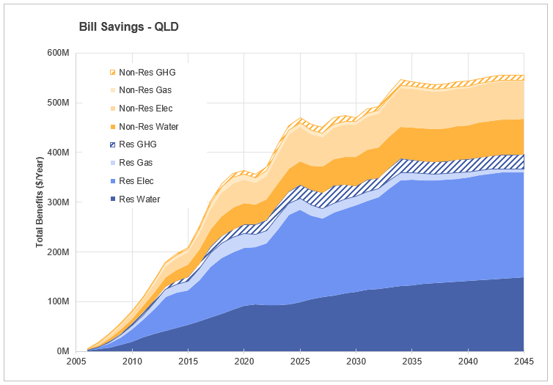
Figure G12 Bill Savings – Queensland

- SA

Water Savings
By 2045, around 23,000 ML/year is expected to be saved in SA across all sectors, over half by residential single dwellings. Visitation and accommodation facilities make the greatest contribution to non-residential dwellings, with work & study and hospital & aged care facilities providing minor contributions. In 2021 there is a slight decline in water savings in the hospital & aged care and accommodation sectors, most likely because of COVID-19. After 2030, water savings slow in all sectors due to uptake and near saturation of highly efficient fixtures.
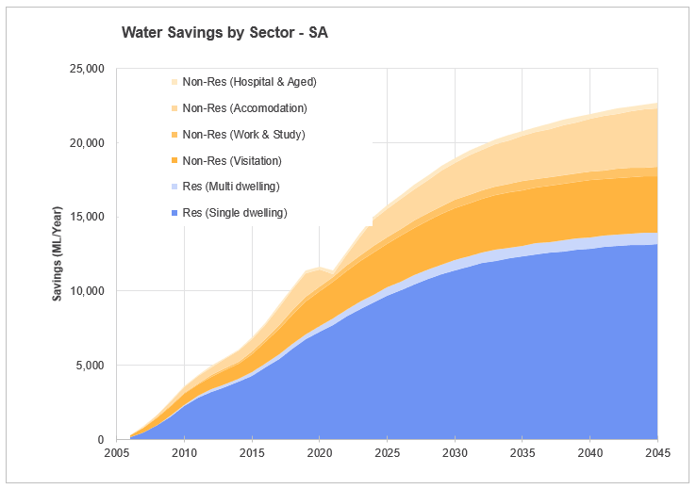
Figure G13 Water Savings by Sector – SA

In residential households, showers, basins, and washing machines account for most water savings, with total savings peaking at 14,000 ML/year in 2045. Growth is steepest until 2030, then slows as high-efficiency models become standard. In non-residential settings, basins dominate savings, followed by showers. Both fixtures show steep growth in savings until 2019, after which there is a sharp decline of almost 1000 ML/year throughout the COVID-19 pandemic until 2021. From here, high growth occurs until 2025, and then water savings slow through to 2045. The flatter curves of toilets and urinals indicate smaller and steadier savings with plateaus from around 2025 and 2030 respectively. As high-use fixtures such as tapware (predominately showers and basins) become more common in both residential and non-residential contexts, consistent and substantial savings are expected.
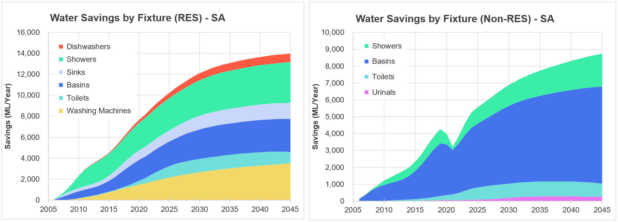
Figure G14 Water Savings by Fixture (Res and Non-Res) – SA

Energy and GHG Savings
Energy savings are projected to peak between 13,00 and 14,00 TJ/year by 2045 and are dominated by savings in gas. Both gas and electricity energy savings show higher growth until 2030, followed by slower growth and a plateau in electric savings. GHG savings are dominated by the residential sector, but both sectors experience the greatest growth between 2005 and 2023, followed by a second peak in 2027 and a sharp decline in savings before only very slight growth from 2032.
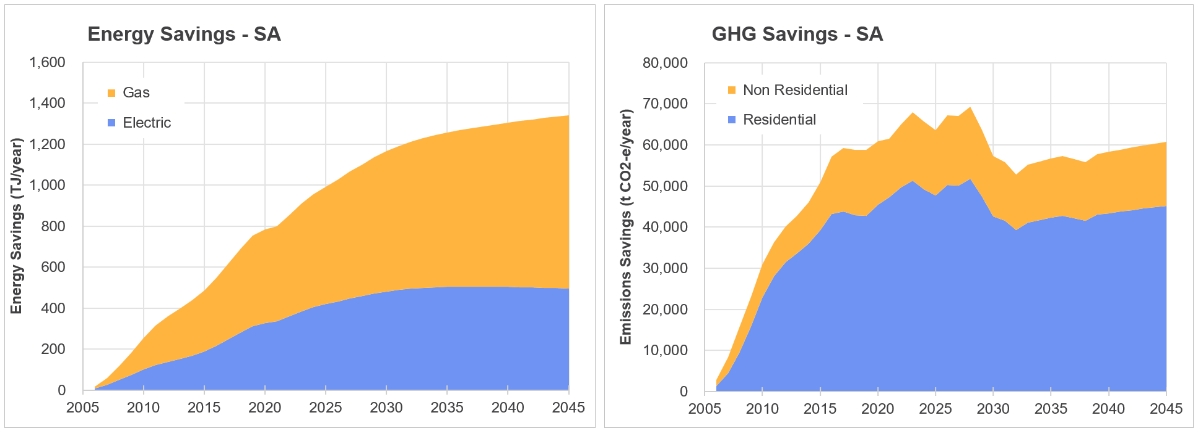
Figure G15 Energy and GHG Savings – SA

Bill Savings
By 2045, over half of total benefits will come from residential bill savings, with the majority of these from split between water, electricity and gas savings. Non-residential water and gas savings also show an even split, followed closely by savings in electricity. Total customer benefits have the strongest growth up to 2018, where they peak at just under 120M AUD/year. A small but rapid decline to 100M AUD/year in benefits then occurs until 2022, after which the total benefits grow rapidly again until 2025. The peak is more pronounced in the non-residential sector, probably as a result of the COVID-19 pandemic. Beyond 2025, there is a small but steady increase in total benefits. After 2025, GHG savings are more substantial in the residential sector.
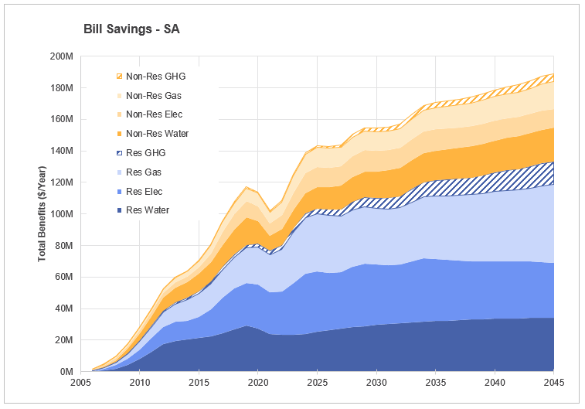
Figure G16 Bill Savings – SA
- WA

Water Savings
By 2045, Western Australia is expected to save around 34,000 ML/year of water across all sectors, over half by residential single dwellings. Visitation and accommodation facilities make the greatest contribution to non-residential dwellings, with work & study and hospital & aged care facilities making very minor contributions. Between 2020 and 2021 there is a small plateau in the hospital & aged care and accommodation water savings, before a sharp increase puts them back in line to mirror the savings growth of the other sectors. After 2030, water savings begin to plateau in all sectors due to uptake and near saturation of highly efficient fixtures.
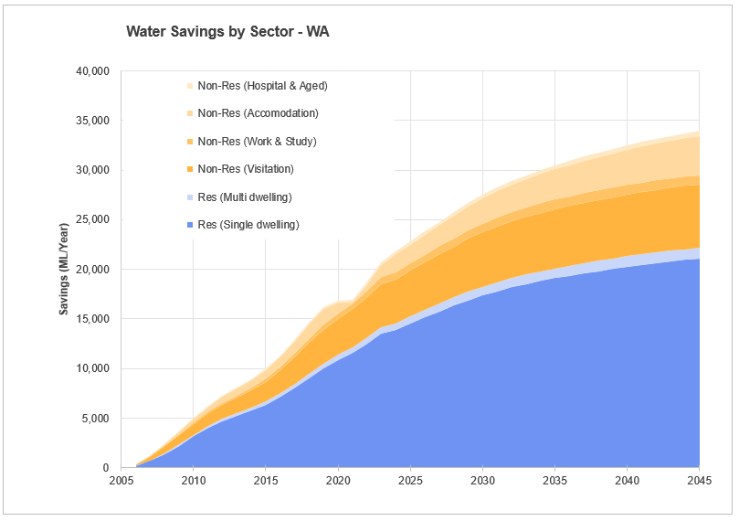
Figure G17 Water Savings by Sector – WA

In residential households, showers, basins, and washing machines account for most water savings, with total savings peaking at nearly 23,000 ML/year in 2045. Growth is steepest until 2030, then slows as high-efficiency models become standard. In non-residential settings, basins dominate savings, followed by showers. Both fixtures show steep growth until 2021, where water savings drops by about 800 ML/year. Beyond 2021, high growth occurs until 2025, followed by slower savings through to 2045. The flatter curves of toilets and urinals indicate smaller and steadier savings over the period.
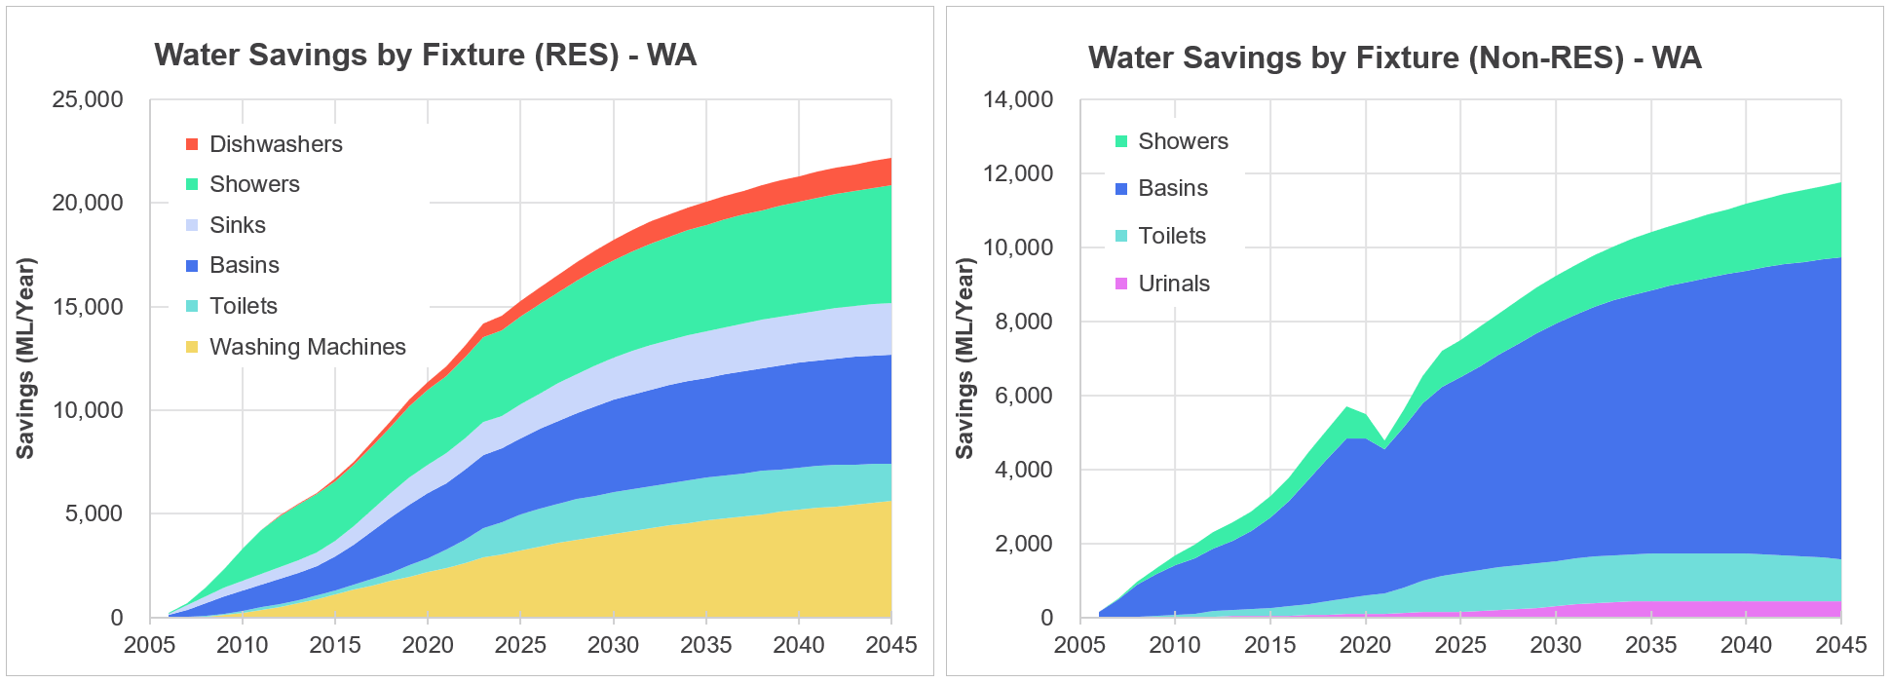
Figure G18 Water Savings by Fixture (Res and Non-Res) – WA

Energy and GHG Savings
Energy savings are expected to peak at nearly 19,00 TJ/year by 2045 and are dominated by savings in gas. Electricity savings show more gradual growth over the period, whereas gas savings are stronger until about 2030. The greatest GHG savings are made in the residential sector, however, both residential and non-residential sectors experience the greatest growth between 2005 and 2024, peaking at nearly 120,000 t CO₂/year. This peak is followed by a sharp decline in savings until 2030, where GHG savings slowly increase again until 2045.
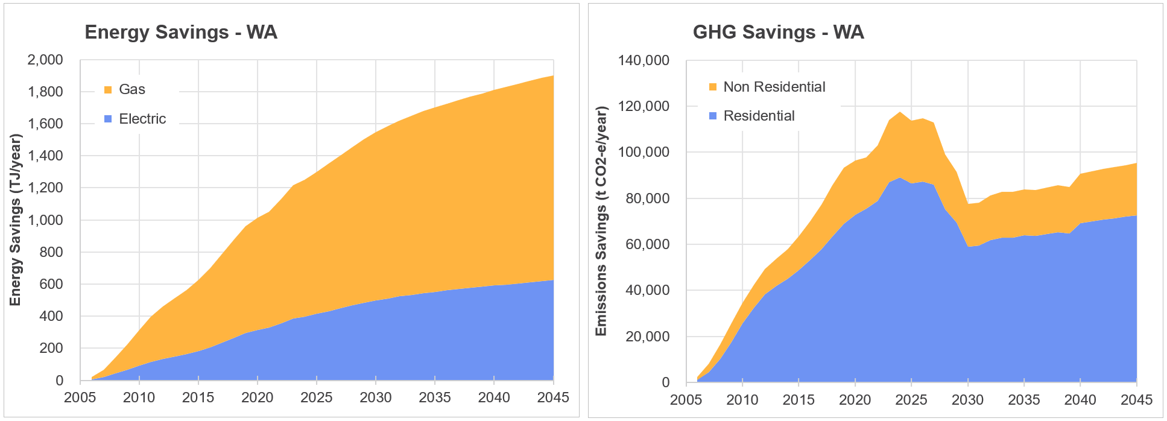
Figure G19 Energy and GHG Savings – WA

Bill Savings
By 2045, over half of total benefits will come from residential bill savings, with the majority of these split between water, electricity and gas savings. Non-residential water and gas savings also show an even split, followed closely by savings in electricity. Total customer benefits have the strongest growth up to 2020, where they peak at just under 120M AUD/year. A small but rapid decline to 100M AUD/year in benefits occurs in 2021 in conjunction with COVID-19 pandemic and is more pronounced in the residential sector. Beyond 2025, there is a small but steady increase in total benefits, and GHG savings are more substantial in the residential sector.
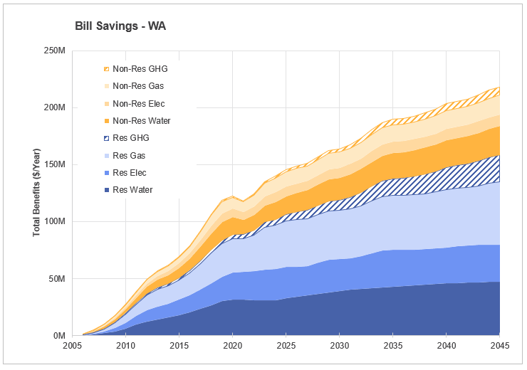
Figure G20 Bill Savings – WA
- Tasmania

Water Savings
By 2045, Tasmania is expected to save nearly 9,500 ML/year of water across all sectors. Residential single dwellings and non-residential accommodation dominate these savings, followed by savings in the visitation sector of around 1,000 ML/year. All other sectors provide minor contributions. Strong growth in all sectors occurs until 2021, where hospital & aged care and accommodation water savings decrease by about 900 ML/year. This fluctuation occurs in conjunction with the COVID-19 pandemic and does not affect any other sector. After 2025, growth begins to slow due to uptake and near saturation of highly efficient fixtures.
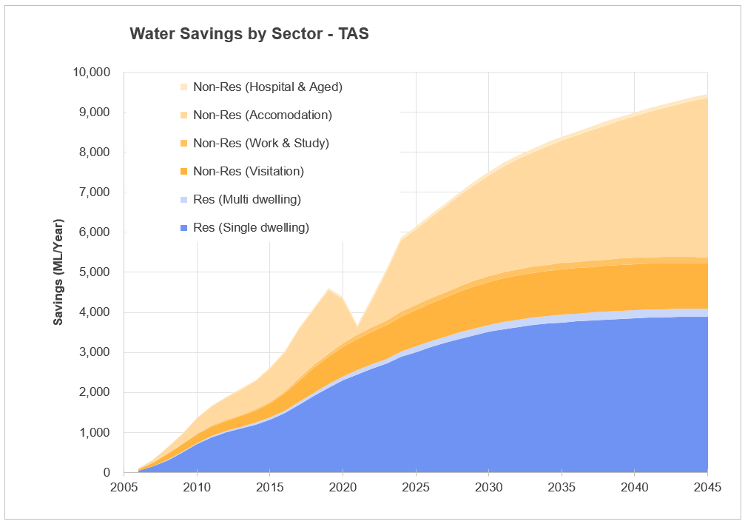
Figure G21 Water Savings by Sector – TAS

In residential households, showers, basins, and washing machines account for most water savings, with total savings peaking at just over 4,000 ML/year in 2045. Growth is steepest until 2030, then slows as high-efficiency models become standard. In non-residential settings, basins dominate savings, followed by showers. Both fixtures show steep growth in savings until 2021 where a sharp decline to around 1000 ML/year occurs. Water savings recover by 2024, and slow growth occurs until 2045. The flatter curve of toilets indicates smaller growth until 2025 followed by a plateau, and savings made by urinals are negligible.
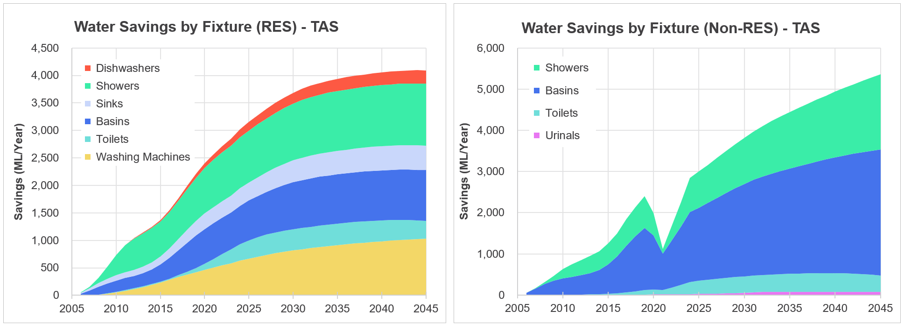
Figure G22 Water Savings by Fixture (Res and Non-Res) – TAS

Energy and GHG Savings
Energy savings are expected to peak at nearly 550 TJ/year by 2045 and are almost completely dominated by savings in electricity. Gas is expected to contribute to savings of less than 50 TJ/year. Energy savings in both gas and electricity follow the same curve, with high growth to a slight peak of around 310 TJ/year in 2019, after which, more gradual growth occurs. GHG savings fluctuate over the period, reaching peaks in 2011, 2021 and 2027, the highest of which is in 2027, at around 25,000 t CO₂/year for both residential and non-residential sectors. After 2035, GHG savings plateau at below 5,000 t CO₂/year. The greatest GHG emissions savings are consistently made in the residential sector.
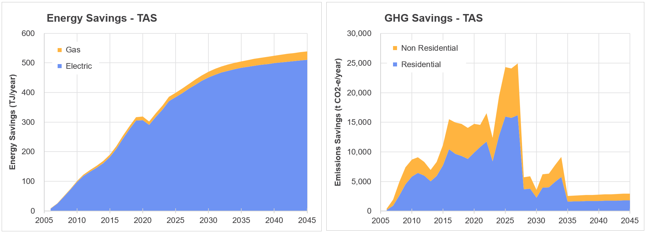
Figure G23 Energy and GHG Savings – WA

Bill Savings
By 2045, over half of total benefits (around 25M AUD/year) will come from residential bill savings, with residential electricity providing the majority. Electricity benefits also dominate the non-residential sector, followed by water benefits. Total customer benefits have the strongest growth up to 2019, where they peak at nearly 35M AUD/year followed by a small but rapid decline in 2021, after which the total benefits grow rapidly again until 2024. Beyond this, bill savings are projected to peak in 2034, before decreasing to plateau for all sectors as efficient fixtures near saturation in both residential and non-residential sectors.
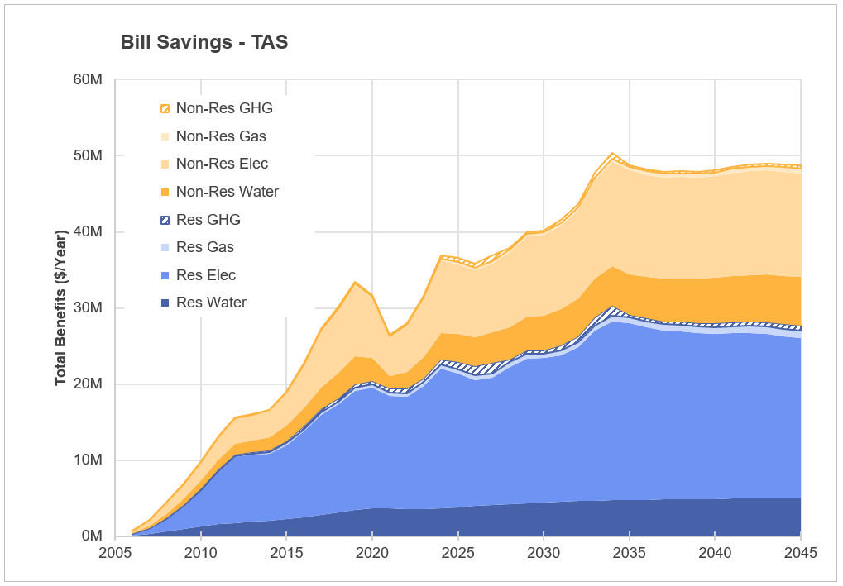
Figure G24 Bill Savings – TAS
- NT

Water Savings
Water savings in the NT are dominated non-residential accommodation, which contributes to over half of savings by 2045. In 2021, a rapid drop in this sector occurs in conjunction with COVID-19, where less than 200 ML/year of water is saved, but this picks back up in 2024. All other sectors follow a steadier water savings curve, and single dwellings dominate the residential sector, reaching nearly 1,500 ML/year of savings by 2045.
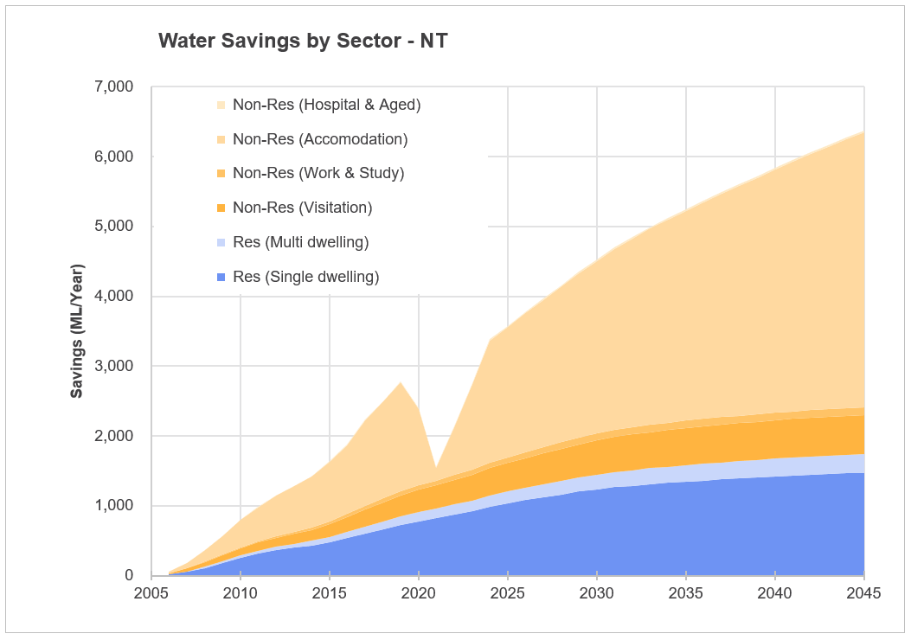
Figure G25 Water Savings by Sector – NT

In residential households, showers, basins, and washing machines account for most water savings, with total savings peaking at nearly 1,800 ML/year in 2045. Growth is steepest until 2030, then slows as high-efficiency models become standard. In non-residential settings, showers and basins dominate savings. Both fixtures show steep growth until 2019, where savings peaks at nearly 2,000 ML/year. In 2021, savings for these fixtures decrease, and almost no water savings made by showers in this year. However, in 2024, they recover and continue to grow steadily. The flatter curves of toilets indicate smaller and steadier savings over the period, water savings by urinals are negligible. As high-use fixtures such as tapware (predominately showers and basins) become more common in both residential and non-residential contexts, consistent and substantial savings are expected.
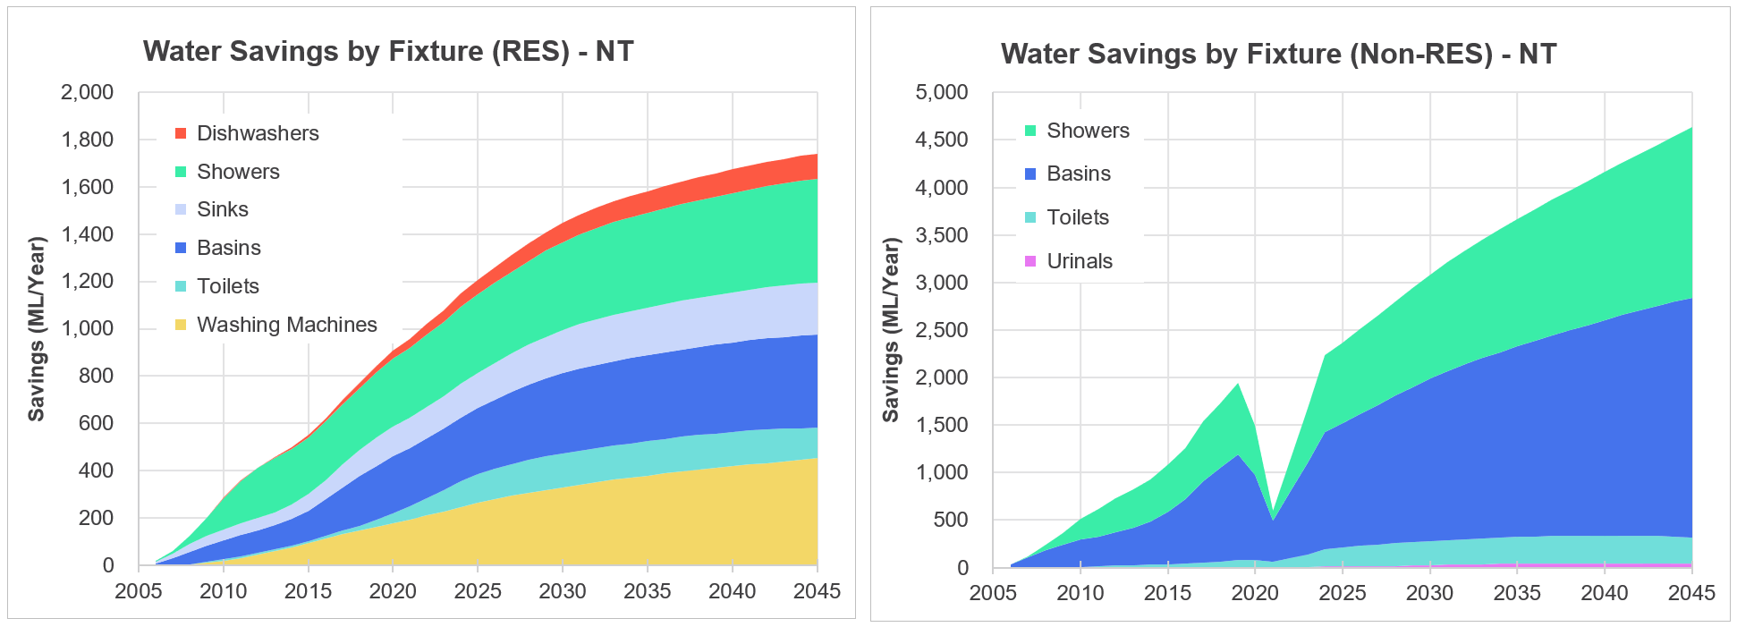
Figure G26 Water Savings by Fixture (Res and Non-Res) – NT

Energy and GHG Savings
Energy savings are the smallest of all states and are expected to peak at around 230 TJ/year by 2045. In the Northern Territories, they are almost totally dominated by savings in electricity. High growth occurs until 2021, where savings drop by about 40 TJ/year, but recover in 2024 to grow steadily. GHG savings remain relatively equal between the residential and non-residential sectors, with the non-residential sector showing greater fluctuations in savings over time. By 2045 both sectors are expected to save a total of nearly 24,000 t CO₂/year.
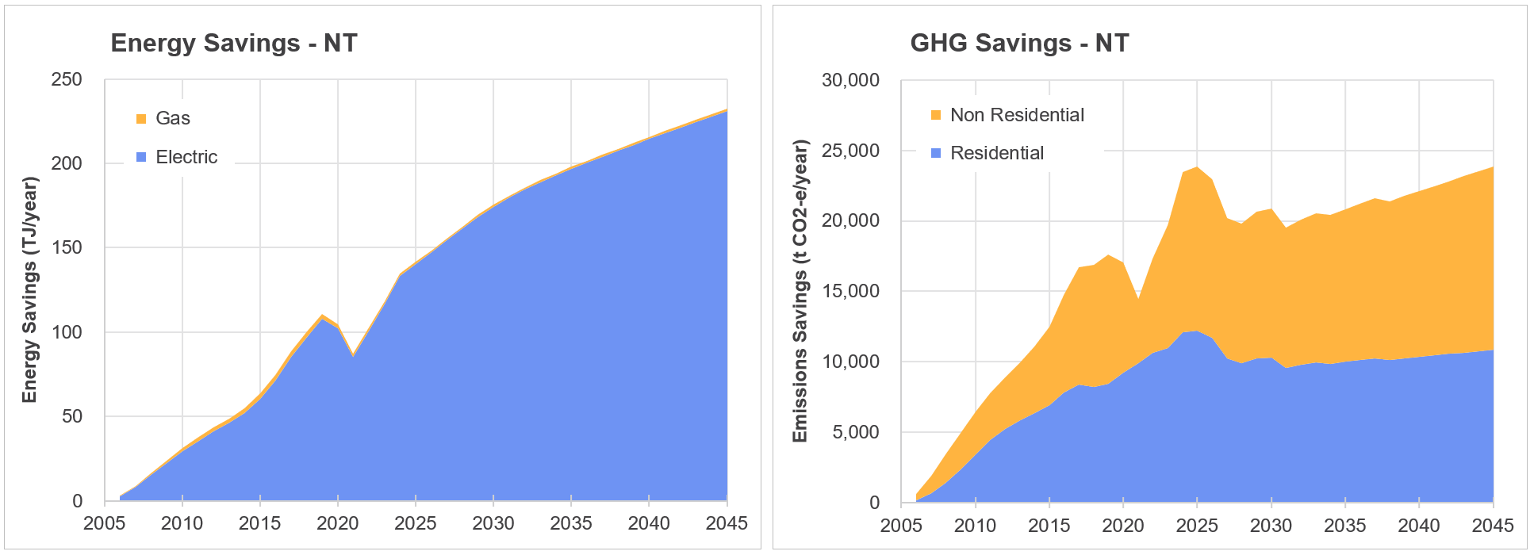
Figure G27 Energy and GHG Savings – NT

Bill Savings
By 2045, over half of total benefits are projected to come from non-residential bill savings, with the majority split between water and electricity. Electricity savings dominate in the residential sector, and no gas savings are apparent in either sector. Total customer benefits have the strongest growth up to 2019, where they peak at just under 18M AUD/year. A small but rapid decline to around 12M AUD/year in benefits then occurs in 2022 in conjunction with COVID-19 pandemic, after which the total benefits grow rapidly again until 2025. Beyond 2025, total benefits increase steadily, and GHG benefits remain relatively equal for both sectors.
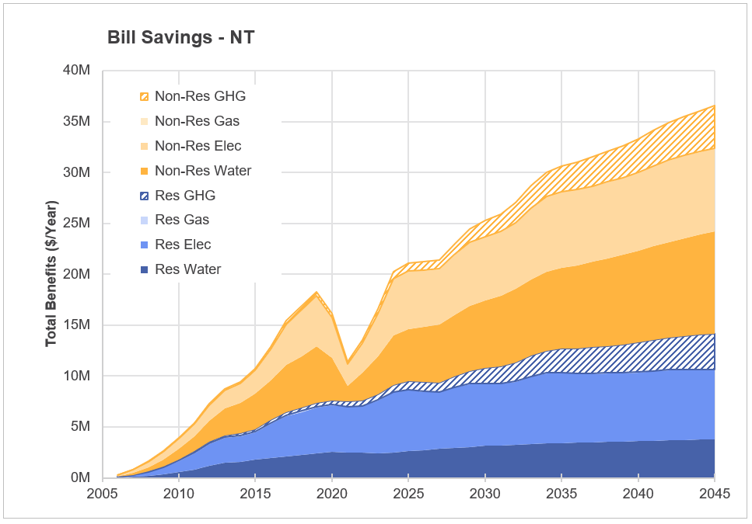
Figure G28 Bill Savings – NT
- ACT

Water Savings
By 2045, around 9,200 ML/year of water will be saved in the ACT across all sectors, the majority by non-residential accommodation, followed by residential single dwellings. Non-residential visitation and residential multi dwellings make smaller contributions. Again, there are almost no water savings in non-residential accommodation in 2021, causing the abrupt drop of around 1000 ML/year. All other sectors are unaffected. After 2030, water savings slow in all sectors due to uptake and near saturation of highly efficient fixtures.
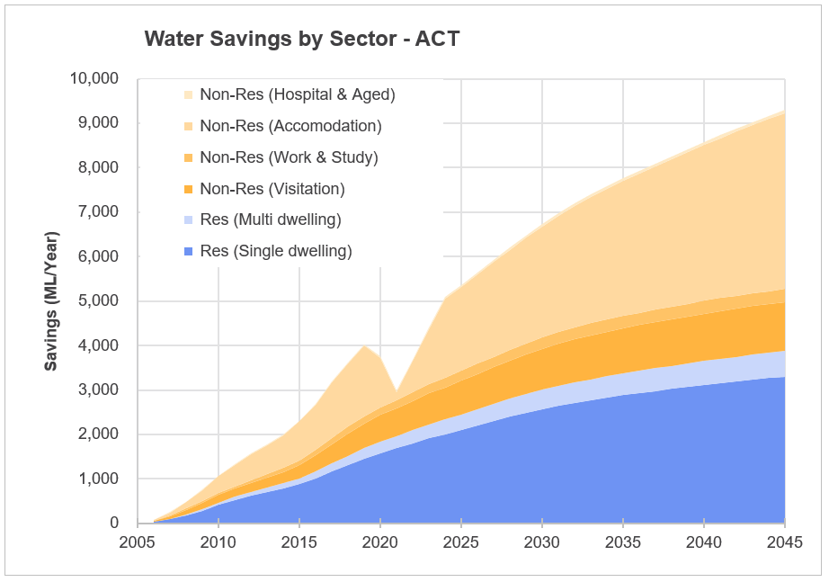
Figure G29 Water Savings by Sector – ACT

In residential households, showers, basins, and washing machines account for most water savings, with total savings peaking at nearly 4,000 ML/year in 2045. Growth is steepest until 2030, then slows as high-efficiency models become standard. In non-residential settings, basins dominate savings, followed by showers. Both fixtures show steep growth in savings until 2021, where there is an abrupt decrease in water savings for these two fixtures, and almost no savings made by showers in this year. However, by 2024, savings have stabilised and continue to grow steadily until 2045. Non-residential toilets show minor savings (consistently under 1,000 KL/year), while savings made by urinals are negligible. As high-use fixtures such as tapware (predominately showers and basins) become more common in both residential and non-residential contexts, consistent savings are expected for ACT.
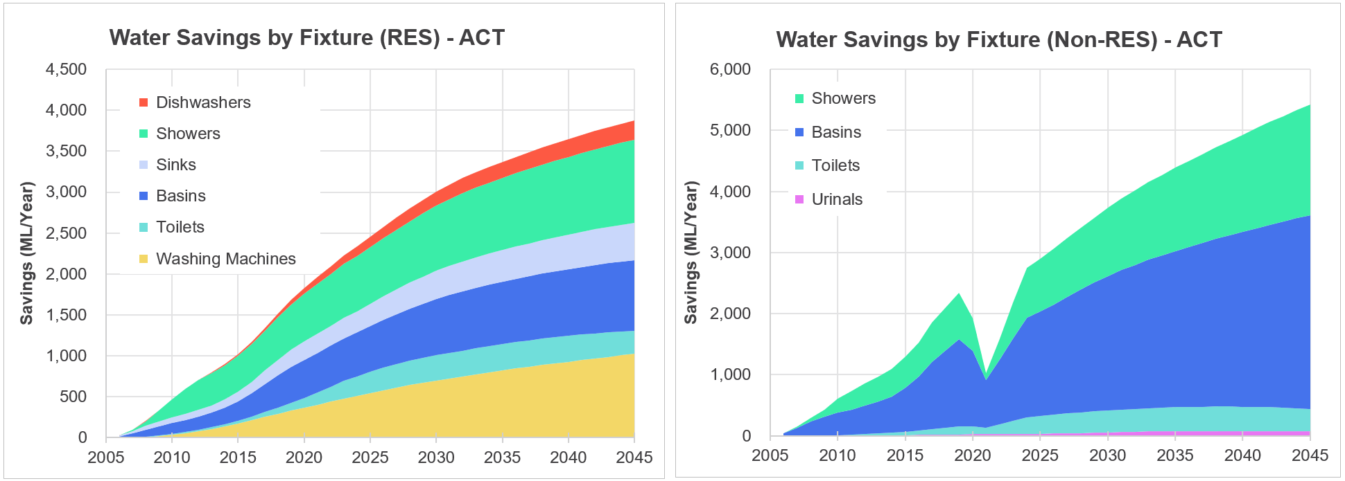
Figure G30 Water Savings by Fixture (Res and Non-Res) – ACT

Energy and GHG Savings
Energy savings are expected to peak at nearly 650 TJ/year by 2045 and are dominated by gas. Electricity savings show more gradual growth early on, followed a plateau from 2025 at around 100 TJ/year. A small drop in gas savings occurs in 2021 but recovers by 2024 to increase steadily until 2045. The greatest GHG savings are made in the residential sector (20,000 t CO₂/year expected in 2045), but both sectors experience the greatest growth between 2005 and 2024, peaking at nearly 37, 000 t CO₂/year. This peak is followed by a decline in savings until 2030, where GHG savings slowly increase again until 2045.
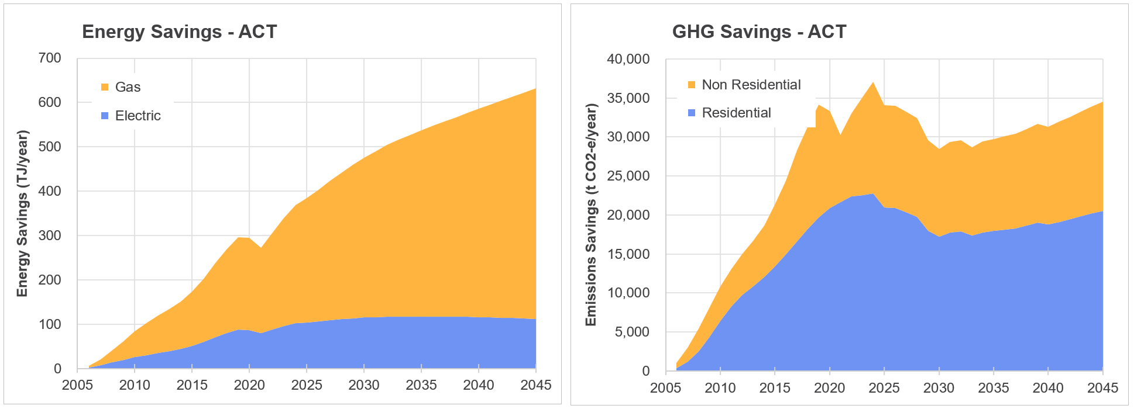
Figure G31 Energy and GHG Savings – ACT

Bill Savings
By 2045, a relatively even split in total benefits is expected between the residential and non-residential sectors, with total benefits reaching nearly 59M AUD/year. In both sectors, water benefits dominate, followed by gas benefits. Small benefits are expected for electricity, and GHG benefits are negligible. The 2021 drop in conjunction with COVID-19 has the greatest impact on the non-residential sector, which recovers by 2024.
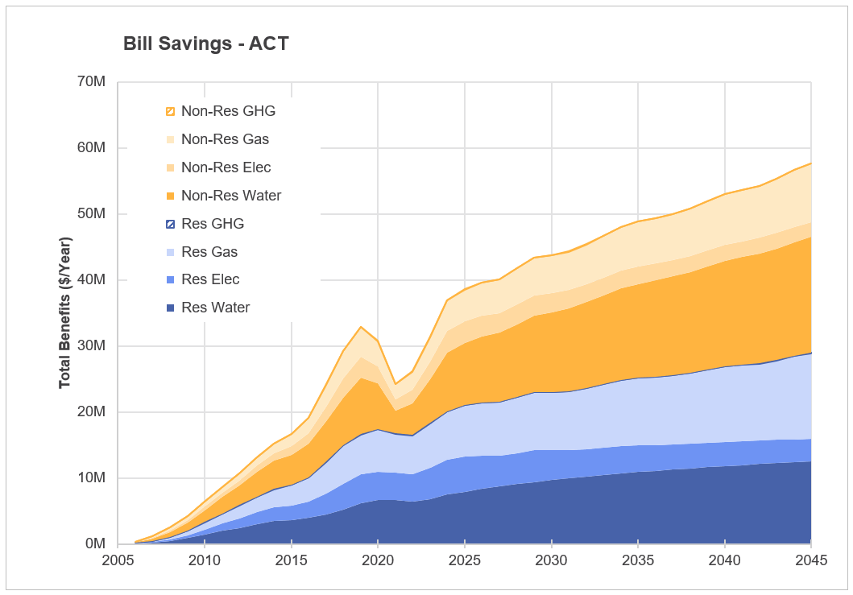
FigureG32 Bill Savings – ACT

- All Results Tables

Water Savings Results
Table H112 Calendar year annual water savings for each state
Calendar | Water savings, GL/yr
Year | NSW | VIC | QLD | SA | WA | TAS | NT | ACT | Total | Cumul.
2006 | 1.1 | 0.9 | 0.7 | 0.3 | 0.4 | 0.1 | 0.1 | 0.1 | 3.6 | 3.6
2007 | 3.4 | 2.8 | 2.1 | 0.9 | 1.2 | 0.3 | 0.2 | 0.3 | 11.3 | 14.9
2008 | 6.6 | 5.5 | 4.1 | 1.7 | 2.4 | 0.6 | 0.4 | 0.5 | 21.7 | 36.6
2009 | 9.9 | 8.4 | 6.2 | 2.6 | 3.7 | 1.0 | 0.6 | 0.8 | 33.0 | 69.6
2010 | 13.3 | 11.4 | 8.3 | 3.6 | 5.0 | 1.4 | 0.8 | 1.1 | 44.8 | 114.4
2011 | 16.2 | 14.0 | 10.1 | 4.3 | 6.2 | 1.7 | 1.0 | 1.3 | 54.8 | 169.3
2012 | 18.7 | 16.2 | 11.7 | 5.0 | 7.2 | 1.9 | 1.1 | 1.6 | 63.4 | 232.7
2013 | 20.9 | 18.3 | 13.1 | 5.5 | 8.1 | 2.1 | 1.3 | 1.8 | 71.0 | 303.7
2014 | 23.4 | 20.5 | 14.7 | 6.1 | 8.9 | 2.3 | 1.4 | 2.0 | 79.3 | 383.1
2015 | 26.7 | 23.4 | 16.7 | 6.9 | 10.0 | 2.6 | 1.6 | 2.3 | 90.2 | 473.3
2016 | 30.9 | 27.0 | 19.2 | 7.9 | 11.3 | 3.0 | 1.9 | 2.7 | 103.8 | 577.1
2017 | 35.7 | 31.1 | 22.1 | 9.1 | 13.0 | 3.6 | 2.2 | 3.2 | 119.9 | 697.1
2018 | 40.3 | 35.0 | 25.0 | 10.3 | 14.6 | 4.1 | 2.5 | 3.6 | 135.3 | 832.4
2019 | 44.4 | 38.6 | 27.6 | 11.4 | 16.2 | 4.6 | 2.8 | 4.0 | 149.6 | 982.0
2020 | 46.7 | 40.4 | 29.1 | 11.6 | 16.9 | 4.4 | 2.4 | 3.8 | 155.2 | 1,137.3
2021 | 48.4 | 41.4 | 30.1 | 11.4 | 16.9 | 3.7 | 1.6 | 3.0 | 156.3 | 1,293.6
2022 | 52.1 | 44.8 | 32.8 | 12.6 | 18.7 | 4.4 | 2.1 | 3.7 | 171.3 | 1,464.9
2023 | 56.1 | 48.5 | 35.6 | 13.9 | 20.7 | 5.1 | 2.8 | 4.4 | 187.0 | 1,651.9
2024 | 59.3 | 51.1 | 37.7 | 15.0 | 21.8 | 5.9 | 3.4 | 5.1 | 199.3 | 1,851.2
2025 | 62.3 | 53.8 | 39.6 | 15.8 | 22.8 | 6.2 | 3.6 | 5.4 | 209.3 | 2,060.5
2026 | 65.2 | 56.5 | 41.4 | 16.5 | 23.8 | 6.4 | 3.8 | 5.6 | 219.2 | 2,279.7
2027 | 68.1 | 59.1 | 43.2 | 17.2 | 24.8 | 6.7 | 4.0 | 5.9 | 228.9 | 2,508.6
2028 | 70.8 | 61.7 | 44.9 | 17.8 | 25.7 | 7.0 | 4.2 | 6.2 | 238.2 | 2,746.8
2029 | 73.3 | 64.0 | 46.5 | 18.4 | 26.6 | 7.3 | 4.4 | 6.5 | 247.0 | 2,993.8
2030 | 75.6 | 66.2 | 48.0 | 19.0 | 27.5 | 7.5 | 4.5 | 6.7 | 255.1 | 3,248.9
2031 | 77.7 | 68.2 | 49.3 | 19.4 | 28.2 | 7.7 | 4.7 | 7.0 | 262.3 | 3,511.1
2032 | 79.5 | 70.0 | 50.4 | 19.9 | 28.9 | 7.9 | 4.8 | 7.2 | 268.6 | 3,779.8
2033 | 81.1 | 71.6 | 51.5 | 20.2 | 29.5 | 8.1 | 5.0 | 7.4 | 274.3 | 4,054.1
2034 | 82.5 | 73.0 | 52.4 | 20.5 | 30.0 | 8.2 | 5.1 | 7.6 | 279.4 | 4,333.5
2035 | 83.8 | 74.4 | 53.3 | 20.8 | 30.5 | 8.4 | 5.2 | 7.8 | 284.2 | 4,617.7
2036 | 85.1 | 75.6 | 54.0 | 21.1 | 30.9 | 8.5 | 5.4 | 7.9 | 288.5 | 4,906.2
2037 | 86.2 | 76.8 | 54.8 | 21.3 | 31.3 | 8.6 | 5.5 | 8.1 | 292.7 | 5,198.9
2038 | 87.3 | 78.0 | 55.5 | 21.5 | 31.7 | 8.8 | 5.6 | 8.3 | 296.7 | 5,495.7
2039 | 88.4 | 79.1 | 56.2 | 21.8 | 32.1 | 8.9 | 5.7 | 8.4 | 300.6 | 5,796.2
2040 | 89.4 | 80.2 | 56.8 | 22.0 | 32.5 | 9.0 | 5.8 | 8.6 | 304.3 | 6,100.5
2041 | 90.3 | 81.2 | 57.4 | 22.1 | 32.8 | 9.1 | 5.9 | 8.7 | 307.8 | 6,408.3
2042 | 91.2 | 82.2 | 58.0 | 22.3 | 33.1 | 9.2 | 6.1 | 8.9 | 311.1 | 6,719.4
2043 | 92.0 | 83.1 | 58.5 | 22.5 | 33.4 | 9.3 | 6.2 | 9.0 | 314.1 | 7,033.5
2044 | 92.8 | 84.0 | 59.0 | 22.6 | 33.7 | 9.4 | 6.3 | 9.2 | 316.9 | 7,350.4
2045 | 93.5 | 84.8 | 59.5 | 22.7 | 33.9 | 9.5 | 6.4 | 9.3 | 319.5 | 7,669.9
Table 13H2 Financial year annual water savings for each state
Financial | Water savings, GL/yr
Year | NSW | VIC | QLD | SA | WA | TAS | NT | ACT | Total | Cumul.
2006/2007 | 2.3 | 1.9 | 1.4 | 0.6 | 0.8 | 0.2 | 0.1 | 0.2 | 7.4 | 7.4
2007/2008 | 5.0 | 4.1 | 3.1 | 1.3 | 1.8 | 0.5 | 0.3 | 0.4 | 16.5 | 23.9
2008/2009 | 8.2 | 6.9 | 5.1 | 2.2 | 3.0 | 0.8 | 0.5 | 0.6 | 27.4 | 51.3
2009/2010 | 11.6 | 9.9 | 7.2 | 3.1 | 4.3 | 1.2 | 0.7 | 0.9 | 38.9 | 90.2
2010/2011 | 14.7 | 12.7 | 9.2 | 3.9 | 5.6 | 1.5 | 0.9 | 1.2 | 49.8 | 140.0
2011/2012 | 17.4 | 15.1 | 10.9 | 4.7 | 6.7 | 1.8 | 1.1 | 1.4 | 59.1 | 199.2
2012/2013 | 19.8 | 17.3 | 12.4 | 5.2 | 7.6 | 2.0 | 1.2 | 1.7 | 67.2 | 266.4
2013/2014 | 22.2 | 19.4 | 13.9 | 5.8 | 8.5 | 2.2 | 1.4 | 1.9 | 75.2 | 341.6
2014/2015 | 25.1 | 22.0 | 15.7 | 6.5 | 9.4 | 2.5 | 1.5 | 2.2 | 84.8 | 426.4
2015/2016 | 28.8 | 25.2 | 17.9 | 7.4 | 10.6 | 2.8 | 1.8 | 2.5 | 97.0 | 523.4
2016/2017 | 33.3 | 29.0 | 20.6 | 8.5 | 12.1 | 3.3 | 2.1 | 2.9 | 111.9 | 635.3
2017/2018 | 38.0 | 33.0 | 23.5 | 9.7 | 13.8 | 3.9 | 2.4 | 3.4 | 127.6 | 762.9
2018/2019 | 42.3 | 36.8 | 26.3 | 10.8 | 15.4 | 4.4 | 2.6 | 3.8 | 142.5 | 905.4
2019/2020 | 45.6 | 39.5 | 28.3 | 11.5 | 16.5 | 4.5 | 2.6 | 3.9 | 152.4 | 1,057.8
2020/2021 | 47.6 | 40.9 | 29.6 | 11.5 | 16.9 | 4.0 | 2.0 | 3.4 | 155.8 | 1,213.6
2021/2022 | 50.3 | 43.1 | 31.4 | 12.0 | 17.8 | 4.0 | 1.8 | 3.3 | 163.8 | 1,377.5
2022/2023 | 54.1 | 46.7 | 34.2 | 13.3 | 19.7 | 4.7 | 2.4 | 4.0 | 179.2 | 1,556.6
2023/2024 | 57.7 | 49.8 | 36.6 | 14.5 | 21.2 | 5.5 | 3.1 | 4.7 | 193.1 | 1,749.7
2024/2025 | 60.8 | 52.5 | 38.6 | 15.4 | 22.3 | 6.0 | 3.5 | 5.2 | 204.3 | 1,954.0
2025/2026 | 63.7 | 55.2 | 40.5 | 16.1 | 23.3 | 6.3 | 3.7 | 5.5 | 214.3 | 2,168.3
2026/2027 | 66.6 | 57.8 | 42.3 | 16.8 | 24.3 | 6.6 | 3.9 | 5.8 | 224.1 | 2,392.4
2027/2028 | 69.4 | 60.4 | 44.0 | 17.5 | 25.3 | 6.9 | 4.1 | 6.1 | 233.6 | 2,625.9
2028/2029 | 72.0 | 62.9 | 45.7 | 18.1 | 26.2 | 7.1 | 4.3 | 6.3 | 242.6 | 2,868.5
2029/2030 | 74.5 | 65.1 | 47.2 | 18.7 | 27.1 | 7.4 | 4.4 | 6.6 | 251.0 | 3,119.6
2030/2031 | 76.7 | 67.2 | 48.6 | 19.2 | 27.9 | 7.6 | 4.6 | 6.9 | 258.7 | 3,378.2
2031/2032 | 78.6 | 69.1 | 49.9 | 19.7 | 28.6 | 7.8 | 4.8 | 7.1 | 265.4 | 3,643.7
2032/2033 | 80.3 | 70.8 | 51.0 | 20.0 | 29.2 | 8.0 | 4.9 | 7.3 | 271.5 | 3,915.1
2033/2034 | 81.8 | 72.3 | 51.9 | 20.4 | 29.8 | 8.2 | 5.1 | 7.5 | 276.9 | 4,192.0
2034/2035 | 83.2 | 73.7 | 52.8 | 20.7 | 30.3 | 8.3 | 5.2 | 7.7 | 281.8 | 4,473.8
2035/2036 | 84.4 | 75.0 | 53.7 | 20.9 | 30.7 | 8.5 | 5.3 | 7.8 | 286.3 | 4,760.2
2036/2037 | 85.6 | 76.2 | 54.4 | 21.2 | 31.1 | 8.6 | 5.4 | 8.0 | 290.6 | 5,050.8
2037/2038 | 86.8 | 77.4 | 55.1 | 21.4 | 31.5 | 8.7 | 5.5 | 8.2 | 294.7 | 5,345.5
2038/2039 | 87.9 | 78.6 | 55.8 | 21.6 | 31.9 | 8.8 | 5.7 | 8.3 | 298.6 | 5,644.2
2039/2040 | 88.9 | 79.7 | 56.5 | 21.9 | 32.3 | 8.9 | 5.8 | 8.5 | 302.4 | 5,946.6
2040/2041 | 89.9 | 80.7 | 57.1 | 22.1 | 32.7 | 9.0 | 5.9 | 8.7 | 306.0 | 6,252.6
2041/2042 | 90.8 | 81.7 | 57.7 | 22.2 | 33.0 | 9.2 | 6.0 | 8.8 | 309.4 | 6,562.0
2042/2043 | 91.6 | 82.7 | 58.3 | 22.4 | 33.3 | 9.2 | 6.1 | 9.0 | 312.6 | 6,874.6
2043/2044 | 92.4 | 83.6 | 58.8 | 22.5 | 33.6 | 9.3 | 6.2 | 9.1 | 315.5 | 7,190.1
2044/2045 | 93.1 | 84.4 | 59.2 | 22.6 | 33.8 | 9.4 | 6.3 | 9.2 | 318.2 | 7,508.4
2045/2046 | 93.8 | 85.3 | 59.7 | 22.8 | 34.1 | 9.5 | 6.4 | 9.4 | 320.9 | 7,829.3

Energy Savings Results

Electricity Savings Results
Table H314 Calendar year annual electricity savings for each state
Calendar | Annual Electricity Savings (TJ/year)
Year | NSW | VIC | QLD | SA | WA | TAS | NT | ACT | Total | Cumul.
2006 | 30 | 19 | 42 | 8 | 6 | 8 | 3 | 3 | 119 | 119
2007 | 89 | 62 | 131 | 26 | 21 | 24 | 8 | 8 | 369 | 488
2008 | 170 | 122 | 254 | 49 | 43 | 47 | 15 | 13 | 713 | 1,201
2009 | 266 | 193 | 390 | 74 | 67 | 71 | 22 | 19 | 1,102 | 2,304
2010 | 369 | 264 | 530 | 101 | 93 | 97 | 29 | 25 | 1,510 | 3,813
2011 | 458 | 324 | 654 | 121 | 116 | 118 | 35 | 30 | 1,857 | 5,670
2012 | 535 | 372 | 762 | 138 | 135 | 133 | 41 | 35 | 2,151 | 7,821
2013 | 604 | 414 | 859 | 152 | 150 | 146 | 46 | 39 | 2,410 | 10,231
2014 | 679 | 459 | 967 | 168 | 164 | 161 | 52 | 44 | 2,694 | 12,925
2015 | 775 | 516 | 1,103 | 189 | 183 | 182 | 61 | 51 | 3,059 | 15,985
2016 | 892 | 588 | 1,275 | 216 | 207 | 209 | 71 | 60 | 3,518 | 19,502
2017 | 1,023 | 670 | 1,477 | 248 | 236 | 244 | 85 | 70 | 4,053 | 23,555
2018 | 1,150 | 752 | 1,676 | 281 | 265 | 277 | 97 | 80 | 4,577 | 28,132
2019 | 1,264 | 827 | 1,860 | 311 | 294 | 305 | 108 | 88 | 5,057 | 33,189
2020 | 1,332 | 871 | 1,980 | 328 | 314 | 306 | 102 | 87 | 5,319 | 38,508
2021 | 1,386 | 901 | 2,091 | 336 | 328 | 291 | 85 | 79 | 5,498 | 44,006
2022 | 1,458 | 963 | 2,247 | 361 | 356 | 318 | 101 | 87 | 5,891 | 49,898
2023 | 1,528 | 1,029 | 2,402 | 385 | 385 | 343 | 117 | 95 | 6,284 | 56,182
2024 | 1,574 | 1,073 | 2,517 | 404 | 398 | 371 | 133 | 102 | 6,573 | 62,754
2025 | 1,619 | 1,124 | 2,621 | 419 | 414 | 384 | 140 | 104 | 6,827 | 69,581
2026 | 1,662 | 1,177 | 2,734 | 433 | 432 | 398 | 147 | 106 | 7,090 | 76,671
2027 | 1,702 | 1,405 | 2,843 | 447 | 450 | 412 | 154 | 109 | 7,522 | 84,193
2028 | 1,738 | 1,639 | 2,949 | 459 | 467 | 426 | 161 | 111 | 7,951 | 92,144
2029 | 1,770 | 1,876 | 3,049 | 471 | 483 | 439 | 168 | 113 | 8,369 | 100,513
2030 | 1,794 | 2,114 | 3,139 | 481 | 498 | 451 | 174 | 115 | 8,766 | 109,280
2031 | 1,813 | 2,350 | 3,217 | 489 | 512 | 460 | 180 | 116 | 9,136 | 118,415
2032 | 1,826 | 2,581 | 3,286 | 494 | 524 | 468 | 185 | 117 | 9,480 | 127,895
2033 | 1,835 | 2,804 | 3,346 | 498 | 534 | 474 | 189 | 117 | 9,798 | 137,692
2034 | 1,841 | 3,013 | 3,400 | 501 | 544 | 479 | 193 | 117 | 10,088 | 147,780
2035 | 1,845 | 3,206 | 3,450 | 503 | 553 | 483 | 197 | 117 | 10,353 | 158,133
2036 | 1,847 | 3,381 | 3,495 | 504 | 561 | 487 | 200 | 117 | 10,592 | 168,725
2037 | 1,849 | 3,536 | 3,539 | 504 | 569 | 490 | 204 | 117 | 10,807 | 179,533
2038 | 1,850 | 3,671 | 3,581 | 504 | 576 | 493 | 208 | 117 | 11,000 | 190,533
2039 | 1,851 | 3,787 | 3,621 | 504 | 584 | 496 | 211 | 116 | 11,171 | 201,704
2040 | 1,851 | 3,886 | 3,661 | 503 | 591 | 499 | 214 | 116 | 11,322 | 213,027
2041 | 1,852 | 3,968 | 3,700 | 502 | 598 | 502 | 218 | 115 | 11,455 | 224,481
2042 | 1,851 | 4,035 | 3,737 | 501 | 605 | 504 | 221 | 115 | 11,570 | 236,051
2043 | 1,850 | 4,089 | 3,773 | 499 | 612 | 507 | 225 | 114 | 11,669 | 247,720
2044 | 1,848 | 4,133 | 3,808 | 497 | 618 | 509 | 228 | 113 | 11,755 | 259,475
2045 | 1,846 | 4,168 | 3,842 | 495 | 625 | 511 | 231 | 112 | 11,829 | 271,304

Table H415 Financial year annual electricity savings for each state
Financial | Annual Electricity Savings (TJ/year)
Year | NSW | VIC | QLD | SA | WA | TAS | NT | ACT | Total | Cumul.
2006/2007 | 59 | 40 | 87 | 17 | 14 | 16 | 6 | 5 | 244 | 244
2007/2008 | 130 | 92 | 192 | 37 | 32 | 36 | 12 | 11 | 541 | 785
2008/2009 | 218 | 157 | 322 | 62 | 55 | 59 | 19 | 16 | 908 | 1,693
2009/2010 | 317 | 228 | 460 | 87 | 80 | 84 | 26 | 22 | 1,306 | 2,999
2010/2011 | 414 | 294 | 592 | 111 | 105 | 108 | 32 | 28 | 1,683 | 4,682
2011/2012 | 496 | 348 | 708 | 130 | 126 | 125 | 38 | 33 | 2,004 | 6,686
2012/2013 | 569 | 393 | 811 | 145 | 142 | 140 | 44 | 37 | 2,280 | 8,966
2013/2014 | 642 | 436 | 913 | 160 | 157 | 154 | 49 | 42 | 2,552 | 11,518
2014/2015 | 727 | 487 | 1,035 | 178 | 174 | 172 | 56 | 48 | 2,877 | 14,395
2015/2016 | 833 | 552 | 1,189 | 202 | 195 | 196 | 66 | 55 | 3,288 | 17,684
2016/2017 | 957 | 629 | 1,376 | 232 | 221 | 227 | 78 | 65 | 3,785 | 21,469
2017/2018 | 1,086 | 711 | 1,576 | 265 | 250 | 260 | 91 | 75 | 4,315 | 25,784
2018/2019 | 1,207 | 789 | 1,768 | 296 | 280 | 291 | 102 | 84 | 4,817 | 30,601
2019/2020 | 1,298 | 849 | 1,920 | 320 | 304 | 306 | 105 | 87 | 5,188 | 35,789
2020/2021 | 1,359 | 886 | 2,036 | 332 | 321 | 299 | 94 | 83 | 5,409 | 41,198
2021/2022 | 1,422 | 932 | 2,169 | 349 | 342 | 304 | 93 | 83 | 5,695 | 46,892
2022/2023 | 1,493 | 996 | 2,325 | 373 | 370 | 330 | 109 | 91 | 6,088 | 52,980
2023/2024 | 1,551 | 1,051 | 2,460 | 394 | 392 | 357 | 125 | 99 | 6,428 | 59,408
2024/2025 | 1,597 | 1,099 | 2,569 | 411 | 406 | 378 | 137 | 103 | 6,700 | 66,108
2025/2026 | 1,641 | 1,151 | 2,678 | 426 | 423 | 391 | 144 | 105 | 6,958 | 73,067
2026/2027 | 1,682 | 1,291 | 2,788 | 440 | 441 | 405 | 151 | 108 | 7,306 | 80,373
2027/2028 | 1,720 | 1,522 | 2,896 | 453 | 458 | 419 | 158 | 110 | 7,736 | 88,109
2028/2029 | 1,754 | 1,757 | 2,999 | 465 | 475 | 433 | 165 | 112 | 8,160 | 96,269
2029/2030 | 1,782 | 1,995 | 3,094 | 476 | 491 | 445 | 171 | 114 | 8,568 | 104,837
2030/2031 | 1,803 | 2,232 | 3,178 | 485 | 505 | 455 | 177 | 116 | 8,951 | 113,788
2031/2032 | 1,819 | 2,465 | 3,251 | 491 | 518 | 464 | 182 | 116 | 9,308 | 123,095
2032/2033 | 1,830 | 2,692 | 3,316 | 496 | 529 | 471 | 187 | 117 | 9,639 | 132,734
2033/2034 | 1,838 | 2,908 | 3,373 | 500 | 539 | 476 | 191 | 117 | 9,943 | 142,677
2034/2035 | 1,843 | 3,109 | 3,425 | 502 | 548 | 481 | 195 | 117 | 10,220 | 152,897
2035/2036 | 1,846 | 3,293 | 3,472 | 503 | 557 | 485 | 199 | 117 | 10,473 | 163,370
2036/2037 | 1,848 | 3,458 | 3,517 | 504 | 565 | 488 | 202 | 117 | 10,700 | 174,069
2037/2038 | 1,849 | 3,603 | 3,560 | 504 | 573 | 492 | 206 | 117 | 10,904 | 184,973
2038/2039 | 1,850 | 3,729 | 3,601 | 504 | 580 | 495 | 209 | 117 | 11,086 | 196,059
2039/2040 | 1,851 | 3,837 | 3,641 | 503 | 588 | 498 | 213 | 116 | 11,247 | 207,306
2040/2041 | 1,852 | 3,927 | 3,680 | 503 | 595 | 501 | 216 | 116 | 11,388 | 218,694
2041/2042 | 1,851 | 4,001 | 3,718 | 502 | 602 | 503 | 220 | 115 | 11,512 | 230,206
2042/2043 | 1,851 | 4,062 | 3,755 | 500 | 609 | 505 | 223 | 114 | 11,619 | 241,826
2043/2044 | 1,849 | 4,111 | 3,791 | 498 | 615 | 508 | 226 | 113 | 11,712 | 253,538
2044/2045 | 1,847 | 4,151 | 3,825 | 496 | 622 | 510 | 229 | 112 | 11,792 | 265,330
2045/2046 | 1,845 | 4,190 | 3,859 | 494 | 628 | 512 | 233 | 111 | 11,872 | 277,202

Gas Savings Results
Table 16H5 Calendar year annual gas savings for each state
Calendar | Annual Gas Savings (TJ/year)
Year | NSW | VIC | QLD | SA | WA | TAS | NT | ACT | Total | Cumul.
2006 | 27 | 47 | 13 | 10 | 14 | 0 | 0 | 4 | 115 | 115
2007 | 96 | 154 | 45 | 32 | 47 | 1 | 0 | 13 | 389 | 504
2008 | 206 | 314 | 91 | 66 | 97 | 2 | 1 | 27 | 804 | 1,307
2009 | 343 | 507 | 141 | 109 | 156 | 3 | 1 | 42 | 1,303 | 2,610
2010 | 494 | 714 | 191 | 155 | 221 | 4 | 2 | 59 | 1,840 | 4,450
2011 | 622 | 894 | 231 | 193 | 279 | 5 | 2 | 72 | 2,299 | 6,748
2012 | 725 | 1,043 | 263 | 223 | 327 | 6 | 2 | 84 | 2,674 | 9,422
2013 | 807 | 1,169 | 286 | 247 | 365 | 6 | 3 | 95 | 2,978 | 12,400
2014 | 886 | 1,298 | 306 | 269 | 400 | 7 | 3 | 107 | 3,276 | 15,676
2015 | 979 | 1,454 | 328 | 297 | 443 | 8 | 3 | 123 | 3,634 | 19,311
2016 | 1,090 | 1,642 | 351 | 331 | 492 | 9 | 3 | 142 | 4,062 | 23,372
2017 | 1,210 | 1,849 | 374 | 371 | 553 | 10 | 3 | 167 | 4,537 | 27,909
2018 | 1,321 | 2,044 | 386 | 409 | 612 | 11 | 3 | 189 | 4,976 | 32,885
2019 | 1,419 | 2,216 | 389 | 443 | 668 | 12 | 3 | 209 | 5,359 | 38,243
2020 | 1,473 | 2,304 | 376 | 457 | 701 | 12 | 2 | 208 | 5,533 | 43,777
2021 | 1,522 | 2,356 | 361 | 463 | 723 | 11 | 2 | 194 | 5,632 | 49,408
2022 | 1,610 | 2,487 | 353 | 493 | 776 | 12 | 2 | 218 | 5,951 | 55,359
2023 | 1,709 | 2,630 | 347 | 524 | 832 | 13 | 1 | 244 | 6,301 | 61,660
2024 | 1,794 | 2,722 | 339 | 550 | 854 | 14 | 1 | 267 | 6,542 | 68,202
2025 | 1,888 | 2,829 | 332 | 573 | 885 | 15 | 1 | 281 | 6,804 | 75,006
2026 | 1,989 | 2,945 | 329 | 596 | 919 | 16 | 1 | 297 | 7,090 | 82,097
2027 | 2,092 | 2,797 | 326 | 619 | 953 | 16 | 1 | 313 | 7,117 | 89,214
2028 | 2,195 | 2,633 | 323 | 642 | 987 | 17 | 1 | 330 | 7,127 | 96,341
2029 | 2,296 | 2,449 | 319 | 664 | 1,019 | 18 | 1 | 346 | 7,111 | 103,452
2030 | 2,390 | 2,245 | 314 | 684 | 1,048 | 19 | 1 | 361 | 7,062 | 110,514
2031 | 2,477 | 2,022 | 307 | 701 | 1,074 | 20 | 1 | 374 | 6,976 | 117,491
2032 | 2,556 | 1,786 | 299 | 717 | 1,097 | 20 | 1 | 387 | 6,863 | 124,354
2033 | 2,628 | 1,547 | 288 | 730 | 1,117 | 21 | 1 | 399 | 6,731 | 131,085
2034 | 2,693 | 1,314 | 277 | 742 | 1,134 | 22 | 1 | 410 | 6,593 | 137,678
2035 | 2,755 | 1,094 | 265 | 754 | 1,151 | 22 | 1 | 420 | 6,462 | 144,140
2036 | 2,813 | 893 | 252 | 764 | 1,165 | 23 | 1 | 430 | 6,341 | 150,481
2037 | 2,868 | 714 | 237 | 774 | 1,179 | 23 | 1 | 440 | 6,237 | 156,718
2038 | 2,921 | 559 | 223 | 783 | 1,193 | 24 | 1 | 450 | 6,155 | 162,873
2039 | 2,973 | 430 | 207 | 793 | 1,206 | 25 | 1 | 460 | 6,094 | 168,967
2040 | 3,023 | 323 | 192 | 802 | 1,219 | 25 | 1 | 470 | 6,054 | 175,021
2041 | 3,072 | 237 | 175 | 811 | 1,231 | 26 | 1 | 479 | 6,034 | 181,055
2042 | 3,120 | 171 | 155 | 820 | 1,243 | 26 | 1 | 489 | 6,026 | 187,080
2043 | 3,167 | 120 | 137 | 828 | 1,255 | 27 | 1 | 500 | 6,035 | 193,116
2044 | 3,213 | 83 | 120 | 836 | 1,266 | 28 | 1 | 510 | 6,057 | 199,173
2045 | 3,258 | 57 | 104 | 844 | 1,277 | 28 | 1 | 520 | 6,090 | 205,263

Table 17H6 Financial year annual gas savings for each state
Financial | Annual Gas Savings (TJ/year)
Year | NSW | VIC | QLD | SA | WA | TAS | NT | ACT | Total | Cumul.
2006/2007 | 62 | 100 | 29 | 21 | 31 | 1 | 0 | 9 | 252 | 252
2007/2008 | 151 | 234 | 68 | 49 | 72 | 1 | 1 | 20 | 596 | 848
2008/2009 | 274 | 410 | 116 | 87 | 127 | 2 | 1 | 35 | 1,053 | 1,901
2009/2010 | 418 | 611 | 166 | 132 | 189 | 4 | 2 | 50 | 1,571 | 3,472
2010/2011 | 558 | 804 | 211 | 174 | 250 | 5 | 2 | 65 | 2,069 | 5,542
2011/2012 | 673 | 969 | 247 | 208 | 303 | 5 | 2 | 78 | 2,486 | 8,028
2012/2013 | 766 | 1,106 | 275 | 235 | 346 | 6 | 3 | 90 | 2,826 | 10,854
2013/2014 | 846 | 1,234 | 296 | 258 | 382 | 7 | 3 | 101 | 3,127 | 13,981
2014/2015 | 933 | 1,376 | 317 | 283 | 421 | 7 | 3 | 115 | 3,455 | 17,436
2015/2016 | 1,035 | 1,548 | 340 | 314 | 468 | 8 | 3 | 133 | 3,848 | 21,284
2016/2017 | 1,150 | 1,745 | 363 | 351 | 523 | 9 | 3 | 155 | 4,299 | 25,583
2017/2018 | 1,265 | 1,946 | 380 | 390 | 583 | 11 | 3 | 178 | 4,756 | 30,339
2018/2019 | 1,370 | 2,130 | 388 | 426 | 640 | 12 | 3 | 199 | 5,167 | 35,507
2019/2020 | 1,446 | 2,260 | 383 | 450 | 685 | 12 | 3 | 208 | 5,446 | 40,953
2020/2021 | 1,498 | 2,330 | 368 | 460 | 712 | 12 | 2 | 201 | 5,582 | 46,535
2021/2022 | 1,566 | 2,421 | 357 | 478 | 749 | 12 | 2 | 206 | 5,791 | 52,326
2022/2023 | 1,659 | 2,559 | 350 | 509 | 804 | 13 | 2 | 231 | 6,126 | 58,452
2023/2024 | 1,751 | 2,676 | 343 | 537 | 843 | 14 | 1 | 256 | 6,422 | 64,873
2024/2025 | 1,841 | 2,776 | 335 | 562 | 870 | 15 | 1 | 274 | 6,673 | 71,547
2025/2026 | 1,938 | 2,887 | 330 | 584 | 902 | 15 | 1 | 289 | 6,947 | 78,494
2026/2027 | 2,040 | 2,871 | 327 | 607 | 936 | 16 | 1 | 305 | 7,104 | 85,598
2027/2028 | 2,144 | 2,715 | 324 | 630 | 970 | 17 | 1 | 321 | 7,122 | 92,720
2028/2029 | 2,246 | 2,541 | 321 | 653 | 1,003 | 18 | 1 | 338 | 7,119 | 99,839
2029/2030 | 2,343 | 2,347 | 317 | 674 | 1,033 | 18 | 1 | 353 | 7,087 | 106,926
2030/2031 | 2,434 | 2,134 | 311 | 693 | 1,061 | 19 | 1 | 368 | 7,019 | 113,945
2031/2032 | 2,516 | 1,904 | 303 | 709 | 1,085 | 20 | 1 | 381 | 6,920 | 120,865
2032/2033 | 2,592 | 1,667 | 294 | 724 | 1,107 | 21 | 1 | 393 | 6,797 | 127,662
2033/2034 | 2,660 | 1,431 | 283 | 736 | 1,125 | 21 | 1 | 404 | 6,662 | 134,324
2034/2035 | 2,724 | 1,204 | 271 | 748 | 1,142 | 22 | 1 | 415 | 6,528 | 140,851
2035/2036 | 2,784 | 993 | 258 | 759 | 1,158 | 23 | 1 | 425 | 6,401 | 147,253
2036/2037 | 2,840 | 804 | 244 | 769 | 1,172 | 23 | 1 | 435 | 6,289 | 153,542
2037/2038 | 2,894 | 637 | 230 | 779 | 1,186 | 24 | 1 | 445 | 6,196 | 159,738
2038/2039 | 2,947 | 495 | 215 | 788 | 1,199 | 24 | 1 | 455 | 6,124 | 165,862
2039/2040 | 2,998 | 376 | 200 | 797 | 1,212 | 25 | 1 | 465 | 6,074 | 171,937
2040/2041 | 3,048 | 280 | 183 | 806 | 1,225 | 26 | 1 | 475 | 6,044 | 177,980
2041/2042 | 3,096 | 204 | 165 | 815 | 1,237 | 26 | 1 | 484 | 6,030 | 184,010
2042/2043 | 3,143 | 145 | 146 | 824 | 1,249 | 27 | 1 | 494 | 6,030 | 190,041
2043/2044 | 3,190 | 102 | 129 | 832 | 1,260 | 27 | 1 | 505 | 6,046 | 196,087
2044/2045 | 3,236 | 70 | 112 | 840 | 1,271 | 28 | 1 | 515 | 6,074 | 202,161
2045/2046 | 3,282 | 38 | 95 | 848 | 1,283 | 28 | 1 | 525 | 6,101 | 208,262

GHG Savings Results
Table H718 Calendar year annual cumulative GHG savings for each state
Calendar | Cumulative GHG saving, Mt CO2 –e
Year | NSW | VIC | QLD | SA | WA | TAS | NT | ACT | Total | Cumul.
2006 | 0.0 | 0.0 | 0.0 | 0.0 | 0.0 | 0.0 | 0.0 | 0.0 | 0.0 | 0.0
2007 | 0.0 | 0.0 | 0.1 | 0.0 | 0.0 | 0.0 | 0.0 | 0.0 | 0.2 | 0.2
2008 | 0.1 | 0.1 | 0.1 | 0.0 | 0.0 | 0.0 | 0.0 | 0.0 | 0.4 | 0.6
2009 | 0.2 | 0.2 | 0.2 | 0.0 | 0.1 | 0.0 | 0.0 | 0.0 | 0.8 | 1.4
2010 | 0.3 | 0.3 | 0.4 | 0.1 | 0.1 | 0.0 | 0.0 | 0.0 | 1.3 | 2.7
2011 | 0.5 | 0.5 | 0.6 | 0.1 | 0.1 | 0.0 | 0.0 | 0.0 | 1.9 | 4.7
2012 | 0.7 | 0.7 | 0.8 | 0.2 | 0.2 | 0.0 | 0.0 | 0.1 | 2.7 | 7.3
2013 | 0.9 | 0.9 | 1.0 | 0.2 | 0.2 | 0.0 | 0.0 | 0.1 | 3.5 | 10.8
2014 | 1.1 | 1.2 | 1.3 | 0.2 | 0.3 | 0.1 | 0.1 | 0.1 | 4.3 | 15.1
2015 | 1.4 | 1.4 | 1.6 | 0.3 | 0.4 | 0.1 | 0.1 | 0.1 | 5.3 | 20.5
2016 | 1.7 | 1.7 | 2.0 | 0.4 | 0.4 | 0.1 | 0.1 | 0.1 | 6.4 | 26.9
2017 | 2.0 | 2.0 | 2.4 | 0.4 | 0.5 | 0.1 | 0.1 | 0.2 | 7.7 | 34.6
2018 | 2.4 | 2.3 | 2.8 | 0.5 | 0.6 | 0.1 | 0.1 | 0.2 | 9.0 | 43.6
2019 | 2.8 | 2.7 | 3.3 | 0.5 | 0.7 | 0.1 | 0.1 | 0.2 | 10.5 | 54.1
2020 | 3.2 | 3.1 | 3.8 | 0.6 | 0.8 | 0.1 | 0.2 | 0.3 | 12.0 | 66.1
2021 | 3.6 | 3.4 | 4.4 | 0.7 | 0.9 | 0.2 | 0.2 | 0.3 | 13.5 | 79.6
2022 | 4.0 | 3.8 | 4.9 | 0.7 | 1.0 | 0.2 | 0.2 | 0.3 | 15.1 | 94.8
2023 | 4.4 | 4.2 | 5.5 | 0.8 | 1.1 | 0.2 | 0.2 | 0.4 | 16.8 | 111.6
2024 | 4.9 | 4.6 | 6.1 | 0.9 | 1.2 | 0.2 | 0.2 | 0.4 | 18.5 | 130.1
2025 | 5.2 | 5.0 | 6.7 | 0.9 | 1.3 | 0.2 | 0.2 | 0.4 | 20.1 | 150.2
2026 | 5.6 | 5.4 | 7.2 | 1.0 | 1.4 | 0.3 | 0.3 | 0.5 | 21.7 | 171.9
2027 | 5.9 | 5.9 | 7.7 | 1.0 | 1.6 | 0.3 | 0.3 | 0.5 | 23.2 | 195.1
2028 | 6.2 | 6.3 | 8.2 | 1.1 | 1.7 | 0.3 | 0.3 | 0.5 | 24.6 | 219.7
2029 | 6.5 | 6.6 | 8.5 | 1.2 | 1.7 | 0.3 | 0.3 | 0.6 | 25.8 | 245.5
2030 | 6.7 | 6.9 | 8.7 | 1.2 | 1.8 | 0.3 | 0.4 | 0.6 | 26.7 | 272.2
2031 | 7.0 | 7.2 | 8.9 | 1.3 | 1.9 | 0.3 | 0.4 | 0.6 | 27.6 | 299.7
2032 | 7.2 | 7.4 | 9.1 | 1.3 | 2.0 | 0.3 | 0.4 | 0.7 | 28.4 | 328.1
2033 | 7.4 | 7.7 | 9.2 | 1.4 | 2.1 | 0.3 | 0.4 | 0.7 | 29.2 | 357.3
2034 | 7.7 | 7.9 | 9.4 | 1.5 | 2.1 | 0.3 | 0.4 | 0.7 | 30.0 | 387.3
2035 | 7.9 | 8.0 | 9.6 | 1.5 | 2.2 | 0.3 | 0.5 | 0.7 | 30.7 | 418.0
2036 | 8.1 | 8.0 | 9.7 | 1.6 | 2.3 | 0.3 | 0.5 | 0.8 | 31.3 | 449.3
2037 | 8.3 | 8.1 | 9.8 | 1.6 | 2.4 | 0.3 | 0.5 | 0.8 | 31.9 | 481.2
2038 | 8.5 | 8.1 | 10.0 | 1.7 | 2.5 | 0.3 | 0.5 | 0.8 | 32.5 | 513.7
2039 | 8.8 | 8.2 | 10.1 | 1.7 | 2.6 | 0.3 | 0.5 | 0.9 | 33.1 | 546.7
2040 | 9.0 | 8.2 | 10.2 | 1.8 | 2.7 | 0.3 | 0.6 | 0.9 | 33.6 | 580.3
2041 | 9.2 | 8.2 | 10.3 | 1.9 | 2.7 | 0.3 | 0.6 | 0.9 | 34.2 | 614.5
2042 | 9.4 | 8.2 | 10.5 | 1.9 | 2.8 | 0.3 | 0.6 | 1.0 | 34.8 | 649.3
2043 | 9.6 | 8.3 | 10.6 | 2.0 | 2.9 | 0.3 | 0.6 | 1.0 | 35.3 | 684.6
2044 | 9.8 | 8.3 | 10.7 | 2.0 | 3.0 | 0.3 | 0.7 | 1.0 | 35.9 | 720.6
2045 | 10.1 | 8.3 | 10.8 | 2.1 | 3.1 | 0.4 | 0.7 | 1.1 | 36.5 | 757.1

Table H819 Financial year annual cumulative GHG savings for each state
Financial | Cumulative GHG saving, Mt CO2 –e
Year | NSW | VIC | QLD | SA | WA | TAS | NT | ACT | Total | Cumul.
2006/2007 | 0.0 | 0.0 | 0.0 | 0.0 | 0.0 | 0.0 | 0.0 | 0.0 | 0.1 | 0.1
2007/2008 | 0.1 | 0.1 | 0.1 | 0.0 | 0.0 | 0.0 | 0.0 | 0.0 | 0.3 | 0.4
2008/2009 | 0.2 | 0.2 | 0.2 | 0.0 | 0.0 | 0.0 | 0.0 | 0.0 | 0.6 | 1.0
2009/2010 | 0.3 | 0.3 | 0.3 | 0.1 | 0.1 | 0.0 | 0.0 | 0.0 | 1.1 | 2.0
2010/2011 | 0.4 | 0.4 | 0.5 | 0.1 | 0.1 | 0.0 | 0.0 | 0.0 | 1.6 | 3.7
2011/2012 | 0.6 | 0.6 | 0.7 | 0.1 | 0.2 | 0.0 | 0.0 | 0.0 | 2.3 | 6.0
2012/2013 | 0.8 | 0.8 | 0.9 | 0.2 | 0.2 | 0.0 | 0.0 | 0.1 | 3.1 | 9.1
2013/2014 | 1.0 | 1.0 | 1.2 | 0.2 | 0.3 | 0.1 | 0.0 | 0.1 | 3.9 | 13.0
2014/2015 | 1.3 | 1.3 | 1.5 | 0.3 | 0.3 | 0.1 | 0.1 | 0.1 | 4.8 | 17.8
2015/2016 | 1.6 | 1.5 | 1.8 | 0.3 | 0.4 | 0.1 | 0.1 | 0.1 | 5.9 | 23.7
2016/2017 | 1.9 | 1.8 | 2.2 | 0.4 | 0.5 | 0.1 | 0.1 | 0.2 | 7.1 | 30.7
2017/2018 | 2.2 | 2.2 | 2.6 | 0.4 | 0.5 | 0.1 | 0.1 | 0.2 | 8.4 | 39.1
2018/2019 | 2.6 | 2.5 | 3.1 | 0.5 | 0.6 | 0.1 | 0.1 | 0.2 | 9.8 | 48.8
2019/2020 | 3.0 | 2.9 | 3.6 | 0.6 | 0.7 | 0.1 | 0.1 | 0.2 | 11.2 | 60.1
2020/2021 | 3.4 | 3.2 | 4.1 | 0.6 | 0.8 | 0.1 | 0.2 | 0.3 | 12.8 | 72.9
2021/2022 | 3.8 | 3.6 | 4.6 | 0.7 | 0.9 | 0.2 | 0.2 | 0.3 | 14.3 | 87.2
2022/2023 | 4.2 | 4.0 | 5.2 | 0.8 | 1.0 | 0.2 | 0.2 | 0.3 | 16.0 | 103.2
2023/2024 | 4.7 | 4.4 | 5.8 | 0.8 | 1.2 | 0.2 | 0.2 | 0.4 | 17.7 | 120.8
2024/2025 | 5.1 | 4.8 | 6.4 | 0.9 | 1.3 | 0.2 | 0.2 | 0.4 | 19.3 | 140.1
2025/2026 | 5.4 | 5.2 | 7.0 | 0.9 | 1.4 | 0.2 | 0.3 | 0.5 | 20.9 | 161.0
2026/2027 | 5.8 | 5.7 | 7.5 | 1.0 | 1.5 | 0.3 | 0.3 | 0.5 | 22.4 | 183.5
2027/2028 | 6.1 | 6.1 | 8.0 | 1.1 | 1.6 | 0.3 | 0.3 | 0.5 | 23.9 | 207.4
2028/2029 | 6.4 | 6.5 | 8.4 | 1.2 | 1.7 | 0.3 | 0.3 | 0.5 | 25.2 | 232.6
2029/2030 | 6.6 | 6.8 | 8.6 | 1.2 | 1.8 | 0.3 | 0.3 | 0.6 | 26.2 | 258.8
2030/2031 | 6.9 | 7.0 | 8.8 | 1.3 | 1.9 | 0.3 | 0.4 | 0.6 | 27.1 | 285.9
2031/2032 | 7.1 | 7.3 | 9.0 | 1.3 | 1.9 | 0.3 | 0.4 | 0.6 | 28.0 | 313.9
2032/2033 | 7.3 | 7.5 | 9.1 | 1.4 | 2.0 | 0.3 | 0.4 | 0.7 | 28.8 | 342.7
2033/2034 | 7.5 | 7.8 | 9.3 | 1.4 | 2.1 | 0.3 | 0.4 | 0.7 | 29.6 | 372.3
2034/2035 | 7.8 | 7.9 | 9.5 | 1.5 | 2.2 | 0.3 | 0.4 | 0.7 | 30.4 | 402.6
2035/2036 | 8.0 | 8.0 | 9.6 | 1.5 | 2.3 | 0.3 | 0.5 | 0.8 | 31.0 | 433.6
2036/2037 | 8.2 | 8.1 | 9.8 | 1.6 | 2.4 | 0.3 | 0.5 | 0.8 | 31.6 | 465.2
2037/2038 | 8.4 | 8.1 | 9.9 | 1.7 | 2.4 | 0.3 | 0.5 | 0.8 | 32.2 | 497.4
2038/2039 | 8.6 | 8.1 | 10.0 | 1.7 | 2.5 | 0.3 | 0.5 | 0.8 | 32.8 | 530.2
2039/2040 | 8.9 | 8.2 | 10.2 | 1.8 | 2.6 | 0.3 | 0.6 | 0.9 | 33.3 | 563.5
2040/2041 | 9.1 | 8.2 | 10.3 | 1.8 | 2.7 | 0.3 | 0.6 | 0.9 | 33.9 | 597.4
2041/2042 | 9.3 | 8.2 | 10.4 | 1.9 | 2.8 | 0.3 | 0.6 | 0.9 | 34.5 | 631.9
2042/2043 | 9.5 | 8.2 | 10.5 | 2.0 | 2.9 | 0.3 | 0.6 | 1.0 | 35.1 | 666.9
2043/2044 | 9.7 | 8.3 | 10.6 | 2.0 | 3.0 | 0.3 | 0.6 | 1.0 | 35.6 | 702.6
2044/2045 | 10.0 | 8.3 | 10.8 | 2.1 | 3.1 | 0.4 | 0.7 | 1.0 | 36.2 | 738.8
2045/2046 | 10.2 | 8.3 | 10.9 | 2.1 | 3.2 | 0.4 | 0.7 | 1.1 | 36.8 | 775.6

Bill Savings Results
Table 20H9 Calendar year annual bill savings for each state
Calendar | Annual Bill Savings ($M/year)
Year | NSW | VIC | QLD | SA | WA | TAS | NT | ACT | Total | Cumul.
2006 | 5.8 | 3.6 | 5.1 | 1.4 | 1.3 | 0.7 | 0.2 | 0.3 | 18.4 | 18.4
2007 | 18.8 | 12.2 | 16.5 | 4.6 | 4.5 | 2.1 | 0.8 | 1.2 | 60.6 | 79.0
2008 | 39.2 | 26.3 | 33.3 | 9.5 | 9.6 | 4.3 | 1.5 | 2.4 | 126.1 | 205.0
2009 | 66.9 | 45.8 | 53.2 | 17.1 | 16.7 | 6.7 | 2.5 | 4.2 | 212.9 | 418.0
2010 | 97.5 | 69.4 | 76.4 | 27.2 | 26.2 | 9.5 | 3.7 | 6.4 | 316.4 | 734.3
2011 | 127.6 | 95.5 | 104.0 | 39.1 | 37.3 | 12.8 | 5.2 | 8.6 | 430.0 | 1,164.4
2012 | 154.5 | 116.3 | 137.1 | 51.5 | 47.9 | 15.3 | 7.0 | 10.7 | 540.3 | 1,704.6
2013 | 169.9 | 139.2 | 171.7 | 58.4 | 54.9 | 15.8 | 8.4 | 13.1 | 631.3 | 2,335.9
2014 | 187.5 | 155.6 | 187.5 | 62.4 | 59.5 | 16.3 | 9.0 | 15.2 | 693.0 | 3,028.9
2015 | 214.1 | 166.5 | 198.4 | 69.0 | 66.7 | 18.6 | 10.3 | 16.6 | 760.1 | 3,789.0
2016 | 244.9 | 195.2 | 236.8 | 78.3 | 76.0 | 22.0 | 12.3 | 19.0 | 884.5 | 4,673.6
2017 | 286.8 | 230.4 | 286.9 | 92.8 | 88.7 | 26.6 | 14.8 | 24.1 | 1,051.1 | 5,724.7
2018 | 320.7 | 266.9 | 317.6 | 105.2 | 102.8 | 29.5 | 16.2 | 29.1 | 1,188.0 | 6,912.7
2019 | 340.3 | 297.2 | 335.3 | 114.4 | 114.3 | 32.8 | 17.5 | 32.8 | 1,284.8 | 8,197.5
2020 | 349.2 | 304.8 | 339.7 | 110.9 | 117.8 | 31.0 | 15.3 | 30.7 | 1,299.4 | 9,496.9
2021 | 338.2 | 294.2 | 330.0 | 98.8 | 113.4 | 25.7 | 10.7 | 24.1 | 1,235.1 | 10,731.9
2022 | 344.7 | 303.9 | 341.9 | 105.0 | 118.9 | 27.2 | 12.7 | 26.1 | 1,280.2 | 12,012.1
2023 | 382.3 | 344.0 | 382.4 | 121.3 | 129.1 | 30.9 | 15.6 | 31.3 | 1,436.9 | 13,449.0
2024 | 417.9 | 373.3 | 421.8 | 135.2 | 133.3 | 35.8 | 18.9 | 36.8 | 1,573.0 | 15,022.0
2025 | 437.9 | 388.3 | 433.5 | 138.9 | 138.1 | 35.0 | 19.6 | 38.5 | 1,629.7 | 16,651.7
2026 | 438.8 | 398.5 | 416.4 | 137.8 | 140.0 | 34.0 | 19.5 | 39.5 | 1,624.5 | 18,276.3
2027 | 436.3 | 405.2 | 405.9 | 137.7 | 141.2 | 34.7 | 19.7 | 40.0 | 1,620.6 | 19,896.9
2028 | 454.1 | 423.8 | 421.6 | 143.2 | 146.7 | 37.3 | 20.9 | 41.7 | 1,689.3 | 21,586.1
2029 | 469.4 | 440.8 | 433.3 | 146.9 | 151.4 | 39.3 | 21.9 | 43.3 | 1,746.1 | 23,332.3
2030 | 469.2 | 449.8 | 443.0 | 145.9 | 152.4 | 39.6 | 22.2 | 43.7 | 1,765.8 | 25,098.1
2031 | 471.9 | 460.1 | 454.6 | 145.5 | 154.2 | 40.5 | 22.6 | 44.2 | 1,793.7 | 26,891.8
2032 | 480.1 | 472.6 | 463.2 | 146.7 | 157.6 | 42.5 | 23.2 | 45.3 | 1,831.3 | 28,723.1
2033 | 495.9 | 500.5 | 486.6 | 151.6 | 163.3 | 46.1 | 24.5 | 46.6 | 1,915.2 | 30,638.3
2034 | 510.2 | 526.9 | 506.9 | 156.5 | 168.7 | 48.3 | 25.5 | 48.0 | 1,991.0 | 32,629.4
2035 | 514.8 | 534.1 | 507.6 | 157.6 | 170.2 | 48.2 | 25.8 | 48.8 | 2,007.0 | 34,636.4
2036 | 516.6 | 536.4 | 504.7 | 157.7 | 170.4 | 47.5 | 25.9 | 49.3 | 2,008.4 | 36,644.8
2037 | 520.0 | 539.7 | 503.3 | 158.4 | 171.3 | 47.2 | 26.1 | 50.0 | 2,016.0 | 38,660.8
2038 | 524.2 | 545.2 | 505.0 | 159.2 | 172.9 | 47.3 | 26.4 | 50.8 | 2,031.0 | 40,691.7
2039 | 528.6 | 549.0 | 506.0 | 160.2 | 175.4 | 47.2 | 26.7 | 51.9 | 2,045.1 | 42,736.9
2040 | 534.2 | 554.0 | 508.6 | 162.2 | 178.1 | 47.3 | 27.1 | 53.0 | 2,064.4 | 44,801.3
2041 | 539.2 | 560.6 | 512.8 | 163.5 | 179.2 | 47.8 | 27.6 | 53.6 | 2,084.4 | 46,885.7
2042 | 543.3 | 565.7 | 515.8 | 164.1 | 180.0 | 48.0 | 28.1 | 54.2 | 2,099.2 | 48,984.9
2043 | 548.6 | 568.8 | 517.3 | 165.8 | 182.5 | 48.1 | 28.4 | 55.3 | 2,114.9 | 51,099.8
2044 | 554.5 | 569.0 | 516.4 | 168.0 | 185.5 | 47.9 | 28.6 | 56.6 | 2,126.6 | 53,226.3
2045 | 558.6 | 569.3 | 515.7 | 169.1 | 187.4 | 47.7 | 28.9 | 57.6 | 2,134.4 | 55,360.8

Table 21H10 Financial year annual bill savings for each state
Financial | Annual Bill Savings ($M/year)
Year | NSW | VIC | QLD | SA | WA | TAS | NT | ACT | Total | Cumul.
2006/2007 | 12.3 | 7.9 | 10.8 | 3.0 | 2.9 | 1.4 | 0.5 | 0.8 | 39.5 | 39.5
2007/2008 | 29.0 | 19.3 | 24.9 | 7.0 | 7.0 | 3.2 | 1.1 | 1.8 | 93.3 | 132.8
2008/2009 | 53.1 | 36.0 | 43.2 | 13.3 | 13.1 | 5.5 | 2.0 | 3.3 | 169.5 | 302.3
2009/2010 | 82.2 | 57.6 | 64.8 | 22.1 | 21.5 | 8.1 | 3.1 | 5.3 | 264.6 | 566.9
2010/2011 | 112.6 | 82.4 | 90.2 | 33.1 | 31.8 | 11.2 | 4.4 | 7.5 | 373.2 | 940.1
2011/2012 | 141.1 | 105.9 | 120.6 | 45.3 | 42.6 | 14.0 | 6.1 | 9.6 | 485.1 | 1,425.3
2012/2013 | 162.2 | 127.7 | 154.4 | 54.9 | 51.4 | 15.5 | 7.7 | 11.9 | 585.8 | 2,011.1
2013/2014 | 178.7 | 147.4 | 179.6 | 60.4 | 57.2 | 16.1 | 8.7 | 14.1 | 662.2 | 2,673.2
2014/2015 | 200.8 | 161.0 | 192.9 | 65.7 | 63.1 | 17.5 | 9.7 | 15.9 | 726.6 | 3,399.8
2015/2016 | 229.5 | 180.8 | 217.6 | 73.6 | 71.4 | 20.3 | 11.3 | 17.8 | 822.3 | 4,222.1
2016/2017 | 265.9 | 212.8 | 261.9 | 85.5 | 82.4 | 24.3 | 13.5 | 21.5 | 967.8 | 5,189.9
2017/2018 | 303.8 | 248.7 | 302.3 | 99.0 | 95.8 | 28.0 | 15.5 | 26.6 | 1,119.6 | 6,309.5
2018/2019 | 330.5 | 282.1 | 326.5 | 109.8 | 108.6 | 31.1 | 16.8 | 30.9 | 1,236.4 | 7,545.9
2019/2020 | 344.8 | 301.0 | 337.5 | 112.7 | 116.1 | 31.9 | 16.4 | 31.7 | 1,292.1 | 8,838.0
2020/2021 | 343.7 | 299.5 | 334.8 | 104.9 | 115.6 | 28.3 | 13.0 | 27.4 | 1,267.2 | 10,105.2
2021/2022 | 341.4 | 299.0 | 336.0 | 101.9 | 116.1 | 26.4 | 11.7 | 25.1 | 1,257.6 | 11,362.8
2022/2023 | 363.5 | 324.0 | 362.1 | 113.1 | 124.0 | 29.0 | 14.1 | 28.7 | 1,358.6 | 12,721.4
2023/2024 | 400.1 | 358.7 | 402.1 | 128.3 | 131.2 | 33.4 | 17.2 | 34.1 | 1,504.9 | 14,226.3
2024/2025 | 427.9 | 380.8 | 427.6 | 137.1 | 135.7 | 35.4 | 19.2 | 37.7 | 1,601.3 | 15,827.7
2025/2026 | 438.3 | 393.4 | 424.9 | 138.4 | 139.1 | 34.5 | 19.5 | 39.0 | 1,627.1 | 17,454.8
2026/2027 | 437.5 | 401.8 | 411.1 | 137.8 | 140.6 | 34.4 | 19.6 | 39.8 | 1,622.6 | 19,077.4
2027/2028 | 445.2 | 414.5 | 413.7 | 140.5 | 143.9 | 36.0 | 20.3 | 40.9 | 1,654.9 | 20,732.3
2028/2029 | 461.7 | 432.3 | 427.4 | 145.1 | 149.0 | 38.3 | 21.4 | 42.5 | 1,717.7 | 22,450.0
2029/2030 | 469.3 | 445.3 | 438.1 | 146.4 | 151.9 | 39.5 | 22.0 | 43.5 | 1,756.0 | 24,206.0
2030/2031 | 470.6 | 455.0 | 448.8 | 145.7 | 153.3 | 40.1 | 22.4 | 44.0 | 1,779.8 | 25,985.7
2031/2032 | 476.0 | 466.4 | 458.9 | 146.1 | 155.9 | 41.5 | 22.9 | 44.8 | 1,812.5 | 27,798.2
2032/2033 | 488.0 | 486.6 | 474.9 | 149.2 | 160.5 | 44.3 | 23.8 | 46.0 | 1,873.3 | 29,671.5
2033/2034 | 503.1 | 513.7 | 496.7 | 154.1 | 166.0 | 47.2 | 25.0 | 47.3 | 1,953.1 | 31,624.6
2034/2035 | 512.5 | 530.5 | 507.3 | 157.1 | 169.4 | 48.2 | 25.6 | 48.4 | 1,999.0 | 33,623.7
2035/2036 | 515.7 | 535.2 | 506.1 | 157.6 | 170.3 | 47.8 | 25.8 | 49.0 | 2,007.7 | 35,631.4
2036/2037 | 518.3 | 538.1 | 504.0 | 158.1 | 170.8 | 47.4 | 26.0 | 49.6 | 2,012.2 | 37,643.6
2037/2038 | 522.1 | 542.5 | 504.1 | 158.8 | 172.1 | 47.2 | 26.2 | 50.4 | 2,023.5 | 39,667.1
2038/2039 | 526.4 | 547.1 | 505.5 | 159.7 | 174.2 | 47.2 | 26.6 | 51.3 | 2,038.1 | 41,705.1
2039/2040 | 531.4 | 551.5 | 507.3 | 161.2 | 176.8 | 47.3 | 26.9 | 52.4 | 2,054.8 | 43,759.9
2040/2041 | 536.7 | 557.3 | 510.7 | 162.9 | 178.7 | 47.5 | 27.4 | 53.3 | 2,074.4 | 45,834.3
2041/2042 | 541.3 | 563.2 | 514.3 | 163.8 | 179.6 | 47.9 | 27.8 | 53.9 | 2,091.8 | 47,926.1
2042/2043 | 545.9 | 567.3 | 516.5 | 165.0 | 181.3 | 48.1 | 28.2 | 54.7 | 2,107.0 | 50,033.1
2043/2044 | 551.5 | 568.9 | 516.9 | 166.9 | 184.0 | 48.0 | 28.5 | 55.9 | 2,120.7 | 52,153.8
2044/2045 | 556.6 | 569.2 | 516.1 | 168.6 | 186.5 | 47.8 | 28.8 | 57.1 | 2,130.5 | 54,284.3
2045/2046 | 561.6 | 569.4 | 515.3 | 170.2 | 188.9 | 47.6 | 29.0 | 58.3 | 2,140.3 | 56,424.6

Institute for Sustainable Futures
University of Technology Sydney
PO Box 123 Broadway, NSW, 2007
ISF UTS website

https://www.ibisworld.com/australia/industry/household-appliance-wholesaling/379/
https://www.mordorintelligence.com/industry-reports/australia-washing-machine-market
https://www.expertmarketresearch.com.au/reports/australia-washing-machine-market
https://www.verifiedmarketresearch.com/product/australia-washing-machine-market/
https://www.abc.net.au/news/2025-06-24/victoria-gas-reforms-announcement/105451354

