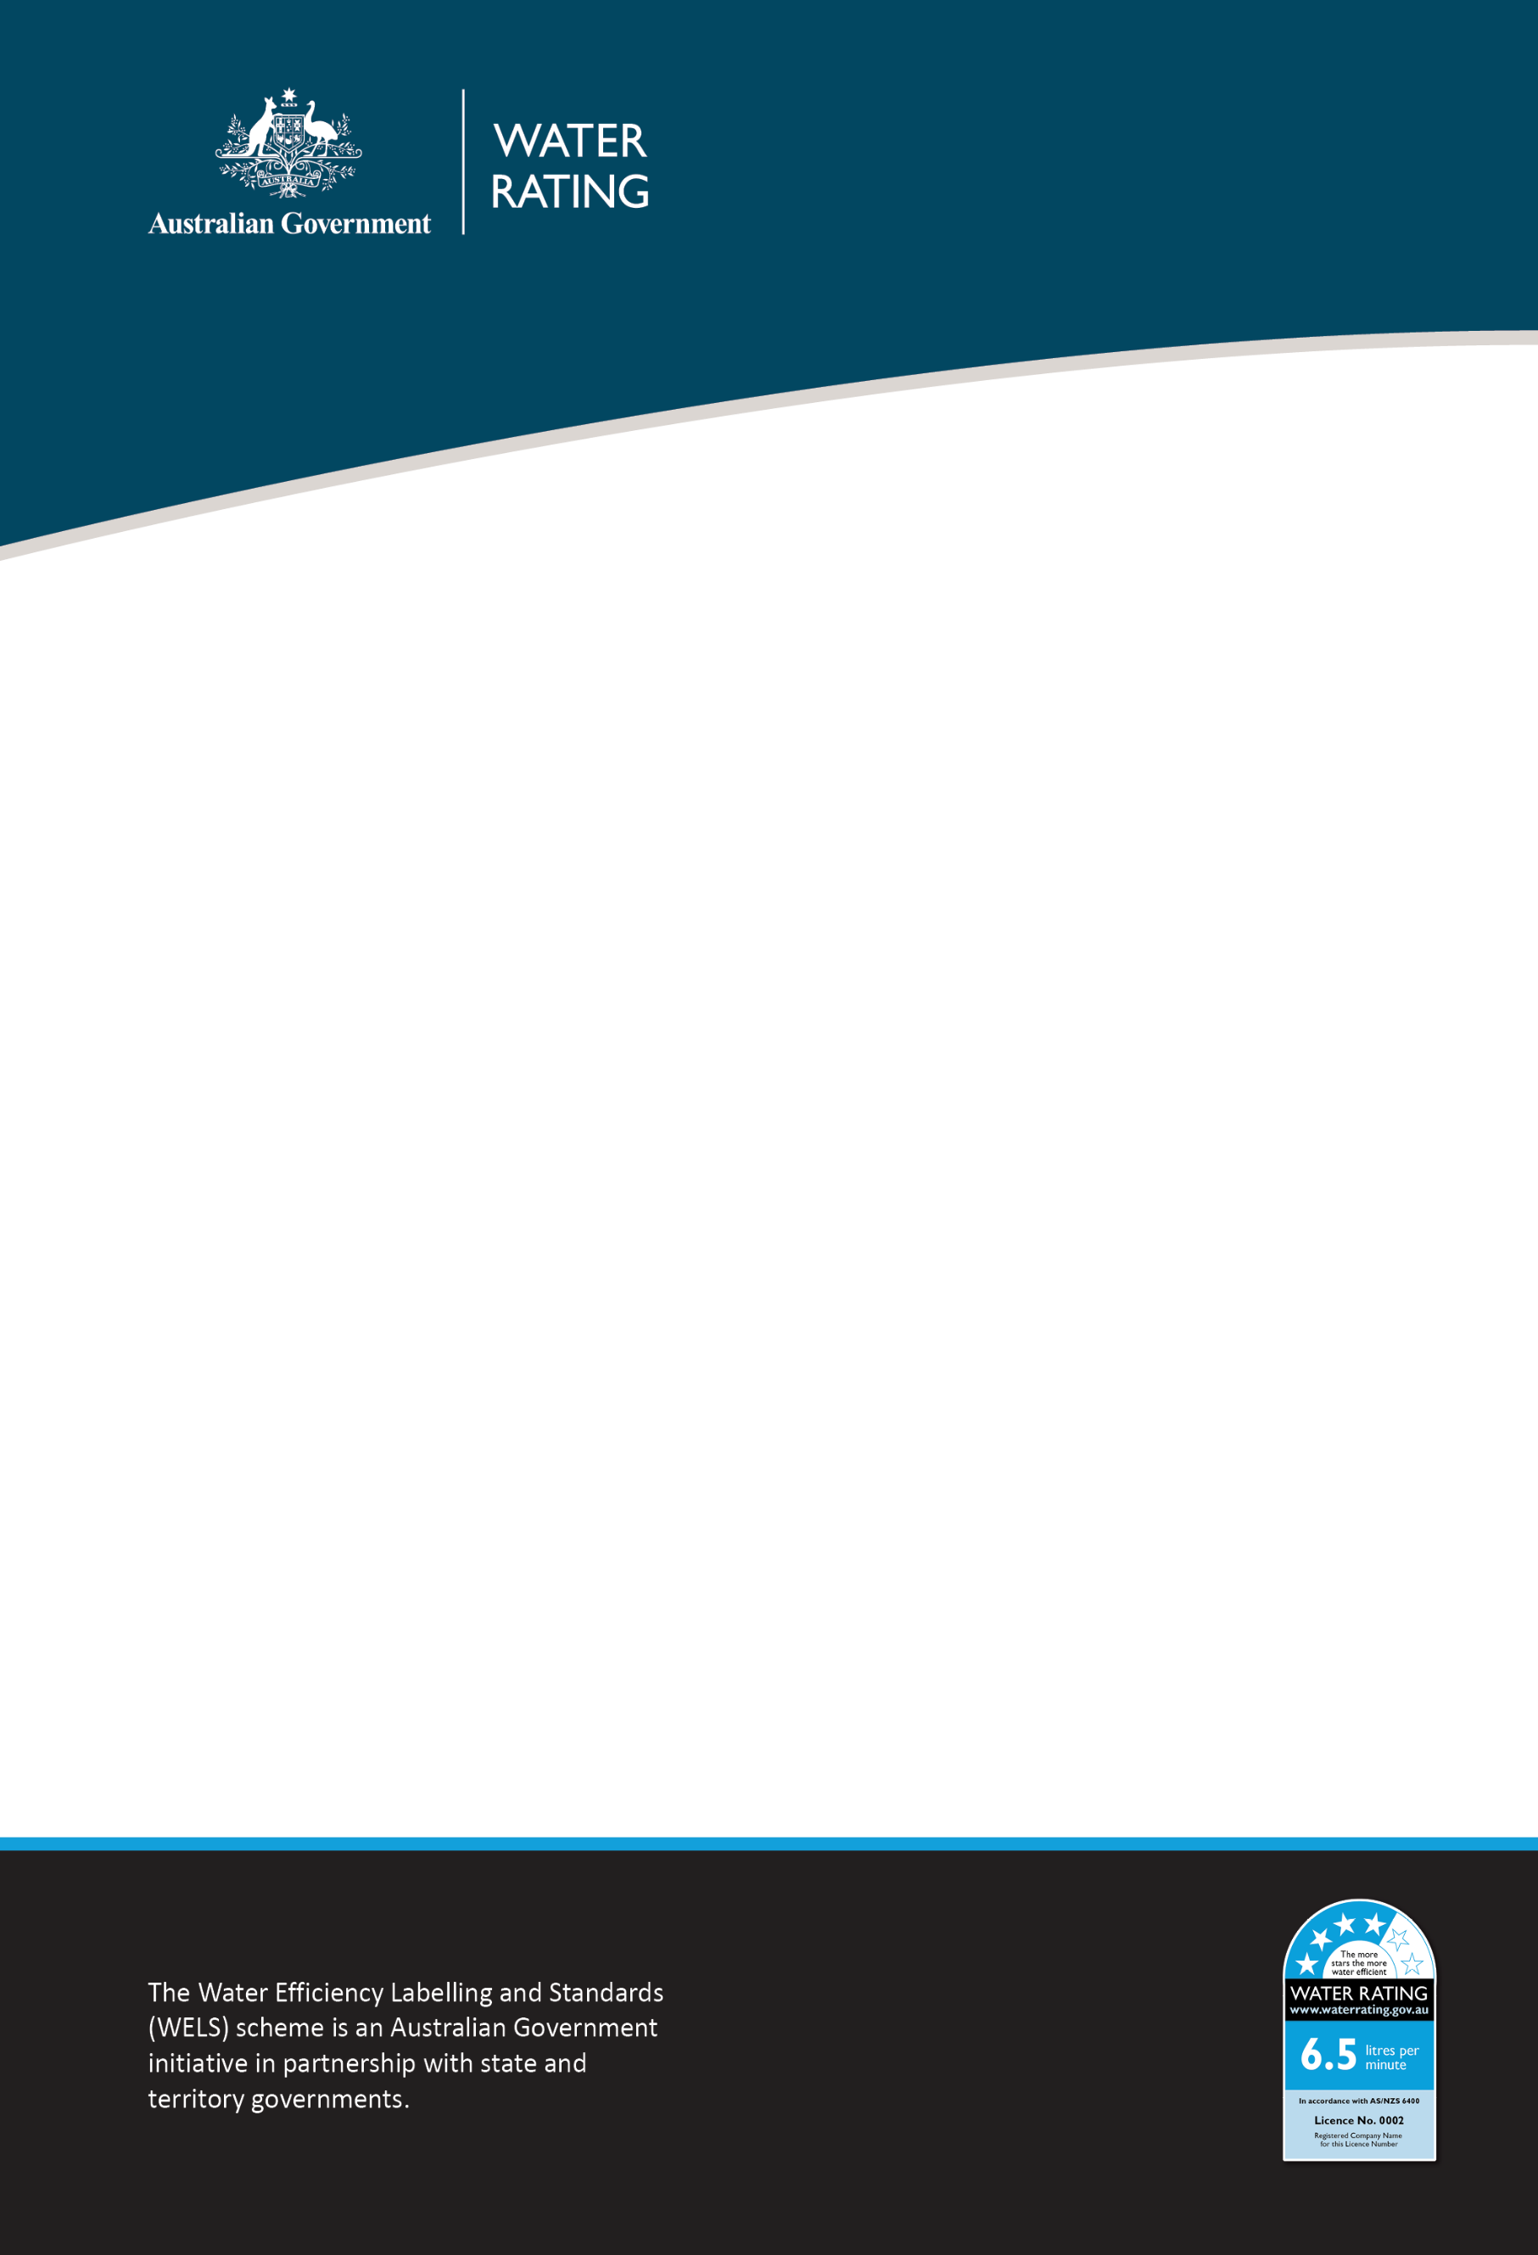

1 December 2025
WELS REGULATOR ADVICE
WELS product labelling requirements: QR codes

Purpose
This advice clarifies the use of QR codes in relation to Water Efficiency Labelling and Standards (WELS) labelling requirements.

Issue
Suppliers have proposed to provide WELS information exclusively through QR codes.
While QR codes can provide additional product information, they cannot replace the mandatory WELS label or text advice required under AS/NZ 6400:2016 Water efficient products – Rating and labelling (the WELS standard). QR code use alone is not consistent with the objectives of the WELS scheme, which requires consumers of WELS products to have access to essential water efficiency information to inform decision making. Reliance on digital tools alone may create technological and socio-economic barriers for some consumers and therefore does not meet the intent of the scheme.

Conditions
The WELS standard applies to the registration, rating and labelling of WELS products. Relevant clauses include:
- Clause 2.5.4.6: All WELS products shall be profiled or displayed such that the required WELS information has a clear and obvious connection to the registered product.

Requirements
In accordance with the WELS standard, either a WELS label containing the required WELS information or WELS text advice containing the required WELS information must be displayed. The content of the label or text advice must be provided as prescribed in the WELS standard. This obligation applies to both physical presentation (on or with a clear and obvious connection to the product and on packaging) and online presentation (including websites, digital product listings, and electronic communications).
A QR code may be provided as a supplementary source of product information. It must not serve as the only means of conveying WELS information.
Example
Where a tap is registered with a 4-star rating, any display during supply must include as a minimum, either:
- The WELS label, with the registered model name and/or the WELS registration number being displayed next to the label to ensure a clear and obvious connection to the product being advertised; or
- WELS text advice, including the word ‘WELS’, WELS registration number, star rating (4-star), and flow rate (in litres per minute).
A QR code linking to further details may be added, but it cannot replace the required WELS label or WELS text advice.

Monitoring and compliance
The WELS compliance team will monitor adherence to these requirements. Products relying solely on QR codes for WELS information will be considered non-compliant under the WELS standard.
Non-compliance will be assessed against legislative requirements and a risk-based approach will be used to determine an appropriate and proportionate response. For more information, refer to the WELS Compliance and Enforcement Policy.

Contact

Compliance enquiries:
1800 372 746 (within Australia) +61 2 5162 1815 (international)
welscompliance@dcceew.gov.au

Registration enquiries:
1800 218 478 (within Australia) +61 2 5162 1816 (international)
wels@dcceew.gov.au

