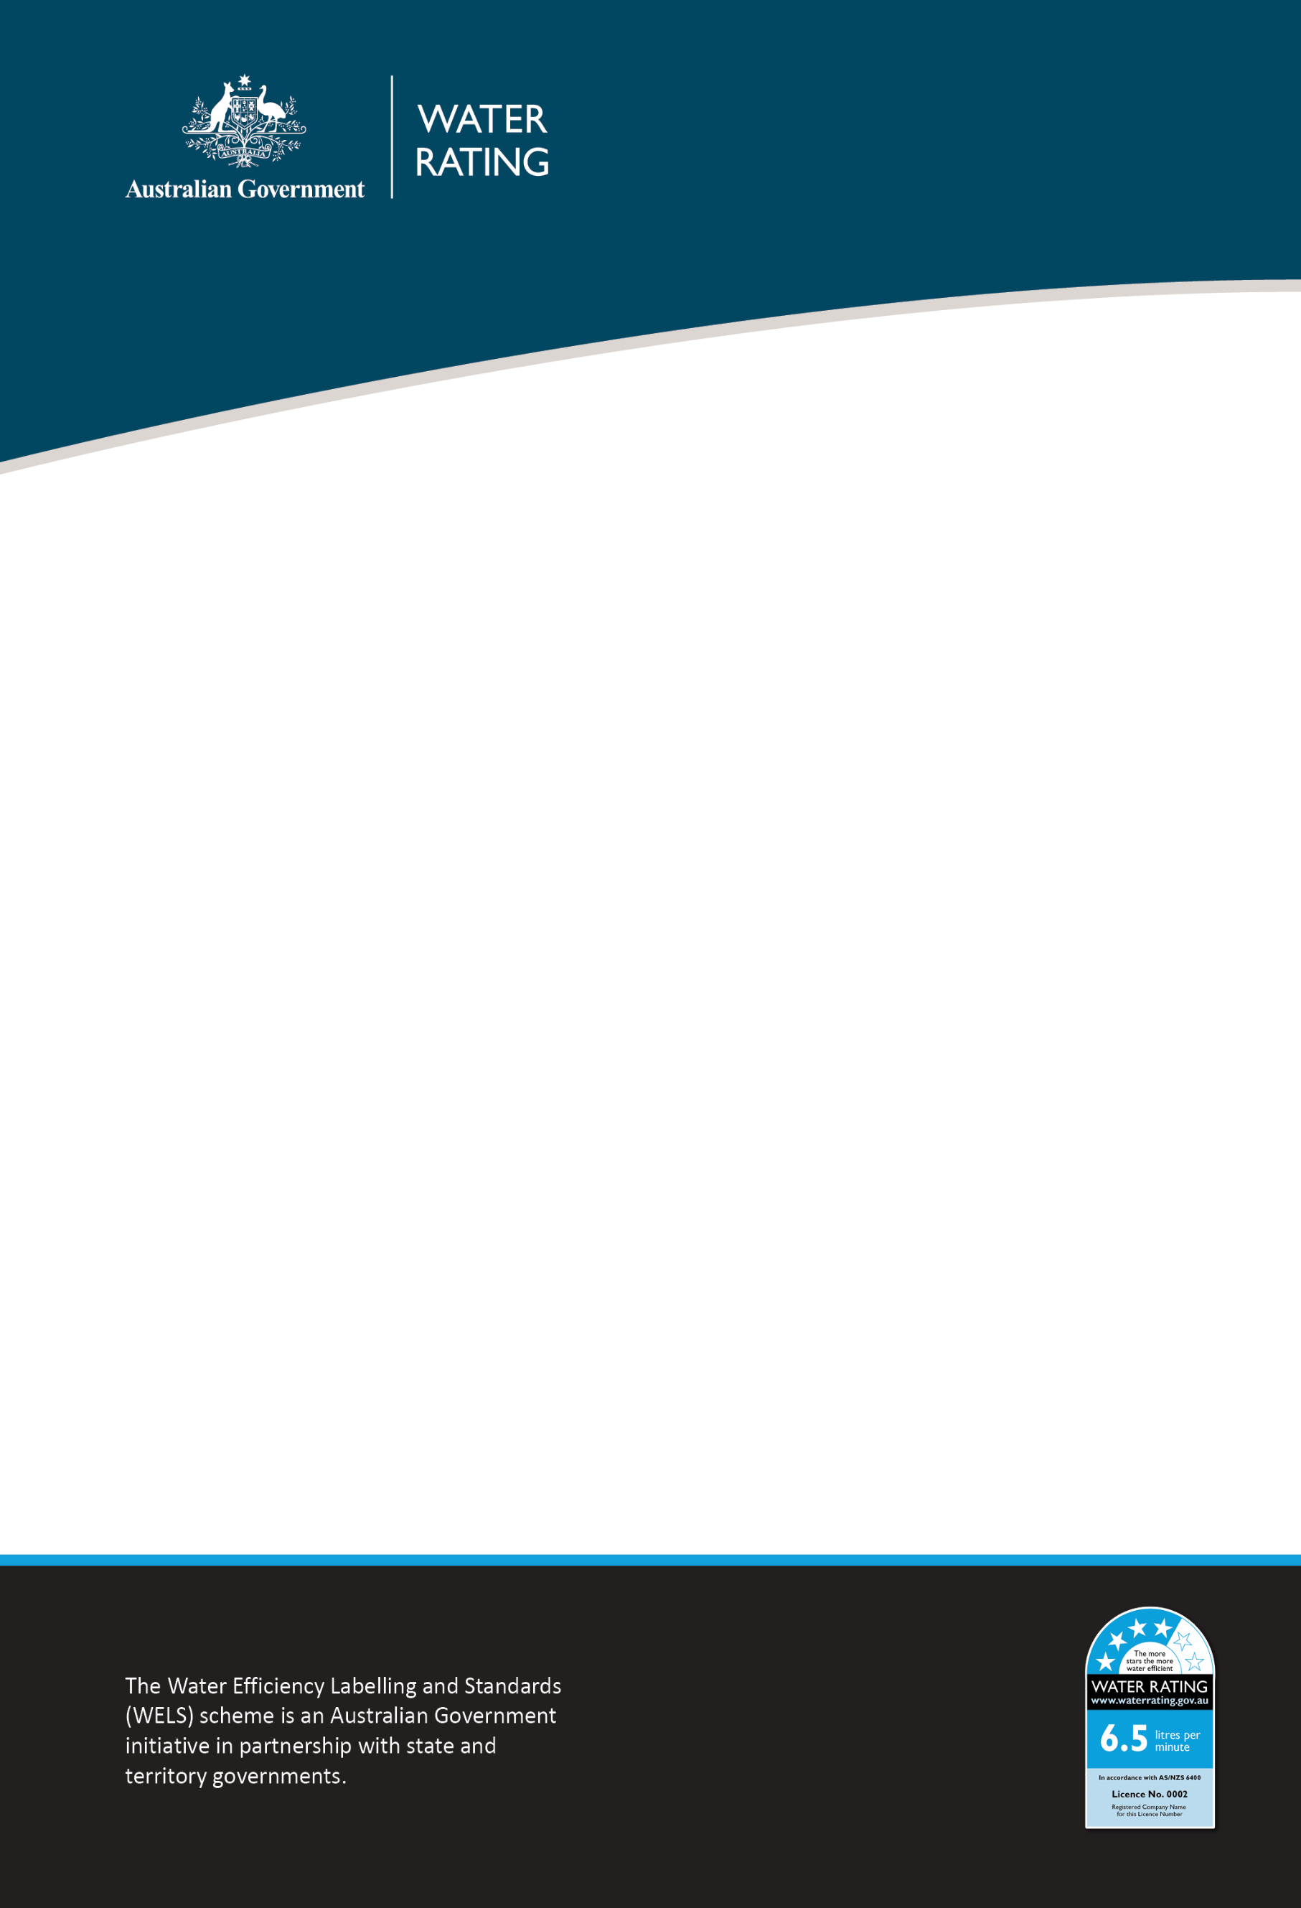

Water Efficiency Labelling and Standards scheme

Compliance Plan 2022–23

Purpose
This document outlines where the Water Efficiency Labelling and Standards (WELS) Regulator will direct effort to ensure the regulatory integrity of the WELS scheme. We may adjust this in response to new intelligence and emerging regulatory priorities and risks.
This document should be read in conjunction with the WELS Compliance and Enforcement Policy.

Our risk-based compliance focus in 2022–23
We will monitor compliance in the following areas:
Area of non-compliance | Activity
Supply of unregistered WELS products | - Conduct onsite inspections of building developments and retail outlets  - Monitor online advertising of WELS products  - Work with co-regulators and e-commerce marketplace administrators to enhance detection capabilities and responses.
Fraud | - Detection of regulated products offered for supply that claim to be WELS registered  - Improvement of compliance analytical capability  - Detection of fraudulent documentation through product registration assessments.
Non-compliant labelling and text advice | - Verifying that WELS products offered for supply correctly reflect the products’ registration details and comply with labelling or text advice requirements.

Our approach to compliance
In addition to our compliance focus areas, we will continue to:
- respond to allegations of non-compliance,
- actively work with industry to promote compliance with and awareness of requirements,
- monitor suppliers of WELS products,
- detect and respond to non-compliance.
We will work with individuals and businesses to encourage and support voluntary compliance by providing education and advice.
Where non-compliance is detected, we assess this against legislative requirements and use a risk-based approach to determine an appropriate and proportionate response. We have a range of options to escalate our response, including the use of civil and enforcement provisions if necessary.
To learn more, please read the WELS Compliance and Enforcement Policy.

Contact us
WELS Compliance Team
1800 372 746 +61 2 6272 5232 (international)
welscompliance@dcceew.gov.au.
Registrations team
1800 218 478 (free call within Australia) or +61 2 6272 4030 (international)
wels@dcceew.gov.au.
Acknowledgement of Country
Our department recognises the First Peoples of this nation and their ongoing connection to culture and country. We acknowledge First Nations Peoples as the Traditional Owners, Custodians and Lore Keepers of the world's oldest living culture and pay respects to their Elders past, present and emerging.
© Commonwealth of Australia 2022
Unless otherwise noted, copyright (and any other intellectual property rights) in this publication is owned by the Commonwealth of Australia (referred to as the Commonwealth).
All material in this publication is licensed under a Creative Commons Attribution 4.0 International Licence except content supplied by third parties, logos, and the Commonwealth Coat of Arms.
The Australian Government acting through the Department of Climate Change, Energy, the Environment and Water has exercised due care and skill in preparing and compiling the information and data in this publication. Notwithstanding, the Department of Climate Change, Energy, the Environment and Water, its employees and advisers disclaim all liability, including liability for negligence and for any loss, damage, injury, expense, or cost incurred by any person as a result of accessing, using or relying on any of the information or data in this publication to the maximum extent permitted by law.

