Water Efficiency Labelling and Standards scheme Compliance Policy

2025

© Commonwealth of Australia 2025
Ownership of intellectual property rights
Unless otherwise noted, copyright (and any other intellectual property rights) in this publication is owned by the Commonwealth of Australia (referred to as the Commonwealth).
Creative Commons licence
All material in this publication is licensed under a Creative Commons Attribution 4.0 International Licence except content supplied by third parties, logos, and the Commonwealth Coat of Arms.
Inquiries about the licence and any use of this document should be emailed to copyright@dcceew.gov.au

Cataloguing data
This publication (and any material sourced from it) should be attributed as: Water Efficiency Labelling and Standards Regulator 2025, Water Efficiency Labelling and Standards Scheme Compliance Policy, Department of Climate Change, Energy, the Environment and Water
This publication is available at waterrating.gov.au
Department of Climate Change, Energy, the Environment and Water
GPO Box 3090 Canberra ACT 2601
Telephone 1800 372 746
Website www.dcceew.gov.au
Disclaimer
The Australian Government acting through the Department of Climate Change, Energy, the Environment and Water has exercised due care and skill in preparing and compiling the information and data in this publication. Notwithstanding, the Department of Climate Change, Energy, the Environment and Water, its employees and advisers disclaim all liability, including liability for negligence and for any loss, damage, injury, expense, or cost incurred by any person as a result of accessing, using or relying on any of the information or data in this publication to the maximum extent permitted by law.
Acknowledgement of Country
Our department recognises the First Peoples of this nation and their ongoing connection to culture and country. We acknowledge First Nations Peoples as the Traditional Owners, Custodians and Lore Keepers of the world's oldest living culture and pay respects to their Elders past, present and emerging.

Contents
1 Introduction 1
1.1 About us 1
1.2 About the scheme 1
1.3 Role of this policy 2
1.4 Our compliance policy 2
2 Our approach to compliance 2
3 Managing compliance 3
3.1 Set policies and procedures 3
3.2 Set conditions and standards 3
3.3 Issue licences and product registrations 4
3.4 Undertake monitoring, verification, collection and analysis 4
3.5 Respond to non-compliance 5
4 Our compliance priorities 7
5 Information disclosure 8
6 Reporting non-compliance 8

Introduction

About us
​​​​​The Water Efficiency Labelling and Standards (WELS) scheme is administered by the WELS Regulator in the Australian Government Department of Department of Climate Change, Energy, the Environment and Water (department), on behalf of all Australian governments.
The WELS Regulator appoints WELS Inspectors and delegates certain powers to departmental officers.

About the scheme
The WELS scheme is Australia's national urban water saving scheme. It contributes towards the department’s outcomes by contributing towards sustainably managing our water resources.
The scheme reduces demand for water by informing Australian consumers about the water efficiency of fittings and appliances at the point of sale and imposes minimum water efficiency requirements for the products.
The scheme operates under the Water Efficiency Labelling and Standards Act 2005 (WELS Act). The objects of the WELS Act are:
- to conserve water supplies by reducing water consumption
- to provide information for purchasers of water-use and water-saving products
- to promote the adoption of efficient and effective water-use and water-saving technologies.
The products that are regulated are illustrated in Figure 1.

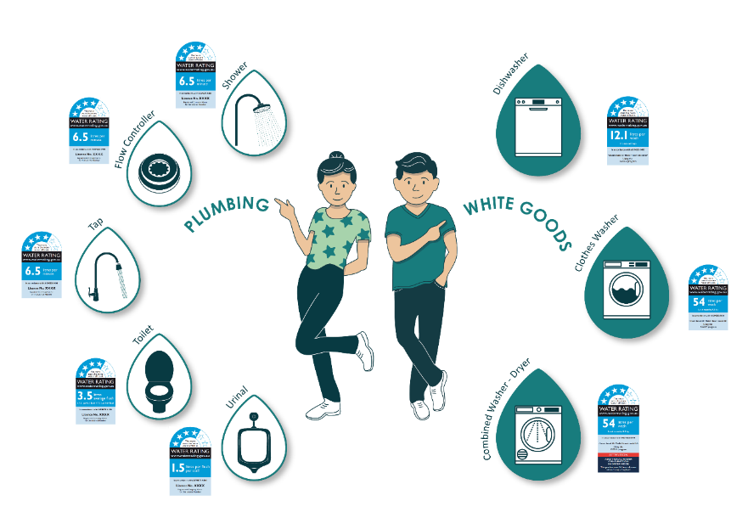
Figure 1. WELS products
Under the WELS legislation, the products are required to meet Australian Standards for water efficiency and must be registered and labelled with their water rating information when offered for supply. The WELS Standard is AS/NZS 6400:2016 Water efficient products – Rating and labelling.
All parts of the supply chain, from manufacturers through to retailers, are regulated entities who have obligations to ensure products offered for sale in Australia are registered and labelled correctly.
For more information about the legislation we administer, see waterrating.gov.au.

Role of this policy
This policy is intended to assist the department, regulated entities and other parties that have duties, obligations and responsibilities under relevant legislation to understand the compliance tools available to the department to ensure legislative requirements are met.
This is an administrative document intended to provide an overview of the WELS Regulator’s compliance tools and general information about when they may use these tools. It does not reduce, extend or modify legislative obligations or powers contained in the legislation.
This policy assists but does not control the WELS Regulator’s compliance-related decisions. Each decision will consider matters relevant to the circumstances.
The use of the term ‘entity’ in this policy refers to a person or business who is legally responsible under the WELS Act.

Our compliance policy
This policy outlines our approach to compliance and how we manage compliance.
This policy operates within the context of the Australian Government’s law enforcement framework but does not apply to the regulatory or compliance activities undertaken by other Australian Government agencies, including those within our portfolio. However, we may partner with these agencies to achieve regulatory outcomes.
This policy should be read in conjunction with the department’s Compliance Policy, available at dcceew.gov.au.

Our approach to compliance
Our compliance approach and posture is to work collaboratively and in partnership with industry, states and territories, other government departments and international partners to achieve regulatory outcomes.
We respond to detected and suspected non-compliance proportionately to the potential harm posed by the non-compliance and in a way that allows for procedural fairness and natural justice.
We acknowledge that most regulated entities accept the obligations imposed on them by legislation and comply voluntarily.
We will work with entities to provide support for them to understand their obligations and to ensure ongoing compliance.
Where non-compliance cannot be resolved cooperatively, the WELS Regulator has a range of options to escalate the response, including the use of civil and enforcement provisions, if necessary.

Managing compliance
In conducting all compliance activities, we aim to make decisions that are lawful, evidence-based and transparent. To administer and enforce the legislation we:
• set policies and procedures
• set conditions and standards
• issue licences and product registrations
• undertake monitoring, verification, collection and analysis, and
• respond to non-compliance.

Set policies and procedures
Our policies and procedures are developed within the WELS legislative framework in addition to broader requirements and obligations of Commonwealth regulators and of public servants. Where appropriate, policies and procedures will be published on the Water Rating website. This includes policies such as the WELS Compliance Policy, procedures such as how to apply to register products under the scheme.

Set conditions and standards
The conditions of the WELS scheme are set out in legislation and Australian and New Zealand standards. Both legislation and standards are developed in consultation with stakeholders who will need to implement the requirements, however legislation is ultimately a decision of government. The WELS Standard AS/NZS 6400 and related product specific standards, are codesigned and voted on with industry and regulators, and the process is overseen and managed by Standards Australia.
Additional technical requirements may be specified when the legislation and standards are unclear. The WELS Regulator may publish regulatory advice notices on the Water Rating website. These are provided to known affected entities. Unless urgent in nature, industry and regulators are consulted on draft notices, to ensure they can be implemented and achieve the desired outcome.

Issue licences and product registrations
Delegated Registration officers grant licences for businesses to gain access to the WELS registration system in order to apply to register products under the scheme.
Registration officers consider the application information and supporting evidence. Where the information is incorrect or insufficient, the application is returned to the registrant for correction and resubmission.
An application can be refused where the information does not support the application. The registrant can seek a review of the decision, and if unsatisfied, can challenge the decision though the Administrative Review Tribunal.
For products that are registered, their registration can be suspended or cancelled if the information relied on in the application was not accurate or changes to no longer be accurate. As for application refusals, the registrant can seek a review of the decision, and if unsatisfied, can challenge the decision though the Administrative Review Tribunal.

Undertake monitoring, verification, collection and analysis
We routinely monitor and verify compliance through inspections and responding to allegations.
Allegations of non-compliance are regularly provided to the WELS Regulator. Each allegation is recorded and assessed.
We also proactively inspect websites, internet marketplaces, retail outlets and display centres for non-compliant products and product labelling. Identifying unlabelled (including incorrectly labelled) and unregistered product being offered for supply is generally straight forward.
Information and data collection and analysis can include:
• asking questions
• inspecting, authenticating, taking extracts from or making copies of documents
• requiring the production of records
• inspecting, examining, taking measurements or conducting tests
• taking images or making recordings
• examining or observing activity conducted on the premises
• accessing data sources including commercial business data sets.
Our targeting for monitoring and verification is risk-based and informed by intelligence. Intelligence includes providing tactical and operational insights into supply chain actors and corporate structures.
Our risk-based targeting ensures that our limited resources are focussed on those activities that detect non-compliance.

Respond to non-compliance
When non-compliance is identified or suspected through inspections and allegations, we consider factors relevant to each case and to the related entity. We may collect further information to confirm or dismiss our concerns. This may include:
• undertaking an intelligence assessment
• conducting additional inspections or audits
• Issuing coercive notices (such as requiring a person to give information to a WELS inspector)
• undertaking investigations in accordance with the Australian Government Investigations Standards
• conducting targeted operations such as multi-agency investigations, intelligence gathering, surveillance activities and a range of law enforcement actions
• using experts
• searching premises under warrant.
Once the initial assessment is complete, we respond to non-compliance by providing educational support about how to comply, undertaking administrative actions, pursuing civil penalties and/or criminal sanctions.

Provide educational support about how to comply
Except for where there is suspected criminal activity (such as fraud) or where there is recidivism, entities will be provided with educational support and advice about how to comply and provided with an opportunity to respond and to correct their non-compliance. Providing information and an opportunity to respond supports procedural fairness and natural justice for regulated entities.
For suppliers of WELS products using e-commerce platforms, we will communicate primarily via platform messaging systems where available. The non-compliant sellers will be given time to correct any non-compliance and to communicate with the WELS Regulator about their circumstances.
We will reassess the entity’s efforts to become compliant and consider their attitude and behaviour in how they choose to respond. We will take mitigating factors into account to ensure a reasonable approach is taken when setting or revising expected timeframes for compliance.

Undertake administrative actions
Where an entity has demonstrated an unwillingness to comply or to make all reasonable efforts to comply, further consideration will be given to case-specific factors of the non-compliance to determine a course of action. The factors include, but are not limited to, the number and types of non-compliance, the potential impact of the entity in the market, the entity’s attitude and behaviour in engaging with the WELS Regulator, and their compliance history.
The WELS Regulator may offer or require a range of actions which are enforceable by the Federal Court.
Enter into an enforceable undertaking
The WELS Regulator can accept an enforceable undertaking that has been voluntarily offered by a regulated entity, under which they offer to take specified action to comply with a legislative provision and to refrain from taking specified non-compliant action to ensure future compliance. Enforceable undertakings can be used to minimise, reduce or eliminate the risk of harm occurring as a result of a regulated entity’s non-compliant behaviour. We will monitor undertakings to ensure the agreed action occurs. The undertaking is a legally binding agreement that can be enforced by the Federal Court.
The benefit to the entity in committing to an enforceable undertaking is that they can take greater responsibility to commit to become compliant.
Require a mandatory compliance audit
These can be issued through a notice requiring an entity to undertake an audit to confirm their compliance with the WELS Act and to provide a written report setting out the results of the audit. These can require that the entity be required to pay a third party to independently conduct and report on the audit. Typically the audit would be of websites and any retail outlets.
Require mandatory remedial action
Remedial action may be required through issuing a notice requiring an entity to take action to remedy non-compliant behaviour or prevent it in the future. This notice may follow a mandatory compliance audit if the entity did not voluntarily correct any non-compliance found.
Restrict product listings and user accounts on marketplace platforms
For suppliers of WELS products using e-commerce platforms who do not correct their listings, where available, we will remove product listings or seek actions from the platform administrator to limit their capacity to offer WELS products until they can demonstrate compliance.
The e-commerce provider may apply their own measures to manage non-compliance in addition to the WELS Regulator’s sanctions. For example, if a seller breaches e-commerce platform policies, a seller’s account may be restricted or disabled.
Issue an infringement
The WELS Regulator may also issue an infringement notice requiring an entity to pay a penalty for a breach as an alternative to prosecution or a civil penalty order issued through a court. Refer to the WELS Infringement Notice Statement for more information.
Payment of the infringement notice will typically discharge any liability for the alleged contravention. If payment does not occur, the WELS Regulator may progress to civil proceedings.
Seek a court-imposed injunction
The WELS Regulator may apply for a court-imposed injunction through the Federal Court. The court order stops an entity from engaging in conduct or require an entity to do an act or thing.

Pursue civil penalties and criminal sanctions
We may escalate to enforcement actions where our initial administrative action did not achieve compliance. Depending on the seriousness of the breach and culpability of the regulated entity, we may use enforcement measures to bring about compliance.
Civil penalties
We can commence civil penalty proceedings against a regulated entity seeking an order requiring them to pay a financial penalty for breaching a civil penalty provision under the WELS Act. A civil penalty imposed by a court is a debt owed to the Commonwealth. The court has extensive powers available to ensure such debts are paid.
We can commence civil penalty proceedings either as a standalone action or following non-payment of an infringement notice. A civil penalty amount can substantially exceed an infringement notice amount for the same contravention.
The WELS Regulator has successfully prosecuted entities who chose not to pay their infringements, and this resulted in penalties being imposed by the Federal Court of over $2M on a company director and their four companies.
Under a range of Commonwealth legislation, court-imposed civil sanctions may be taken into consideration in relation to continuing permissions and future applications for permissions that are external to the WELS scheme.
The WELS Regulator has the power to publicise contraventions of the WELS Act and such information will be made public.
Criminal sanctions
Criminal prosecution is a legal action that may result in a criminal penalty involving imprisonment, a financial penalty, or both. The Criminal Code applies to all strict liability offences under the WELS Act.
These serious penalties mean that criminal sanctions should be used only in situations where such a response is appropriate, such as in the case of deliberate non-compliance, or when recklessness and high risk coincide.
Where criminal behaviour is suspected, we can refer a matter to the Commonwealth Director of Public Prosecutions to commence a criminal prosecution, in accordance with the Prosecution Policy of the Commonwealth.

Our compliance priorities
The compliance priorities of the WELS Regulator are set out in annual WELS Compliance priorities, published on the Water Rating website waterrating.gov.au.

Information disclosure
Information we receive from the public about alleged non-compliance will be handled in a confidential manner. We may share this information with relevant internal areas and with other law enforcement and regulatory agencies as provided for under relevant legislation.
Where legislation permits or requires, we may release details of non-compliance or investigative activities where such a release would support the achievement of the department’s regulatory outcomes or is required by law. In other circumstances, the details of investigation activities may remain confidential once the investigation is complete.
We may choose to release information about entities that have breached or are alleged to have breached our legislation to support our regulatory outcomes. This will be done in accordance with our legal obligations, including the Privacy Act 1988. We will ensure that the released information does not prejudice an entity’s right to a fair hearing or legal process, impinge upon the safety of others involved in the investigation (such as complainants, witnesses and suspects) or prejudice any of our past or future activities.
Request for information from the public, including regulated entities, may be made under the Freedom of Information Act 1982. For details about how to make a Freedom of Information (FOI) request, see Freedom of Information.
The media can greatly assist us by informing the regulated community of its obligations under our laws. This includes communicating the consequences of not complying with our laws. Media enquiries or requests for information should be directed to mediateam@dcceew.gov.au
Non-compliant entities that are subject to court decisions and enforcement actions can expect the outcomes of these matters to be published in accordance with our legal obligations. For information on our compliance outcomes see News and media.

Reporting non-compliance
If you come across something you think does not comply with our legislation, please visit the Water Rating website waterrating.gov.au to find out more information, or report your concern to us via email at email welscompliance@dcceew.gov.au, or by phone (toll-free) on 1800 372 746 (International +61 2 5162 5232).

