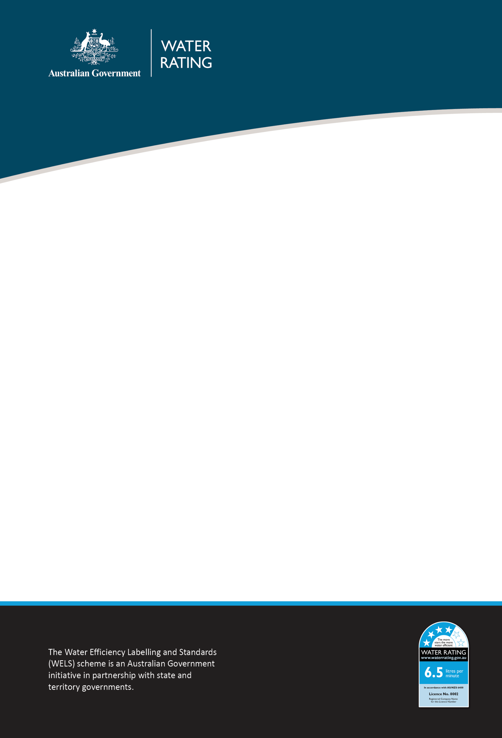

WELS Compliance priorities 2025–26

Purpose
This document outlines where the Water Efficiency Labelling and Standards (WELS) Regulator will direct effort to ensure the regulatory integrity of the WELS scheme. We may adjust this in response to new intelligence and emerging regulatory priorities and risks.

Our compliance focus in 2025–26
We will monitor compliance in the following areas:
Area of non-compliance | Activity
Supply of unregistered WELS products | - Respond to allegations  - Conduct monitoring inspections of retail outlets  - Monitor online advertising of WELS products  - Work with co-regulators and e-commerce administrators to enhance detection capabilities and responses of online marketplaces  - Conduct documentary inspections of building developments  - Provide education of suppliers, plumbers and retailers
Potential fraud | - Monitoring regulated products offered for supply that claim to be WELS registered  - Improvement of intelligence analytics capability  - Monitoring for fraudulent documentation through product registration assessments  - Education of registrants

Non-compliant labelling and text advice | - Respond to allegations  - Conduct onsite inspections of retail outlets  - Monitor online advertising of WELS products  - Provide education to suppliers about their obligations
Inaccurate or incorrect documentation and information in product registration applications and registration renewal | - Assess and validate documents and information provided in product registration applications  - Random auditing of documents and information for product registration renewal applications  - Education of registrants

Our compliance approach
Our compliance approach and posture is to work collaboratively and in partnership with industry, states and territories, other government departments and international partners to achieve regulatory outcomes.
We respond to detected and suspected non-compliance proportionately to the potential harm posed by the non-compliance and in a way that allows for procedural fairness and natural justice.
We acknowledge that most regulated entities accept the obligations imposed on them by legislation and comply voluntarily.
We will work with entities to provide support for them to understand their obligations and to ensure ongoing compliance.
Where non-compliance cannot be resolved cooperatively, the WELS Regulator has a range of options to escalate the response, including the use of civil and enforcement provisions, if necessary.
This approach to compliance operates under the WELS Compliance Policy, available at www.waterrating.gov.au.

Contact

WELS Compliance Team
1800 372 746 (within Australia) +61 2 5162 1815 (international)
mail to: welscompliance@dcceew.gov.au.

Registrations team
1800 218 478 (within Australia) +61 2 5162 1816 (international)
mail to: wels@dcceew.gov.au

