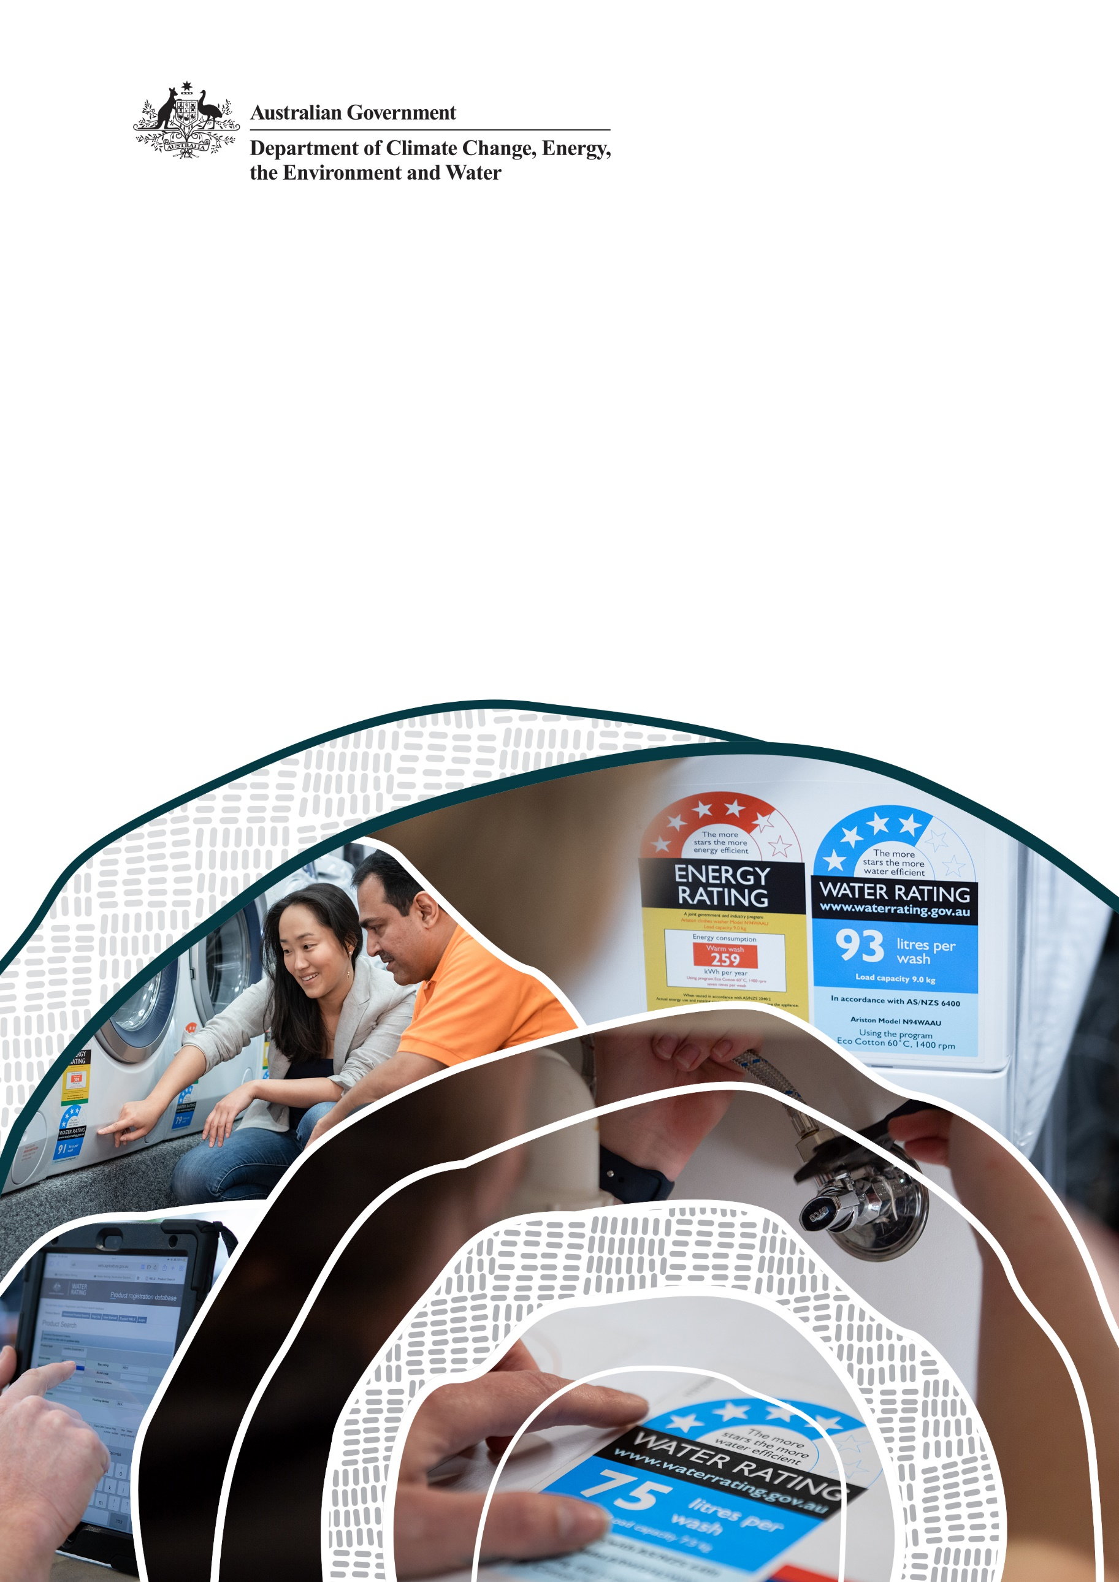
Water Efficiency Labelling and Standards scheme

Product Expansion Program

2025–26 Work plan
Department of Climate Change, Energy, the Environment and Water

© Commonwealth of Australia 2024
Ownership of intellectual property rights
Unless otherwise noted, copyright (and any other intellectual property rights) in this publication is owned by the Commonwealth of Australia (referred to as the Commonwealth).
Creative Commons licence
All material in this publication is licensed under a Creative Commons Attribution 4.0 International Licence except content supplied by third parties, logos and the Commonwealth Coat of Arms.
Inquiries about the licence and any use of this document should be emailed to copyright@dcceew.gov.au.

Cataloguing data
This publication (and any material sourced from it) should be attributed as: DCCEEW 2024, Amendment to the Water Efficiency Labelling and Standards Determination 2013 (No. 2), Department of Climate Change, Energy, the Environment and Water, Canberra, July. CC BY 4.0.
This publication is available at www.waterrating.gov.au/register/new-product-category-nomination.
Department of Climate Change, Energy, the Environment and Water
GPO Box 3090 Canberra ACT 2601
Telephone 1800 920 528
Web dcceew.gov.au
Disclaimer
The Australian Government acting through the Department of Climate Change, Energy, the Environment and Water has exercised due care and skill in preparing and compiling the information and data in this publication. Notwithstanding, the Department of Climate Change, Energy, the Environment and Water, its employees and advisers disclaim all liability, including liability for negligence and for any loss, damage, injury, expense or cost incurred by any person as a result of accessing, using or relying on any of the information or data in this publication to the maximum extent permitted by law.
Acknowledgement of Country
We acknowledge the Traditional Owners of Country throughout Australia and recognise their continuing connection to land, waters and culture. We pay our respects to their Elders past and present.

Contents
Introduction 4
Background 4
1.1 WELS scheme 4
1.2 Product Expansion Program 4
1.3 Product Expansion Program cycle 4
Report on Product Expansion Program 2024-25 Work Plan 6
Products nominated in 2025 6
1.4 Nominated products 7
Threshold tests and prioritisation assessments 8
1.5 Threshold test questions 8
1.6 Products excluded from the threshold test 8
1.7 Threshold test results 8
1.8 Prioritisation assessment criteria 9
1.9 Prioritisation assessment results 10
Product Expansion Program 2025–26 Work Plan 10
APPENDIX A Product descriptions for new products 11
1.10 Commercial dishwashers 11
1.11 Commercial glasswashers 12

Introduction
This document reports on the product nominations received for the Water Efficiency Labelling and Standards (WELS) scheme in 2025, and the outcomes of product threshold tests and prioritisation assessments. It highlights the product expansion focus areas for 2025–26.

Background

WELS scheme
The WELS scheme is Australia’s urban water saving scheme. It aims to reduce demand for drinking water by informing consumers about water efficiency at the point of sale. All Australian states and territories participate in the scheme.
The scheme provides a national approach to applying a mandatory water efficiency star rating to plumbing products and appliances. Products within scope of the scheme are dishwashers, washing machines, washer-dryers and most taps, showers, toilets, urinals and flow controllers.

Product Expansion Program
The objective of the WELS scheme’s Product Expansion Program is to evaluate the benefits of regulating new and existing water-using or water-saving products. The program enables the scheme to respond to:
- shifting product markets, industry innovation and stakeholder expectations
- Recommendation 2.1 of the 2020 Independent Review of the scheme which stated: develop a framework which will prioritise a product range that is most likely to impact on the WELS scheme achieving its objectives in reducing water consumption.
To support an evidence-based evaluation process, a Product Assessment Framework was developed in 2023 in collaboration with industry and state and territory government representatives. The framework allows for potential products to be evaluated in a staged approach, to determine if there is value in further pursuing their inclusion within the scheme.
If there is national cost-benefit in regulating additional products, agreement of the Australian Government Minister for the Environment and Water and a majority of state and territory government Water Ministers is required. Careful consideration would be given to the implementation approach and timing, in consultation with industry.

Product Expansion Program cycle
The Product Expansion Program operates over an annual cycle.
The cycle involves seeking product nominations from stakeholders, performing threshold tests and prioritisation assessments of nominated products, development of an annual work plan, assessment of prioritised products and reporting of assessment outcomes. Figure 1 shows the stages of the annual Product Expansion Program cycle.
Figure 1 – Product Expansion Program cycle

Report on Product Expansion Program 2024-25 Work Plan
Products prioritised as part of the 2024-25 Work Plan included commercial ice makers, commercial clothes washing machines, thermostatic mixing taps and commercial water-cooled wok stoves. During 2024-25, work commenced against all products. Table 1 shows the progress made against each product.
Table 1 – Product assessment progress
Product | 2024-25 work plan priority | Progress to 30 June 2025
Commercial ice makers | 1 | A formal Regulatory Impact Analysis (RIA) was started to evaluate options to improve the water efficiency of commercial ice makers. This involved data acquisition, cost benefit modelling and stakeholder consultation. The RIA is expected to be finalised in 2025-26. The RIA must be approved by the Department of the Prime Minister and Cabinet (Office of Impact Analysis) prior to release.
Commercial clothes washing machines | 2 | It was determined that technical expertise was needed to undertake limited market analysis and to evaluate product data availability. A process to procure these services commenced in 2024-25. Initial evaluation of this product is expected to be completed in 2025-26.
Thermostatic mixing taps | 3 | Thermostatic mixing taps are a type of tap this is specifically excluded from the WELS scheme within the Water Efficiency Labelling and Standards Determination 2013 (No. 2). This exclusion exists due to product limitations that existed at the time that the Determination came into effect. With advancements in innovation and technology, industry have advised that these product limitations no longer apply. A Preliminary Regulatory Assessment was completed with the Office of Impact Analysis, which determined that the impact of regulating thermostatic mixing taps would be less than minor. WELS will look for an appropriate legislative amendment opportunity to include this product within the WELS scheme.
Commercial water-cooled wok stoves | 4 | It was determined that technical expertise was needed to undertake limited market analysis and to evaluate product data availability. A process to procure these services commenced in 2024-25. Initial evaluation of this product is expected to be completed in 2025-26.

Products nominated in 2025
Stakeholders were invited to nominate products from 3 February to 14 March 2025. Consultation and nominations were managed through the Department of Climate Change, Energy, the Environment and Water’s Have Your Say online survey platform.
The department promoted the opportunity to nominate products through a range of communication channels. An emphasis was placed on attempting to consult with new stakeholders whose products also use water in their operation. Communication activities are shown in Table 2.
Table 2 – Product nomination communication activities
Date | Description
3 February 2025 | Targeted email invitation to known stakeholders to nominate products and to share the invitation publicly with their networks.
3 February 2025 | New product category nomination page on the Water Rating website updated, announcing that nominations for 2025 are now open.
3 February – 14 March 2025 | Promoting the opportunity to nominate products on the Water Rating website through a main page slider directing readers to the Have Your Say online survey, timed with the release of the product nomination survey.
12 February 2025 | Departmental social media posts for new product nominations published on Twitter, LinkedIn, Facebook and Instagram.
21 February 2025 | Departmental media release issued advising of the opportunity to nominate products for the WELS scheme.

Nominated products
Six products were nominated by stakeholders and are listed in Table 3.
Four of the products were nominated by the supplier of the product representing direct industry interest in product regulation. The remaining nominations were submitted by a water utility.
Table 3. Products nominated
Nominated product | Nominees | Date nominated
Thermostatic mixing taps | Supplier | 3 February 2025
Thermostatic shower mixer kit | Supplier | 5 February 2025
Cistern (flushing devices) | Supplier | 5 February 2025
Residential dishwashers | Supplier | 10 February 2025
Commercial dishwashers | Water utility | 13 March 2025
Commercial glasswashers | Water utility | 13 March 2025

Threshold tests and prioritisation assessments

Threshold test questions
All nominated products must pass a basic threshold test to be considered for prioritisation and further assessment. Table 4 lists the seven questions that a product must pass.
Products that are already regulated or which have nominated in the previous year will not be considered for this evaluation.
Table 4. Threshold test questions
Question | Description
Question 1 | Does the product meet the WELS Act definition of ‘water-saving’ or ‘water-using’ product?
Question 2 | Is the product supplied or advertised for supply in Australia?
Question 3 | Is the product for either residential or commercial use?
Question 4 | Is the product a stand-alone item (i.e. not part of a system)?
Question 5 | The product does not act like a storage device, from which other products draw water.
Question 6 | Does the product consume water when in use (i.e. does it have a water flow rate)?
Question 7 | Is the product provided in a range of models?

Products excluded from the threshold test
Table 5 sets out the products that were excluded from the threshold test and the basis.
Table 5. Excluded products
Nominated product | Reason for exclusion
Thermostatic mixing taps | Previously nominated and being progressed
Cistern (Flushing devices) | These products are already regulated under the scheme
Residential dishwashers | These products are already regulated under the scheme

Threshold test results
Table 6 shows the outcome of the threshold tests for the remaining products. Thermostatic shower mixer kits failed question 6 and will not progress to the next stage.

Table 6. Threshold test outcomes
Nominated product | Q1 | Q2 | Q3 | Q4 | Q5 | Q6 | Q7
Thermostatic shower mixer kit |  |  |  |  |  | 
Commercial dishwasher
Commercial glasswasher

An indicative definition and scope of the two products that passed the threshold test are provided in Appendix A.

Prioritisation assessment criteria
Prioritisation assessment is used to determine the order that products that pass the threshold test are assessed further. Given that WELS has limited resourcing, prioritisation of nominated products is needed to ensure effort is initially directed to products that may deliver the greatest benefit.
Three broad criteria, containing several sub-criteria, are used to determine product prioritisation:
- potential water savings
  - product prevalence
  - geographical prevalence
  - product water consumption
  - frequency of use
  - user influence
  - product range and differentiation
- energy use (if relevant to the product)
  - direct or indirect energy consumption
  - product priority for the Greenhouse and Energy Minimum Standards Regulator
- ease of assessment
  - alignment with other schemes
  - stakeholder support
  - data availability
  - existing standards
  - ability to test
A weighted score between 1 and 3 is assigned against each sub-criteria, with an aggregate of the weighted scores being calculated. A higher weighting is applied to the potential water saving criteria.

Prioritisation assessment results
Prioritisation resulted in the ordering of nominated products as listed in Table 6. This prioritisation includes active products from the 2024 nomination process. Product statements that provide additional information about the 2025 product nominations are provided at Appendix A.
Table 6. Prioritisation of nominated products
Prioritisation | Nominated product | Prioritisation score
1 | Commercial ice makers | 2.62
2 | Commercial clothes washing machines | 2.54
3 | Commercial dishwashers | 2.41
4 | Thermostatic mixing taps | 2.37
5 | Commercial glasswashers | 2.26
6 | Commercial water-cooled wok stoves | 2.03

Product Expansion Program 2025–26 Work Plan
Subject to available resourcing, Table 7 sets out the work planned for 2025–26.
Table 7. Planned work for 2025-26
Product | Planned Activity
Commercial ice makers | Finalise impact analysis to improve water efficiency. A decision on the approach will be made during 2025-26.
Commercial clothes washing machines | Conduct a technical and market assessment to inform potential in-depth analysis.
Commercial dishwashers | Conduct a technical and market assessment to inform potential in-depth analysis.
Thermostatic mixing taps | Engage with industry to consult on including these products in the WELS scheme. This would be enabled by removing the current exclusion of these products from the Water Efficiency Labelling and Standards Determination 2013 (No.2)
Commercial glasswashers | Conduct a technical and market assessment to inform potential in-depth analysis.
Commercial water-cooled wok stoves | Conduct a technical and market assessment to inform potential in-depth analysis.

APPENDIX A Product descriptions for new products
The following product statements provide a simple description of the product to assist in defining the scope of the product category.
Product statements for commercial ice makers, thermostatic mixing taps, commercial washing machines and commercial water-cooled woks were included in the 2024-2025 workplan published in 2024.

Commercial dishwashers
A commercial dishwasher is an electric dishwasher specifically designed for use in commercial kitchens and settings where high-volume, rapid dishwashing is required. Built to withstand heavy use, these dishwashers feature robust construction, faster cycle times, and larger capacities compared to domestic models. The most efficient commercial dishwashers save water by incorporating multi-stage rinse water reuse.
Main types of commercial dishwashers:
- Undercounter dishwashers: These dishwashers are compact and ideal for small spaces such as coffee shops or small restaurants. Designed to fit under the counter, they are easily accessible and maintainable. They are manually loaded, programmable, front loaded, and typically feature one detergent circulating zone and a freshwater rinse process. While comparable in size to domestic dishwashers, these units offer significantly faster wash cycles.
- Hood dishwashers (also known as pass-through dishwashers): These dishwashers are ideal for medium-sized operations and feature a hood that lifts for easy loading and unloading. They are manually loaded, programmable, and are typically equipped with one detergent-circulating zone and a freshwater rinsing process. Operating at higher temperatures than under-counter models, they offer faster wash cycles. These larger units require more kitchen space.
- Conveyor dishwashers (also known as rack or flight dishwashers): These dishwashers are designed for high-volume operations. These machines use a conveyor belt to move dishes through the washing process. There are two subtypes:
Rack conveyor: Uses pre-loaded racks similar to pass-through units.
Flight conveyor: Glass and dishware is placed directly into fittings built into the conveyor. Flight-type dishwashers are the largest and most powerful, used in very high-volume settings like hospitals and large hotels
Temperature Varieties:
High temperature dishwashers: Use high temperature water (66-71°C) to wash dishes and a final rinse temperature of at least 82°C to fully sanitize them.
Low temperature dishwashers: Use lower-temperature water (49-60°C), which may not completely remove stubborn stains in one wash and requires chemical sanitizing agents during the cycle.

Commercial glasswashers
A commercial glasswasher is a specialised machine designed to quickly and efficiently clean large quantities of glassware. While similar in size and operation to a domestic dishwasher, commercial glasswashers have much shorter cycle times and more critical sanitizing performance. They provide specialised care for glassware, which can be prone to breakage and spotting. Essential in bars and restaurants where glass presentation is key, these machines offer gentle cycles and specific cleaning solutions.
Main types of commercial glasswashers:
- In sink glasswashers: Portable units that fit inside a standard sink, suitable for small establishments with low turnover.
- Undercounter glasswashers: Compact units that fit under the counter, ideal for small to medium-sized establishments.
- Hood glasswashers (pass-through glasswashers): Designed for medium to high-volume operations, these machines have a hood that lifts for easy loading and unloading.
- Conveyor glasswashers: Suitable for high-volume operations, these machines use a conveyor belt to move glasses through the washing process.
Water usage classification:
Wash and dump: These models continuously discharge water (usually via gravity) to waste throughout the wash and rinse phases. Detergent is injected throughout the wash phase as none is retained in the machine. There is no recycling of water, with even the clean, hot rinse water lost.
Recirculation: These models have a basin or ‘wash tank’ in the bottom of the machine which retains a mix of wash and rinse water for use in the wash phase of the next cycle.

