**Water Efficiency Labelling and Standards (WELS) scheme — WELS Registration Portal user instruction manual**

June 2025

## Introduction

WELS is Australia's water efficiency labelling scheme that requires certain products to be registered and labelled with their water efficiency in accordance with the standard set under the national *Water Efficiency Labelling and Standards Act 2005*.

Products currently regulated under the scheme include showers, dishwashers, clothes washing machines (including combination washer/dryers), toilet equipment (including urinals), taps and flow controllers. Minimum water efficiency requirements are specified for all products with some minor exceptions, please refer to water rating web site for more information.

If you supply any of these products, you may need to register and label them.

This manual provides guidance for both new and existing users of the WELS Registration Portal.

If you need further assistance, please contact the WELS Registration team via [Contact Us](https://www.waterrating.gov.au/about/contact).

Contents

Introduction i

**1.** **Access to WELS Registration Portal** 4

1.1. Creating a new user account 4

1.2. Existing user login 9

1.3. Reset password 10

1.4. Changing device (phone) of Authenticator app 10

1.5. User profile update 11

1.6. Sign out 11

**2.** **My organisations** 12

2.1. Register new organisation 12

2.2. View organisation details 12

2.3. Switch organisation 12

**3.** **Dashboard** 13

**4.** **Maintain** 13

4.1. Organisation details 13

4.1.1. Add Secondary Contact 13

4.2. Brands 14

4.2.1. Add a brand to your list 14

4.2.2. Delete a brand from your list 15

4.3. Manufacturers 15

4.3.1. Add a Manufacturer 15

4.3.2. Edit Manufacturer details 16

4.3.3. Deactivate a Manufacturer 16

4.4. Laboratories 16

4.4.1. Add a local test Laboratory: 16

4.4.2. Edit your local test Laboratory details 17

4.4.3. Delete a local test Laboratory 17

**5.** **Models** 17

5.1. Search models 17

5.1.1. View model details 18

5.1.2. Download WELS certificate 18

5.2. Model edits 18

5.3. Minor model edit 18

5.4. Major model edit request 19

5.4.1. View a Major model edit request 19

5.4.2. Recall a Major model edit request 19

5.4.3. Edit a Major model edit request 20

5.4.4. Delete a Major model edit request 20

5.4.5. Major model edit request status 21

**6.** **Applications** 21

6.1. Search Applications 21

6.2. New Product Application 21

6.2.1. Prepare for a new product application 21

6.2.2. Start a new product application 22

6.2.3. Model details 22

6.3. View application details 23

6.4. Recall an application 23

6.5. Edit an application 24

6.6. Delete an application 24

6.7. New product application status 24

**7.** **Renewals** 25

7.1. Overview 25

7.2. Renewals Timeline 25

7.3. Renewal Banners 26

7.4. Model renewal application 26

7.4.1. View renewal application details 27

7.4.2. Recall a renewal application 28

7.4.3. Edit a renewal application 28

7.4.4. Delete a renewal application 28

7.4.5. Renewal application status 28

**8.** **Payments** 30

8.1. Payment Overview 30

8.2. Pay tax invoices 31

**9.** **Contact WELS** 31

## **Access to WELS Registration Portal**

If you are offering regulated products for supply, you will need to register them in the WELS Registration Portal.

You can access WELS Registration Portal by using the link below:

* [WELS Registration Portal](https://wels-portal.environment.gov.au)
* URL - https://wels-portal.environment.gov.au

All users will need to create an account with the new WELS Registration Portal (**post June 2025**), even if you had an account/s with the old system.

Please ensure you use the same **email address** to sign up that was listed for you in the previous database.

## Creating a new user account

New users (**including users of the old system post June 2025**) will need to sign up and provide their contact details to register products.

1. Open [WELS Registration Portal](Https://wels-portal.environment.gov.au) and select Sign in option. You will be presented with the Sign in form.
2. Select ‘Sign up now’ link. This will load the ‘Sign up’ form.

A screen shot of the WELS sign in form.



1. Enter your email address and select ‘Send verification code’.

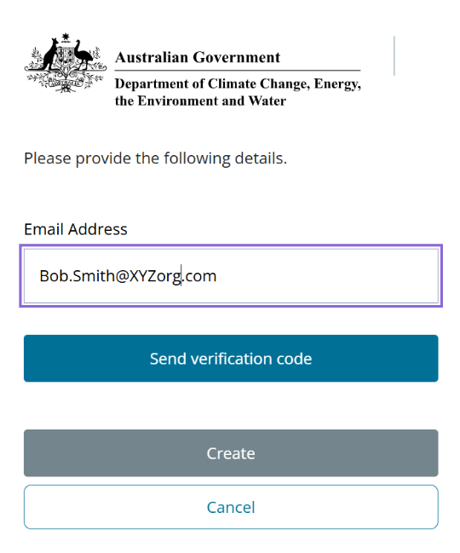

The department will send the verification code to your email address entered in the sign-up form. Please remember to check your spam or junk folder.

1. Enter the code in the ‘Verification code’ field and press ‘verify code’.

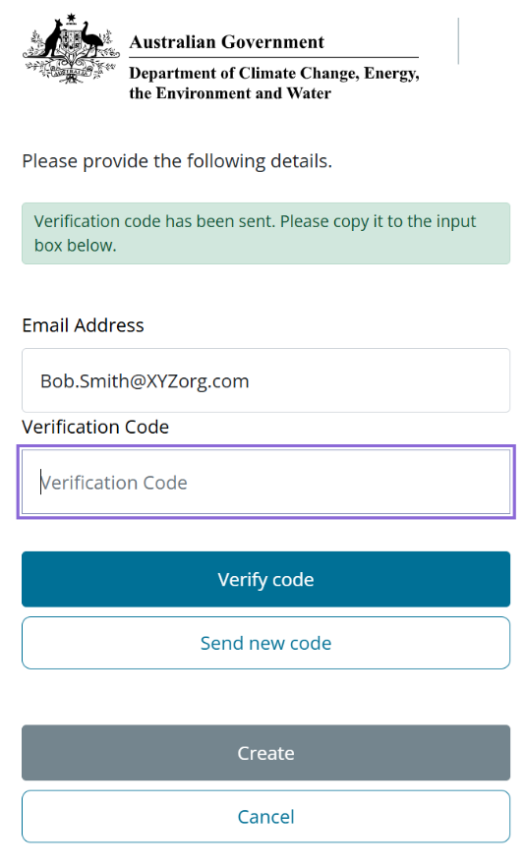

1. Enter your details and a password to create an account.

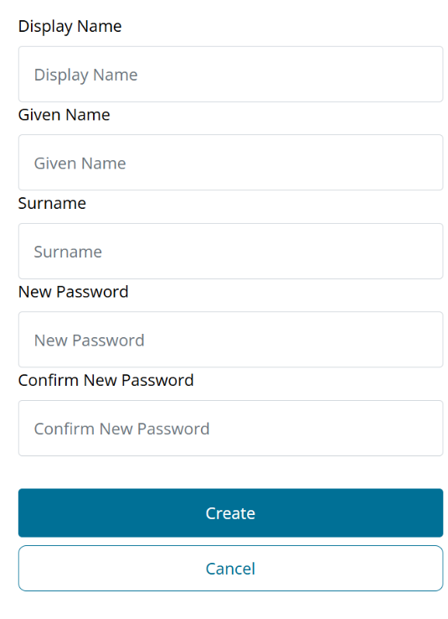

The password entered must meet following criteria:  
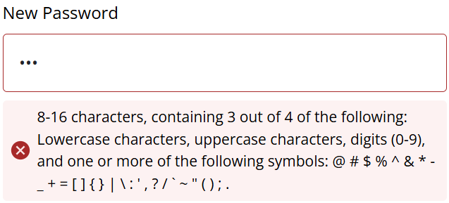

1. Once you click create, you will see instructions to set up multi-factor authentication (MFA).

**Set up multi-factor authentication (MFA)**

Below are the instructions to set up and generate a one-time password (OTP) using the authenticator app.

* 1. Download and install the Microsoft Authenticator App

Before you start, check if you already have an **Authenticator** app installed on your mobile device.

* If you don’t, search, download and install the **Microsoft Authenticator** app from your mobile device’s app store. Alternatively, you may use another authenticator app of your choice.
* On Apple devices, this will be in the App Store or on Android devices, you will need to use the Google Play Store.

 

* 1. Open Authenticator app

Once you’ve installed and opened the Microsoft Authenticator app. Select add ( +) and scan the QR code displayed on the payment portal to register your device.

Select “Work or school account”.

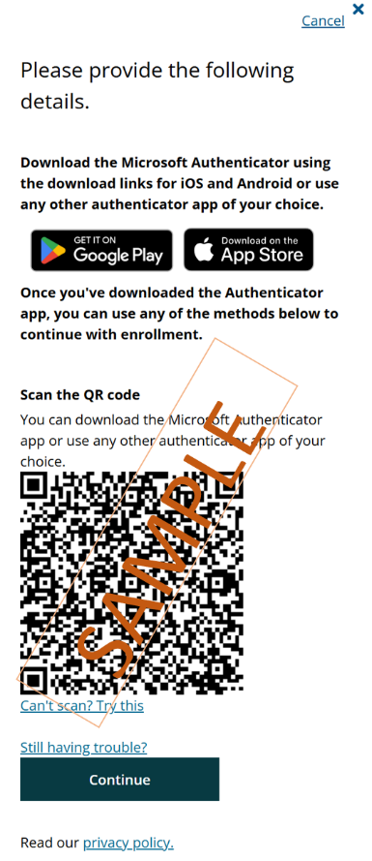

1. Generate one-time passcode (OTP).

The authenticator app is set for use. The authenticator app will generate a one-time passcode that is required to sign in.

1. Enter the one-time passcode in the portal login and click verify.

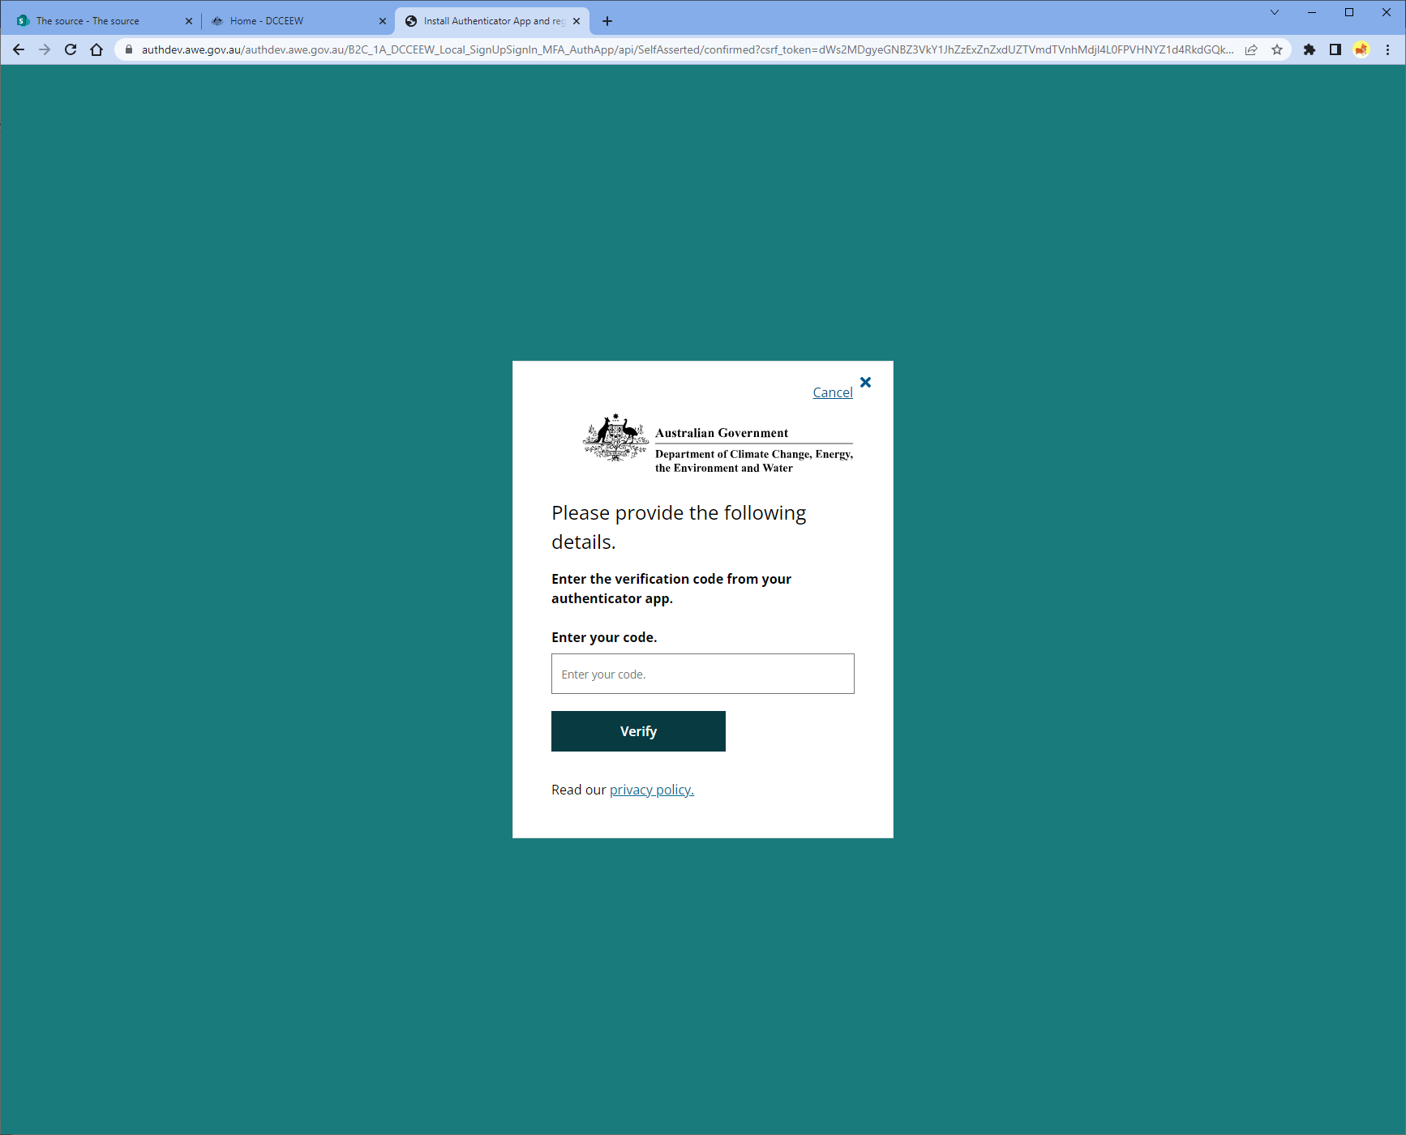

The system will verify your details and navigate you to the user profile page.

1. Verify your details and enter your contact phone number.

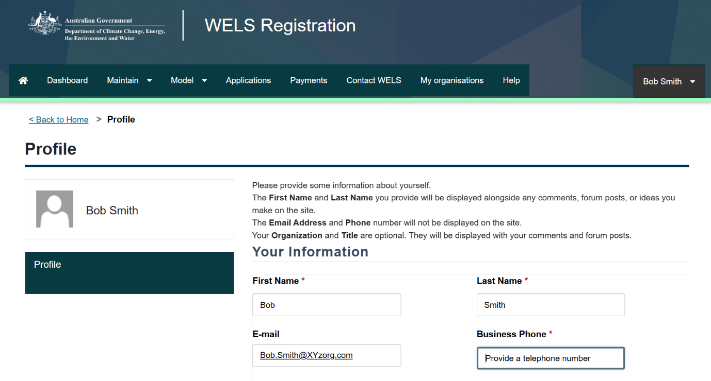

**For more details on multi-factor authentication (MFA) please refer to:**

[What is: Multifactor Authentication - Microsoft Support](https://support.microsoft.com/en-us/topic/what-is-multifactor-authentication-e5e39437-121c-be60-d123-eda06bddf661)

[Multi-factor authentication | Cyber.gov.au](https://www.cyber.gov.au/protect-yourself/securing-your-accounts/multi-factor-authentication)

## Existing user login

Instructions for registrants who already have access to the WELS Registration Portal using login credentials.

All users will need to create an account with the new WELS Registration Portal (post June 2025), even if you had an account with the old system.

**Note:** If you have not logged in as user on the new WELS Registration Portal, you will need to follow the instructions as a '1.1 Create new user account’.

1. Open [WELS Registration Portal](https://wels-portal.environment.gov.au) and enter your email address and password and click ‘Sign in’.

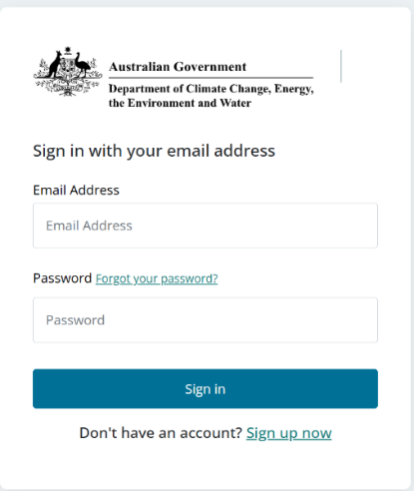

You are required to enter the one-time passcode (OTP).

1. Open the Authenticator app and find the one-time passcode for WELS Registration Portal.
2. Enter the passcode in to “Enter your code” field and click verify.

**Note:** The one-time passcode in the Authenticator app resets every 30 seconds, and a new passcode is generated. Please use the active passcode displayed on the Authenticator app.

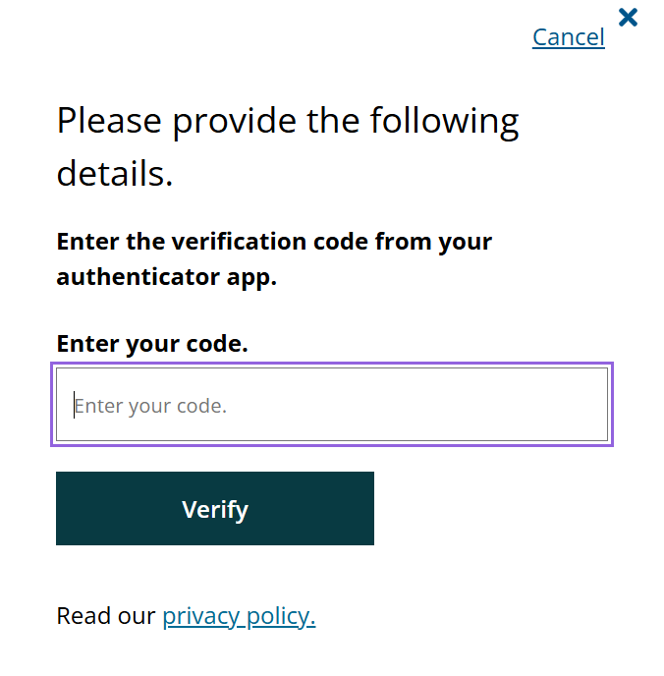

The system will verify your details and navigate you to the WELS Registration Portal landing page.

On the right-hand side (menu bar), your profile name will be displayed.

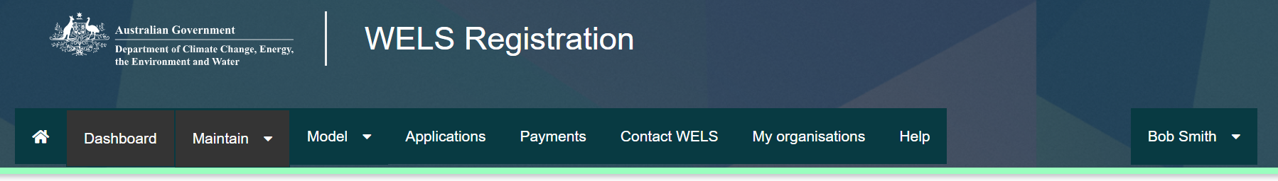

## Reset password

If you have forgotten or want to reset your password.

1. Open the WELS Registration Portal.
2. Click ‘Sign in’.
3. Select the ‘Forgot your password?’.
4. Enter your email address to receive a verification code. The verification code will be sent your registered email address. Please remember to check your spam or junk folder.
5. Enter the code in ‘Verification code’ field and verify code.
6. Enter your new password and save.

## Changing device (phone) of Authenticator app

If you change or upgrade your device used for accessing the one-time Password (OTP) on the Authenticator app for logging into the WELS Registration Portal, you must provide following details in the [**Contact us**](https://www.waterrating.gov.au/about/contact) form to make the OTP accessible on your new device.

* **Subject** – Registration
* **Name** – Your first name and last name
* **Email** – WELS login email address
* **Message** – Enter contact number and a short description (E.g., Changing from iPhone 10 to Samsung Galaxy phone)

A screenshot of a contact form.


The WELS Registration team will validate your request, remove the old device from your WELS user account, and advise when you can login to the WELS Registration Portal. A new QR code will be generated automatically when you login next, allowing you to register with the new device.

## User profile update

To view and update a contact number.

1. Find your profile name. Your profile name is displayed on the right side, top corner of the page (menu bar).
2. Click on the drop down list associated with your profile name.
3. Select ‘Profile’.
4. View your profile details (first name, last name, email address and phone number).
5. You can update your contact number.
6. Click ‘Update’ to save the details.

If you want to update your first name or last name, please contact the WELS Registration team.

**Note:** The email address field is locked from updating. This email address is used for logging in to the WELS Registration Portal and cannot be changed by the WELS Registration team.

You will need to create a new account if your email address changes, please contact the WELS Registration team to link your new user account to your old organisation(s).

## Sign out

To sign out of the WELS Registration Portal:

1. Find your profile name. Your profile name is displayed on the right side, top corner of the page (menu bar).
2. Click on the drop down list associated with your profile name.
3. Select ‘Sign out’.

You are now signed out the WELS Registration Portal. The label is updated to ‘Sign in’.

## **My organisations**

This section will show you how to maintain

* Register new organisation(s)
* View a list of organisations linked to your profile and
* Switch between organisations linked to your profile.

## Register new organisation

You will need to submit a request to register an organisation by providing the organisation details. Your organisation details will be reviewed by the WELS Registration team and approved if the organisation details meet the legislative requirements.

1. Click ‘My organisations’ from the menu bar.
2. Click ‘Register new organisation’.
3. Enter the business and organisation details.
4. Click ‘Submit’.

Your request to register a new organisation will be sent to the WELS Registration team. The status of the request will be displayed as ‘Awaiting assessment’.

You will receive an email confirming your request to register a new organisation has been received by the WELS Registration team.

Once your request to register a new organisation is assessed, the status of the organisation will be updated to ‘Approved’ / ‘Refused’ based on the assessment outcome. You will receive an email to your registered email address to notify if your request is approved or refused.

Please remember to check your spam or junk folder for email notifications.

## View organisation details

You can view the details of the organisations linked to your profile.

1. Click ‘My organisations’ from the menu bar.
2. Click on organisation name or
3. Click on the drop down selection associated with your organisation and Select ‘View details’.

## Switch organisation

If your account is linked to one or more organisations then you can view a list of all linked organisations under “My organisation” menu bar.

To perform organisation specific activities (such as submitting a new product registration application, managing models details etc.) the user will need to select the relevant organisation profile.

To switch to the relevant organisation profile:

1. Click ‘My organisations’ from the menu bar.
2. Click on the drop down button associated with the approved organisation.
3. Select ‘Switch organisation’.

The organisation profile will be loaded, and you can see the organisation name on the right-hand corner of the screen. Please ensure that you confirm that you are on the correct organisation profile before proceeding.

## **Dashboard**

When you sign in, you will be directed to the WELS Registration Portal Dashboard.

When the department has an important message to communicate, the message in highlighted text will appear at the top of this page.

The Dashboard provides you with a snapshot of your applications or activities including:

* Pending applications
* Models registered
* Invoices pending payment
* Renewal application status.

## **Maintain**

This section will show you how to maintain

* Organisation details
* Add or remove secondary contact
* Add or remove Brands
* Add or deactivate Manufacturers
* Add or deactivate local Laboratories.

## Organisation details

Use this section to view your organisation details and manage the secondary contacts of the organisation.

## Add Secondary Contact

A secondary contact can do all tasks associated with WELS applications. However, a secondary contact cannot add another secondary contact to the organisation.

Only the **primary contact** of the organisation can add a secondary contact to the organisation.

#### To add a secondary contact:

1. Select ‘Maintain’ and then ‘Organisation details’ from the menu bar.
2. Under the section ‘Organisation Contacts’, select the ‘Add Secondary Contact’.
3. Enter the secondary contact details.
4. Select ‘Submit’.

The new secondary contact will receive an email with instructions to sign in or sign up (if they do not already have a user account).

The primary contact will receive a copy of the email that was sent to the secondary contact confirming the secondary contact has been added to the organisation.

#### To remove a secondary contact

The **primary contact** can remove a secondary contact associated with your organisation.

1. Select ‘Maintain’ and then ‘Organisation details’ from the menu bar.
2. Under ‘Organisation Contacts’ you can see a list of secondary contacts associated with the organisation.
3. Click on the drop down list associated with the secondary contact.
4. Select ‘Delete’ and confirm to delete the secondary contact.

#### Change primary contact

You are unable to change the primary contact as a user. If the primary contact for your organisation has left, please send an email request through to [wels@dcceew.gov.au](mailto:wels@dcceew.gov.au).

Please provide the reason for the change and following information of the new primary contact:

* Name and position
* Email address
* Contact address and phone number.

## Brands

Use this section to create and maintain your list of brands to use in new product applications.

You need to add your brands here **prior** to starting your applications. You can also request a new brand to be added to the master brand list.

**Note**: You cannot add multiple brands to the one entry, eg. ‘Brand1/Brand2. These must be separate entries in the system.

## Add a brand to your list

1. Select ‘Maintain’ and then ‘Brands’ from the menu bar.
2. You can see the list of brands linked with your organisation.
3. Select ‘Add Brand from Global List’.
4. Search for your brand from the ‘Global brand list’.
5. Check if your brand is listed here.
   1. If your brand is in the ‘Global brand list’ **go to step 6.**
   2. If the brand is not in the ‘Global brand list’ go to **step 9.**
6. Select the brand from the list.
7. Select ‘Add Brand to my list’.
8. The brand should now be added to your Approved Brands. **Process ends here.**
9. Press ‘Cancel’ to close the ‘Global Brand list’ screen.
10. Select ‘Add Brand to List’.
11. Input your brand name and click ‘Submit’. **Process ends here**.

Your brand should now be added to Pending Brands.

You cannot view or select the brand details in the application until the brand is approved by the WELS Registration team.

You will receive an email confirming that your request to add a new brand has been submitted to the WELS Registration team.

Once the WELS Registration team completes the assessment, you will be informed of the assessment result (approved/refused) through email.

## Delete a brand from your list

1. Select ‘Maintain’ and then ‘Brands’ from the menu bar.
2. Find the Brand that you want to delete from your list.
3. Select ‘Delete’ from the drop down list associated with the brand.
4. The brand is no longer visible in your Approved Brands.

## Manufacturers

Use this section to add and edit your manufacturer details.

If you are the manufacturer of the products you are registering, you do not need to input any details here.

If you are not the manufacturer of the products you are registering, you need to have saved your manufacturer details in this area **prior** to uploading your manufacturer letter of authority in your application.

## Add a Manufacturer

1. Select ‘Maintain’ and then ‘Manufacturers’ from the menu bar
2. Search for your Manufacturer from the list, check if your Manufacturer is listed here. If the manufacturer is not included in the list proceed to next step
3. Select ‘Add Manufacturer’
4. Enter the details of the Manufacturer and click ‘Add Manufacturer’
5. The Manufacturer should now be added to your Manufacturers list.

## Edit Manufacturer details

1. Select ‘Maintain’ and then ‘Manufacturers’ from the menu bar.
2. Search for your Manufacturer from the list.
3. Click on the drop down list associated with the Manufacturer.
4. Select ‘Edit’.
5. Update Manufacturer details and click ‘Submit’.  
   The Manufacturer details are now be updated.

## Deactivate a Manufacturer

You can deactivate a manufacturer so they no longer appear in the drop down list in new product applications.

1. Select ‘Maintain’ and then ‘Manufacturers’ from the menu bar.
2. Search for your Manufacturer from the list.
3. Click on the drop down list associated with the Manufacturer.
4. Select ‘Deactivate’.

The Manufacturer will now be listed under ‘Inactive Manufacturer’s.

**Note**: If you do not see it automatically appear in ‘Inactive Manufacturers’ please refresh your page.

## Laboratories

This section is for use by **whitegoods registrants only.**

You can use this section to add a test laboratory that meets the requirements of the Equipment Energy Efficiency Program (E3) if it is not currently listed in the global list when you are adding a test report in your application.

## Add a local test Laboratory:

1. Select ‘Maintain’ and then ‘Laboratories’ from the menu bar.
2. Search for your Laboratory from the list, check if your Laboratory is listed here. If the laboratory is not included in the list proceed to next step.
3. Select ‘Add Laboratory’.
4. Enter the details of the Laboratory and click ‘Submit’.

Your laboratory should now appear in your laboratory list with Active status and will be selectable from a drop down list under “Local list” when adding a test report to your application.

If you are using a National Association of Testing Authorities (NATA) accredited or affiliated international laboratory for testing, this laboratory should be available in the drop down list on the ‘Test Report’ section when you are selecting your laboratory from Global list. If your laboratory is not in the drop down list, you will need to contact us to request adding it to the drop down list. Supporting documentation will be required from the laboratory to process this request.

## Edit your local test Laboratory details

1. Select ‘Maintain’ and then ‘Laboratories’ from the menu bar.
2. Search for your Laboratory from the list.
3. Click on the drop down list c Laboratory.
4. Select ‘Edit’.
5. Update Laboratory details and click ‘Submit’.

The local Laboratory details should now be updated.

## Delete a local test Laboratory

1. Select ‘Maintain’ and then ‘Laboratories’ from the menu bar.
2. Search for your Laboratory from the list.
3. Click on the drop down list associated with the Laboratory.
4. Select ‘Deactivate’.

The Laboratory is now set as ‘Inactive’

## **Models**

This section will show you how to

* search models
* view model details
* download the WELS certificate (PDF)
* maintain model details; and
* manage Major model edits requests.

## Search models

Use this section to search for all your models.

You can search your applications in various fields by using the drop down options and sort your search results by clicking on the title bars (column headings).

1. Select ‘’Model’ and then ‘Search models’ from the menu bar
2. You can enter various model search criteria and click ‘Search’
3. You will see a list of models that match the search criteria
4. You can export your search results to spreadsheet by using the ‘Export to excel’ option.

## View model details

1. From the search results, find a model
2. Click on the drop down button associated with the model
3. Select ‘View’ to view the see full details of the model.

## Download WELS certificate

The WELS certificate is now available to download in the WELS Registration Portal.

1. From the search results, find a model
2. Click on the drop down button associated with the model
3. Select ‘Download certificate’

The WELS certificate will be downloaded in PDF format.

## Model edits

Once a model is registered in the WELS Registration Portal, you can make some changes to the registered model details.

**Note:** You are unable to change the performance (water usage) or star rating after the model is registered. You will need to submit a new product application.

Updates to the model name, model code or adding/removing common variants do not require approval by the WELS Registration team. Please use the Minor model edit functionality (5.2.1) to make these changes. The changes are effective immediately in the system.

If you need to update the image, WaterMark references or add individual variants, you will need to submit a Major model edit request (5.2.2). These will be assessed by the WELS Registration team and will be approved or rejected.

## Minor model edit

Using this functionality, you can update the minor details of the model such as model name, model code and variants of the model. Updates made to minor details do not need approval from the WELS Registration team.

1. Select ‘Model’ and then ‘Search models’ from the menu bar
2. Find the appropriate model using the search function
3. Click on the drop down button associated with the model
4. Select ‘Minor Edit’
5. Update the fields as required
6. Select ‘Update minor details’.

Updates have been applied and details are now saved.

## Major model edit request

Using this functionality, you can update the major details of the model such as product image and WaterMark product ID. Updates made to major details needs to be reviewed and approved by the WELS Registration team.

1. Select ‘Model’ and then ‘Search models’ from the menu bar
2. Find the appropriate model using the search function
3. Click on the drop down button associated with the model
4. Select ‘Major Edit’
5. A Major model edit request will be created
6. Scroll through the model details
7. Update model details and ‘Submit’ application.

Your Major model edit request has now been submitted for review by the WELS Registration team.

You will receive an email confirming your request to update model details has been submitted to the WELS Registration team.

Once the request is assessed by the WELS Registration team, you will be notified of the outcome of assessment (approved/refused).

## View a Major model edit request

Under this section, you can view the model edit requests that you have submitted and their statuses.

1. Select ‘Model’ and then ‘Model edit requests’ from the menu bar
2. You can see a list of Major model edit requests submitted.
3. Click on the drop down list associated with the model.
4. Select ‘View’.

You can see updates to the Major model edit request that has been submitted.

## Recall a Major model edit request

A Major model edit request can be recalled when the application is in ‘Submitted – awaiting assessment’ status.

1. Select ‘Model’ and then ‘Model edit requests’ from the menu bar
2. Use the filter ‘Request status’ to search for requests in Submitted – awaiting assessment’ status
3. You can see a list of Major model edit requests in ‘Submitted – awaiting assessment’ status
4. Click on the drop down list associated with the model
5. Select ‘Recall’.

Your application has now been recalled, and the status of the application is displayed as ‘Recalled’.

You will receive an email confirming your model edit request has been recalled.

## Edit a Major model edit request

You can update details of a model edit request only when the request status is in ‘Draft’, ‘Recalled’ or ‘Returned’.

1. Select ‘’Model’ and then ‘Model edit requests’ from the menu bar
2. You can see a list of Major model edit requests that are ‘Draft’, ‘Recalled’ or ‘Returned’ status
3. Click on the drop down list associated with the model
4. Select ‘Edit’
5. Your model edit request will be opened
6. Modify the details and submit request.

Your model edit request will be submitted and the status of the request will be displayed as ‘Submitted – awaiting assessment’.

If you have updated a model edit request that was returned by the WELS Registration team, then the status of your returned request will be displayed as ‘Resubmitted’.

You will receive an email confirming your request to update model details has been received by the WELS Registration team.

Once the request is assessed by the WELS Registration team, you will be notified of the outcome of assessment (approved/refused/returned).

## Delete a Major model edit request

You can delete a model edit request only when the request status is in ‘Draft’ or ‘Recalled’.

1. Select ‘’Model’ and then ‘Model edit requests’ from the menu bar
2. You can see a list of Major model edit requests that is ‘Draft’ or ‘Recalled’ status
3. Click on the drop down list associated with the model
4. Select ‘Delete’
5. Confirm deletion by clicking ‘Confirm delete’

Your model edit request will be deleted and cannot be accessed from the ‘Model edit request’ section.

## Major model edit request status

Your Major model edit request will be in one of the following statuses:

**Draft –** The Major model edit request has been started but has not been submitted.

**Submitted – awaiting assessment –** The Major model edit request has been submitted and is awaiting assessment by the WELS Registration team.

**Recalled –** The Major model edit request has been recalled.

**Returned –** The Major model edit request has been returned to you for action. Please refer to the comments provided in the email for the action required. You can also view these comments in the portal within the application.

**Resubmitted –** The Major model edit request has been resubmitted after being returned and is waiting for reassessment.

**Under delegate review –** The Major model edit request assessment has been completed by an assessment officer and is being reviewed by a delegate.

**Approved –** The Major model edit request has been approved and the changes made in the database. The updated details will be displayed in the WELS product register within 30 minutes.

**Refused –** The Major model edit request has been refused. Models details in the registration database remain unchanged.

## **Applications**

This section will show you how to

* search existing new product applications
* prepare for a new product application
* start a new product application
* manage existing applications

## Search Applications

Use this section to search for all your applications.

You can search your applications in various fields by using the drop down options and sort your search results by clicking on the title bars (column headings).

## New Product Application

Use this section to prepare your new applications.

## Prepare for a new product application

Before starting a new application, you need to make sure that you have:

* supporting documentation relevant to test report/s, and manufacturer letter of authority (if required)
* WaterMark Product ID (for plumbing products only)
* checked that the brand you want to use in your application is in your brand list. If the brand is not on your list, then you will need to submit a request to add new brand to your list.
* prepared an image of the product/s to upload when you are completing your application.

You can list up to 5 models on the same application. The models must be the same product type, subtype, brand and share the critical components outlined in the WELS standard. They must also use the **same** test report. If these requirements are not met, you will need to submit the remaining models on a separate application.

Every model must be registered as it is offered for supply. If it cannot be traced in our product search portal ([Public Register](https://wels-public-register.environment.gov.au)) then it is not registered.

## Start a new product application

1. Click ‘Applications’ from menu bar
2. Select ‘Create’
3. Complete the application fields and continue through the screens by pressing ‘Save & Next’.

## Model details

Each product will have a different application form with different questions. The following generic information must be included with your application for all products:

#### **Model name and model code**

For every product you register you will be asked to supply the model name and the model code.

The model name is the name as supplied on the packaging of the product or the advertising that the consumer will use to identify the model. For example, it could be the Wombat 300 mm basin tap.

The model code is the unique identifier that you use for your product, it could be the same as the model name or it could be different for example—a stock control code.

#### **Model ID on Test Report**

The 'Model ID on Test Report' is the model code you're referencing on the test report. You must provide a ‘Model ID on Test Report’ reference for each model in the application.

If you are declaring that the performance of the model is the same as a model with slightly different components then you must provide supporting information. You must provide a statement that the products have the same critical components and/or attach schematics to demonstrate that the waterways are the same.

#### **Image**

Please upload an image that clearly shows the model that you are registering. The images are made publicly available on the product search website once registered.

**Note:** For shower applications, the spray pattern (face) of all shower heads must be visible in the image for assessment.

#### **Performance claims**

Input the performance details of your product. The system will calculate and display the star rating of your product.

**Note**: If you have more than one model in the application, then use the performance (water consumption) values of the model with the highest water consumption. The models must have the same star rating.

**Note:** Do not round results found on the test report, please input the results as found on the test report.

#### **Declaration**

You are required to confirm that you have read and confirmed the declaration on the information and documents you have submitted as part of your application. This will be used for the purposes of assessing your application and the performance of our statutory responsibilities.

## View application details

Under this section, you can view a list of new product applications, their statuses and content.

1. Click ‘Applications’ from menu bar
2. You can see a list of applications created
3. Use search criteria to search for specific application(s) and click ‘Apply’
4. Results matching the search criteria is displayed
5. From the search results, click on the drop down list associated with the application
6. Select ‘View’ from the drop down list
7. Your submitted application will be opened in read only mode. You can see the contents of the application.

## Recall an application

A new product application can be recalled when the application is in ‘Submitted – awaiting assessment’ status.

1. Click ‘Applications’ from menu bar
2. You can see a list of applications in ‘Submitted – awaiting assessment’ status
3. Click on the drop down list associated with the application
4. Select ‘Recall’.

Your application has now been recalled and the status of the application is displayed as ‘Recalled’.

You will receive an email confirming your application has been recalled.

## Edit an application

You can update details of an application only if the application status is in ‘Draft’, ‘Recalled’ or ‘Returned’.

1. Select ‘Applications’ from the menu tab
2. You can see a list of application you have created
3. Click on the drop down list associated with the application
4. Select ‘Edit’
5. Your application will be opened
6. Modify the details and submit application.

Your application will be submitted and the status of the application will be displayed as ‘Submitted – awaiting assessment’.

You will receive an email confirming your application has been resubmitted and received by the WELS Registration team.

## Delete an application

You can delete an application only when the request status is in ‘Draft’ or ‘Recalled’.

1. Select ‘Applications’.
2. You can see a list of applications that is ‘Draft’ or ‘Recalled’ status.
3. Click on the drop down list associated with the application.
4. Select ‘Delete’.
5. Confirm deletion by clicking ‘Confirm delete’.

Your application will be deleted and cannot be accessed from the ‘Applications’ section.

You will receive an email confirming the draft WELS application was deleted.

## New product application status

Use this section to check the status of your new product application.

**Draft** **–** The new product application has been started but has not been submitted.

**Submitted – awaiting assessment -** The new product application has been submitted and is awaiting assessment by the WELS Registration team.

**Recalled –** The new product application has been recalled.

**Resubmitted –** The new product application has been resubmitted and is awaiting assessment by the WELS Registration team.

**Under Assessment –** The new product application is currently being assessed by the WELS Registration team.

**Returned** **–** The new product application has been returned to you for further action. Please refer to the comments provided in the email for the action required. You can also view these comments in the portal within the application.

**Under delegate review –** The new product application assessment has been completed by an assessment officer and is being reviewed by a delegate.

**Awaiting Payment –** The new product application has been provisionally approved by the delegate and is now waiting on payment or is dependent on another application that requires payment. Please go to the ‘Payments’ section to view payment details and download invoice. It may take approximately 3 working days to receive notification of a tax invoice available for download.

**Approved –** The new product application has been approved and the models are now registered.

**Refused** **–** The new product application has been refused. The models in the application are not registered.

## **Renewals**

## Overview

Models are registered up until the 22 July each year. The registration will expire on following 22 July unless the registration of the models is *renewed*. The department will notify you in advance of the pending expiry, and of the steps that you need to take to renew the registration of your models for another 12 months.

## Renewals Timeline

The renewal submission period is open from 15 September to 5 December each year. You must submit the models you want to renew during this period.

On 15 September, your models will be updated from *Registered* to *Expiring*:

* *Expiring* models are still registered, and you may continue to supply these models for sale in Australia.

**Note**: *Expiring* status only appears on the WELS Registration Portal, the models will appear as *Registered* on the WELS Product Register.

* You will receive an email notifying you of this and that your Renewal Application has been generated and is available for completion.
* If you wish to maintain the registration of your models you must complete and submit this application promptly. Once provisionally approved, you will need to pay the renewal invoice to complete the renewal.

**Note:** that you must pay your invoice by 22 January to avoid your registrations going into *Ceasing* status.

On 5 December, the deadline for renewal applications occurs. This is the last day to submit your renewal application.

On 22 January, your models will be updated from *Expiring* to *Ceasing*:

* *Ceasing* models are still registered, and you may continue to supply these models for sale in Australia.

**Note**: *Ceasing* status appears on the WELS Registration Portal and the WELS Product Register.

* You will receive an email notifying you of this.
* If you have previously submitted the renewal application, you will still be able to respond to issues raised by the department and/or pay the invoice for the renewal of the models.

On 22 July, your models will be updated from *Ceasing* to *Expired*. The department will also refuse any outstanding renewal applications, and the department will not be able to accept payments for outstanding renewal application invoices.

* *Expired* models are **not** registered, and you may **not** continue to supply these models for sale in Australia.
* If your renewal application was outstanding, the application will also be refused.
* You will receive an email notifying you of this.
* You will need to submit new product applications if you wish to re-register these models for sale and supply in Australia.

## Renewal Banners

Before you log into the portal during the renewals period (see the timeline section above), banners explaining the process will be displayed. A sample banner is provided below (dates will vary):

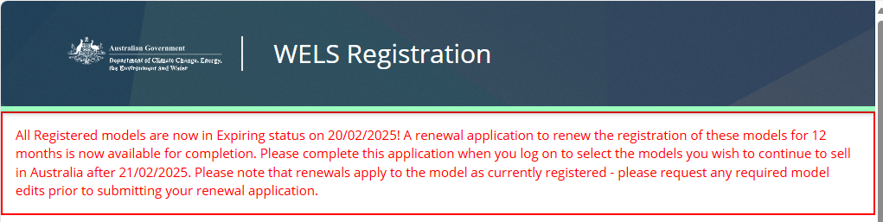

## Model renewal application

Your draft renewal application will automatically be generated for you on 15 September (see Renewals Timeline above). When you open the renewal application you will be presented with three tabs:

* Models marked for renewal – this is a list of the models that will be submitted for renewal. This list will initially default to all your currently registered models as being selected for Renewal.
  + You may remove models that you do not wish to renew from here, and those models will then appear in the *Models not being renewed*list (see below)
  + You may also request a Major model edit directly from this page.

**Note:** You will **not** be able to request Major model edits after your renewal application is submitted and with the WELS Registration team for assessment.

* + Please request any required Major model edits before you submit (or re-submit) your renewal application.
* Models not being renewed – this is a list of the models that will **not** be submitted for renewal. This list will initially default to being empty.
  + Any of your registered models that you have unlinked from the application will appear here, and
  + You may add the unlinked models back into the application. Those models will be removed from here and reappear in the *Models marked for renewal* list.
* Model Audits – this is a list of any model audits conducted by the WELS Registration team during the assessment of your renewal application.
  + This list will initially be empty.
  + When the department assesses your renewal application, some of your models may be audited, and
  + Any audit results will be provided to you here if the application is returned to you for action.

Once you are satisfied with your selection of models to be renewed for the next year you may proceed to the next section. Depending on the status of your application and models, you may receive validation errors – the errors will inform you of any actions that you need to take.

#### **Declaration**

You are required to confirm that you have read and confirmed the declaration on the information and documents you have submitted as part of your application. This will be used for the purposes of assessing your application and the performance of our statutory responsibilities.

## View renewal application details

Once you have submitted your renewal application, you can view the application in the Model renewal application screen.

1. Select ‘Model’ and ‘Model renewal application’ in the menu bar.
2. You will see a list of renewal applications.
3. Click on the drop down list associated with the renewal application.
4. Select ‘View’ from the drop down list.
5. Your submitted application will be opened in read only mode. You can see the contents of the application.

## Recall a renewal application

A renewal application can be recalled when the application is in ‘Submitted – awaiting assessment’ status.

1. Select ‘Model’ and ‘Model renewal application’ in the menu bar.
2. You can see your renewal application in ‘Submitted – awaiting assessment’ status.
3. Click on the drop down list associated with the application.
4. Select ‘Recall’.

Your renewal application has now been recalled and the status of the renewal application is displayed as ‘Recalled’.

You will receive an email confirming your renewal application has been recalled.

## Edit a renewal application

You can edit a renewal application if the application status is in ‘Draft’, ‘Recalled’ or ‘Returned’.

1. Select ‘Model’ and ‘Model renewal application’ in the menu bar.
2. You can see your renewal application in ‘Draft’, ‘Recalled’ or ‘Returned’ status.
3. Click on the drop down list associated with the application.
4. Select ‘Edit’.
5. Your application will be opened.
6. Make appropriate edits and submit or save the renewal application.

## Delete a renewal application

You cannot delete your renewal application. The WELS Registration Portal will remove the renewal application from view when the renewal application can no longer be submitted or approved. Refer to the Renewals Timeline (Section 9.2) for more general information about the renewal process.

## Renewal application status

Your renewal application will be in one of the following statuses:

**Draft** **–** The renewal application has been automatically generated but has not been submitted.

**Submitted – awaiting assessment** **–** The renewal application has been submitted and is awaiting assessment by the WELS Registration team. You can recall the renewal application in this status for amendment.

**Recalled –** The renewal application has been recalled by you prior to the WELS Registration team commencing its assessment. A renewal application can be recalled by you only when the application is in ‘Submitted – awaiting assessment’ status and you can then resubmit it after making necessary changes. A recalled and resubmitted renewal application will be treated as the first submission by the WELS Registration team.

**Resubmitted –** The renewal application has been resubmitted and is awaiting assessment by the WELS Registration team.

**Under Assessment** **–** The renewal application is currently being assessed by the WELS Registration team.

**Returned** **–** The renewal application has been returned to you for further action. Please refer to the comments provided in the email or WELS Registration Portal for the action required.

**Under delegate review** **–** The assessment of your renewal application is completed by an assessment officer and is being reviewed by a delegate.

**Awaiting Payment** **–** The renewal application has been provisionally approved by the delegate and is now waiting on payment or is dependent on another application that requires payment. Please go to the ‘Payments’ section to view payment details and download invoice. It may take approximately 3 working days to receive notification of a tax invoice available for download.

**Approved** **–** The renewal application has been approved and the registration of the models has been renewed.

**Refused –** The renewal application has been refused. The models in the application will not be renewed and will expire on 22 July of that year.

## **Payments**

Use this section to display all the information regarding your current tier and tier fee, manage your payments, and forecast fees when you submit your applications.

## Payment Overview

This section is divided into three subsections, each is described below.

#### Registered/Invoiced Models

This section summarises the models that you have registered, and/or have been invoiced for after the assessment of the applications.

#### Submitted Models

This section summarises the models in applications that you have submitted but that have not yet been provisionally approved and invoiced.

#### Payment Details

Use this section to view and download your tax invoices and receipts.

A tax invoice will be issued for any payments required. All contacts receive an email when an invoice has been uploaded. Do not make a payment until you have downloaded your tax invoice.

All contacts with a login to your organisation in the product registration portal can access tax invoices and receipts. We do not email these documents out. You will need to login and download them as required.

Receipts for your payments are stored here. You will be sent an email when a new receipt is uploaded and you access this portal to download the receipt.

When a receipt is uploaded, your application/s will be released for processing.

To access your tax invoices and receipts:

1. Select ‘Payments’.
2. Scroll down past the Registered/Invoices Models and the Submitted Models sections described above to the Payment Details section.
3. Your tax invoices and payments/receipts are listed here.
   * 1. Select the invoice number hyperlink to view the details of each invoice (including payments) and to download the tax invoice.
     2. Alternatively, select the view action from the menu bar to access the same view.
4. When the invoice details are displayed you can:
   * 1. Click on the Invoice hyperlink to download the tax invoice, and
     2. Within the Payment receipt section, click on an Invoice receipt file hyperlink to download the payment receipt.

## Pay tax invoices

When you make a payment by bank transfer/electronic funds transfer, you must input the tax invoice number in your reference field first (for example, 300XXXXXXXX). If you do not enter the tax invoice number, there will be a delay in processing your payment.

The reference field only transmits a small amount of text so please ensure the tax invoice number is the first thing you input in this field prior to sending the payment.

**Important:** If you are making a payment from outside Australia by bank transfer/electronic funds transfer your bank will charge you fees to process the transaction. You must ensure that all fees are paid in addition to the total amount owing so that the correct invoiced AUD$ amount is received. Failure to do this will result in delays to your registration. Until full payment of a tax invoice is received we cannot progress your registrations.

## **Contact WELS**

Use the ‘Contact WELS’ section to send your enquiry to the WELS Registration team.

As a registered WELS user, you can submit an enquiry via the Contact WELS form.

Enquiries submitted as a registered user will be associated with the organisation.

1. Click on ‘Contact WELS’ menu tab.
2. Enter details such as subject, message and attach document (if required).
3. Click ‘Submit’.

You will receive an email confirming your enquiry has been received by the WELS Registration team.

All enquiries sent via the Contact WELS form will be available to view on the portal.