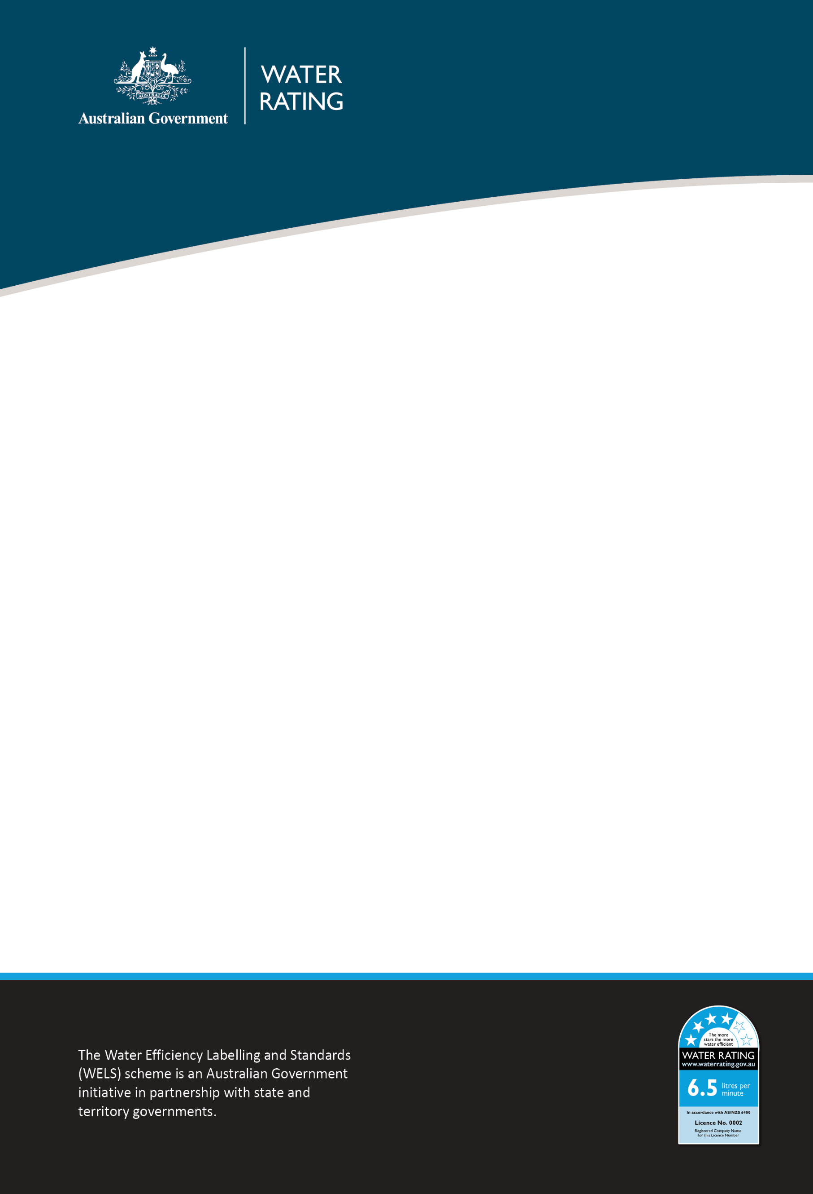

24 March 2025
WELS REGULATOR ADVICE
Amendments to Water Efficiency Labelling and Standards legislation

Purpose
To inform stakeholders that amendments to the Water Efficiency Labelling and Standards Determination 2013 (No.2) (WELS Determination) came into force on 21 February 2025. The amended Determination can be found on the Federal Register of Legislation - https://www.legislation.gov.au/F2013L01574/latest/text. The amendments include:
- incorporating the latest versions of relevant standards and codes
- updating WELS products categories
- clarifying registration requirements and grounds for cancelling or suspending registration.

Issue
The WELS Determination outlines Water Efficiency Labelling and Standards (WELS) products and standards and provides for the registration and maintenance of a register of WELS products. The WELS Determination was last amended in 2016. The 2025 amendments were necessary to reference updated standards and codes issued by Standards Australia and the Australian Building Codes Board.

Key Amendments
Updated reference to AS/NZS 6400:2016
The WELS Determination now references AS/NZS 6400:2016 (incorporating Amendments up to and including No. 2). This includes the introduction of 5-star shower ratings and the establishment of minimum water efficiency standards for all WELS products except flow controllers. For further information refer to WELS Regulator Advice Transition to new standard amendments.

Section 6 of the WELS Determination
Section 6 (Determination of WELS products) has been amended to deregulate miscellaneous products. Of note, these include:
- Bottle fillers, bottle filler outlets, drinking fountains and drinking fountain outlets that meet specific conditions. To be excluded from the WELS scheme, a drinking fountain or bottle filler must be certified in accordance with WMTS-105:2016, and a drinking fountain outlet or bottle filler outlet must be certified in accordance with AS 3718:2021 and categorised by a WaterMark conformity assessment body as 'drinking fountains and bottle fillers’.
This means that deregulated products no longer need to be registered or WELS labelled. For deregulated products that are currently registered, product registrations will automatically expire on 21 July 2026.
Businesses will not need or be able to register new models of deregulated products. Any registration application received for these products will not be assessed

Action for WELS product registrants
Registrants must:
- not renew the WELS registration of products that meet the requirements of Section 6 of the WELS Determination to be excluded from the WELS scheme (e.g. drinking fountains, drinking fountain outlets, bottle fillers and bottle filler outlets) during the 2025 registration renewal period.
- ensure that this product stock is not WELS-labelled from 21 July 2026 or earlier, to assist retailers to meet the requirements for floor stock (refer to Action for WELS product suppliers).

Action for WELS product suppliers
Suppliers must:
- for the deregulated products, ensure that packaging, in store labelling (such as shelves or displays) and any offers for sale online do not have WELS labelling by 21 July 2026.

Monitoring and compliance
Non-compliance will be assessed against legislative requirements and a risk-based approach will be used to determine an appropriate and proportionate response. For more information, refer to the WELS Compliance and Enforcement Policy.

Contact

Compliance enquiries:
1800 372 746 (within Australia) +61 2 5162 1815 (international)
welscompliance@dcceew.gov.au

Registration enquiries:
1800 218 478 (within Australia) +61 2 5162 1816 (international)
wels@dcceew.gov.au

