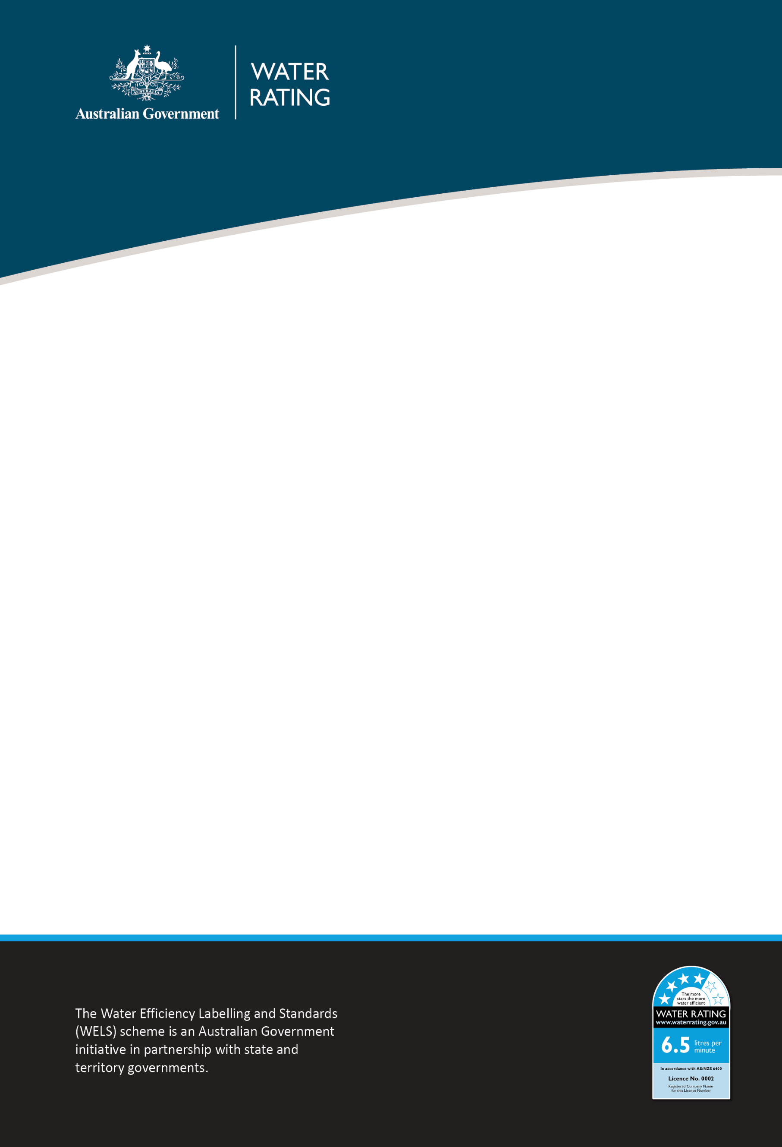

29 July 2025
WELS REGULATOR ADVICE
Registration and labelling requirements: Taps and showers supplied with additional flow controllers

Purpose
This advice applies to taps and showers that are supplied with additional flow controllers that can be interchanged. It sets out the registration requirements and recommended labelling when supplying these types of Water Efficiency Labelling and Standards (WELS) products.
This advice does not apply to aerators supplied for installation in taps over a bath.

Issue
The WELS team has received enquiries from registrants seeking clarification on the registration and labelling requirements for taps and showers that are supplied with additional flow controllers that can be interchanged.

Conditions
The WELS standard (AS/NZ 6400:2016) applies to the registration and labelling of tap equipment and shower products.
The standard specifies that where there is a change to one or more of the critical specifications or components for taps or showers, the product is deemed to be a new model for WELS registration purposes. Flow controllers are a critical component of taps and showers.

Requirements
There are requirements that must be met by both registrants and suppliers of the products.
The requirements must be met within 12 months from the date this notice is issued.

WELS product registrants
Registrants must:
- apply for separate WELS product registrations for each flow controller option provided with a tap or shower.
- provide clear instructions with the product on how the flow controller can be changed, including identification of flow controllers with their corresponding WELS star rating and flow rate.
- ensure product packaging displays the WELS label for each flow controller option on the same product packaging face.
- ensure product packaging clearly identifies the factory fitted flow controller configuration inside the tap or shower on the same product packaging face as the WELS labels.
- ensure that the product packaging includes each registered model name, unless they are identical.
It is recommended that the tap or shower is factory fitted with the highest star rating flow controller.
It is recommended that the WELS labels on the packaging are arranged adjacent to each other (horizontally or vertically), starting with the highest star rating and moving to the lowest.
Consideration is being given to specifying the above recommendations as requirements within a future revision of the WELS standard (AS/NZ 6400:2016).
Example
A business supplies a 6-star rated tap with an additional 4-star rated flow controller included in the packaging. The product must be registered for 6-star and 4-star registrations. The packaging must be WELS labelled for both registrations.
WELS product suppliers
Suppliers must:
- ensure the WELS labels on product packaging meet the requirements (refer to the dot points 3, 4 and 5 for registrants).
- ensure that advertising (print and physical display) states the WELS information for the highest star rating or the star rating of the factory fitted flow controller.
- It is optional to provide WELS information for other flow controller configurations in advertising.
- Where WELS information is provided for other flow controller configurations, information must be provided for all flow controller configurations.
- ensure that advertising (online) states the WELS information for all flow controller configurations.
It is recommended that where advertising states all WELS information, the WELS labels or text advices are arranged adjacent to each other (horizontally or vertically), starting with the highest star rating and moving to the lowest.
Example
A business sells a 4-star rated tap with additional 3, 5 and 6-star rated flow controllers included in the packaging. The in-store labelling, as a minimum, must provide the labelling information as 6-star (highest star) or 4-star (factory fitted). For online advertising, the WELS information for the 3, 4, 5 and 6-star ratings must be shown.

Monitoring and compliance
The WELS compliance team will work with businesses to encourage and support voluntary compliance through education and advice.
Non-compliance will be assessed against legislative requirements and a risk-based approach will be used to determine an appropriate and proportionate response. For more information, refer to the WELS Compliance and Enforcement Policy.

Contact

Compliance enquiries:
1800 372 746 (within Australia) +61 2 5162 1815 (international)
welscompliance@dcceew.gov.au

Registration enquiries:
1800 218 478 (within Australia) +61 2 5162 1816 (international)
wels@dcceew.gov.au

